**Suffolk Youth Justice Plan**

**2025 - 2026**

|  |  |
| --- | --- |
| **Contents** | **Page** |
| Introduction | 3 |
| Vision and Strategy | 4 |
| Governance leadership and partnership arrangements | 4 |
| Progress on priorities in the 2024-2025 plan | 5 |
| Performance over the previous year | 11 |
| Risk and issues | 14 |
| Suffolk Youth Justice Plan for 2025-2026 | 15 |
| Child First | 15 |
| Resources and Services | 16 |
| Board Development | 17 |
| Workforce Development | 17 |
| Evidence-based practice and innovation | 17 |
| Evaluation | 18 |
| Priorities for the coming year | 18 |
| Standards for children in youth justice system | 18 |
| Service development | 19 |
| National Priorities | 20 |
| Children from groups which are over-represented | 20 |
| Policing | 20 |
| Prevention | 21 |
| Diversion | 21 |
| Education | 21 |
| Restorative approaches and victims | 23 |
| Serious violence, exploitation and contextual safeguarding | 24 |
| Detention in police custody | 24 |
| Remands | 25 |
| Use of custody and resettlement | 25 |
| Working with families | 25 |
| Appendix 1: Board Membership | 26 |
| Appendix 2: Service structure | 27 |
| Appendix 3: Budget costs and contributions | 29 |
| Appendix 4: Staff demographics | 30 |

**Introduction**

I am pleased to present the Suffolk Youth Justice Plan for 2025-2026. The plan and the priorities have been developed and agreed with the Suffolk Youth Justice Management Board and will be signed off by Suffolk County Council (SCC) Full Council. Children, staff, and volunteers have also been consulted about what is important to them. The plan covers both an annual report on achievements during 2024-2025 and the priorities for 2025-26 and how they will be achieved.

Throughout the year, we have welcomed new members to the Board, including representatives from HM Courts, the Chair of the Youth Magistrates, and the Cabinet Member for Children and Young People Services.

The Youth Justice Management Board has a keen interest in developing a Child First approach across the partnership. The Board acknowledges the need for change at all levels, requiring ongoing review and challenge across the system.

The service has made progress this year in offering a range of data and information products, enhancing the Board's understanding of the children supported by the service.

We have seen fewer children detained in police custody overnight and a reduction in community and custodial orders compared to the previous year. Additionally, Suffolk also received a visit from the Youth Justice Board following a reduction in the number of serious violence offences committed by children.

The Board and I would like to express our sincere appreciation for the dedication and commitment demonstrated by the Youth Justice Service staff and partners in their contribution to keeping Suffolk safe.

The Youth Justice Management Board will monitor priorities against this plan and include the voices of children and their families to ensure accountability.

On behalf of the Management Board, I am pleased to present Suffolk’s Youth Justice Plan 2025-2026.

Assistant Chief Constable Eamonn Bridger

Suffolk Youth Justice Management Board Chair

**Vision and Strategy**

The Suffolk Youth Justice Management Board and service align with the Youth Justice Board (YJB) vision of a Child First Youth Justice System. This means putting children at the heart of what we do. The youth justice system should treat children as children, see the whole child, including any structural barriers they face and focus on better outcomes for children. This will also create safer communities with fewer victims.

The Suffolk Youth Justice Service (SYJS) practice model follows Child First principles and aligns with the Signs of Safety framework used by Suffolk County Council's Children and Young Peoples Services (CYPS). This ensures a shared language and supports partnership working.

The strategic priorities for the service are to:

* Reduce the number of children entering the youth justice system
* Reduce reoffending by children in the youth justice system
* Reduce the use of youth detention and improve resettlement outcomes
* Improve safety, wellbeing, and outcomes for children in or on the edges of the youth justice system

These priorities are met by fostering relationships and leveraging strengths. This involves supporting children to develop a positive sense of self, collaborating with their personal and professional network, considering the victims' needs, and using data to guide and shape service delivery.

**Governance leadership and partnership arrangements**

SYJS governance is through the Suffolk Youth Justice Management Board which is chaired by the Assistant Chief Constable from Suffolk Constabulary. The statutory youth justice partners are represented on the board. Board membership can be found in Appendix 1.

SYJS sits within Suffolk County Council’s Children Services and the Head of Service reports to the Assistant Director (AD) for Children’s Social Care, Corporate Parenting and Youth Justice. SYJS is represented on the Suffolk Safeguarding Partnership by the AD for Children’s Social Care, Corporate Parenting and Youth Justice. The service has strategic links to The Safer and Stronger Communities Board through the Public Health representative on the board and direct involvement with delivery of the countywide work programme to reduce child exploitation. The Head or Deputy Head of Service also attend the Multi Agency Public Protection Arrangements (MAPPA) Strategic Board, Local Criminal Justice Board (LCJB), Multi-Agency Safeguarding Hub (MASH) Strategic Board, the Integrated Offender Management (IOM) Board, Suffolk Constabulary Children and Young People’s Board and the Safer in Schools Board. The service is linked into other Suffolk County Council Children Services at a strategic level through regular Heads of Service meetings. The Head of Service co-chairs the Unnecessary Criminalisation of Children in Care and Care Leavers Meeting. Operational Managers from SYJS attend the Norfolk and Suffolk Out of Court Disposal Scrutiny Panel. The service is also part of the Local Serious Violence Duty Partnership and Multi-Agency Criminal Exploitation (MACE) panel.

The three teams which make up SYJS are multi-agency and include police staff, educational psychologists, speech, language and communication therapists (SALT), substance misuse and primary mental health workers (PMHW). A probation officer and clinical psychologist are based in Ipswich but provides a service to the whole county. SYJS staff include directly employed qualified social workers. SYJS teams are co-located with other parts of Children’s Services and are based in Ipswich, Bury St Edmunds, and Lowestoft.

The service also has links with the third sector including the YMCA and Anglia Care Trust (who deliver the Appropriate Adult Service in Suffolk) and is working to develop strong links with a wider range of local community and voluntary organisations.

Appendix 2 shows the staffing structure of the Suffolk Youth Justice Service.

Appendix 3 shows the budget and partnership contributions.

Appendix 4 shows the ethnicity, sex and disability information for the service.

**Progress on priorities in the 2024-25 plan**

**Improve the quality of work with children to support their safety and wellbeing and reduce the risk of reoffending and harm to others as measured via regular reporting to the Management Board.**

* Enhancing the Management Board's understanding and connection to the service through direct observations enables them to effectively challenge and support service leaders. Board members have been invited to observe the operations of the service firsthand. Several members, including the Chair, attended an Out of Court Disposal Panel, while other board members, such as the Board Member for Social Care, participated in meetings with the Leadership and Locality Teams and observed proceedings at the Youth Court.
* The Board approved a regular agenda slot for discussing practice issues through case examples or hearing from children and families. This slot will also include learning from serious incident reviews.
* The service introduced a countywide risk management panel and regularly holds Out of Court Disposal panels with Suffolk Constabulary, involving key partner agencies and internal specialists.
* Staff have undertaken bespoke training to support the development of casework and completed mandatory annual training from SCC, covering topics like equality, diversity, inclusion, and neurodiversity.

Service specific training undertaken in 2024-2025 included:

|  |  |
| --- | --- |
| Training Undertaken | Details |
| Prevention and Diversion Assessment Tool | Training on the use of the prevention and diversion assessment tool |
| Court Practice and Report Writing | Court practice and report writing |
| Collaborative Planning | Collaborative planning with children and their personal and professional networks to ensure safety and wellbeing |
| Mental Capacity Act | Understanding of the Mental Capacity Act for children and young people undertaken by managers |
| Supervising Staff | Training on supervising staff working with children who display sexually harmful behaviour |
| Effective Practice and Interventions | Effective practice and interventions for working with children who display sexually harmful behaviour |
| Restorative Approaches | Restorative approaches within SYJS |
| Understanding Child's Journey | Understanding the child’s journey within children’s services to support safety and wellbeing |

* Training on constructive resettlement and working with children with traumatic brain

injury has been delayed. Staff feedback indicated a need for more time to apply learning in assessment and planning. This training is now scheduled for 2025-2026.

* In line with the SYJS workforce development strategy, four staff completed the Youth Justice Effective Practice Certificate and one completed the Unitas Effective Practice Award in Diversion, alongside the three Seconded Police Officers.
* The Induction process was revised based on staff feedback, creating a new induction and practice hub to support robust starts in youth justice. This includes effective assessments and collaborative planning with children and their networks.
* A new internal quality assurance meeting has been initiated, chaired by the Head of Service.
* A peer audit has been completed with a neighbouring service, and the Centre for Justice Innovation is providing external scrutiny to the out-of-court work.

Thematic audits which took place included:

* A victim and restorative approaches audit.
* A joint audit with Probation on transitions between youth justice and Probation with a focus on outcomes for children in care.
* A safeguarding audit of children including children at risk of exploitation.

**To advocate for a Child First approach across the partnership.**

* The Board participated in a development session by Child First Consultancy to deepen their understanding of the child first approach across the youth justice system.
* Reducing the number of children who enter the formal youth justice system for the first time (First-Time Entrants or FTE) is one approach to divert from the stigma associated with involvement in the youth justice system. Suffolk Constabulary and SYJS implemented a Joint Action Plan to reduce the number of children who become FTEs. The Multi Agency Out of Court Decision Making Panel meets weekly, using the expertise of the panel members to ensure appropriate decisions are made to support children, provide access to effective support for desistance, and consider the victim’s views and safety.
* Suffolk Constabulary, SYJS and the Public Protection Unit worked collaboratively to produce an out of court process for cases involving harmful sexual behaviour (HSB). The police officers based in Youth Justice have also worked with the HSB lead in SYJS, to support their understanding of this area of work.
* SYJS has led an awareness raising session with local Youth Magistrates on Child First approaches to Youth Justice.
* Speech, Language and Communication (SALT) staff in the service have delivered training to Appropriate Adults so that they are able to better support communication with children in police custody.
* Efforts to enhance planning quality have focused on supporting children to develop a pro-social identity by offering activities, interactions, and roles (AIR) to help them view themselves positively. Operational teams have a budget to support activities that achieve this aim.
* The Restorative Approaches Team seeks reparation placements that provide children with new opportunities for activities, interventions and roles.
* With the assistance of our SALT specialist staff SYJS has also introduced a range of accessible leaflets for children and parents and carers covering what to expect at court in custody and on the different court order such as Referral Orders to help them understand what to expect.

**To promote and maximise the benefits of restorative approaches in service delivery.**

* SYJS adheres to the [Code of Practice for Victims of Crime](https://www.gov.uk/government/publications/the-code-of-practice-for-victims-of-crime). A team of Restorative Approaches Practitioners (RAPs) work directly to support victims of youth crime. A thematic audit on victim support and restorative approaches was presented to the Management Board. The audit's detailed recommendations were incorporated into an action plan, approved by the Management Board.
* Progress in implementing the plan includes hosting a service day dedicated to working with victims and restorative approaches. Additionally, a directory of support services for victims is now available. Changes have also been made to internal processes to ensure that RAPs attend Multi-Agency Public Protection Arrangement (MAPPA) meetings, Out of Court Panels, and Risk Meetings to ensure that the victims' perspectives are adequately represented.
* The RAPs take a contextual safeguarding approach to ensure victim safety and have access to a dedicated budget to support this.
* Victims’ views (including safety issues) are sought prior to all decision making and information is shared with SYJS on the protected characteristics of victims, to support an individualised approach.
* The Restorative Approaches Policy has been revised to increase the safety of current and potential victims. The policy will be fully implemented during 2025.
* The Referral Order Volunteer recruitment campaign has been successfully completed, with significant contributions from children involved with the service. Training is scheduled to begin in early 2025-2026, with children playing a key role in delivering the training.

**To increase the numbers of children working with the service in suitable education, training, or employment.**

* Three Education, Training and Employment (ETE) Coordinators have been appointed on a fixed-term basis, with induction support from Suffolk's Virtual School, facilitated by the Head of Virtual School.
* ETE Coordinators build and maintain relationships with local education and training providers. They attend specialist meetings, such as Fair Access and EHCP panel meetings, and collaborate with partner agencies to ensure the best outcomes for children in the SYJS cohort. Providing a single contact point for education partners has improved communication and partnership working.
* The ETE Coordinators are available to assist practitioners in ensuring that all relevant children are referred for assessment to special educational needs and disabilities (SEND) services.
* There has been an improvement in the accuracy and comprehensiveness of both ETE and SEND data and improved information sharing.
* Data on SEND support, EHCP, exclusions and suspensions for children receiving new youth justice outcomes is sourced from education and social care systems and shared with allocated case workers and ETE Coordinators monthly. This information is used to complete recording around SEND and inform assessment and planning.
* SYJS has reviewed the role of the educational psychologists in teams to ensure their work is focused on children whose educational status is most at risk.
* The service has formalised partnership agreements to improve the visibility of justice involved children, with the highest need. Agreements are now in place between SYJS and the following services:
  + Educational Psychology Service
  + Virtual School and College
  + The Alternative Provision and Fair Access Team
* These agreements ensure that children open to SYJS are recognised as a priority group. Joined up working between the Virtual School and the SYJS, ensures that the plans for children in care (CIC) are informed by their personal education plan (PEP).

* SYJS aims to establish an agreement with Family Services in early 2025-2026.
* The external evaluation of the ETE project was initially included in the 2024-2025 plan. However, with the approval of the Board, it has been decided that this will not proceed. The service aims to retain specialist ETE Coordinators in permanent positions based on current experience and will work with Human Resources to achieve this objective.
* The service has enhanced its delivery of accredited ASDAN courses through additional staffing capacity. ASDAN, an education charity, offers a variety of courses at SYJS, including basic English and Maths, which can lead to further training or education.

**To reduce the extent of over-representation of groups of children such as those from a minority ethnic background and children in care in the youth justice system.**

* Members of the Management Board have been reporting disproportionality data from their agencies and raising awareness of the issue within their organisations. For example, Probation and SYJS conducted a joint audit on the transition between the two services, focusing on care leavers' experiences. The Board member representing Child and Adolescent Mental Health Service (CAMHS) in Suffolk collaborated with CAMHS colleagues to allocate time on meeting agendas for discussions about access to services for various groups of children. They also engaged with their practice lead to identify barriers to engagement for specific groups of children.
* SYJS has been actively working with partners to raise awareness about the pathways leading to overrepresentation in the youth justice system. For instance, it has delivered presentations to education partners on the overrepresentation of certain groups of children in school exclusions and suspensions. Additionally, SYJS has presented on this topic to Suffolk Magistrates.
* With support from Public Health and Communities, the service has introduced equality, diversity and inclusion (EDI) champions into each team. The champions have access to a wide range of EDI learning and development resources which they promote in their own teams together with the use of targeted resources for specific groups of children. EDI is a regular item at team meetings. Discussion and action are supported at all levels of the service through a quarterly intelligence report on overrepresentation within the service.
* SYJS has continued to develop links with local community organisations who are able to support children as part of exit planning once their time with SYJS is over.
* The Centre for Justice Innovation as part of their work with SYJS will be supporting our understanding of why we are seeing some groups of children overrepresented in the pre-court space.

**To improve the quality and availability of key data internally (for example mental health) as well as including available partnership data to ensure a robust understanding of the cohort and trends.**

* A comprehensive needs assessment for children sentenced at court was completed during 2024-25 using PowerBi to allow for interrogation. A needs assessment of children at the pre-court stage has also been developed in a similar way, this is based on the out of court assessment which was implemented into the case management system in July 2024.
* Data analysing the protected characteristics (including gender, ethnicity, age and social care status) of children working with the service is included in reports produced for the management board and SYJS leadership team. Further development is needed to allow reporting on all protected characteristics.
  + In 2024-2025 children of mixed ethnicity were overrepresented across all disposals, and in particular for children given a youth caution. However, there has been a reduction in the proportion of Black children seen across most outcomes:

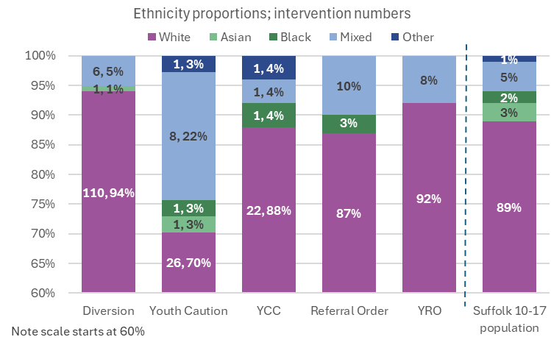

* + In the out of court space, girls made up nearly a third of the out of court cohort, at 30.6%, this is a slight increase on the previous year from 28.5%. The increase was more pronounced for Youth Cautions where the proportion of girls increased from 25% to 35%. While all age groups have reduced in number compared to last year, this has happened more in the younger age groups. Supervised outcomes given to 10-14-years olds reduced by 50%, 17-year-olds reduced by 10%.
  + For community court orders (Referral Orders and Youth Rehabilitation Orders), The proportion of girls are broadly the same as the previous year, and at 12.3% is much lower than the out of court outcomes. Just over 40% of all community court outcomes were given to 17-year-olds in 2024-2025, with 16% given to 13-14-year-olds (no outcomes given to 10-12-year-olds). There were only 3 children who received custodial outcomes in 2024-2025.
* The live operational dashboard has become more comprehensive through the addition of more in depth information around education (attendance and suitability) and accommodation suitability.
* Automated updates on the Social Care status of children open to the SYJS have been developed and will start feeding directly into the case management system shortly.
* A Key Performance Indicator (KPI) dashboard has been developed in PowerBI, following the counting rules set out by the YJB. This dashboard captures KPI data for children at the point of their intervention ending and will be used to improve data quality as well as monitoring performance and reporting to management board. The dashboard links up with other systems used by Suffolk County Council, i.e. KPI 7: “Wider Services involvement” is sourced from Suffolk’s social care system (LiquidLogic).
* A comprehensive SYJS Annual (2023-2024) statistics pack was developed and presented to the management board. The analysis gives a strategic overview across pre and post court cohorts, first time entrants, local reoffending, serious youth violence, offences and education attendance & suitability. The updated pack for 2024-2025 is currently being finalised.

**Performance over the previous year**

There was a total of 259 intervention programmes following an outcome in financial year 2024-2025, relating to 236 children. There was a reduction of girls in the younger cohort compared to last year. 27% of children aged 10-14 were female compared to 32% the previous year. Children of mixed ethnicity are overrepresented in the SYJS cohort, but both Black and Asian children are underrepresented compared to the 10-17-year-old population in Suffolk.

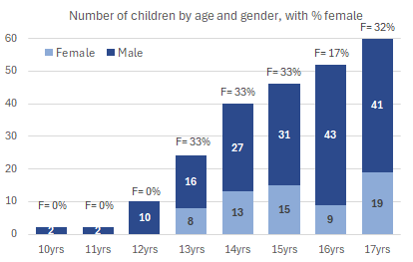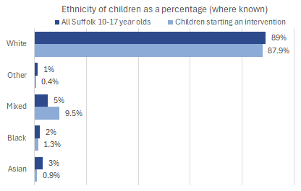

*Age, Gender and Ethnicity of children receiving a supervised outcome in FY 2024/2025*

**National Indicators**

National indicators are presented to SYJS management board quarterly with comparisons made to regional, YJS family and national rates. Underlying cohorts are analysed to identify any disproportionality and what actions can be implemented to improve performance. The tables below show Suffolk’s rates for each of the 4 National Indicators.

**First time entrants:**



Suffolk successfully reduced their FTE rate prior to this financial year, however there was a steady increase in the rate from quarter 3 in 2023-2024 to quarter 2 in 2024-2025. Continued joint working with police through the out of court panels has contributed to the FTE rate reducing in the two latest periods measured from 180, to 163 to 153 per 100,000 10-17-year-olds in FY 2024/2025. While the total number of children who became FTEs this year was higher than previous year (117 compared to 110), a month-by-month breakdown compared to 2023-2024 shows that in the second half of the year there was a notable decrease, indicating that the FTE rate will continue to improve.

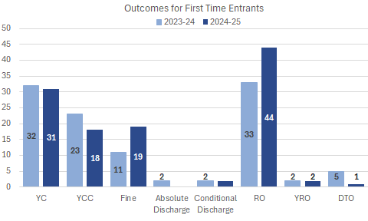Court outcomes are now the most likely outcome for FTEs – 58% were court compared to 50% the previous year. The most common outcome resulting in a child becoming an FTE was Referral Orders (38%) followed by Youth Cautions (26%). The number of Fines as the main outcome for a FTE increased from the previous financial year, now making up 16%.

**Use of Custody:**



After a peak in the number of custodial outcomes given to children in Suffolk in the calendar year 2023, leading to two quarters with a use of custody rate of 0.19, the rate has been reducing (improving) through financial year 2024-2025. Of the 11 children given a custodial sentence in 2023, 5 were not previously known to SYJS. The latest use of custody rate in Suffolk of 0.04 per 1,000 10-17-year-olds, represents 3 children given a custodial outcome. This rate is lower than all comparator groups.

**Reoffending:**



Recent quarters have seen a reduction in Suffolk’s binary reoffending rate, with both the cohort of children receiving a statutory outcome in the reporting period and those going on to reoffend reducing substantially. However, in the latest period measured the reoffending rate has increased in Suffolk. The small quarterly cohorts in individual Youth Justice Services lead to large fluctuations from quarter to quarter.

Local reoffending analysis has identified that there are typically 3-4 children committing up to 90% of the reoffences. SYJS is working with partners to address the needs of these children. Where they are still on active interventions, the children are receiving additional senior management oversight across the partnership.

**Key Performance Indicators**

SYJS have been using local data to report on the 10 KPIs introduced by the YJB in April 2023. While it is not yet possible to make comparisons to other YJS’s performance, the management board monitors each KPI through quarterly reports and SYJS team managers use their oversight to make sure children are referred to specialist services as needed. Specialist staff (i.e. educational psychologists, substance misuse workers, ETE Coordinators etc.) all have access to the case management system and are able to view any referrals made to them within the system, allowing for their recording of referral outcomes.

Below is a summary of Suffolk’s KPI figures:



Improved recording consistency has resulted in an increase in the identification of Special educational needs and Mental health needs. There is a slightly increasing proportion of victims who engage in restorative opportunities since measurement began. In addition, victim safety work is offered to support the victim move on from the crime. Reparation has been extended into the pre-court space to support children to make amends and build and develop a pro-social identity.

**Risks and issues**

SYJS maintains a risk register that is regularly reviewed by the Management Board. Since the last inspection in 2022, the service has been undergoing continuous improvement. However, there have been challenges in delivery, primarily due to absences in key management roles, vacancies, and difficulties in recruiting suitable and experienced staff to fill these positions.

SYJS has deployed managers flexibly and recruited temporary additional management support in a dedicated improvement and coaching role to help improve capacity including considering more hybrid roles to widen the geographical pool of available recruits. It remains the case both in Suffolk and nationally that it is sometimes difficult to recruit experienced youth justice staff at all grades.

During 2024-2025 additional capacity was brought in from the Intelligence Hub to support the development of several new data products to inform decision making at both operational and strategic level.

The ETE outcomes for justice involved children have not yet improved at the pace required. During 2025-2026 the YJS will move the ETE workers under the Virtual School improving collaboration, resource sharing and improving the data.

Funding concerns for Turnaround and SALT staff have been resolved with new funding announced.

His Majesty's Inspectorate of Probation (HMIP) has published a new inspection criteria for Youth Justice Services, and a self-assessment of actions has been completed to prepare for this new framework.

SYJS is aware of the risks to staff safety and wellbeing posed by the impact of the work they do and has a range of measures in place to support staff including providing personal safety devices for all frontline staff and staff training on professional boundaries. Staff are also able to access a wide range of wellbeing support through SCC. Staff exit interview data is also used to identify any trends and themes.

**Suffolk Youth Justice Plan for 2025-26**

**Child First**

The child first approach which is based on the four principles below is part of the vision and strategy for the service and integral to the SYJS practice model.

The planned activities to develop child-first practices in Suffolk for 2025-26 are as follows.

* The establishment of a Youth Advisory Board to facilitate consultation and co-production with children. This will include the development of activities during the school holidays and children identifying suitable reparation projects that support building pro-social identity.
* Undertake the YJB Child First Self-Assessment Toolkit and agree an action plan.
* Collaborate with a third sector organisation to conduct a 'hackathon' involving children, with the objective of providing recommendations to the Management Board regarding the priorities for 2026-2027.
* SYJS plans to hold two main consultation events with children in 2025-2026 to ensure it captures the voice of the child. The first of these involved children known to the service who shared their views of working with the service.
* This will be followed by an event in June when which will take place in person and will involve supporting children to meet and give feedback to referral order panel members.
* Looking ahead, the service is committed to deepening engagement and participation, with plans that include group-based activities to build problem-solving, teamwork, and social skills, as well as greater collaboration with children and their support networks throughout their time with the service.
* This will be supported by a strengthened feedback offer, including the use of self-assessment tools, end-of-order surveys, and feedback gathered as part of quality assurance audits to ensure children and families can reflect on their experiences and shape future practice.
* The service also plans to host joint staff-and-child events to further strengthen relationships and create shared experiences that build trust and connection.
* At a wider level, the YJB management board has now introduced a regular slot for children to attend and present their views and experiences. This not only reinforces a strong commitment to embedding children’s voices in strategic decision-making but also ensures that insights from lived experience continue to inform and influence practice across SYJS.

**Resources and services**

SYJS is funded centrally and through the contributions from the Youth Justice Board and statutory partner agencies, in accordance with the Crime and Disorder Act 1998. These can be found in Appendix 3. All funds are used to deliver Youth Justice Services. Any annual over or underspend relative to the core grant and reserves is transferred to a designated reserve. This enables the service to respond to changing demand.

The SYJS has appointed a part time clinical psychologist to facilitate partnership case formulations for selected children. These formulations will support partners to have a shared understanding of the child and agree a sequenced plan. The clinical psychologist will also provide group clinical supervision to each of the three operational teams, which is an essential element of effective Trauma Informed Practice.

The Youth Justice Board Grant supports essential youth justice services for children and is subject to specific terms and conditions. It must be used to achieve the following outcomes:

• Reduce the number of children in the youth justice system

• Reduce reoffending by children in the youth justice system

• Improve the safety and wellbeing of children in the youth justice system; and

• Improve outcomes for children in the youth justice system

Contributions in kind from partner agencies and external funding has allowed for additional services and initiatives that expand delivery to earlier intervention and children on the periphery of entry to the Youth Justice System.

**Board development**

Following a Child First development session in 2024-2025, the board has identified actions that will start to facilitate system change in alignment with the Child First evidence base. The board will also undertake an additional development session, hosted by the Centre for Justice Innovation. Board members are invited to attend training hosted by the SYJS and have committed to listening to and acting upon the voices of children.

**Workforce Development**

SYJS has undertaken a training needs analysis to inform this year’s plan. Staff within the service continue to complete a recognised qualification in youth justice - the Youth Justice Effective Practice Certificate – to ensure a skilled and knowledgeable workforce are applying evidence-informed approaches to their work with children and communities. The service provides a rolling programme of assessment and planning training.

The training plan 2025-26 includes:

Remand, custodial sentences and constructive resettlement (this will be jointly delivered with Children’s Social Care and Leaving Care)

Supporting children who have experienced traumatic brain injury

Motivational Interviewing

Substance use

AIM3

Domestic abuse

National standards

Management training and development

Members of the Management Board contribute to the training plan through expertise and commissioning. This includes contributions from Public Health and Communities and CAMHS.

**Evidence-based practice and innovation.**

During 2024-2025 the service has been identifying and working with reparation placements which take a ‘Child First’ approach and offer children opportunities to develop positive identities. This work will continue in 2025-2026. Success to date includes a reparation project offering an apprenticeship and children going on to regularly volunteer following YJS support, making a positive contribution to their local community.

The Criminal Exploitation (CE) Hubs hosted by SYJS now have a dedicated parent worker who is delivering 1:1 and small group work sessions to parent and carers of children at risk of criminal exploitation, using resources originally developed in Suffolk as part of the YJB funded County Lines Pathfinder. Additionally, the CE Hubs have been piloting a ‘Bystander’ approach in schools with the intention of implementing this method in group sessions within SYJS.

SYJS is embarking on a new arts-based project. This initiative will provide children with opportunities to display their artistic talents and creativity. This project will not only help them develop their skills but also boost their confidence and sense of accomplishment.

SYJS will collaborate with education colleagues to pilot a targeted prevention program for a select group of schools, aimed at children at risk of exclusion who are not currently receiving support from SYJS. The wrap-around support provided by SYJS is expected to help these children stay in education.

**Evaluation**

In 2024-2025 the Centre for Justice Innovation started working with SYJS to review and advise on delivery of out of court work in Suffolk in line with best practice nationally and this will continue into 2025-2026.

The SYJS will also internally review the targeted prevention offer to schools to explore what impact this has. It is hoped that this pilot will provide sector-wide learning in Suffolk.

**Priorities for coming year**

**Standards for children in the Youth Justice System**

A thematic review was conducted for transitions, victims, and safeguarding. Alongside internal audits, the service performed a peer audit with a neighbouring county. Actions taken following these audits include:

* Transition to probation workbook and planning document developed
* Joint briefings with YJS, probation and leave care staff regarding transitions to probation
* A review of the information provided by police in relation to victims
* A review of victim related processes and documentation
* Development of bitesize training sessions to cover topics such as:
  + Missing children
  + Challenges in education
  + Children carrying weapons
  + Internal and external controls
  + Professional curiosity
  + Diversity
  + Substance use
  + Low mood
  + Identity and diversity

**Service Development**

The plan for ongoing service improvement includes:

* Expanding the diversionary offer so that all children can benefit from the full range of outcomes
* Partnership reviews for YJB Serious Incident Notifications and remand cases
* Aligning the development and review of a child’s plan with wider planning in CYPS
* Continued development work with the Centre for Justice Innovation
* A peer review with another neighbouring county
* Management training and development

**Intelligence priorities for 2025-2026**

* In-depth offences reporting and analysis:
  + Analysing the youth justice case management system and police data.
  + Consider disproportionality, re-offending, offence location hotspots etc.
* Victim recording and reporting:
  + Align with new inspection criteria
  + Gain understanding of victim’s protected characteristics, disproportionality in establishing contact, offer of restorative interventions and delivery.
* Publish out of court assessment needs analysis.
* Establish reporting around referrals to specialist services and outcomes of these referrals.
* Disproportionality and protected characteristics reporting – using the YJB disparity toolkit, local reporting and cross referencing with other services to create an annual summary highlighting over- and under-represented groups in the SYJS cohorts.
* Improved education, training and employment reporting, combining existing data sources (including PBI dashboards) to be able to view in-depth ETE data for the youth justice cohort.

**National Priority Areas**

**Children from groups which are over-represented**

The SYJS Plan seeks to tackle over-represented groups in Suffolk by:

* The development of a service disproportionality action plan.
* Jointly driving the Unnecessary Criminalisation of Children in Care and Care Leavers Plan across the system.
* Working with the Centre for Justice Innovation to better understand why we are seeing some groups of children over-represented in the out of court space.
* A local directory of services and referral routes was developed to ensure practitioners are aware of the opportunities available, and external agencies are invited to team meetings to share information, build relationships and help embed a community-based, collaborative approach.
* A dedicated practitioner hub has been developed to provide accessible information that helps deepen understanding of the specific needs and experiences of these groups. The hub includes a range of tailored resources to support direct work and interventions, ensuring practice is both informed and responsive.
* The service also has an established partnership with the local organisation Future Female Society, which delivers a variety of targeted projects aimed at supporting and empowering girls. In addition, SYJS is actively working with wider services to develop a more comprehensive offer for both girls and boys to address issues relating to Violence Against Women and Girls (VAWG), recognising the importance of early intervention, awareness, and trauma-informed responses.
* Alongside this, the service continues to focus on building practitioner confidence and capability in working with families and wider support networks, particularly when supporting younger children, to ensure a more holistic, inclusive, and relational approach to intervention thorough bitesize workshops and more in-depth reflective practice sessions.

**Policing**

A new Police Electronic Notification to YOT (PENY) has been devised by Suffolk Constabulary, with contributions from SYJS which will further improve the quality of PENY submissions and therefore the quality of information shared by the Police with the service. This is due to be implemented in Autumn 2025.

SYJS and Suffolk Constabulary will introduce a local joint protocol on applications for Ancillary (Civil) Orders for children in 2025.

Suffolk Police provide monthly information regarding children who they are most concerned about, linked to police data. This information will be utilised to support systemic safeguarding responses, including the use of targeted prevention referrals.

The use of deferred prosecution scheme will be introduced in the out of court arena in 2025-2026. Utilising deferred prosecutions would bridge the gap where offences could not be mitigated down from a statutory outcome using the gravity matrix, but diversion and non-statutory outcome would be in the best interest of the child and all parties.

Alternatives to prosecution for motoring and potentially bringing this into the Out of Court panel will be explored with Police, SYJS and court in 2025-2026.

**Prevention**

The Turnaround Programme has expanded its eligibility criteria and, as a result, a slightly modified delivery model will be implemented in 2025-2026. The programme has so far been used to support children over an extended period, facilitating phased re-introductions to education, extended family intervention and supporting access to positive activities. The project will develop further to allow for a wider range of targeted interventions to a wider cohort of children both on a one to one and group basis across the county.

The Criminal Exploitation (CE) Hubs are collaborating with Ipswich Town Football Club and Ipswich Borough Council to offer knife awareness sessions in schools.

The CE Hubs are working in partnership with the NSPCC to deliver a 12-week Child Criminal Exploitation (CCE) programme to groups of children across the county. The programme includes educational workshops and sessions where the children are designing leaflets for CCE awareness that will be distributed to schools across the county.

**Diversion**

Suffolk will continue to focus on diverting children from the formal youth justice system when appropriate. To support this initiative, the Centre for Justice Innovation (CJI) began collaborating with SYJS in late 2024 to review and refine the county's out-of-court process. A consultant from the CJI has met with the Suffolk Constabulary, as well as SYJS staff, to consider the out-of-court provision. The consultant observed the decision-making panel and participated in the Norfolk and Suffolk Out of Court Scrutiny panel. Recommendations for further improvements will be implemented in 2025-2026.

**Education**

The ETE Coordinators provide a single point of contact for education providers. The ETE Coordinators attend the In Year Fair Access Panel and have close working relationships with the Virtual Schools Service and the Alternative Provision Service.

SYJS plans to create an in-service program for children not attending education, addressing the need for personal, social, health, and economic (PSHE) education to be provided alongside the child's intervention when necessary.

In 2024-2025 there were 237 children receiving a pre-court or post-court outcome in Suffolk. Of these, 60% (143) were of statutory school age (SSA) and 40% (94) above SSA.

|  |  |  |  |
| --- | --- | --- | --- |
|  | Statutory school age | Above statutory school age | **Total** |
| **Pre-court (non-statutory)** | 78 | 33 | **111** |
| **Pre-court (statutory)** | 35 | 22 | **57** |
| **Post-court** | 30 | 39 | **69** |
| **Total** | **143** | **94** | **237** |

The children had the following attendance:

|  |  |  |  |  |  |  |
| --- | --- | --- | --- | --- | --- | --- |
| **Statutory School Age** | **#** | **%** |  | **> Statutory School Age** | **#** | **%** |
| Full time education | 66 | 46% |  | Full time education | 35 | 38% |
| Part time education | 39 | 27% |  | Part time education | 20 | 21% |
| Not attending offered hrs | 20 | 14% |  | Not attending offered hrs | 2 | 2% |
| CME/no hrs offered | 17 | 12% |  | NEET/no hrs offered | 37 | 39% |
| *ETE not recorded* | *1* | *1%* |  | *ETE not recorded* | *0* |  |
| **Total** | **143** | **100%** |  | **Total** | **94** | **100%** |

ETE recording has improved compared to last year. The proportion of children in full time education is the same as last year for SSA, but lower for those above SSA (down from 52% to 37%). However, a higher proportion of above SSA children are in part time education (up from 9% to 21%). The improved recording, one of the impacts of having ETE Coordinators in each team, allows SYJS to have a more accurate picture of the ETE situation of children involved with youth justice and target interventions accordingly.

Exclusions, suspensions and children Electively home educated (EHE) in the statutory school age cohort:

|  |  |  |  |  |  |  |
| --- | --- | --- | --- | --- | --- | --- |
|  |  |  | | **Statutory School Aged children who are:** | | |
|  | **SSA #** | | **% of SSA cohort** | **CiC** | **Racialised groups** | **White** |
| **Total number of children** | **143** | |  | 15 | 15 | 124 |
| Children with exclusions | 12 | | 8.4% | 0% | 0% | 9.7% |
| Children with suspensions | 40 | | 28.0% | 13.3% | 6.7% | 29.8% |
| Children EHE | 3 | | 2.1% | 0% | 0% | 2.4% |

28% of statutory school aged children had been the subject of at least one suspension in the previous 12 months. This proportion is lower for children in care and those from racialised groups. All children who had been excluded or were electively home educated were white.

ETE suitability and Special Educational Needs:

* Of children in full time education of statutory school age 95% were judged to be in suitable education, the equivalent number for above SSA children in full time ETE is 89%.
* Just under half (46% or 66 children) of statutory school aged children had identified special educational needs. Of these, 40 (60% of SSA children with SEN) had an EHCP plan in place.
* For above SSA children, 28% (26 children) had SEN identified with 77% of these having an EHCP plan in place.
* A slightly higher proportion of children with SEN are in an education setting that are judged to be suitable.

|  |  |  |  |  |  |  |
| --- | --- | --- | --- | --- | --- | --- |
| **Statutory School Age** | **SEN** | **No SEN** |  | **> Statutory School Age** | **SEN** | **No SEN** |
| In suitable ETE | 62% | 61% |  | In suitable ETE | 54% | 54% |
| CME/no hrs offered | 6% | 17% |  | NEET/no hrs offered | 35% | 41% |
| Alternative provision | 56% | 16% |  | Alternative provision | 46% | 9% |
| From racialised groups | 12% | 9% |  | From racialised groups | 12% | 16% |

*Table above shows percentage of all SSA / >SSA children respectively who are 1) in suitable education, 2) CME/NEET, 3) attending alternative provision and 4) from racialised groups. The percentages are split between those children who have an identified Special educational need, and those who don’t. The different percentages are not mutually exclusive as you go row by row, so they do not add up to 100%. For example, 62% of SSA children with identified SEN are in suitable education (the remaining 38% are not), many of them are in alternative provision, and some are from racialised groups.*

Children involved with SYJS who have identified SEN are less likely to be children missing education or NEET. Children with SEN are more likely to attend alternative education provisions than those with no identified SEN.

A slightly higher proportion of SSA children with SEN are from racialised groups, but the opposite is true for those of above SSA.

**Restorative approaches and victims**

Restorative approaches is a priority area for the service and the development plan is directly overseen by the Head of Service. The Restorative Approaches Team is now fully staffed, having experienced some staffing gaps historically. External supervision has been arranged to provide reflective opportunities for RAPs. The service has sought several external training events to improve the knowledge and skills of the RAP team. This includes contextual safeguarding, aimed at transferring knowledge from the criminal exploitation space over to support victims of youth crime to live safely in their communities. All vulnerable victims (as defined by the Code of Practice for Victims) are offered a home visit along with enhanced service contact, in line with their wishes. The risk assessment process has been reviewed and a new policy launched.

**Serious violence, exploitation and contextual safeguarding.**

SYJS remains an integral member of the countywide multi-agency group responsible for overseeing the implementation of the serious violence duty as outlined in the Police, Crime, Sentencing and Courts Act 2022. Additionally, SYJS hosts the Criminal Exploitation (CE) Hubs, which are pivotal to the countywide response to exploitation in Suffolk. SYJS is a permanent member of Suffolk’s Multi-Agency Criminal Exploitation (MACE) panels and makes referrals to MACE. Staff from the CE Hubs are also key stakeholders at monthly MACE meetings. As a first responder, SYJS works with partners to ensure that a National Referral Mechanism is submitted if a child is suspected to be a victim of modern-day slavery and has close links with the MAPPA co-ordinator.

In 2024-2025 the CE Hubs developed an educational programme designed to empower children to identify signs of criminal exploitation and how to respond safely. This has been presented in Suffolk schools, reaching over 800 students in the first month.

In 2025–2026 this will be rolled out more widely in schools and the roll out will see Suffolk Police working in collaboration with the CE Hubs to present the programme.

**Detention in police custody**

In collaboration with Norfolk Youth Justice Service, SYJS will continue to co-chair regular meetings with police custody staff, fostering and adoption services, and emergency out-of-hours duty services. These meetings will review the cases of all children eligible for transfer to local authority accommodation under PACE regulations and address other safeguarding issues in police custody. We have observed a continued reduction in the number of children being remanded in police custody overnight decreasing from 41 in 2023/24 to 21 in 2024/25.

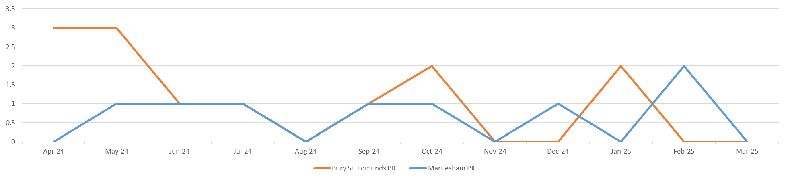

**Remands**

In 2024-2025 a new Bail and Remand Policy was introduced in Suffolk, following agreement with the Heads of Service from Children in Care, MASH and Social Care Fieldwork. It has been developed with the recommendations from the joint thematic inspection of work with children subject to remand in youth detention in mind and encompasses the rights and entitlements for children remanded to youth detention accommodation (YDA) or remanded to local authority accommodation (RLAA).

The policy introduces a new process so that once it is identified that a child or children are at risk of remand to youth detention a professionals meeting is convened, which includes the SYJS court officer and is chaired by Safeguarding. The meeting explores options for bespoke and robust bail packages to further reduce custodial remands. The Management Board also now receive additional information about any child who has been remanded, each quarter.

In 2025-2026 SYJS will introduce a multiagency remand scrutiny panel.

**Use of custody and resettlement**

The custody and resettlement policy was updated at the end of 2024. This policy has been endorsed by the senior leadership team in Children's Social Care.

Training on custody and resettlement will be delivered to a select number of practitioners in the year 2025-2026, with the aim of developing a core team possessing this specialised knowledge base. The seconded probation officer will be secondarily allocated to all custodial sentences, utilising their specialist skills and experiences.

For any child remanded to YDA or receiving a custodial sentence, progress will be discussed in the multi-agency risk panels. This will provide additional senior management oversight regarding the safety of the children and others, as well as their rights and entitlements

**Working with families**

SYJS works with families as part of our practice model. As part of our ongoing commitment to enhancing the quality of planning, the SYJS acknowledges the significant role that parents and carers play in aiding their child's efforts to desist from offending. The RAPs also provide tailored family support to parents and caregivers in relevant cases. Furthermore, this includes offering assistance to parents whose children have been affected by youth crime.

**16. Signature**

Assistant Chief Constable Eamonn Bridger

Suffolk Youth Justice Management Board Chair

**Appendix 1: Management Board Membership**

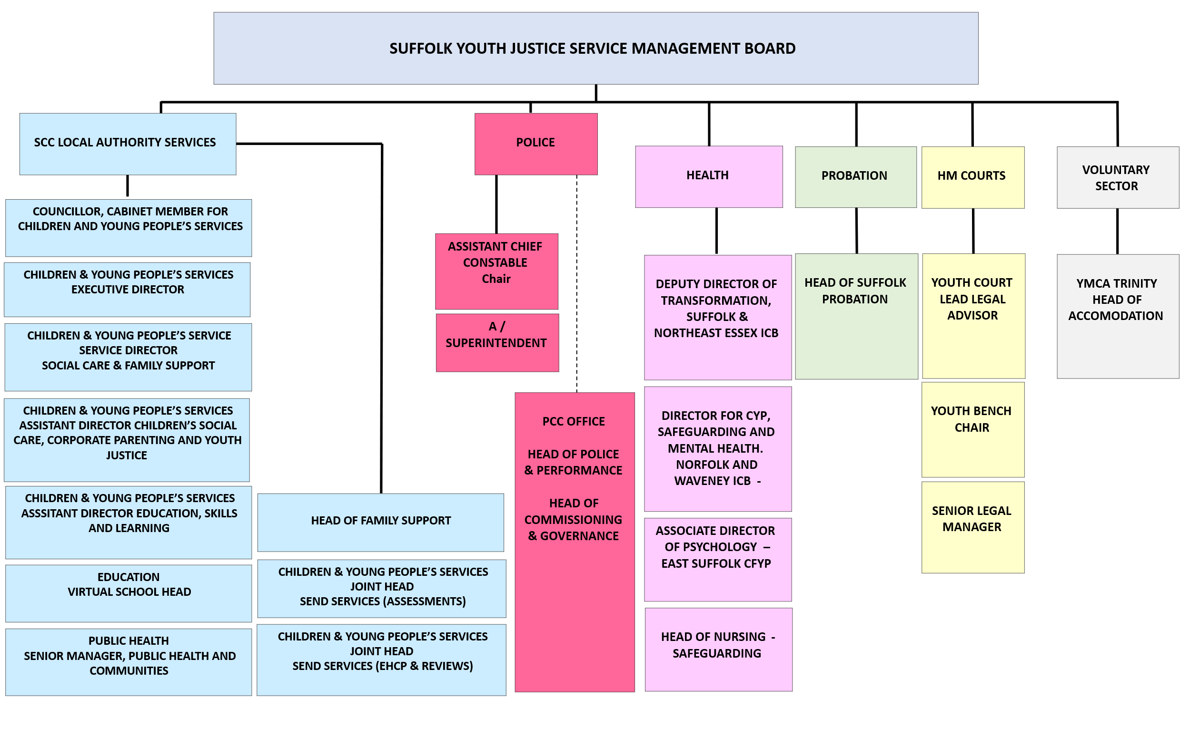

**Appendix 2: Staffing Structure**

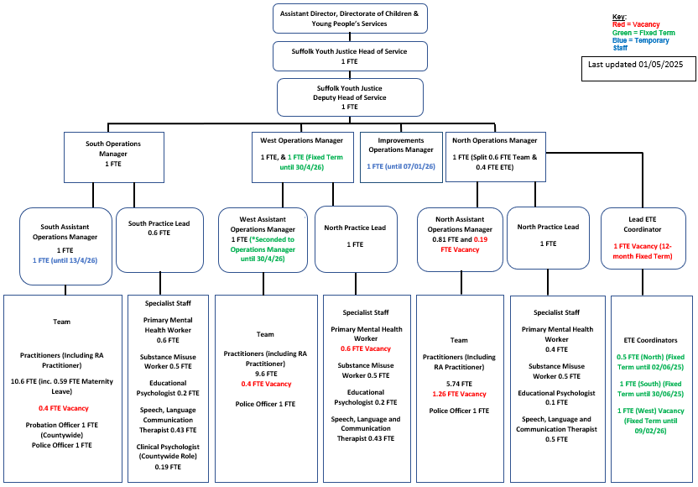

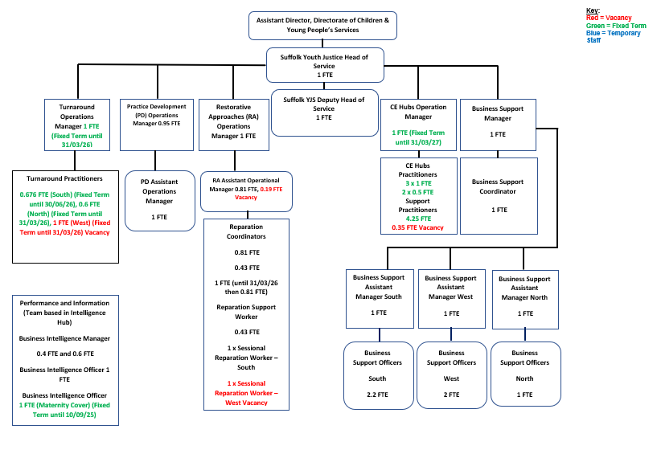

**Appendix 3: Budget costs and contributions**

**Appendix 4: Ethnicity, Sex and Disability**

End of Document