What are comic strip conversations?

Comic strip conversations, created by Carol Gray, are simple visual representations of conversation. They can show:

- the things that are actually said in a conversation
- how people might be feeling
- what people's intentions might be.

Comic strip conversations use stick figures and symbols to represent social interactions and abstract aspects of conversation, and colour to represent the emotional content of a statement or message.

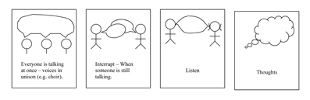
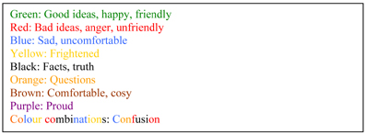

From Carol Gray's -Comic strip conversations

By seeing the different elements of a conversation presented visually, some of the more abstract aspects of social communication (such as recognising the feelings of others) are made more 'concrete' and are therefore easier to understand.
Comic strip conversations can also offer an insight into how an autistic person perceives a situation.

How to use comic strip conversations

Comic strip conversations can help autistic people to understand concepts that they find particularly difficult. People draw as they talk and use these drawings to learn about different social situations.

In a comic strip conversation, the autistic person takes the lead role with parents, carers or teachers offering support and guidance.

Start with small talk (for example, talking about the weather) to get people familiar with drawing whilst talking and to mimic ordinary social interactions.
Ask a range of questions about a specific situation or type of social interaction. The autistic person answers by speaking and drawing their response.

Summarise the event or situation you've discussed using the drawings as a guide.
Think about how you can address any problems or concerns that have been identified.

Develop an action plan for similar situations in the future. This will be a helpful guide for the autistic person.

For complex situations, or for people who have difficulty reporting events in sequence, comic strip boxes may be used, or drawings can be numbered in the sequence in which they occur.

Comic strip conversations can be used to plan for a situation in the future that may be causing anxiety or concern, for example an exam or a social event. However, remember that plans can sometimes change. It's important to present the information in a way which allows for unexpected changes to a situation.

How to make your own comic strip conversation

You can use just paper, pencils, crayons and markers, use computer word processing applications, or you could use an app.

Ask the person you are supporting to choose what materials they would like to use.
Some people may like to have their comic strip conversations in a notebook, or saved on their smartphone or tablet, so that they can refer to them as needed, and easily recall key concepts.

