IMPORTANT INFORMATION  «Number» «Road»  «Town»  «County» «Postcode» | Your Ref:  Our Ref: 227852 ALL SAINTS RPZ  Date: 21st July 2023  Enquiries to: James Prime  Tel: 0345 606 6171  Email: consultations@suffolkhighways.org

Dear Sir / Madam,
ALL SAINTS AREA, NEWMARKET – PROPOSED RESIDENTS PARKING ZONE
INFORMAL CONSULTATION 24th JULY – 11th AUGUST 2023
LOCATION : Warrington Street

In November 2021, a survey was sent to all businesses and residents on streets within the All Saints area of Newmarket, to gauge support for implementing a Residents Parking Zone (RPZ) in response to longstanding complaints about parking problems caused by non-residents. The results of the survey showed there was enough support to develop a RPZ scheme on some of the streets, including your street, and to carry out further informal consultations. As a resident/business, this letter notifies you of the informal consultation on proposals to implement a new RPZ in the All Saints area, which includes Warrington Street.
A RPZ means that you would need to purchase a virtual permit to be able to park in specially marked residents parking bays on the street and the fees for permits are listed overleaf. Fees are set to cover the cost of administering the RPZ and providing dedicated enforcement, not to make a profit. The benefit of a RPZ is that it will help to prevent people who do not live in your area (except your own visitors) from parking on your street at the times that it is proposed to be in operation, which is from 8am to 6pm Monday to Saturday. Outside of these times anyone can park in the bays. The proposals also include the provision of some waiting restrictions to control parking in between the residents parking bays and across driveways and at junctions.
Due to the size of the zone it is not practical to send you details for the whole area and so residents are only being sent plans for the street they live in. However, further details about the proposal and detailed plans for each street are available at www.suffolk.gov.uk/council-and-democracy/consultations-petitions-and-elections/consultations/all-saints-newmarket-residents-parking-zone. Attached to this letter is a copy of the proposed plans showing the extent of the RPZ and the proposed permit parking bay details for Warrington Street.
These proposals are being informally advertised between 24th JULY – 11th AUGUST 2023. This period provides an opportunity for you to make representation either in support, or to object to the proposals. Should you wish to make an objection or any other representations related to these proposals and / or the associated waiting restrictions, please specify the grounds on which they are made, and send to consultations@suffolkhighways.org or phone our customer service centre on 0345 606 6171 quoting the reference 227852 ALL SAINTS RPZ.
Once the closing date for receiving objections and comments has passed all comments will be reviewed and a decision will be made by senior councillors and officers from the Council on whether this scheme is taken further to a formal consultation process. If a decision is made to introduce a new RPZ for your area, then this will be administered and enforced by West Suffolk Council on Suffolk County Council’s behalf and they will write to all affected residents and businesses separately closer to the date when the RPZ would be introduced to provide details about how to apply for a permit(s).
Yours sincerely,

James Prime
Design Engineer
Suffolk Highways

Fees incurred as a result of this scheme would be as follows:

First Resident Permit (car or motorcycle) | £80 Annual Fee
Business Permit | £240 Annual Fee
Visitor Permits (booklet of ten 1-day Vouchers) | £10 (up to a maximum of 12 booklets per year)
Replacement Permit (lost, stolen or damaged) | £12.50

These fees are set to cover the cost of enforcing the restrictions and operating the Scheme, and not with the intention of making a profit.

A copy of the draft plans showing the roads affected, together with a copy of the Council’s reasons for this proposal, will be on display between 24th JULY – 11th AUGUST 2023 at the following address;
Newmarket Town Council,
Memorial Hall,
High St,
Newmarket,
CB8 8JP

PLAN SHOWING THE EXTENT OF THE PROPOSED ALL SAINTS RESIDENTS PARKING ZONE

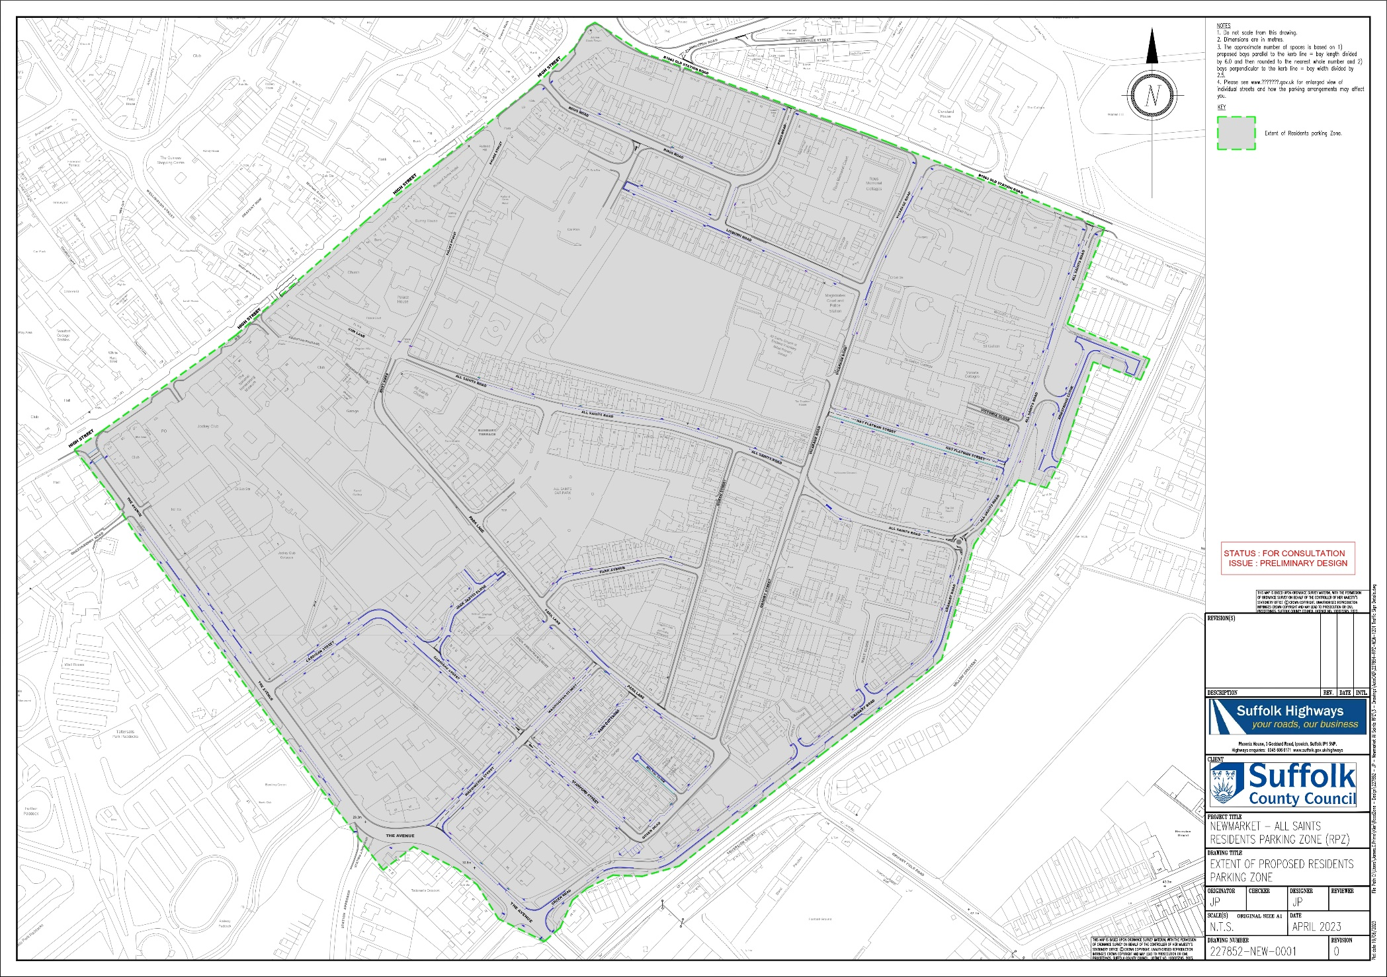

PLAN SHOWING THE PROPOSED RESIDENT PARKING ZONE IN WARRINGTON STREET.
