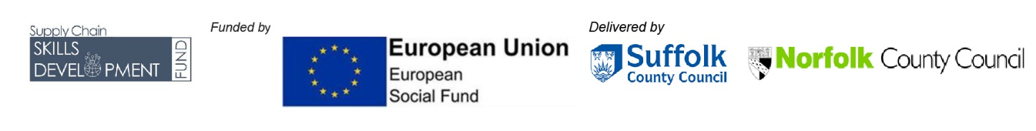

Supply Chain Skills Development Fund

Eligibility
The Supply Chain Skills Development Fund (SCSDF) eligibility for existing SMEs and Company’s operating within the local infrastructure supply sector.
You must not be a charity or a not-for-profit organisation.
As an SME to be considered eligible for a grant through the SCSDF you must be able to answer yes to each of the points below by the time you submit your application form:
- Are you an SME actively trading for at least 6 months or more? (The definition of an SME is that your business has between 1 and 249 employees, which have an annual turnover not exceeding EUR 50 million, and or an annual balance sheet total not exceeding EUR 43 million and be less than 25% owned by another company or combination of other companies).
For all Companies:
- Do you pay your business rates to one of the local authorities based in New Anglia (i.e.: Suffolk: Ipswich Borough Council, Babergh Mid Suffolk District Council, West Suffolk Council, East Suffolk Council, Norfolk: Breckland District Council, Broadland District Council, Great Yarmouth Borough Council, King’s Lynn and West Norfolk Council, North Norfolk District Council, South Norfolk Council.
- Do you have cash match? Cash funding is the difference between the grant you are seeking and the remaining cost of your project. All applications must provide cash funding which can be sourced from the private sector, but not other Public Funds. Loans, overdrafts, savings or company funds are considered to be eligible cash match, and these must be secured and in place prior to approval of an SCSDF grant.
- Can you obtain 3 comparable quotes* for the proposed training expenditure?
- Can you provide full financial accounts, or if you’ve only been trading for 6 months, robust management accounts?
- Can you provide a detailed proposed training plan which fully outlines how your project relates to the objectives set out in the SCSDF guidance document?
Please note that quotes or tender documentation for project expenditure should not be from persons or businesses connected to your business, directors, or shareholders.
If you answered yes to all the above, then you are eligible for consideration, and we recommend that you complete the application form. You may wish to contact the SCSDF Project Team to discuss your project and seek advice on project costs before you make an application. Email: supplychainskills@suffolk.gov.uk

