
Suffolk County Council Guidance Sending and receiving secure email using OME
Suffolk County Council’s standard secure email system is called OME (which stands for Office 365 Message Encryption). Sensitive items are marked at the Council end, which automatically encrypts the emails. Recipients then need to decrypt the email, either by requesting a “one-time passcode”, or by signing into a Microsoft of Google account (if they have one).

OME is the standard secure email system used by Suffolk County Council (SCC) and allows emails to be sent securely between the Council and individuals and external organisations. Council staff will mark any sensitive emails they wish to send with the label “OFFICIAL-SENSITVE”. This will ensure the email is encrypted between the Council and you or your organisation.
Summary
- When you receive a sensitive email from Suffolk County Council using OME, you won’t be able to view the content immediately, as it will still be encrypted.
- You will receive an email with subject containing text OFFICIAL-SENSITIVE.
- You will need to click the blue Read the message button to open the message.
- You will be directed to a screen asking you to sign in to view the message.
- If you choose onetime passcode the screen will change to a form requesting, you enter a onetime passcode.
- You will be sent a onetime passcode to the same mailbox.
- You will need to go your inbox copy the one time passcode and return to the form requesting the onetime passcode where you can paste the code and open the message.
For more detail, including screenshots see below

The numbers on the images are detailed in the text below each image.
The email you receive will look something like the one below.
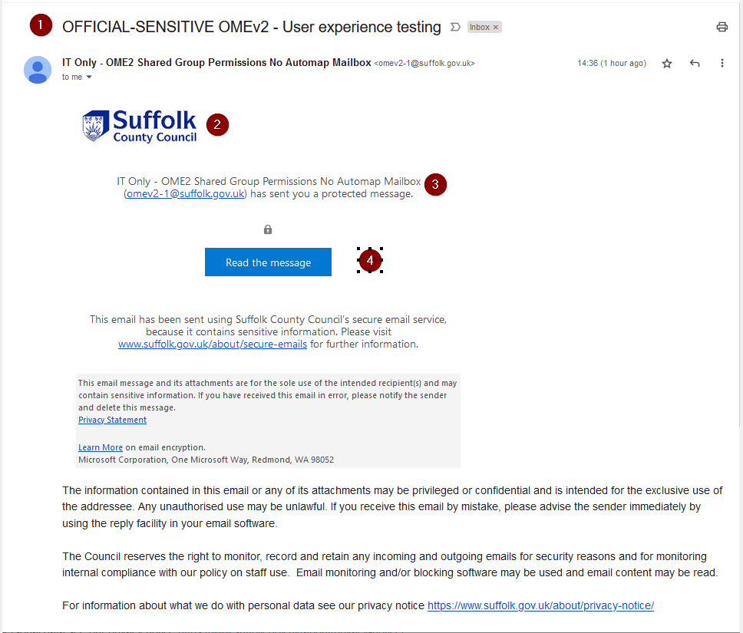
- The subject will begin with OFFICIAL-SENSITIVE
- The Suffolk County Council logo will be displayed.
- The senders display name and email address will be displayed.
- There will be a blue button Read the message.

Unlocking an encrypted email from SCC
Click the blue Read the Message button.
You’ll be directed to a page like below:
- Suffolk County Council icon will be displayed.
To unlock a sensitive encrypted email from Suffolk County Council, you can either:
- 6. Sign into your Google or Microsoft account (if you have one). Your Google or Microsoft account provides enough assurance that you are who you say you are.
or
- 7. Request a one-time passcode. This will be emailed to you; just enter the code to unlock the email from SCC (illustrated further below)
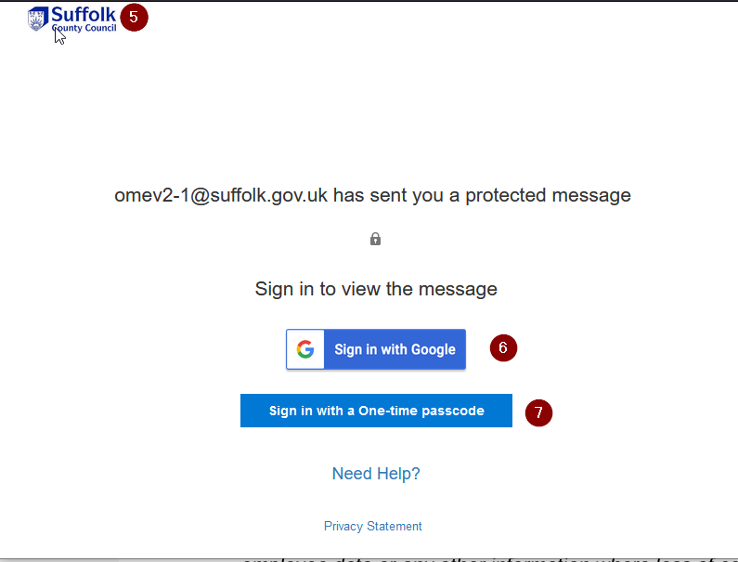

If you are using a one-time passcode
Keep the secure message webpage open while you check your email for the passcode.
Do not select "Read the message" again.
The passcode will be sent to the same email address where you received the secure message.

Using a mobile phone or tablet?
- Leave the browser page asking for the code open.
- Switch to your email app.
- Open the email containing the one-time passcode.
- Note or copy the code.
- Switch back to your browser.
- Enter the code on the page that is already open.
- Select Continue.

Using email in a web browser?
Keep the secure message open in one browser tab and open your email in another tab to retrieve the code.
Return to the secure message tab and enter the code.

Important
If you request a new one-time passcode, your previous code will no longer work.
Always enter the most recent code you have received.

If you selected one-time passcode the window will change to a screen like below
8. The Suffolk County Council logo is displayed
9. There is a box requesting a one-time passcode value
Return to your inbox to retrieve the one-time passcode.
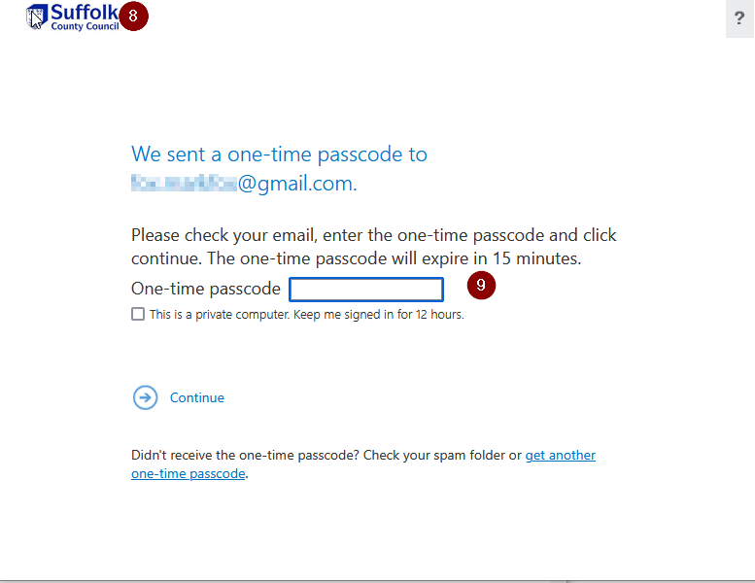
In your inbox you’ll see a one-time passcode email. Check your Junk Mail/Spam folder if you cannot see it.
10. The message will be from MicrosoftOffice365@messaging.microsoft.com
11. The Suffolk County Council logo will be displayed
12. The one-time passcode is displayed. Copy or note the one-time passcode.
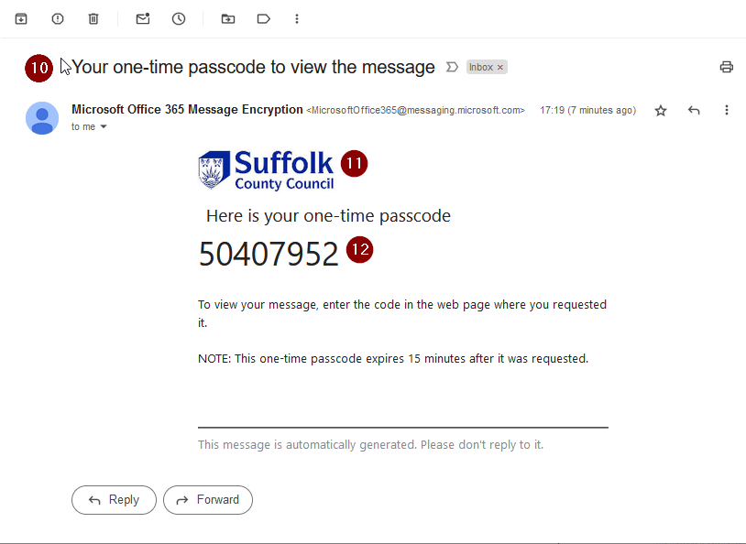

Return to the page requesting the one-time passcode.
13. Paste or type the one-time passcode from above
14. Click Continue.
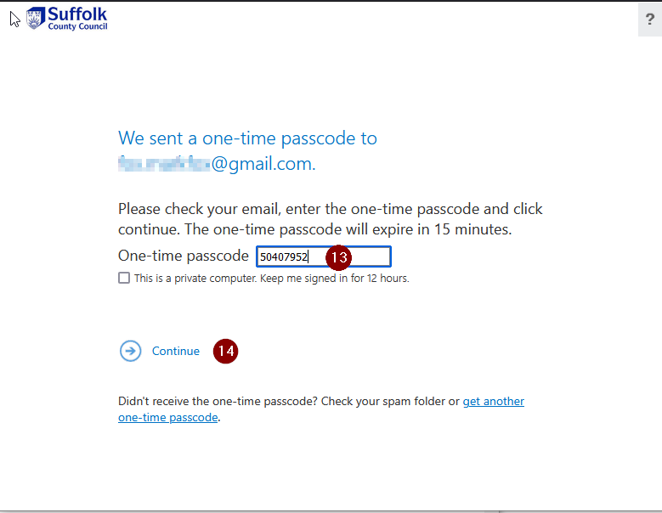

Troubleshooting
If your passcode does not work
- Check that you are using the most recent passcode you requested.
- Check that you have entered the code correctly.
- Make sure you are entering the code on the webpage where you requested it.
- If you requested another code, do not use an earlier code.
- If the code has expired, restart the process and request a new code.

I closed the webpage
Don't worry. Open the secure email again and select Read the message to restart the process.
If you request a new one-time passcode, wait for the new email and use the newest code.

What will the “unlocked” email look like?
Once you’ve unlocked your email, it should look like a normal email. At the top of the email should be a message that says: “OFFICIAL SENSITIVE – Personal data on health, care and finances of customers, employee data or any other information where loss of confidentiality would significantly impact safety or corporate reputation.”
15. The subject is displayed
16. The sender display name and email address is displayed.
17. There is an OFFICIAL-SENSITIVE grey banner on the message.
18. The secure message is displayed, plus any attachments.

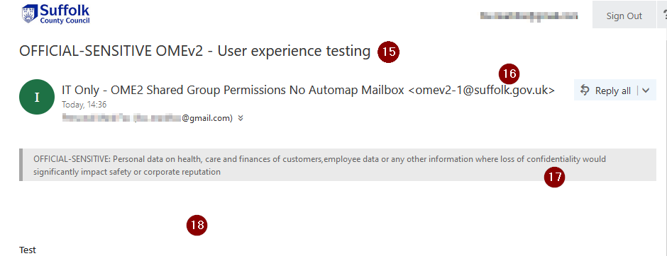

Securely replying to the email
You can securely reply to the same email using the reply option.
19. Click the down arrow
20. Choose the appropriate option
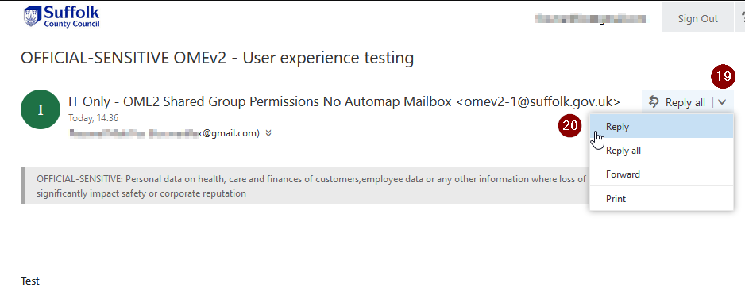

21. Type your secure reply
22. Attach any relevant documents
23. Click Send
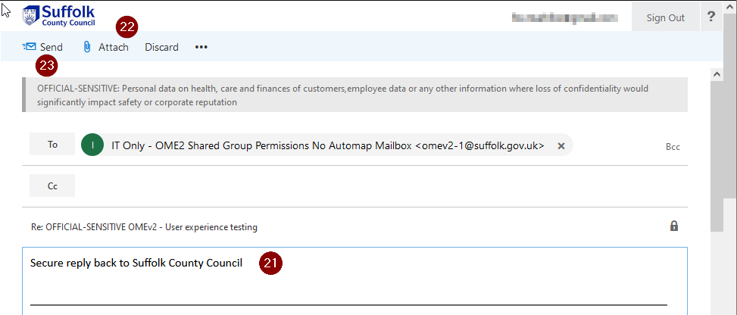
Sending new sensitive email to Suffolk County Council
If your organisation or email provider doesn’t have a secure email connection with SCC (known as a TLS connection), you’ll need to request a secure “thread” or conversation with the Council. Once this secure thread is established, all subsequent replies in the conversation/thread are secure.
To request a secure thread:
- Send a standard email to your contact at SCC
- In your email, ask your SCC contact to reply and mark the email OFFICIAL-SENSITIVE This will set up the secure thread.
- Once, you’ve opened the reply they send you, you’ll be able to reply to this enclosing and sensitive information you want to send to the Council.
Improving your organisations’ experience of secure email with SCC
In addition to OME (the Council’s standard email service), Suffolk County Council also runs an enhanced secure email service called TLS (Transport Layer Security). TLS is a secure connection between two organisations and it’s highly likely we can set one up between the Council and your organisation (however big or small).
The secure TLS connection between our two organisations, when set up, means that the use of one-time passcodes isn’t needed. Secure email can be sent from SCC to your organisation, and vice versa, in the same way as normal emails.
Suffolk cannot setup TLS connections with consumer email services; OME is the only method of securely transmitting the email. Please do not request a TLS connection for consumer email services like Gmail, Hotmail, BT Mail, Yahoo Mail, or any other consumer email service.
Requesting a TLS connection with Suffolk County Council
To request a TLS connection between your organisation and Suffolk County Council, please send your details, and the details of a person who provides your email services, to information.management@suffolk.gov.uk

