The Suffolk map can be displayed on the screen or opened in a new window

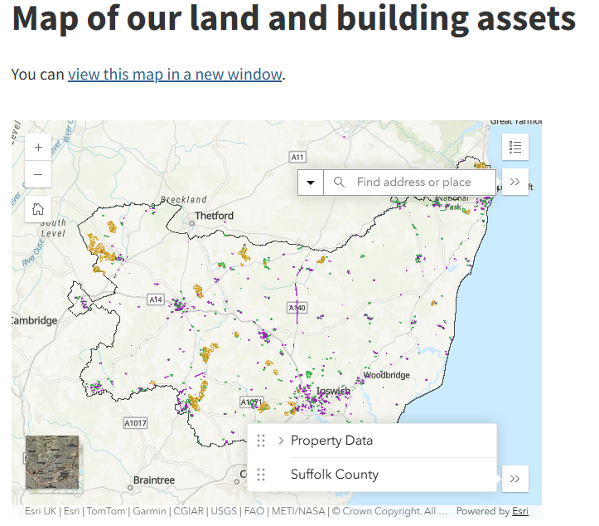
To get to a specific property, use the search item at the top of the screen and use postcode to search. This will get you near to where you need to be.
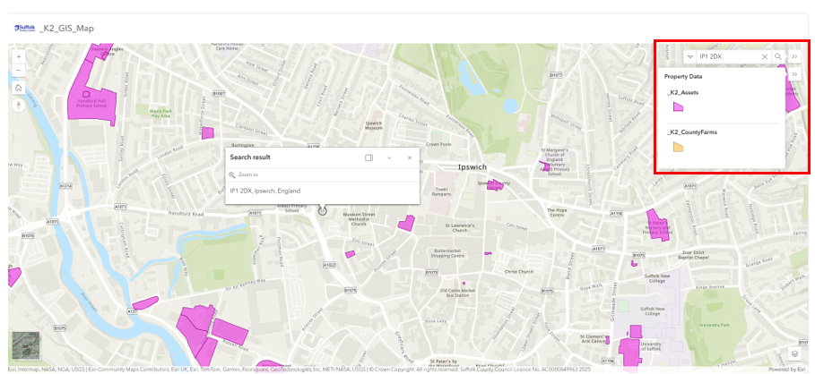
You have access to further layers (bottom right) which you can turn on or off using the visibility icon to the right in the layer control.
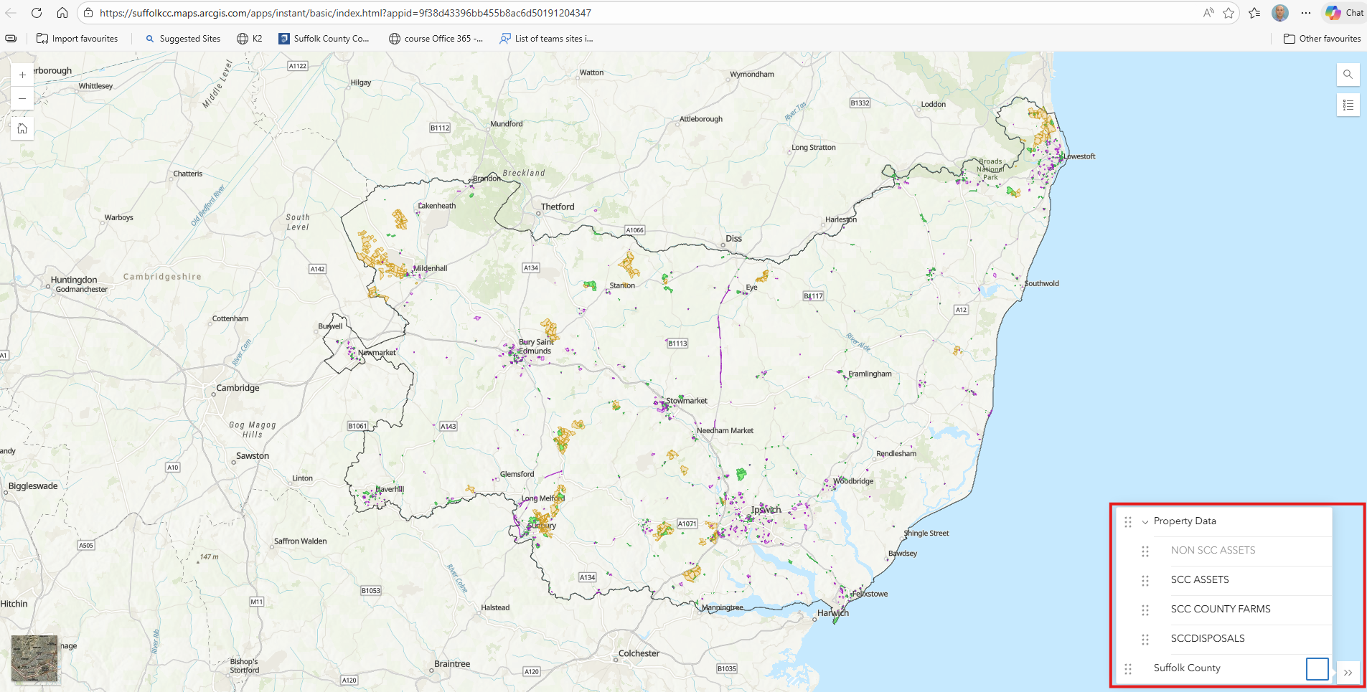

Additional functionality
To move around the map, Click and hold down left mouse button, then move map
For zooming use mouse wheel or plus and minus in the top left corner of plan.

Click on the actual polygon. This will bring up the attributes for that polygon which will include the Establishment Reference and Site Reference which is useful if you need to speak with us.

Other layer attributes can be obtained in the same way. Open and highlight a different layer, click on the polygon.

You can also turn on aerial photos – Bottom left – And also toggle back to the normal view using the same icon bottom left.
