**How to enter customer actuals into the provider portal.**

**Initial view of customer CPLI**

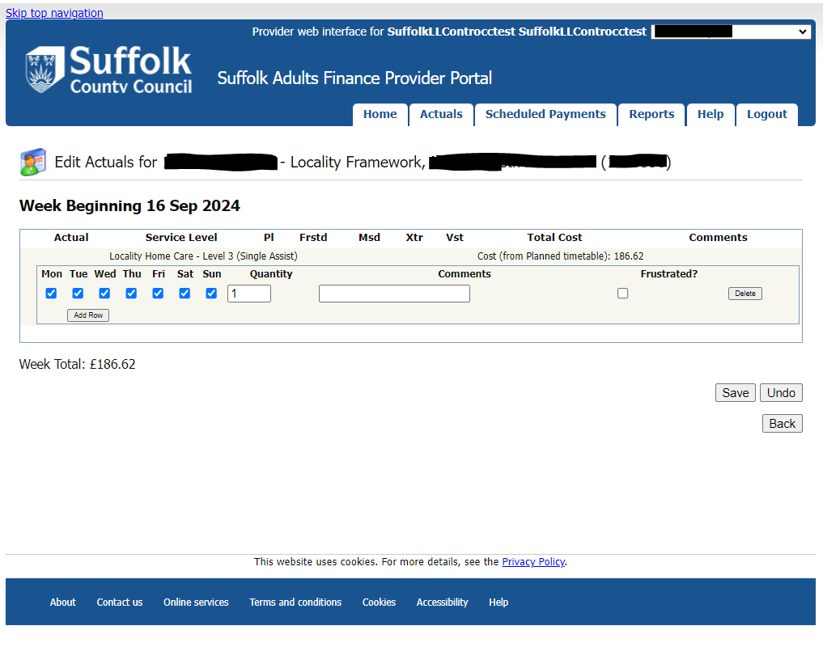

**View following hospital admission**

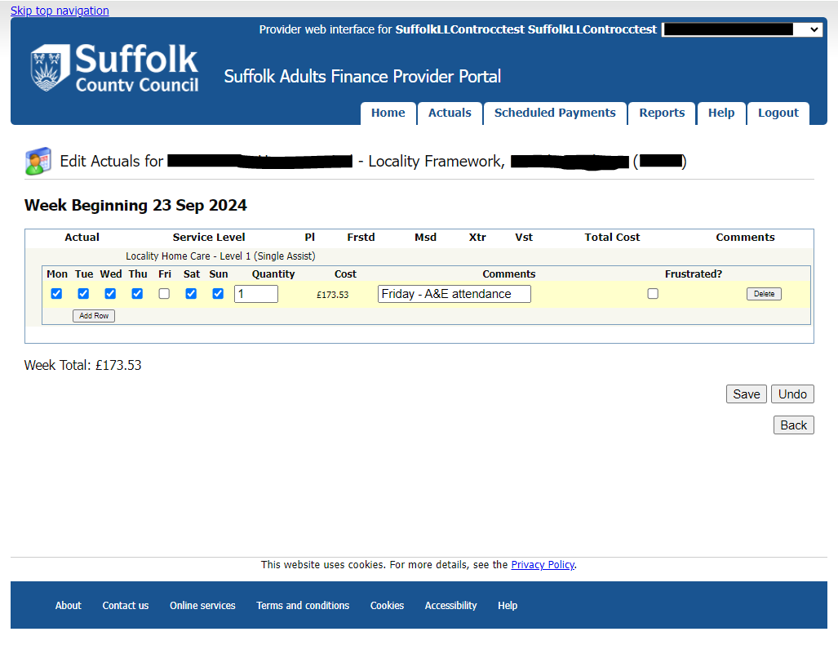

**Up to 30 mins one off variations now need no prior approval but these will continue to be audited**.

**View of one-off 30-minute variation.**

**View of delivering under commissioned time.**

**View of Double up care**

**Table of decimal conversions**

|  |  |
| --- | --- |
| Time in mins | Time in decimals |
| 00:30 | 0.5 |
| 00:35 | 0.58 |
| 00:40 | 0.67 |
| 00:45 | 0.75 |
| 00:50 | 0.83 |
| 00:55 | 0.92 |
| 01:00 | 1 |
| 01:05 | 1.08 |
| 01:10 | 1.17 |
| 01:15 | 1.25 |
| 01:20 | 1.33 |
| 01:25 | 1.42 |
| 01:30 | 1.5 |
| 01:35 | 1.58 |
| 01:40 | 1.67 |
| 01:45 | 1.75 |
| 01:50 | 1.83 |
| 01:55 | 1.92 |
| 02:00 | 2 |