SCC ICT
Promoting Pupils for the New Academic Year
Step by step user guide for schools
Author : David Sheppard
Authorised by : Lizzie Winter
Version : 2.0
Date : 31/05/2023

Table of contents
Contents
1. Introduction 3
1.1. Purpose 3
1.2. Assumptions and Constraints 3
2. Promoting pupils 3
2.1. Accessing Promotion 3
2.2. Mapping Promotion 4
2.3. Promote Pastoral Groups 5
3. Useful Links: 7

Introduction

Purpose
Procedure documentation for promoting pupils in a new academic year in Sims .Net version 7.210.

Assumptions and Constraints
This guide needs to be used in conjunction with your ESS Detailed End of Year Procedure. This can be located from the Sims 7 Documentation Centre.
These instructions are primary school focused but can be used as guidance for secondary schools.
Assumption is that the staff changes have been made in sims. The new academic year has been created and the pastoral structure has been created.

Promoting pupils
Promoting pupils is undertaken where children are moved from one year to the next. It allows the user to promote to classes that have been setup in the new pastoral structure. This can be managed in build or nuanced for individual students.

Accessing Promotion
To promote pupils, click on ‘Routines | School | Promotion’.
You will be greeted with a dialogue box indicating that this will take time to prepare for, click ‘OK’.
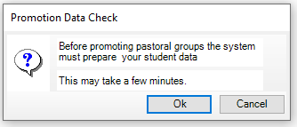
The next box will be a loading box that can takes a few minutes to complete.
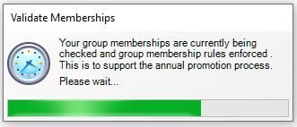

Mapping Promotion
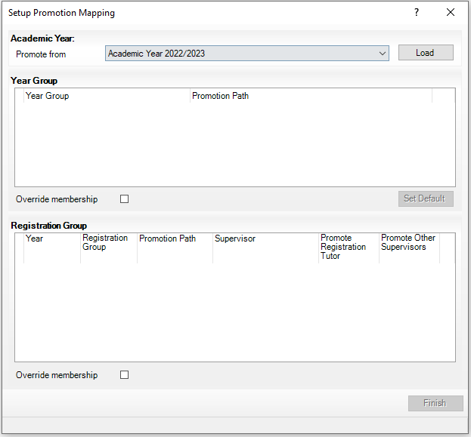
Select the correct academic year to promote from, this would be academic year 2022/2023. Then select the ‘Load’ button to load the year group box.
Note: It is important to ensure you are using the correct academic year as this could promote pupils and thereby make changes that are very difficult to correct.
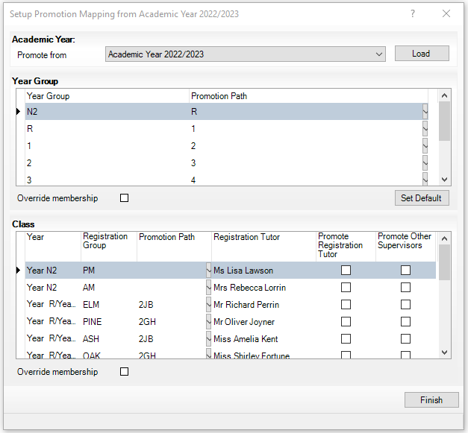
From this dialogue box, it automatically creates a mapping path, ie from year R to year 1. Also, from this dialogue box you can assign the current academic year class to another class. This is a bulk application of the paths and this dialogue box you cannot set individual child path. If you have run this previously and do not wish to overwrite your previous attempt, ensure that the tick box to ‘Override membership’ is deselected.
Note: Normally the default path is the preferred option.

Note: If schools have multiple nurseries, ensure that the correct path is selected, ie N1 is mapped to N2, etc.
Additionally, the school may desire to promote the tutors and/or supervisors a class has to the next year group so that the tutor and/or supervisors follows that registration group. This can be done by selecting the promote registration tutor and/or promote other supervisors tick boxes accordingly.
Once happy with the options set, click on ‘Finish’.

Promote Pastoral Groups
This will take you to a window where you can review the bulk transitions.
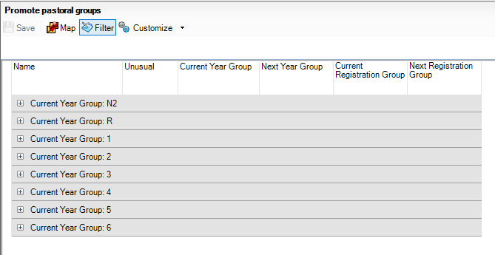
Note: This may be a good point to save your progress!
You can expand year groups by selecting the ‘+’ symbol. The ‘-‘ symbol will then appear, selecting this symbol will collapse the group again.
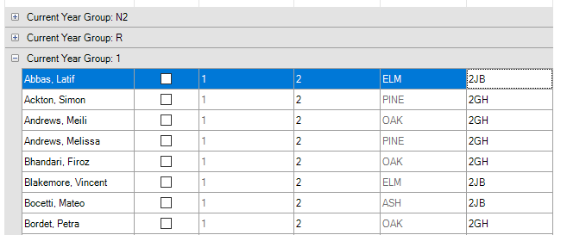

You can customize the sort order using the ‘Customize’ button.
This allows you to sort by groups within groups, for example, sorting by current year group, then by current registration group and finally by name. Click ‘OK’ to action the sort once completed.
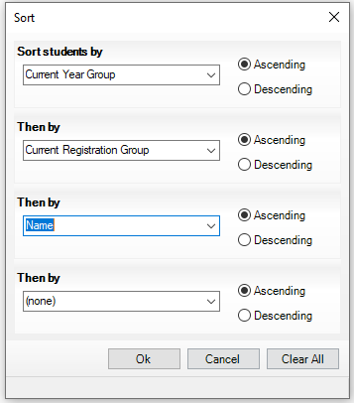
From this grid you can set individual movement as desired, you can only make changes to the next academic year. The current academic year will be greyed out, indicating that changes cannot be made.
For example: If I am moving Meili Andrews on my training database from Oak class to 2JB instead of 2GH I will need to go to the column ‘Next Registration Group’ for Meili, click in the cell and select the alternative option I desire.
The filter option restricts the drop-down choices when you are altering the default promotions.
For instance, if you are altering the registration group for a pupil, with the filter selected, you will only see from the drop-down options for that ‘Next Year Group’ that they are being promoted to. With the filter option not selected, you will see the registration groups for the entire pastoral structure setup for the next academic year.

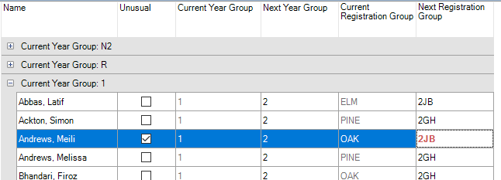
The tick box for the column ‘Unusual’ automatically becomes selected when the cell for ‘Next Registration Group’ has been adjusted. Meili will now promote from Oak to 2JB when the academic year starts.
Once you have concluded the promotions you can save this promotion version by clicking on the ‘Save’ button.
The promotion path will be implemented once the academic year begins.

Useful Links:
Sims 7 Documentation Centre

