


MLL Connect and Protect Fortinet Filtering Instruction Guide

Version | Date Issued | Status | Reason for Change
0.1 | 17/04/2025 | Current | First draft for review
1.0 | 13/05/25 | Published | First formal release

Table of Contents
1 Finding Fortinet 3
2 Making Changes 3
Selecting a Filter to change 3
Blocking/Unblocking a Category 3
Blocking/Unblocking a URL 4
Adding am SSL Inspection Exemption 6
3 Running Reports 7
4 Checking Logs 8

© MLL Telecom Limited 2025.
All rights reserved.
This document is confidential to MLL Telecom and use and disclosure by the recipient is restricted to internal use by the recipient. This document does not constitute a representation or warranty and is not contractual unless specifically referenced in a written contract between MLL Telecom and the recipient.

Finding Fortinet
https://fpl.mlltelecom.com/

Making Changes

Selecting a Filter to change
- On the left-hand menu, go to Security > Firewall Objects
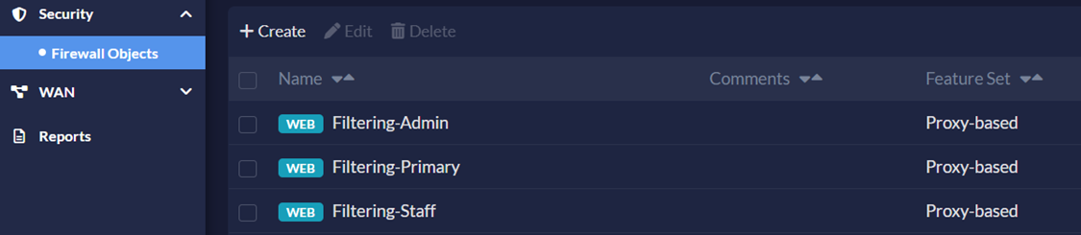
- Select the Filter you wish to change (e.g. for which filtering group)
- Click Edit

Blocking/Unblocking a Category
WARNING: Allowing or Blocking a Category can have a significant impact on the filter and should only be done with due consideration.
- Once you have selected a Filter, scroll down to the Category Based Filter section
- Select the desired Category
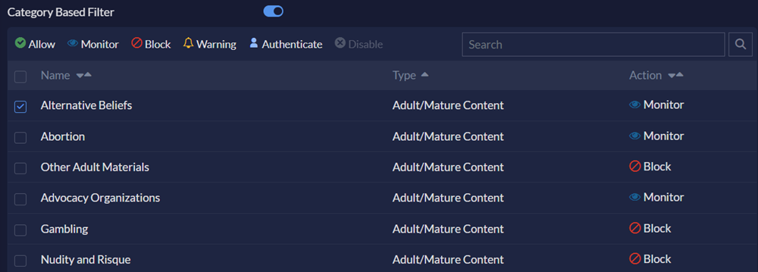
- Click the action required:
ALLOW
Permit access to the sites in the category.
MONITOR
Permit and log access to sites in the category.
BLOCK
Prevent access to the sites in the category. Users trying to access a blocked site see a replacement message indicating the site is blocked.
WARNING
Display a message to the user allowing them to continue if they choose.

NOTE: For certain Safeguarding and Security Categories, whilst they can be set to Allow here, will still be blocked in the No-Override Filter which is not accessible from FortiPortal.
- Once you have completed the changes to the filter, scroll all the way to the bottom of the Filter page and click Save.
- To install the changes on the device, click Install in the top right-hand corner. Select your device from the list. Click Install. Click Yes to confirm the installation. The progress bar in the Install dialog shows the status of the installation. Once the package is installed, click Finish.

Blocking/Unblocking a URL
1. Once you’ve selected a Filter, scroll down to the the Static URL filter
2. Click +Create
3. Enter the details of the URL and Action required:
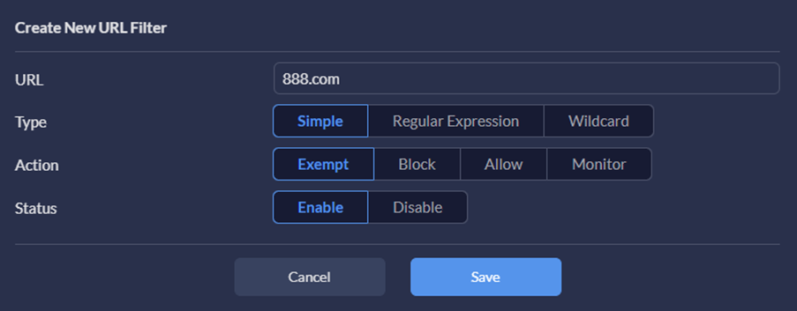
4. Click Save
5. Once you have completed the changes to the filter, scroll all the way to the bottom of the Filter page and click Save.
6. To Install the changes on the device, click Install in the top right-hand corner. Select your device from the list. Click Install. Click Yes to confirm the installation. The progress bar in the Install dialog shows the status of the installation. Once the package is installed, click Finish.
Type:

SIMPLE
The FortiGate tries to strictly match the full context. For example, if you enter www.facebook.com in the URL field, it only matches traffic with www.facebook.com. It won't match facebook.com or message.facebook.com.
WILDCARD
Entering *.facebook.com in the URL field will match www.facebook.com but will also match help.facebook.com, and facebook.com/images
REGULAR EXPRESSION
Do not use unless familiar with Perl-compatible regular expression.

Action:
EXEMPT
The 'Exempt' action for an entry in the URL filter will permit the traffic to pass through the firewall without any further scanning. There will be no match against FortiGuard web filters (FortiGuard categories), Web Content Filter or so on. Use this for websites that are 100% safe.
BLOCK
The 'Block' action for an entry in the URL filter will block any further traffic to a specified URL.
ALLOW
The 'Allow' action for an entry in the URL filter will permit the firewall to continue scanning against FortiGuard Web Filter (FortiGuard categories). Use this for websites that may contain some questionable pages.
MONITOR
The 'Monitor' action for an entry in the URL filter will have the same effect as the action 'Allow', but the traffic will be logged. Use this for websites you want to track access for.
The Report screen will show you all of the reports run in the last <date range> selected in top left.
To run a new report, click Run Reports in top right. Fill out the drop downs as required for Report Duration, Report to run, and device to report from (your school’s Fortinet router).
Click Save.

Adding am SSL Inspection Exemption
NOTE: For certain websites, the connection can be blocked if the traffic is fully inspected by the filter. These websites are usually those involving financial and banking or other private information. A website can be exempted from inspection by including it on the SSL Exempt List.
1. On the left-hand menu, go to Security > Firewall Objects
2. Select Address from the list of available Objects
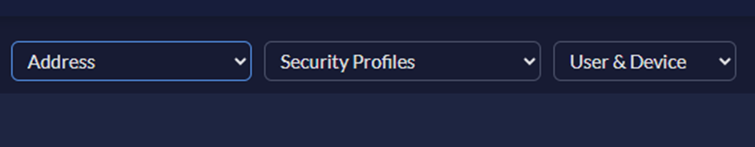
3. Click +Create
4. Change the Type to FQDN and enter the details of the URL required:
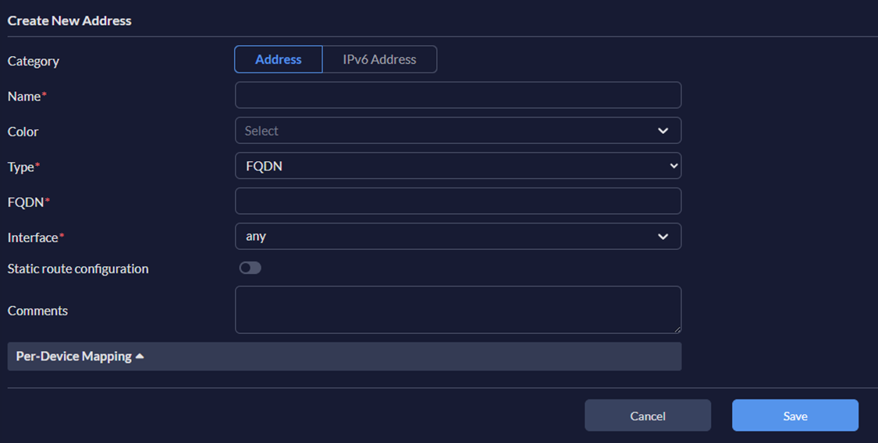
5. Click Save.
- Select SSL/SSH Inspection from the list of available Firewall Objects
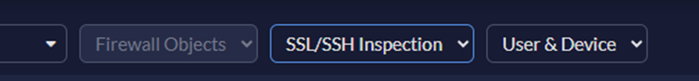
7. Select the C&P deep-inspection and click Edit
8. Scroll down to Exempt from SSL Inspection section
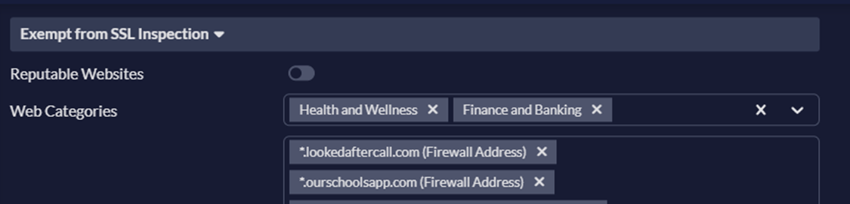
9. Here you can add in either an entire category (not recommended) or a website URL you have previously entered as an Address object in stages 1 to 5 above.
10. Once you have completed the changes to the filter, scroll all the way to the bottom of the Filter page and click Save.
11. To Install the changes on the device, click Install in the top right-hand corner. Select your device from the list. Click Install. Click Yes to confirm the installation. The progress bar in the Install dialog shows the status of the installation. Once the package is installed, click Finish.

Running Reports
- On the Left-Hand menu go to Reports
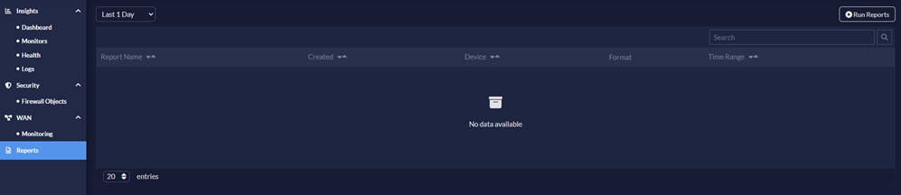
2. Click Run Reports in the top right-hand corner of the Screen. Populate drop down boxes with required report duration, reports to run (multiple can be selected at once) and devices to run the reports on (your Fortigate device). Then click Save.
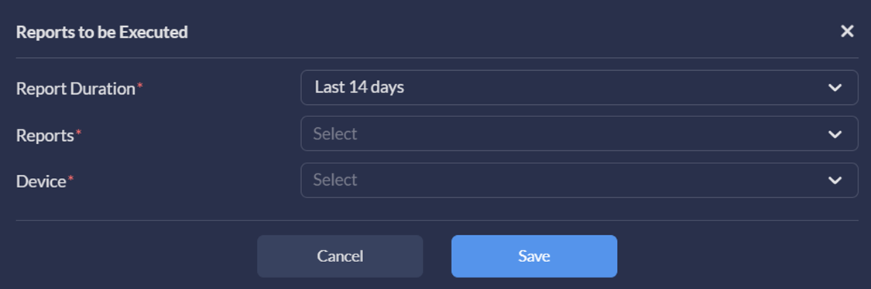
3. The report will run and populate in the recently run report screen.
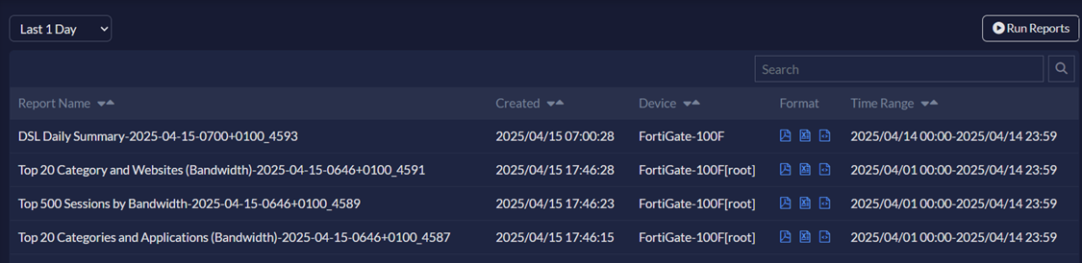

Checking Logs
1. On the left-hand menu go to Insights > Logs
2. Select Web Filter logs, the web filter device, and the period of time required for the logs.
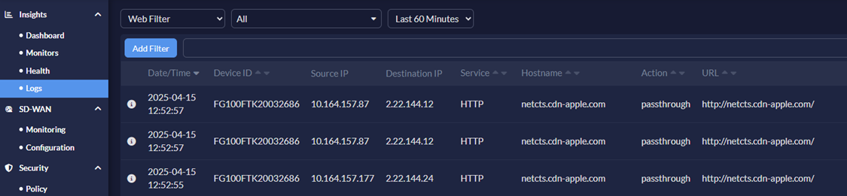
3. Additional filtering can be applied with the Add Filter button. i.e. Source IP, URL, Category Description. These filters can also be quickly added for entries from the logs by double clicking on the required item.
4. Additional fields can be added by clicking the cog in the top right hand corner
