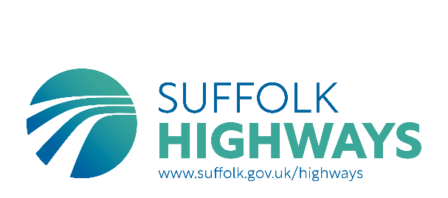

LORRY PROHIBITION – 7.5 TONNES WEIGHT RESTRICTION EXEMPTION PERMIT APPLICATION FORM
- From April 1st 2025, the charge for each 7.5 tonnes weight restriction exemption permit is £60.
- One permit will be issued per vehicle registration to one permitted zone.
- If you are requesting multiple permits, there will be a £60 charge per vehicle for each permit allocation. For example, the charge for 1 vehicle requiring a permit for 2 locations will be £120 the charge for 2 vehicles requiring a permit for 2 locations will be £240, but the total cost can be made via one payment.
- Payment is made via an online system which you will receive a link to upon receipt and approval of your application.
- If an alternative payment method is required, please state this with submission of an application.
- Alternative payment methods are through invoice or cheque. If payment is made by cheque, application forms must be accompanied by full payment made payable to SUFFOLK COUNTY COUNCIL, and sent to the address below:
Highways Licensing & Enforcement Team
Suffolk Highways
Phoenix House
3 Goddard Road East
Ipswich IP1 5NP

A receipt for the cheque will be provided along with your permit(s).
We are unable to process permit applications until we receive fully completed application form with confirmation of the preferred method of payment.
Please attach a copy of your completed application and send this to vehiclepermits@suffolk.gov.uk for processing.

1. | Highlight the location(s) of the permit you are applying for (or remove other locations as necessary)  £60 fee for each location | A1088, Ixworth  C634, The Street, Barnham  C408/C409, Saxham Street  B1106, The Street, Fornham
2. | Name of Haulier who will be using the permit
3. | Address of the Haulier who will be using the permit
4. | Email address of the Haulier  who will be using the permit
5. | Contact telephone number of the Haulier who will be using the permit
7. | Brief reasons for requesting permit
8. | Estimated number of journeys along selected road per month (return journeys count as 2 journeys)
9. | What are the origins/destinations of these journeys likely to be? (Please list all stops made in each trip)
10. | Please explain why other routes without weight restrictions cannot be used

Vehicle Registration: | License No. (if renewing) | Expiry Date (if renewing)

STATEMENT OF AGREEMENT:
- I agree that any exemption permits issued to me/my company for local journeys will be returned to Suffolk Highways if the vehicles named on the permits are scrapped or sold.
- I understand that failure to adhere to this requirement will mean withdrawal of any amended permit that has already been issued prior to receipt of the old one without a refund.
- I also understand and accept that the exemption permits issued to me/my company are a concession and may be withdrawn at any time, and in particular if they are used for longer distance journeys and not used for their intended purpose of facilitating local journeys only, and that a refund will not be made.
- Permits may also be withdrawn if vehicles are driven with excessive speed or without due care and attention.
- I am applying for ……… (number of permits) and payment to be made to Suffolk County Council for the sum of £……………….(number of permits x £60 per permit)

PLEASE COMPLETE A, B and C BELOW TO CONFIRM THE ACCURACY OF THE INFORMATION PROVIDED IN THIS FORM AND YOUR ACCEPTANCE OF THE STATEMENT OF AGREEMENT
A | Name
B | Company name
C | Contact Address
Date

Notes:
- If you provide an email address, all future correspondence will be sent to that address.
- If you submit this form by email, your email will be regarded as a signature of agreement.
- Please allow fourteen days for the processing of your application, please ensure applications are submitted suitably in advance to accommodate this.

