

Visual Supports to Aid Communication Information Sheet

To communicate with your child/young person:

  - When your child/young person is playing with a toy, eating a food or doing an activity, you can show the child/young person a photo or symbol of the same thing.
  - When your child/young person is used to the photos/symbols, you can show them to the child/young person before you give the food, or a toy. Then give them the object straight away.
  - If you are going to see someone or to a different place, give the child/young person a photo/symbol of that person or place to show them who you are seeing or where you are going. Do the same if someone is coming to your house.
  - Using photos or symbols on a visual schedule/timetable (see visual schedule guidelines).

When using photos/symbols, do not forget to still speak to your child/young person.
The photos/symbols are a visual prompt not a replacement for speech. Your speech therapist can advise if your child/young person would be better using photos, colour or black and white symbols and how to move on from photos to symbols when appropriate.
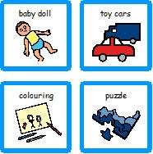

To encourage your child/young person to communicate with you:

PECS (Picture Exchange Communication System) is a structured, behavioural programme that helps children communicate using pictures rather than words or signing

With PECS children/young people are taught (by someone trained) to exchange pictures for something they want.
