

Quiet Time Information Sheet
Quiet time is a non-confrontational way of giving your child time out when they need to calm down to help prevent a meltdown.
Choose an area in the home where quiet time is going to happen. If no space is available you could use a beanbag or pop up tent to create an area.
You can show your child a symbol so they know it is quiet time:
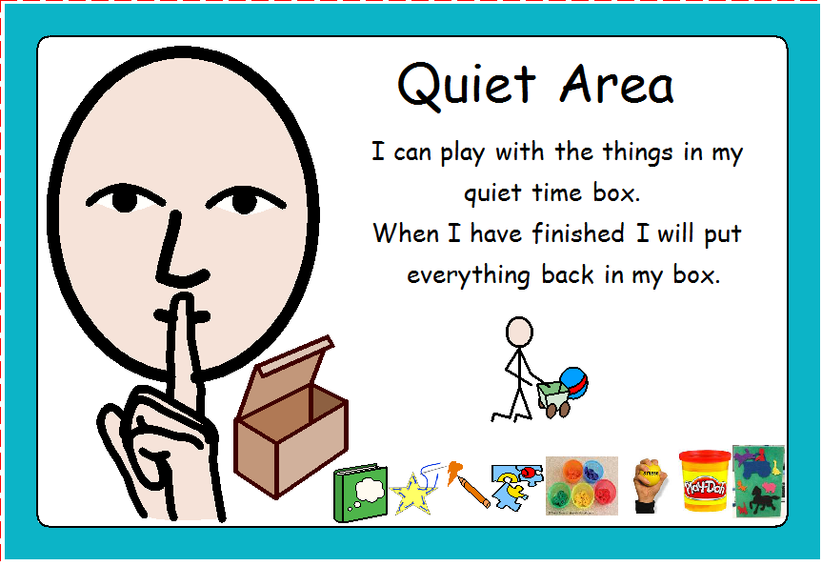

Create a quiet time box/bag with your child. This need not cost you a penny. If you have a shoe box you could spend time decorating it with your child so it is special to them. You can use a draw string bag instead of a box; this should be about the size of a PE bag.
Place 4-6 items in the box that your child can play with on their own.
These should be items that are special and are only played with during quiet time.
You do not need to rush out and buy items for the box/bag, instead encourage your child to choose items from their own things to put in the box/bag.
Box/bag suggestions:
- Book
- Threading cards
- Drawing pad and colouring pencils
- Stress ball/toy
- Tub of play-doh
- Sorting activity
- Fuzzy felt
- Play figure

