

‘Pica Box’ Information Sheet

Pica is an eating disorder referring to the eating or mouthing of non-edible and inappropriate items such as clothing, faeces, dirt or stones. One purpose of this behaviour could be a sensory function i.e. they enjoy the texture or taste of the item or a continuation of infant mouthing behaviour and the person not understanding the difference between edible and non-edible items.

One technique to manage this potentially dangerous behaviour is to offer safe alternatives of similar taste or texture that the person is allowed to explore with their mouth and/or eat. These items should be chosen specifically for the individual based on an assessment of the types of items they choose.

The items can then be placed in small plastic or Tupperware pots which are available to the person to either help themselves (if appropriate to do so) or to request verbally, with a symbol/ photo or using an electronic device such as a Talkpad.

Here is an example of the types of food that might be suitable and how they can be requested by the person:

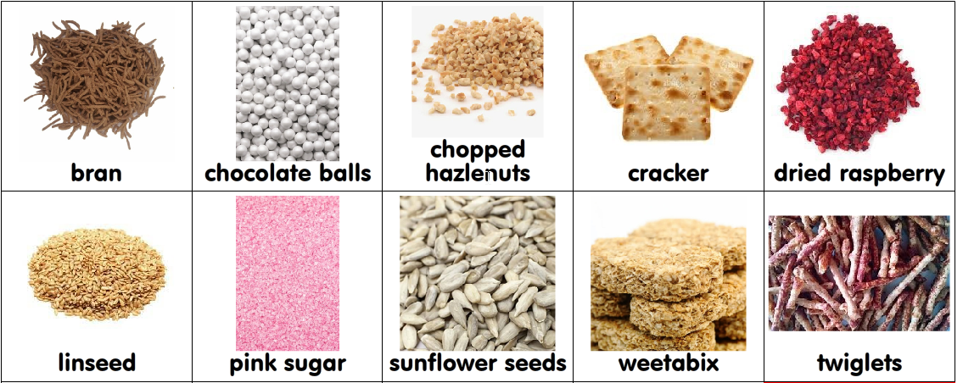

As part of your assessment of the person’s pica it is important to look at whether there are particular enviornments, locations, times of the day or activities where they are more likely to seek items to explore. In these situations you can pre empt the behaviour by having the alternative items accessible.

If the behaviour is more unpredictable or there are additional times that the pica behaviour is an issue then they will need to be encouraged to return the non edible item or put it in the bin and redirected to the alternative items. A social story could be introduced to reinforce this and how to request an appropriate item should be modelled to the person if required.

