

‘First and Then’ or ‘Now and Next’ Information Sheet
These can be used:
- To encourage/remind the young person to complete a specific activity
- To structure part or all of the young person’s day
- To reduce anxiety and offer reassurance
- To increase independence and self esteem
It is important to agree if you are going to call them ‘First and Then’ or ‘Now and Next’ to ensure continuity for each young person.
The cards can be made up from photographs, symbols, words or a combination of these. Cards can be laminated to enable them to be reused.
The cards identify either 2 specific activities to be completed or a specific activity that needs to be completed followed by a reward, e.g.

First eat your dinner then you can play on the computer (the reward for doing the activity).
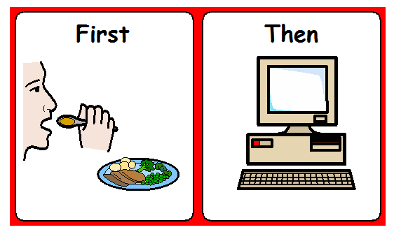

The cards should be made specifically for the individual person.
The cards should be used consistently every day.
Rewards needs to be given immediately so the young person learns that by completing the activity the reward follows.
Involve your child in the process and try to make it a positive and enjoyable experience.
When first using the card try something that you know your child can achieve straight away, this will increase their confidence and motivation to get the reward.

