

‘Catch Them Being Good’ Information Sheet

‘Catch Them Being Good’ cards are a good way of recording all the times that your child carries out an instruction without negotiation! The spiral of negative behaviours can be very hard to cope with for both parents/carers and the child. Very often when constantly coping with negative behaviour, it is easy to miss those times when a child does exactly what you want. Those situations are a golden opportunity to praise the child and reinforce positive behaviour!

If a child has low self esteem or is anxious about certain things, this is a good resource that if used consistently, will help to increase self esteem and hopefully reduce negative moments!

A card can be created on the computer or drawn by hand. The adult may like to help the child to create the resource. If possible, laminate the card so that wipe clean pens can be used to record ticks. It can be in the form of a chart showing the days of the week and a row of space for ticks or stickers. You may have a clear idea of what behaviours you would like to see more of, such as good sharing, good playing or listening to instructions. If that is the case then illustrate the card with hand drawn pictures or clip art from the computer.
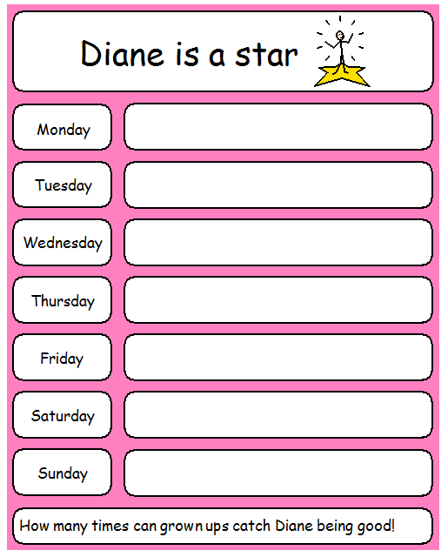

Ensure that all adults that come into contact with the child share their positive moments, and that they are recorded with the child. Get into the habit of looking for the positive and your child will reward you.

