Key Adult/Attuned Adult Approach

Introduction
Introducing a ‘key/attuned adult’ is a relational approach to support CYP to feel secure enough to communicate. There is specific emphasis placed upon building a member of staff building a positive relationship with a CYP based on trust and consistency.

Purpose of Intervention
Within education a CYP may require access to a consistent ‘key/attuned adult’. Efforts should be made to build trust between CYP and this ‘key/attuned adult’ to ensure they feel supported, listened to, and understood. Similarly, such a person should act as a ‘champion’ as well as providing an additional point of contact for CYP's family and facilitate collaborative working between the setting and family.
Relationship building will be key to the CYP’s success in their setting and so this should be prioritised, creating a relationship focused, low demand environment to allow CYP to feel safe to express themself, make mistakes and interact with others as they will only communicate when they feel comfortable, however this process is likely to take time. During this process CYP will require time to ‘decompress’ as sharing views and communicating with others can be taxing and overwhelming.

Target Audience
Many children will benefit from having a ‘key/attuned adult’. All children in nursery setting often have a Key/attuned adult, but this relationship may also be beneficial to CYP in primary, secondary and college settings, particularly CYP with SEMH needs (e.g. those expressing attachment seeking behaviours or require co-regulation with an adult to support their mental health and wellbeing), pupils who are selectively mute, pupils who identify as neurodiverse,. This approach may be particularly useful for some pupils during transitional periods so they have a point of contact in their new setting.

Who Can Deliver the Intervention
Any member of school staff can be a Key/Attuned Adult as a relational approach is good practice in schools, and where possible the child or young person should be involved in selecting their ‘key/attuned adult’. However, careful consideration should be given as to which member of school staff is best placed to offer consistent support to a CYP and build a positive and trusting relationship. (e.g. perhaps a Teaching Assistant who is more consistently available may be more suitable than a particular class-based teacher in some circumstances). Teachers/Teaching Assistants chosen to be ‘key/attuned adults’ should be overseen and supported by the SENCo.

Frequency and Duration
The member of staff should be available to the CYP throughout the day and regular scheduled check-ins should occur. The duration and frequency of the check-ins should be negotiated with the CYP themselves if appropriate.

Key Principles
Attachment Theory: Positive relationships between attachment figures and a child or young person promote feelings of emotional security which are necessary for enjoyment and exploration in their environment.
The Principles of Attunement from Video Interaction Guidance (VIG), a strengths-based approach to promote attunement, sensitivity and mentalization in relationships (see graphic below):
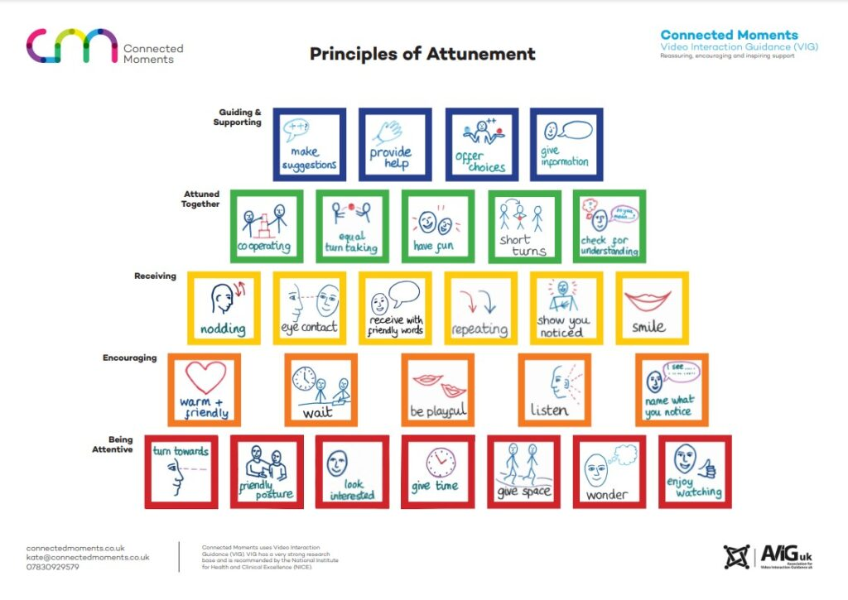
‘Key/attuned adults’ should start their interactions with the CYP at the bottom of the pyramid (the red zone) by ‘being attentive’ and work their way up to ‘encouraging’ initiatives (orange level) and ‘receiving’ initiatives (yellow level) from the CYP so they can become ‘attuned together’ (green level).
Only once this has been achieved should ‘key/attuned adults’ begin ‘guiding and supporting’ CYP (the blue level). This supports ‘key/attuned adults’ to participate in attuned interactions with CYP and build a trusting relationship and attachments.

Training and Implementation
Specific training in relational approaches including how to implement the principles of attunement as a ‘key/attuned adult’ can be negotiated as part of a traded package with the Psychology and Therapeutic Services (P&TS) at Suffolk County Council. Furthermore, a traded package of Video Enhanced Reflective Practice (VERP) can be purchased where a member/members of staff can receive guidance and coaching in their attuned interactions. (verp-leaflet-2021)

Evidence and Outcomes
Evidence suggests that attunement helps us to relate to and connect to others supporting learning and the ability to cope with things we find distressing. Findings also suggest ‘key/attuned adults’ can support children and young people to be successful in developing skills in social, emotional and behavioural domains. This has been found to safeguard against exclusion in some circumstances.

Feedback
Children have expressed that having support from a ‘key/attuned adult’ helps them to be successful at school as they support them to make good choices and are someone they can talk to. Furthermore, Teaching Assistants have reported that being a key/attuned adult has supported their knowledge and confidence in supporting particular children’s needs at school.

11. Further Information and Resources
The Key Adult - Making a difference - SEMH

