Jot the friendly robot.

Jot the Robot Building Wellbeing Workshop Session Plan for Teachers and Educational Settings

Host a ‘Jot the Friendly Robot Building Wellbeing Workshop for your pupils with this step-by-step session plan.

What are the aims of the workshop?

The aim of this robot building workshop is to help children learn about emotional literacy.
The workshop activity provides a fun, creative and comfortable environment for teachers to start a conversation with children about emotional wellbeing, the importance of talking about how we feel, and to look at the things we can do when we feel sad or worried.
The children will learn about how to manage difficult feelings with the help of ‘Jot the friendly robot’s wellbeing tips.
We will be using the children's creativity to create their own robots like Jot, by using recyclable materials.

This workshop is suitable to be delivered as a 45–60-minute group workshop or as a whole school morning or afternoon assembly activity.

Equipment you will need for the workshop:

- Pupils to bring in recyclable items and boxes that they can use to build their robots.
- Jot the friendly robot building workshop wellbeing flashcards
- Brown tape, scissors, and felt tip pens.
- Robot eyes, mouths and buttons print-out (for pupils to cut-out to decorate their robots with).
- Jot the robot building wellbeing workshop worksheet.
These resources can all be downloaded and printed off at: www.suffolk.go.uk/jot

Jot the robot building wellbeing workshop instructions:

- First play the introductory 'Jot the friendly robot building wellbeing workshop video' to your pupils which can be found here www.suffolk.gov.uk/jot or via Youtube here: https://www.youtube.com/watch?v=tJxjO5eKOrM
Pause the video when you get to the slide with the bucket which says...'What do you do to feel better when you are feeling sad, worried or angry?

- Handout the ‘Jot the friendly robot building workshop wellbeing flashcards’ and get pupils to look at them and pass them round. Spend 5-10 minutes discussing with the pupils which of the tips they do which helps them feel better when they feel sad or worried?

- Continue playing the video showing the animated videos of jot the robot through to the end.

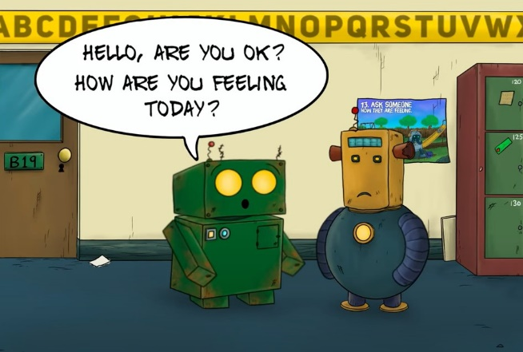

- Get the pupils to decide if they would like to work on own their own or as a team to build their robots. Give pupils 30-45minutes to build their robots (or if they prefer to draw their robots they can).
When building their robots get them to think about:
What their robot does and don't like?
How will their robot help others?
What to call their robot?
Whilst helping pupils to build their robots continue the conversation about what things they like to do that makes them feel better when they feel sad or worried.

- Allow 10-15 minutes at the end to get the pupils back together to show everyone their robots and share their creative ideas for how they built their robots.

- Finish off the workshop session by handing out the 'Jot the robot wellbeing workshop worksheet' which rounds up the workshop activity with some important wellbeing messages for pupils.
- Please download the Jot the friendly robot poster resources to put up on your school noticeboards. Go to www.suffolk.gov.uk/jot

If you would like to request hard copies of the Jot the friendly robot booklet or poster resources, please email: engagementhub.enquiries@suffolk.gov.uk

Jot the friendly robot is a children’s wellbeing campaign created by:
Suffolk County Council's Children and Young People's Engagement Hub Team, and JG Mind Doodles, in partnership with NHS Suffolk and North East Essex Integrated Care Board (ICB)

