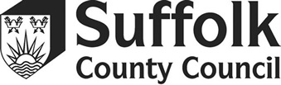**Children’s Community Learning Disabilities Nursing Team**

**Behaviour Support Survey (Young Person)**

**What is the survey about?**

This survey is about the Service and Support you have received from the team. We want to know what you think. The questions should be answered by the child who received the service, but help can be given by the parent /carer where needed. Surveys are anonymous so please do not write your name on the form.

Please tick the one you agree with:

|  |  |  |  |
| --- | --- | --- | --- |
|  | Not Good | Good | Very Good |
| My nurse /support worker knew what I needed help with |  |  |  |
| The help and support I got was |  |  |  |
| My sessions were |  |  |  |
| How was my nurse /support worker at being kind and explaining things |  |  |  |
| If my friends and family use this service, they would think it is |  |  |  |

Please tell us, in your own words, how the nurse /support worker have helped you

and /or how we can make the service better.