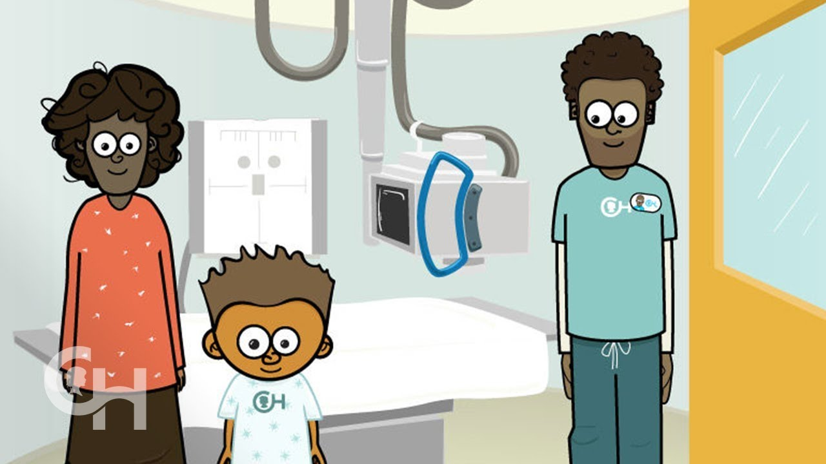

**NAME’s Hospital Story**

**NAME has an x-ray**

**NAME goes to the hospital and has an x-ray.**

**Name in the car park.**

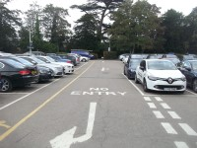

[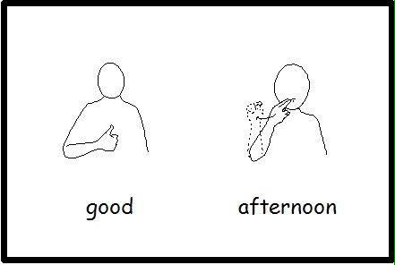](https://www.google.co.uk/url?sa=i&rct=j&q=&esrc=s&source=images&cd=&cad=rja&uact=8&ved=2ahUKEwjZyrn1mJjgAhWRMBQKHcjaBTUQjRx6BAgBEAU&url=https://www.pinterest.co.uk/pin/395261304776025951/&psig=AOvVaw2pvAyVMemldoF4QpyC-KA7&ust=1549030081765691)

**Name can see the hospital.**



**NAME goes through the doors.**

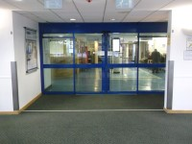

[](https://www.google.co.uk/url?sa=i&rct=j&q=&esrc=s&source=images&cd=&cad=rja&uact=8&ved=2ahUKEwjZyrn1mJjgAhWRMBQKHcjaBTUQjRx6BAgBEAU&url=https://www.pinterest.co.uk/pin/395261304776025951/&psig=AOvVaw2pvAyVMemldoF4QpyC-KA7&ust=1549030081765691)

**NAME can see:**

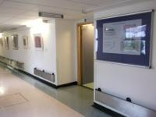

**Xray department door**

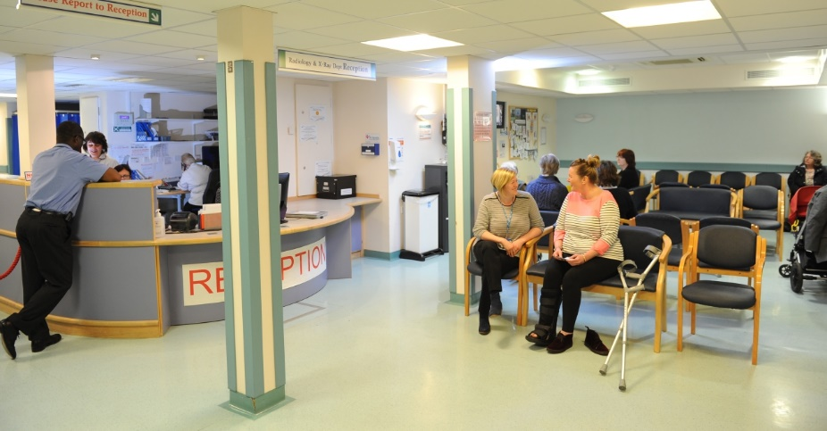

**Chairs**

[](https://www.google.co.uk/url?sa=i&rct=j&q=&esrc=s&source=images&cd=&cad=rja&uact=8&ved=2ahUKEwjZyrn1mJjgAhWRMBQKHcjaBTUQjRx6BAgBEAU&url=https://www.pinterest.co.uk/pin/395261304776025951/&psig=AOvVaw2pvAyVMemldoF4QpyC-KA7&ust=1549030081765691)

**NAME waiting.**

**Good waiting.**

**NAME goes into x ray room.**

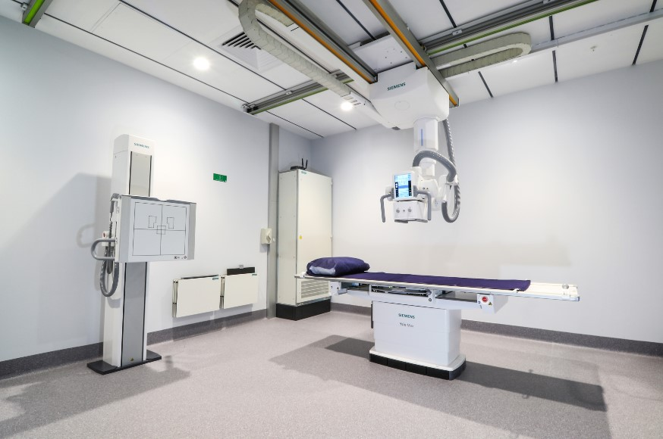

[](https://www.google.co.uk/url?sa=i&rct=j&q=&esrc=s&source=images&cd=&cad=rja&uact=8&ved=2ahUKEwjZyrn1mJjgAhWRMBQKHcjaBTUQjRx6BAgBEAU&url=https://www.pinterest.co.uk/pin/395261304776025951/&psig=AOvVaw2pvAyVMemldoF4QpyC-KA7&ust=1549030081765691)

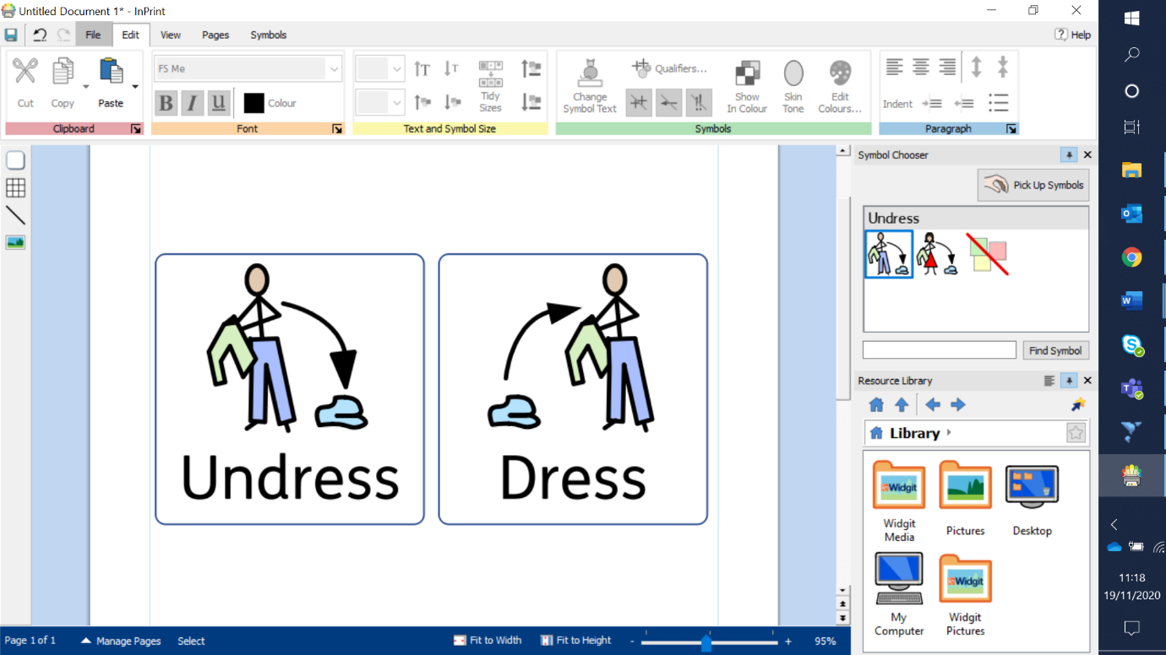

**Clothes off, gown on.**

**Mummy help.**

**Lay down on the bed.**

**NAME waiting.**

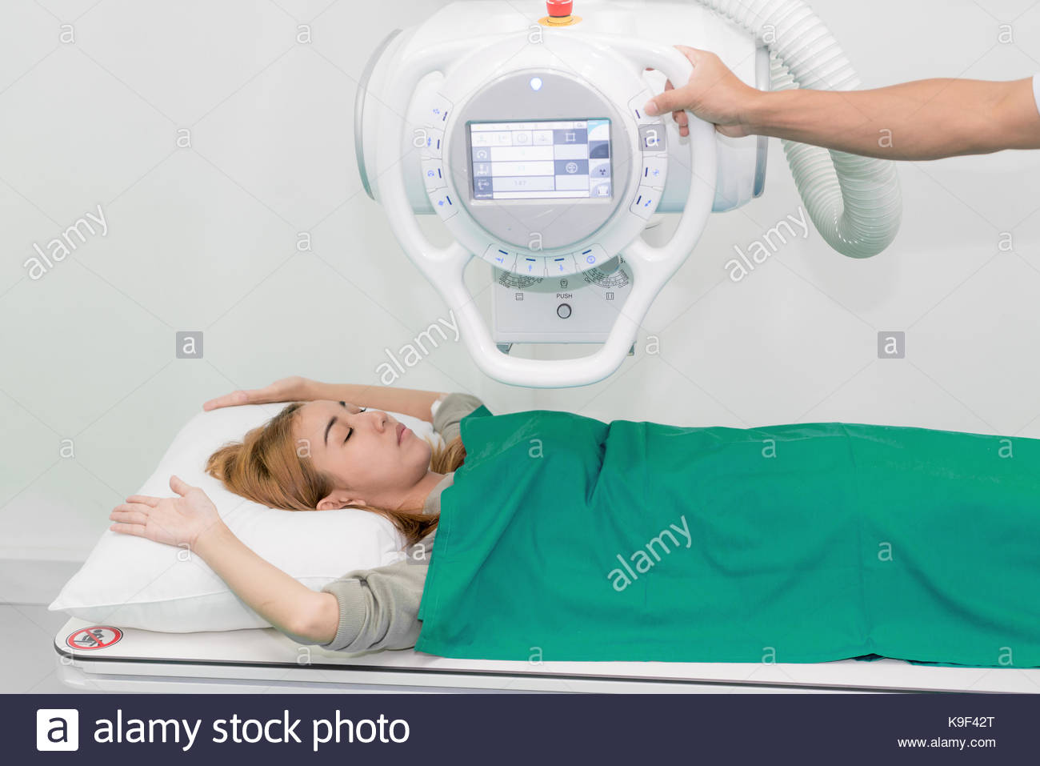

[](https://www.google.co.uk/url?sa=i&rct=j&q=&esrc=s&source=images&cd=&cad=rja&uact=8&ved=2ahUKEwjZyrn1mJjgAhWRMBQKHcjaBTUQjRx6BAgBEAU&url=https://www.pinterest.co.uk/pin/395261304776025951/&psig=AOvVaw2pvAyVMemldoF4QpyC-KA7&ust=1549030081765691)

**Wait for the beep.**



**Finished!**

**stand up.**

**NAME waiting.**

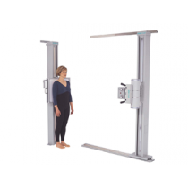

[](https://www.google.co.uk/url?sa=i&rct=j&q=&esrc=s&source=images&cd=&cad=rja&uact=8&ved=2ahUKEwjZyrn1mJjgAhWRMBQKHcjaBTUQjRx6BAgBEAU&url=https://www.pinterest.co.uk/pin/395261304776025951/&psig=AOvVaw2pvAyVMemldoF4QpyC-KA7&ust=1549030081765691)

**Wait for the beep.**



**Finished!**

**Car then home**

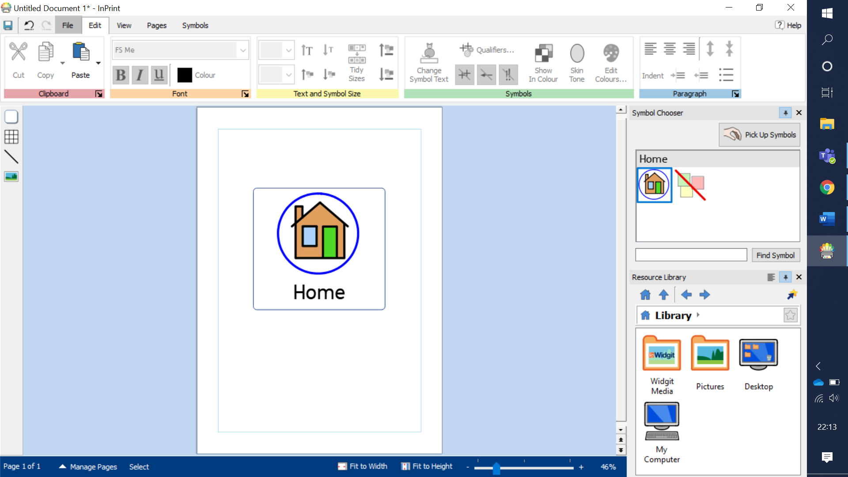



**Well done!**

[](https://www.google.co.uk/url?sa=i&rct=j&q=&esrc=s&source=images&cd=&cad=rja&uact=8&ved=2ahUKEwjZyrn1mJjgAhWRMBQKHcjaBTUQjRx6BAgBEAU&url=https://www.pinterest.co.uk/pin/395261304776025951/&psig=AOvVaw2pvAyVMemldoF4QpyC-KA7&ust=1549030081765691)