|  |  |
| --- | --- |
| **URGENT INFORMATION**  «To»  «Number» «Road»  «Town»  «County» «Postcode» | Your Ref:  Our Ref:  Date: 31 October 2018  Enquiries to: Helen Lightfoot  Tel: 0345 6066171  Email:[safetyandspeedmanagement@suffolk.gov.uk](mailto:safetyandspeedmanagement@suffolk.gov.uk) |

Dear Resident

**STOKE AREA, IPSWICH – PROPOSED NEW RESIDENT PARKING SCHEME**

We are writing to you inform you that Suffolk Highways is looking to establish whether a new Residents Parking Zone within the Stoke area of Ipswich would be both desirable and practical.

The purpose of a Residents Parking Scheme is to give residents and businesses the priority to park in streets that currently experience difficulties as a result of substantial commuter or shopper related parking.

Earlier in the year, some local residents contacted County Councillor Jack Abbott directly with their concerns. As a result, Councillor Abbott would like to invite you to share your views on the concept of a new Residents Parking Scheme for the area.

**Proposed Zone Boundary**

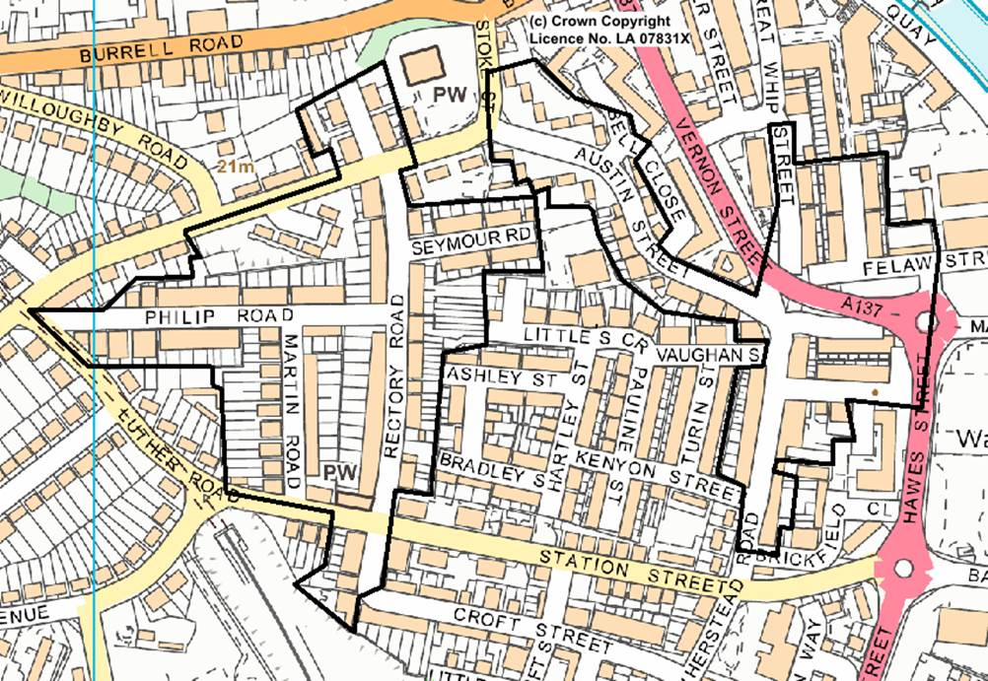

**Resident Parking Schemes explained**

The advantage of introducing a Resident Parking Scheme is to give residents reasonable opportunity to park close to their homes. A second permit for each household can be issued if required.

Permit Holders can park on any street within their Zone.

The Scheme can also improve arrangements for visitors as there is an option to purchase visitor tickets.

All kerbside space will be controlled to remove commuter and shopper related parking.

However, there are limitations to such a Scheme as permits to park in the Zone are charged to the residents and in some cases, it can reduce the amount of on street parking which may or may not be of benefit depending on location.

Residents Parking Schemes do not offer any guarantees for space to be available and vehicles without a permit can park in the Zone outside the restricted times.

To be viable, a Residents Parking Zone must contain a reasonable number of streets and cannot be implemented along isolated single streets.

To ensure continuity, the Scheme would be introduced with the same enforcement times as the other Resident Parking Zones in Ipswich - “Permit Holders Only - Monday to Saturday 8am to 6pm”.

Suffolk Highways will not impose Residents Parking on streets where there is not a clear majority support.

**Current Residents Parking Scheme fees**

|  |  |
| --- | --- |
| First Resident Permit (car or motorcycle) | £40 Annual Fee |
| Second Resident Permit (car or motorcycle) | £70 Annual Fee |
| Business Permit | £200 Annual Fee |
| Visitor Permits (booklet of five 1-day Vouchers) | £5 |
| 1-hour Visitor Time Clock | FREE with first Permit |
| Replacement Permit (lost, stolen or damaged) | £12.50 |

Please note that these fees are set to cover the cost of enforcing the restrictions and operating the Scheme and not with the intention of making a profit.

**Your Views**

Your views are important to us so please take the time to complete and return the enclosed questionnaire. We would also welcome any additional comments and suggestions in relation to this proposal. Please use the space provided at the bottom of the questionnaire.

We would be very grateful to receive your completed questionnaire by Friday 9th November 2018. For postal returns, please use the address shown at the bottom of the questionnaire.  
Alternatively you can complete the questionnaire online at: **https://www.smartsurvey.co.uk/s/Residentsquestionnaire/**

**https://www.smartsurvey.co.uk/s/Businessquestionnaire/**

Thank you for your time, we look forward to hearing from you.

Yours faithfully



For Suffolk Highways

**STOKE AREA, IPSWICH – PROPOSED NEW RESIDENT PARKING SCHEME**

**RESIDENTS QUESTIONNAIRE (please see overleaf for Business Questionnaire)**

|  |  |
| --- | --- |
| **Please provide your address** |  |

|  |  |  |  |  |
| --- | --- | --- | --- | --- |
| **Do you support the proposal for a Resident Parking Scheme in your area?** | **Yes** |  | **No** |  |

|  |  |  |  |  |
| --- | --- | --- | --- | --- |
| **Do you support the option of a second permit per household?** | **Yes** |  | **No** |  |

|  |  |
| --- | --- |
| **How many cars are there in your household?** |  |

|  |  |  |  |  |
| --- | --- | --- | --- | --- |
| **Do you have off-street parking?** | **Yes** |  | **No** |  |

|  |  |
| --- | --- |
| **Where do you usually park?** |  |

|  |  |
| --- | --- |
| **Where do your visitors usually park?** |  |

|  |  |
| --- | --- |
| **Do you find parking difficult, if so when?** |  |

|  |  |
| --- | --- |
| **Any further comments or suggestions** |  |

**Please return to: Safety and Speed Management Team, Suffolk Highways, Phoenix House, 3 Goddard Road, Ipswich, IP1 5NP**

**STOKE AREA, IPSWICH – PROPOSED NEW RESIDENT PARKING SCHEME**

**BUSINESS QUESTIONNAIRE (please see overleaf for Resident Questionnaire)**

|  |  |
| --- | --- |
| **Please provide your business address** |  |

|  |  |
| --- | --- |
| **When does your business operate?** |  |

|  |  |  |  |  |
| --- | --- | --- | --- | --- |
| **Do you support the proposal for a Resident Parking Scheme in the area?** | **Yes** |  | **No** |  |

|  |  |
| --- | --- |
| **How many vehicles are used by employees at your business?** |  |

|  |  |  |  |  |
| --- | --- | --- | --- | --- |
| **Does your business have off-street parking?** | **Yes** |  | **No** |  |

|  |  |
| --- | --- |
| **Where do you and your employees usually park?** |  |

|  |  |
| --- | --- |
| **Where do your visitors or clients usually park?** |  |

|  |  |
| --- | --- |
| **Do you find parking difficult, if so when?** |  |

|  |  |
| --- | --- |
| **Any further comments or suggestions** |  |

**Please return to: Safety and Speed Management Team, Suffolk Highways, Phoenix House, 3 Goddard Road, Ipswich, IP1 5NP**