**How to use Emollient Creams Safely**

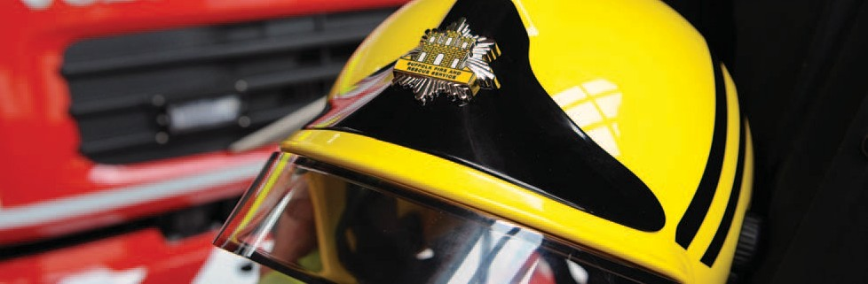

Do you use a skin cream, ointment, lotion, gel, spray, bath oil or soap substitute (sometimes called emollients)? They are used to manage dry skin conditions such as eczema, psoriasis, and ichthyosis.

In the presence of an ignition source, fabric with emollient dried on can catch fire more quickly and burn hotter than clean fabric. This can cause severe burns and even death.

Emollients can transfer from your skin onto clothing, bedding, and bandages. Some dressings and bandages may come with ointment already on them.

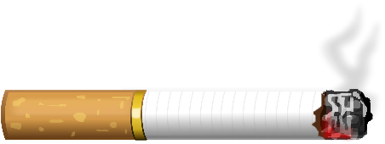

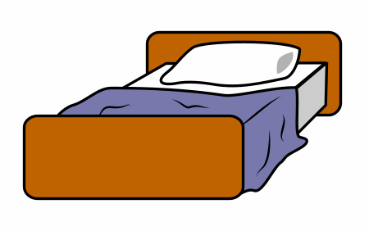

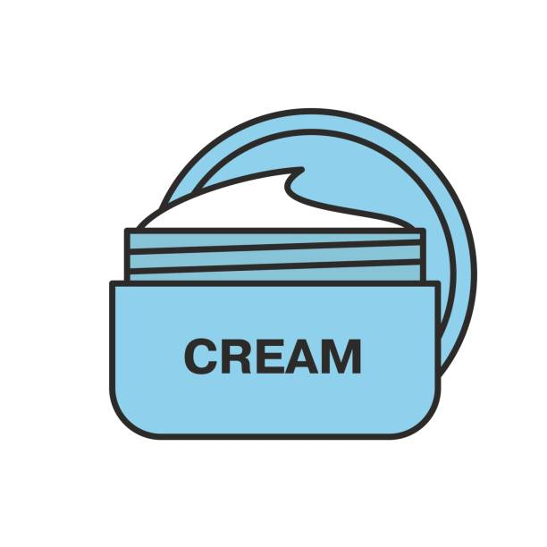

Creams are important in managing different skin conditions.

You should continue to use your skin products as directed by your Doctor, nurse, or pharmacist.

However, it is important that you are aware of the potential danger and know how to keep safe when using these products. 

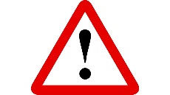

**Stay away from naked flames and heat sources when using these products.**

**Suffolk Fire and Rescue Service Endeavour House, Russell Road, Ipswich, IP1 2BX**

**Tel: 01473 260588**

**Email: fire.businesssupport@suffolk.gov.uk**

Take care the cream does not dry onto cushions, soft furnishings, and bedding. If it does, use uncontaminated throws/covers on your seating and wash your bedding frequently as above.

Change and wash your clothes frequently (preferably daily). Washing your clothes at the highest temperature recommended by the manufacturer might reduce the build-up of emollient on them but does not remove it completely and the danger may remain.

Tell your doctor, nurse, or pharmacist if you normally smoke. They will be able to offer you help and advice to stop smoking.

Please speak to your doctor, nurse, or pharmacist if you have any questions about the information in this leaflet.

Tell your relatives or carers about your treatment and show them this leaflet. Those who care for you can help to keep you safe.

A video containing this information can be viewed by clicking on the link below:

<https://www.youtube.com/watch?v=GAv7RTjDClU&feature=youtu.be&cc_load_policy=1>

Do not smoke, cook, or go near to any naked flames or heat sources such as gas, halogen, electric bar, or open fires whilst wearing clothing or dressings that have been in contact with emollient-treated skin. If this is not possible, take steps to reduce the risk; e.g., use a safety lighter or e-cigarette, remove long sleeved or loose clothing before cooking, put a thick uncontaminated shirt, overall or apron over your clothes and move your chair further away from the open fire or other heat source.

Keeping Safe