SCC ICT

Setting up promotion mapping for the new academic year

Step by step user guide for schools

Author : Chris Skeet
Authorised by : Lizzie Winter

Version : 1.b
Date : 12/04/2022

Table of Contents
Page

1 Introduction 3
1.1 Purpose: 3
1.2 Assumptions and Constraints: 3
2 PROCESS 3
2.1 Promotion 3
2.2 Promotion Mapping 4
2.3 Promote pastoral groups. 6
2.4 Printing class (registration group) lists 7

Introduction

Purpose:

Procedure document for setting up the promotion mapping for the academic year in SIMS.net

Assumptions and Constraints:

This guide needs to be used in conjunction with Capita’s Detailed End of Year Procedure Guide which can be found on the Suffolk County Council Schools IT Website via https://www.suffolk.gov.uk/business/it-services-for-schools-and-academies/schools-information-management-system/#faqs

PROCESS

Promotion

Log into SIMS.net.
Go to Routines | School | Promotion.
You will see the following pop-up.

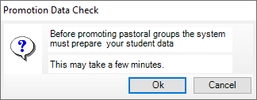

Click on OK to continue.

SIMS will run through the Validate Memberships routine again, this should only take a few seconds to complete as you finished off creating the new academic year by running this routine.

When validate memberships has finished running you will get the promotion mapping screen.

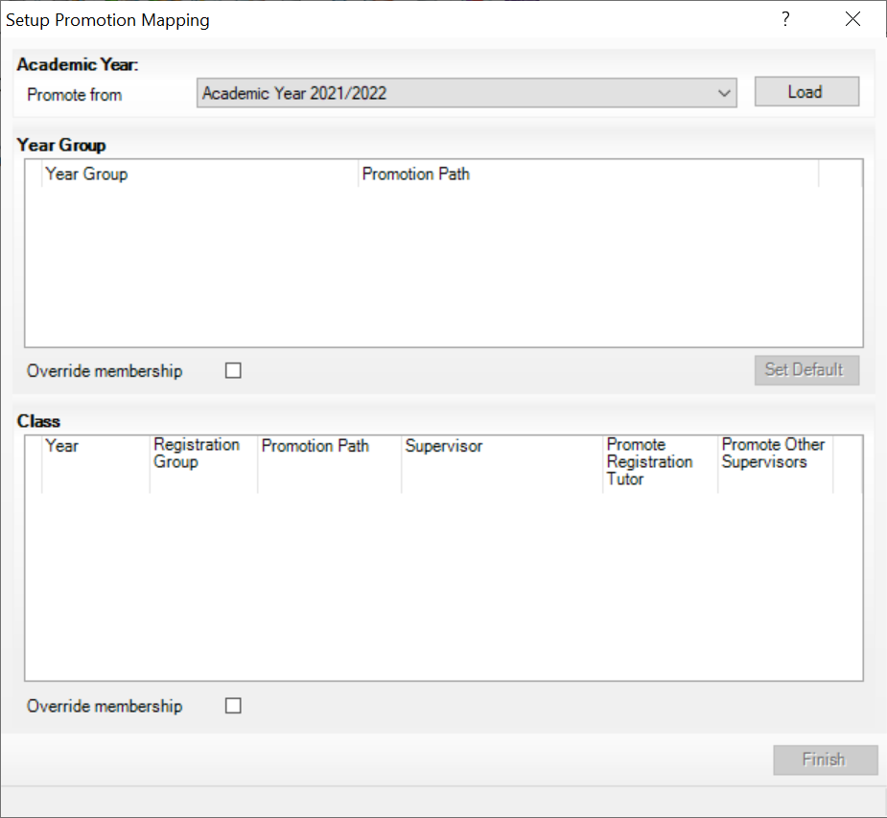

The Promote From should already have the current academic year selected, if it doesn’t say Academic Year 2021/2022 click to change the year.

Click on Load.

Promotion Mapping

The screen shows the promotion paths for the year groups and the classes based on how your pastoral structure is currently setup.

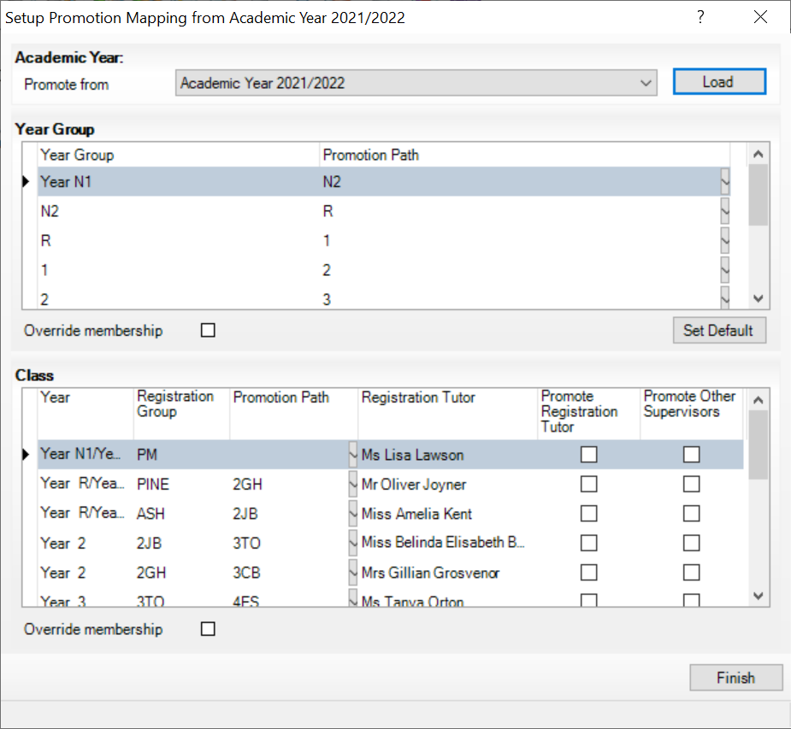

Check you are happy with the promotion path for year groups eg. Year N1 promotes to Year N2, Year N2 promotes to Year R. Tick Override membership

In the screenshot above, the classes do not have a promotion path, this is due to the pastoral structure setup. If all the pupils from one registration class are all being promoted to the same registration group in the next academic year, I can select the correct class under Promotion Path.

If the teacher is staying with the class they currently teach in the next academic year, you can choose to promote them with the class by ticking Promote Registration Tutor.

The same goes for other supervisors linked to a class,

When you are happy with the promotion paths under the classes, tick Override memberships.

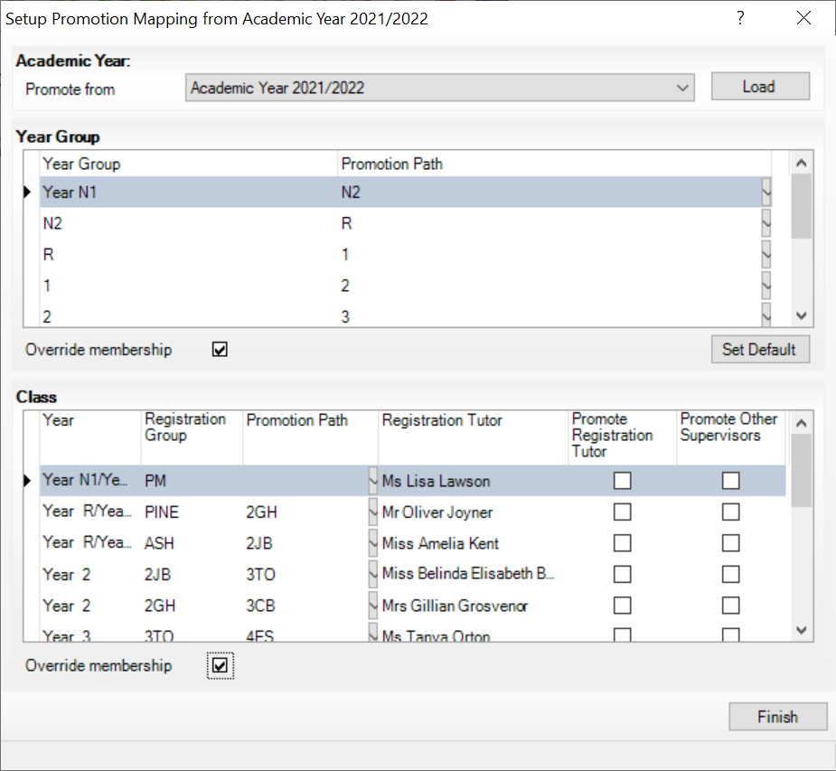

You only need to tick override memberships the first time you are running the promotion mapping, if you need to go back through this process do not tick override memberships under either area.

Click on Finish.

Promote pastoral groups.

You will see the following screen.

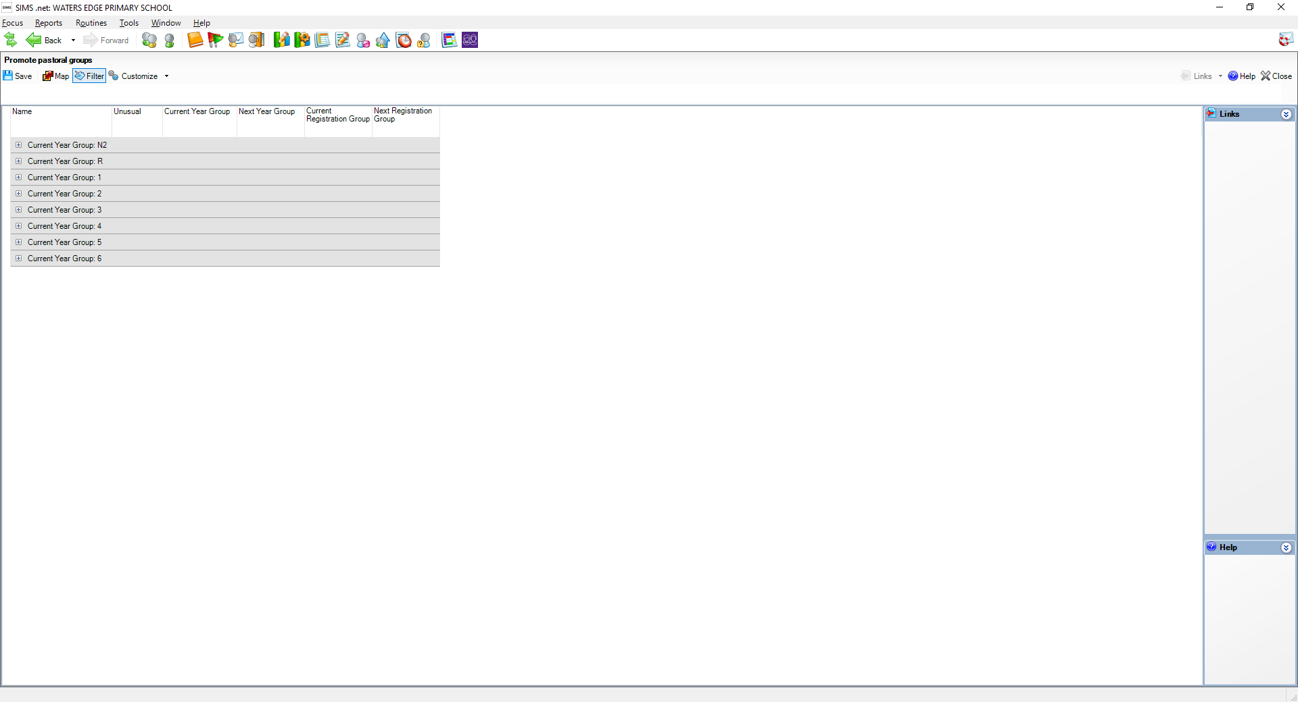

This screen shows the current year groups, click on the + next to each year group to expand and view more details.

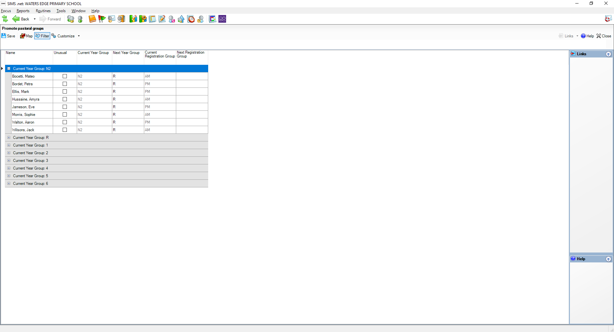

Check the Next Year Group and Next Registration Group is populated for all pupils.

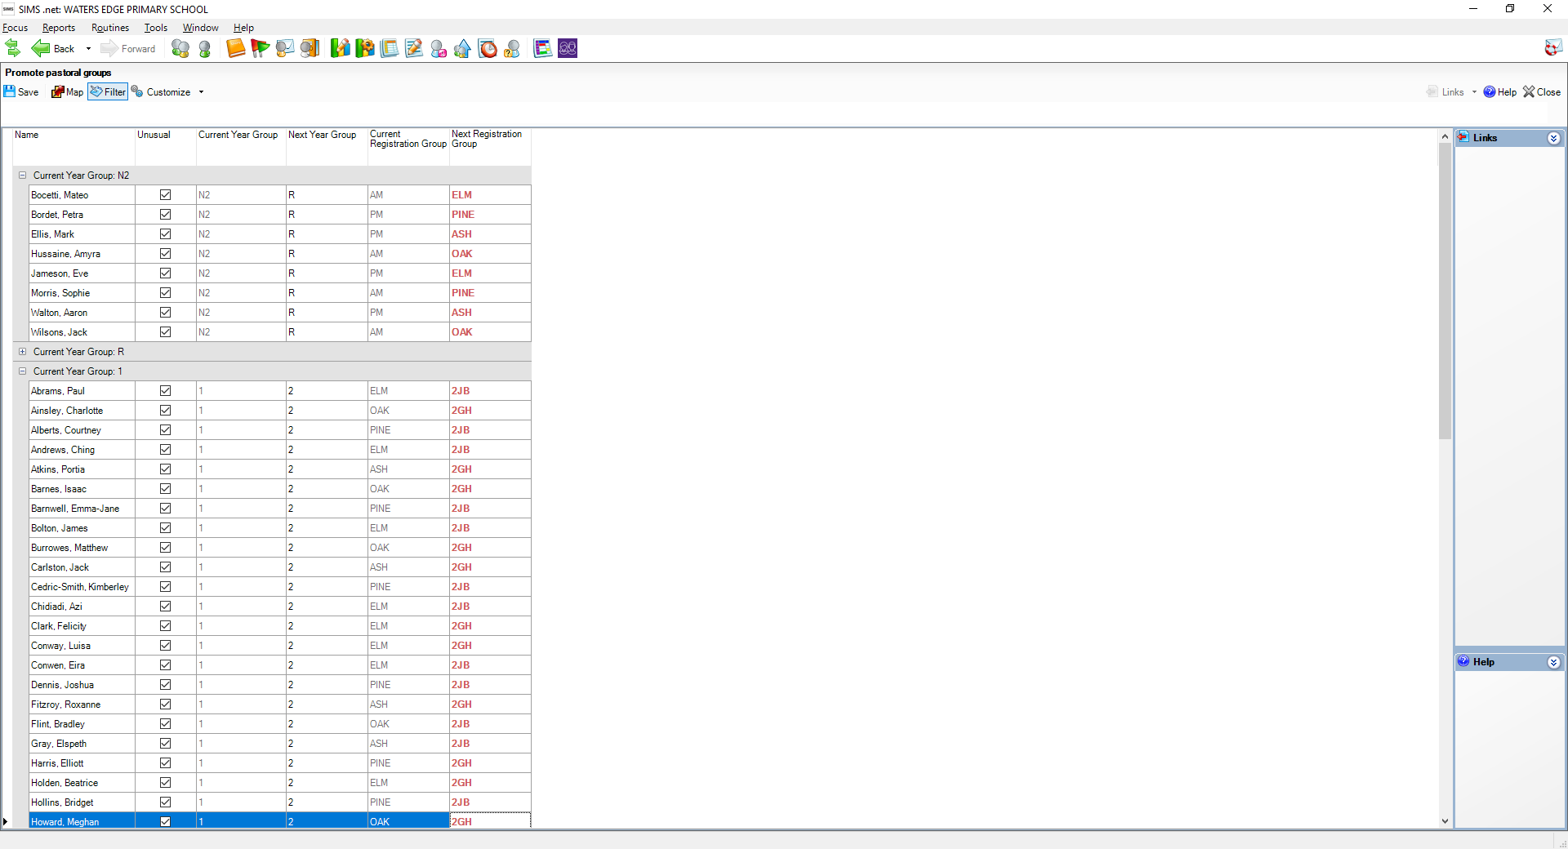

When you are happy with the promotion paths for all pupils, click on Save.

If there are any pupil who are moving to an unusual class (what is on the original promotion path details), you will receive the following pop-up.

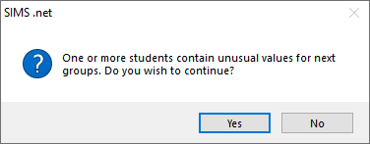

Click on Yes to continue.

You can close the screen.

If you need to make any further amendments to the promotion mapping you can go through the process again, just remember not to tick override memberships on the promotion screen.

Printing class (registration group) lists

Select Reports | Run Report to display the report browser.

Click on the + next to Focus.

Highlight the Student folder.

The reports are in alphabetical order, you need to scroll down to find the report called Registration Group (Dated).

Double click to run the report.

You will see a pop-up asking you to define the parameter values.

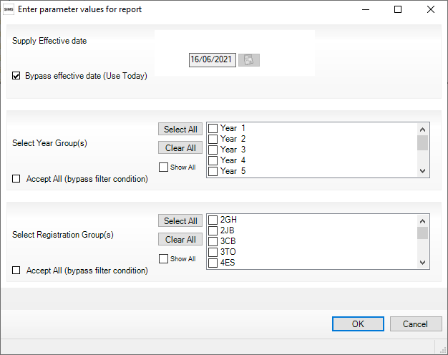

Untick the Bypass effective date (use today) and change the date to the first day of the next academic year, eg. 01/09/2022.

Select the Year Groups and Classes you wish to run the report for, if you want to run the report for the whole school you can tick Accept All (bypass filter condition) in both these areas.

Press OK to run the report.

The report should look like the screen shot below.

If you have not yet accepted your new reception applicants they will not appear, and if you have not yet made your current year 6 pupils leavers, they will appear with no class.

