



If your household or business has accessed the fire and rescue service via an emergency call, your personal information will be shared with the Home Office for research and statistical purposes.

Fire and rescue service

Incident Recording System

Information for individuals

HOW ARE WE USING YOUR INFORMATION?

HOW IS THIS INFORMATION PROVIDED?

The information is provided via the IRS (Incident Recording System), a website managed by the Home Office. It collects information on the incidents attended by FRSs, for example fires, false alarms, road traffic collisions. Some of this information is personal and sensitive so the HO is responsible for ensuring that all data is processed in line with Data Protection legislation.

WHY ARE WE SHARING THIS INFORMATION

HOW DOES THIS AFFECT YOU?

Information collected via the IRS is shared with other Government Departments and academics. Data are only shared for research and statistical purposes, with data sharing agreements in place for personal data to ensure the data share complies with data privacy legislation.

It will not affect the service that you get. The information shared is handled with care in accordance with the law. We are collecting and sharing your information to help us understand better the role and demand on the fire and rescue services and inform fire policy and future service provision.

Privacy Notice for individuals who have accessed

fire and rescue services (FRSs)



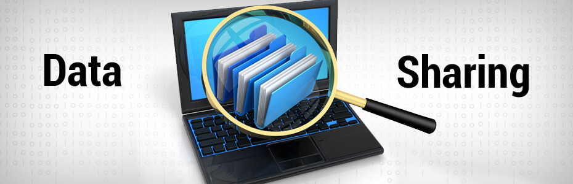

IRS Data are collected by fire and rescue services on behalf of the Home Office (HO) for research and statistical purposes only. Fire and rescue services do not require the consent of individuals to provide the information but individuals have the right to know how and for what purpose the data are being collected, held and used. The processing must have a lawful basis which, in this case, is that the processing is necessary for the performance of a task carried out in the public interest to meet a function of the Crown, a Minister of the Crown or a government department.

Your personal information will be held and processed by the Home Office based at 2 Marsham Street, London SW1P 4DF. The Home Office is the joint controller of this information along with fire and rescue services.

You have the right to object to and restrict the use of your personal information, or to ask to have your data deleted, or corrected. You also have the right to obtain confirmation that your data are being processed, and to access your personal data. Contact details are given below.

The information collected via IRS relates to the incident attended by a fire and rescue service. Some of the information may have been provided by you at the time of the incident. Personal data collected will be held for research and statistical purposes for up to 70 years. When no longer needed, data will be destroyed in a safe manner.

We are aware that some of the data collected are particularly sensitive: for example names and addresses and ethnic group of victims of fires and non-fire incidents. Please rest assured that all the information collected via IRS is treated in accordance with Data Protection requirements and guidelines.

Data are published by HO in aggregate form on a quarterly and annual basis as part of a schedule of routine reports and complementary tables. To access the publications please visit <https://www.gov.uk/government/collections/fire-statistics>

IRS data are shared with other public sector bodies for research and statistical purposes only. For example, data are shared with the Forestry Commission to allow them to pinpoint wildfires in their role for formulating policies to deal with them. More information on whom we share personal data with can be found on our website here: <https://www.gov.uk/government/collections/fire-statistics>

If you require more information on how your personal information is being processed, please email us at [firestatistics@homeoffice.gsi.gov.uk](mailto:firestatistics@homeoffice.gsi.gov.uk)

If you are unhappy with how any aspect of this privacy notice, or how your personal information is being processed, you have the right to lodge a complaint with the Information Commissioner’s Office (ICO): <https://ico.org.uk/concerns/>

Last updated 11.5.18

IF YOU WANT TO KNOW MORE…