

Reward System Information Sheet

Reward Systems can be used for:

- Encouraging good behaviour
- Rewarding good behaviour

The system can be used to stop a particular behaviour by rewarding an appropriate behaviour and can be used alongside a specific programme such as a healthy eating plan or household rules.

The system should be specific to the young person and clear expectations need to be recorded. Decide what behaviour is going to be worked on first – if possible, work on a behaviour where the outcome is achievable the quickest.

The behaviour expectations must be kept to. The reward will only be given when the desirable behaviour is shown.

The system can be made up from photographs, symbols or objects, e.g. marble jar, words or a combination of these. It can be in a number of formats including chart, book, and puzzle, using the interest of the child as a motivator. The chart should be discussed and agreed with the young person. The chart can be divided into periods of time, times of the day, days of the week or specific behaviours.

Recording on the chart can be by words or symbols such as ticks, stars, stickers or smiley faces or could be in puzzle format where a piece of a puzzle is earned and the young person gets the reward when the whole puzzle is complete. If possible, include the young person when creating it.

The recording or token/puzzle piece should be given immediately after the desirable behaviour is shown. A reward should be agreed in advance and recorded.

The chart should be used solely with positive reinforcement to shape the behaviour. No coaxing, nagging or bribery should be used.

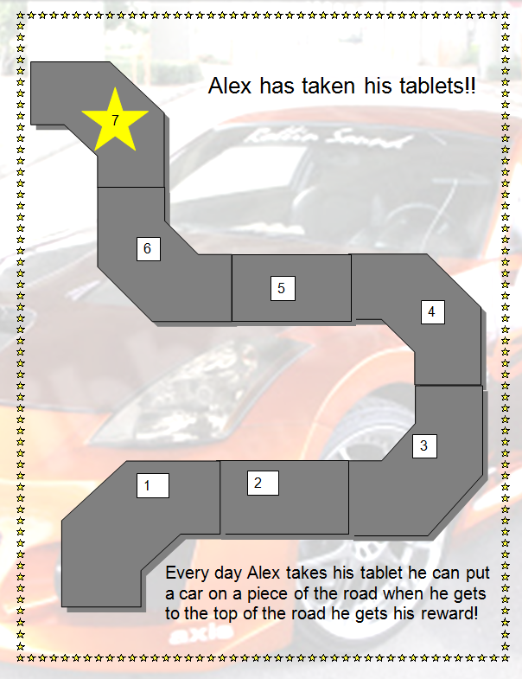
Example reward system:

