Keeping Safe: Home Safety Tool - Part A

Universal – to be commenced/completed with all families at either the antenatal, 6–8-week review or during the transfer-in visit

Date completed:
By whom:
Who else is present:

Children under 5 years old are at highest risk of unintentional injuries in the home. Falls, choking, scalds, burns and poisoning from medicines are the top 5 causes of unintentional injuries in Suffolk.

General Safety Questions

Question | Picture | Yes | No | Action Plan
Do you have at least one smoke alarm fitted and in working order?
If you close your internal doors at night, they will hold back a fire for 15-20 minutes, giving you valuable escape time

Are all lighters and matches safely out of reach of children or in a locked cupboard?  Ensure candles and other naked flames are well out of reach. | 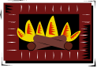
Are window cords/pulls kept out of reach?  Toddlers love to climb. They can suffocate in as little as 20 seconds | 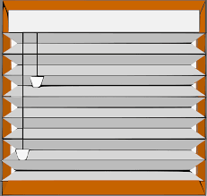
Are cables and leads, mobile phone chargers tidy and out of reach/sight and sockets not overloaded/broken?

Electrical Fire Safety

Have you got a method in place to stop your child falling down the stairs or from balconies? If you have stair gates in place, are they securely and correctly fitted as per the manufacturing instructions?
Are hallways/stairs uncluttered?

Is your child protected from touching fires, radiators, heaters, ovens and hair straighteners?
Should a fire occur, have you discussed your escape plans as a family?

What to do if there is a fire in your home

Do you have a carbon monoxide monitor?  Stay Safe from Carbon Monoxide | 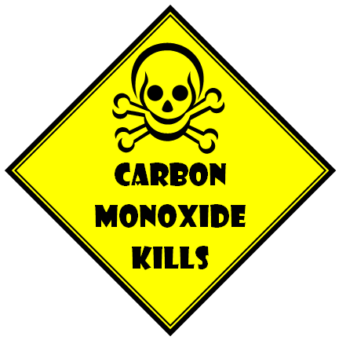
Are children supervised near paddling pools, ponds, full bathtubs or open buckets/tubs of water?  Tip: a child can drown in just one inch of water.  Never leave your child unattended in their bath.  If you have an indoor swimming pool is it secured by a locked door that your child can not access?  If you have an outdoor swimming pool is it securely separated from the main garden by a lockable fence/gate that your child can not access?  Tip: your child must always be supervised when around water.  Water Safety at Home | 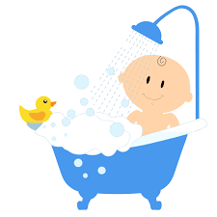  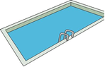
Have you checked that your child cannot fall out of windows or over balconies?
If you have window locks, ensure they are used, and the key kept in a safe place in case of emergencies. Have you ensured your child cannot get out of the home unattended?

Safe sleeping – remove toys from cots. Electronic devices/chargers are kept away from furniture and bedding. Bunkbeds are not advised for under 6-year-olds.  Safer Sleep Advice | 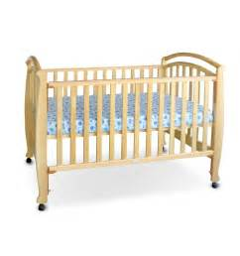
Are all medications, chemicals and e-cigarette refills locked away or out of the reach of children?
Painkillers kept in handbags and bedside cabinets are the most common way for children to be poisoned

Are all detergents, dishwasher tablets, laundry capsules kept out of reach from children? Keep them up, keep them closed, keep them safe.

Are all plastic bags, nappy sacks out of reach?  Babies develop grasp reflex in the first few weeks of life and the hand to mouth reflex means they could grab a nappy sack and get it to their mouth easily | 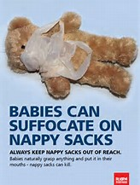
Are all sharp objects, scissors/knives out of the reach of children?
Consider use of cupboard/drawer locks

Is all top-heavy furniture, e.g. bookshelves/ovens/televisions secured to wall or floor?
Some children are prone to climbing and will not be aware of the dangers this could cause.

Is your child protected from all animals/pets? Is their urine/faeces cleaned up promptly?  Tip: Animals should never be left alone with any child unattended. | 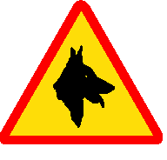
Are small items, e.g. buttons, coins, small toys, e-cigarette refills, button batteries, etc. out of the reach from a child?  If you child swallows a button battery – Act fast  Button Batteries | 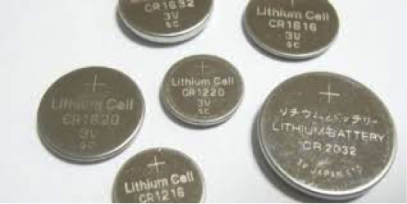
Do you make sure your child is never left unsupervised?

Do you have an appropriate car seat for your child’s weight? Never place a baby seat/chair on raised surfaces.

Child Car Seats: The Law

Do you have a high chair? Does it have a 5-point harness?
Tip: ‘batons not balls’ for babies – chop up foods such as grapes. Avoid prop feeding with bottles

Are hot drinks kept away and out of the reach of children?
Do you run the cold water first in the bath?
Tip: did you know that a hot drink can still severely scald a child, 20 minutes after making.

Do you have plants that could be poisonous?
Teach your child not to eat anything they pick in the garden, park, etc.

For further information and advice please go to:

Child Accident Prevention Trust website

The Royal Society for the Prevention of Accidents

Fire Safety in the Home

Evacuation Route: make sure that everyone in the home, including small children, knows the best way out in case of emergency. Always keep hallways and doorways free of clutter and easily accessible.

Home Safety Packs can be purchased from most major suppliers of baby equipment

Please share this information with any person who may also look after your child.

Is there any indication for a more in-depth assessment?
If yes: please use Part B of the Safety Audit Tool.

References

Public Health England. 2017. Preventing unintentional injuries: A guide for all staff working with children under five years.

