How to find Census Guidance on your SIMS Documentation

Go to your SIMS home page and click on Documentation
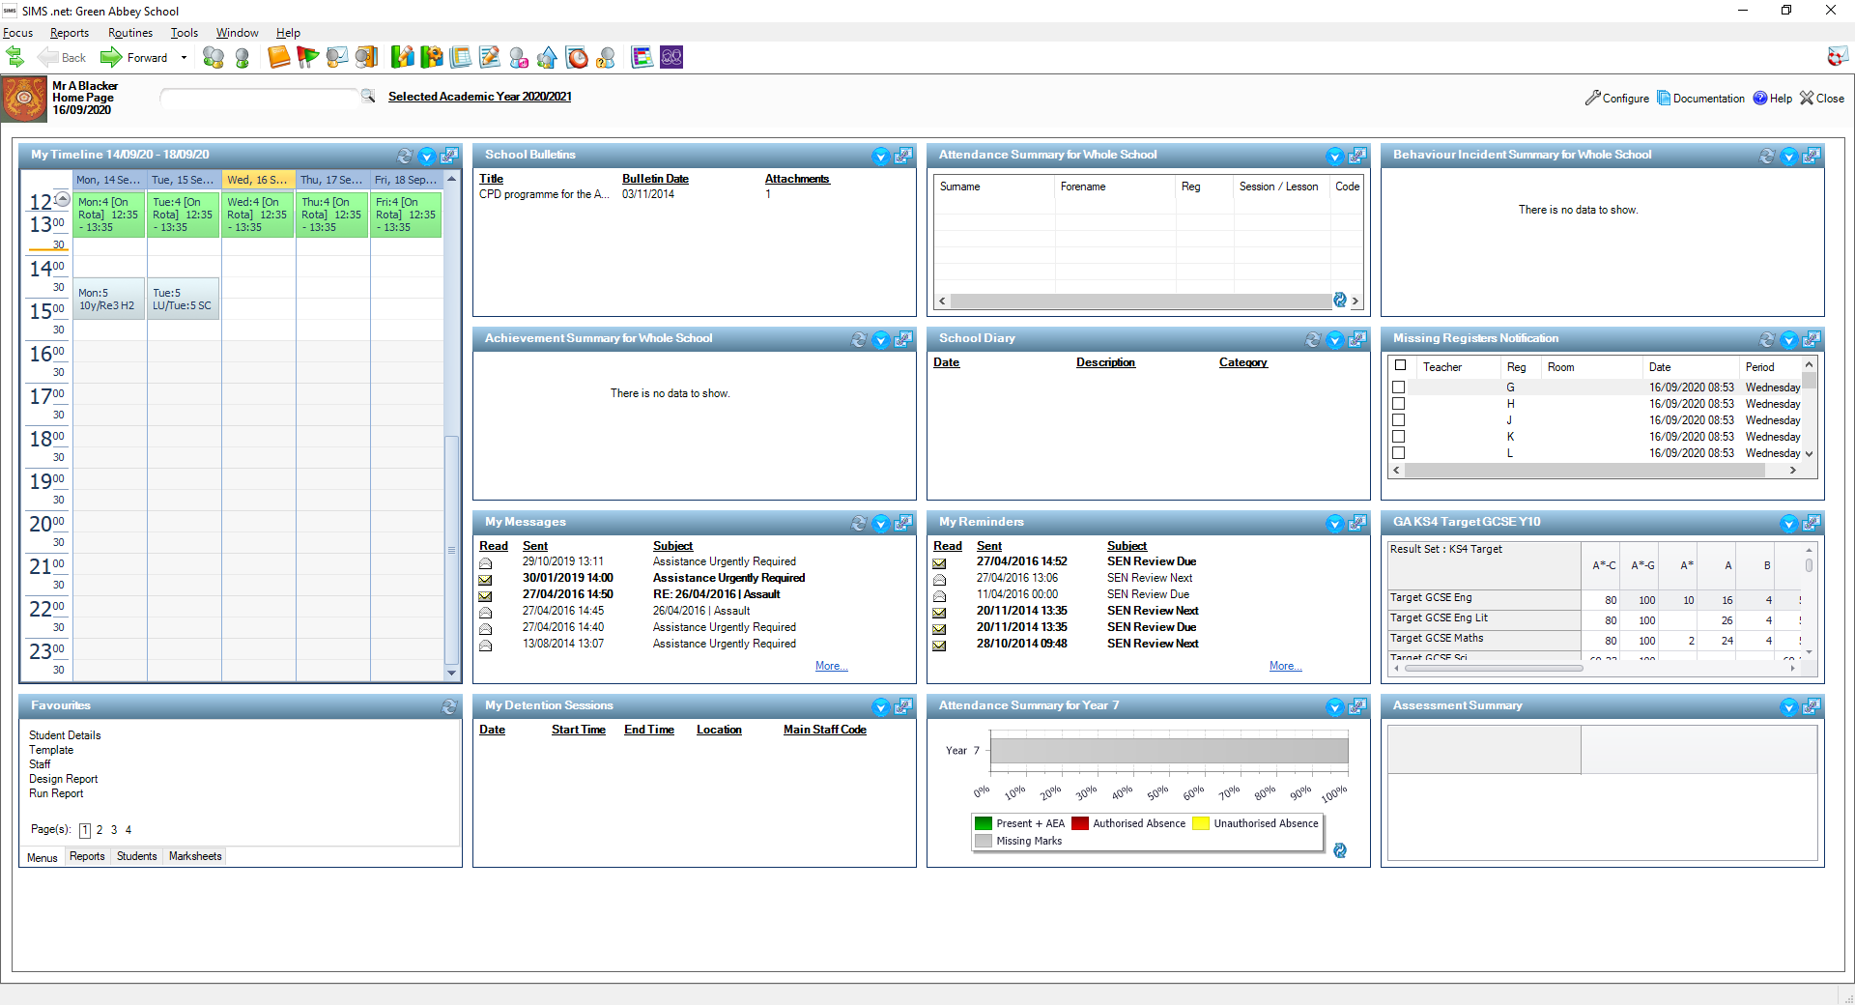
Click on Returns Manager
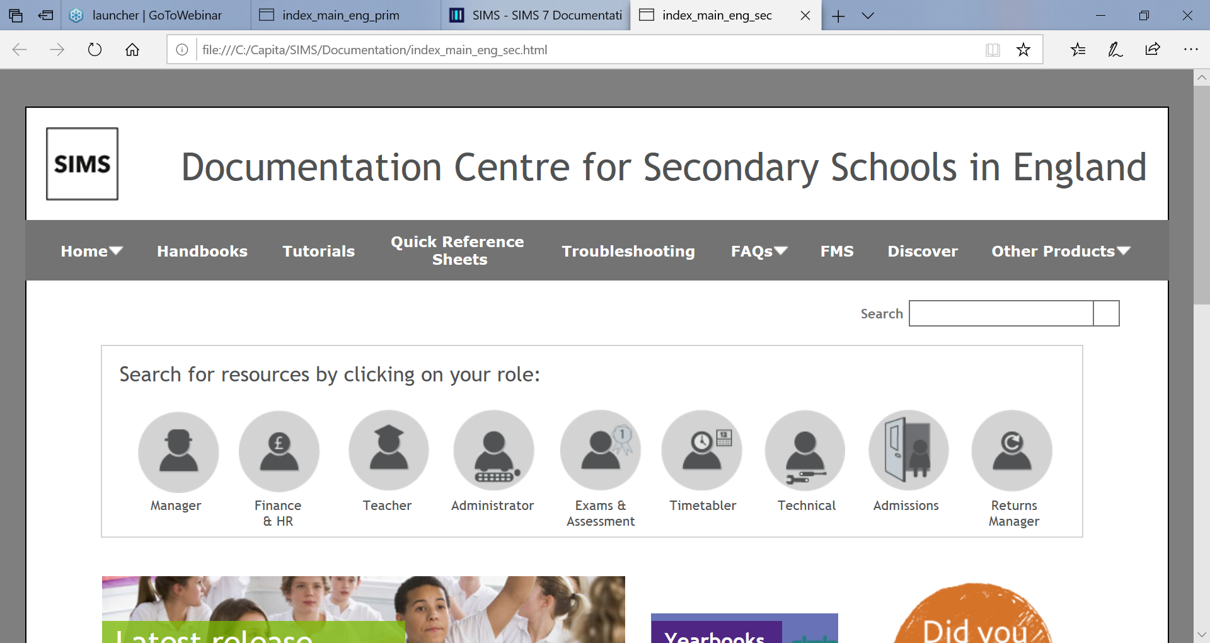

Click on Returns Manager again
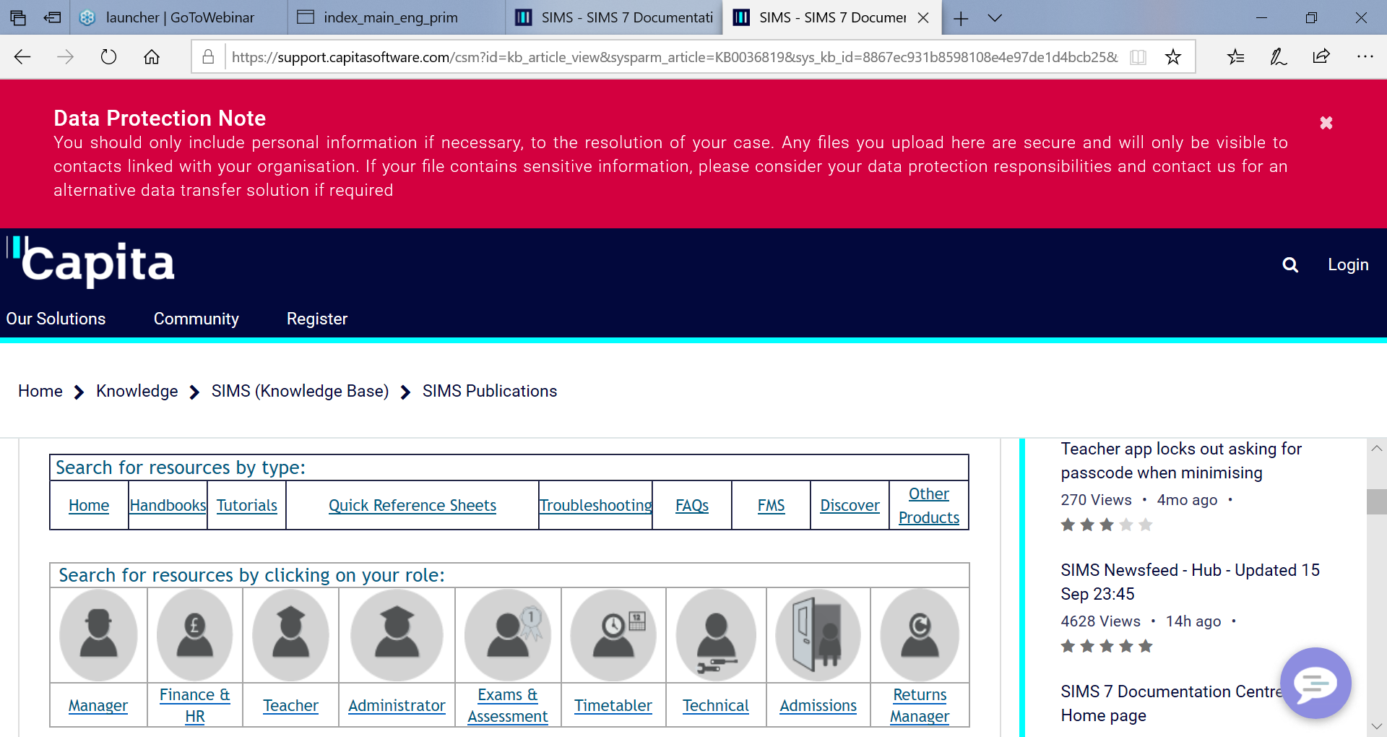

Then scroll down to the England section which is currently being updated to show Autumn Census guidance documentation
Click on the guidance appropriate to your establishment needs.

Click to download the PDF. You will then be able to open the PDF
