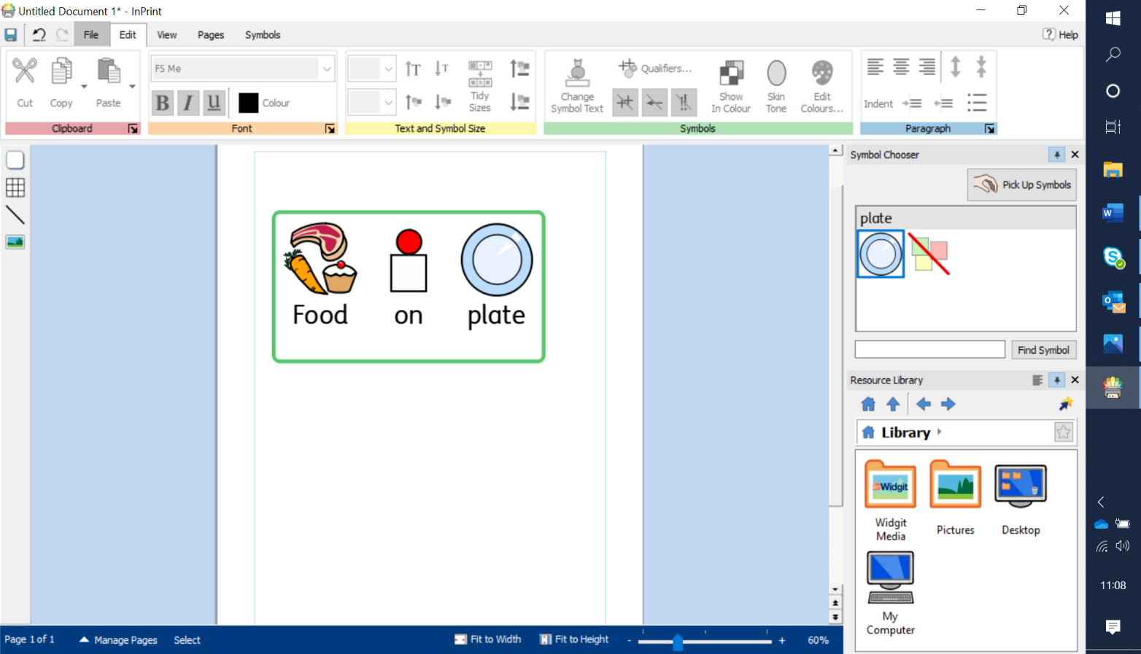

1. Tolerate it on the plate, just look at it. You can start with it far away on the plate and move it closer.
2. Touch the food
3. Smell it
4. Lick it
5. Nibble it
6. Eat it

Never introduce new foods at a “typical mealtime”. If you are introducing a new food, do it in isolation on a plate and target it at non mealtimes.

Systematically work through these stages completing and reinforcing every step. Only once your child has successfully completed each step can a food be moved to their dinner plate during mealtimes.

**Food Desensitisation**

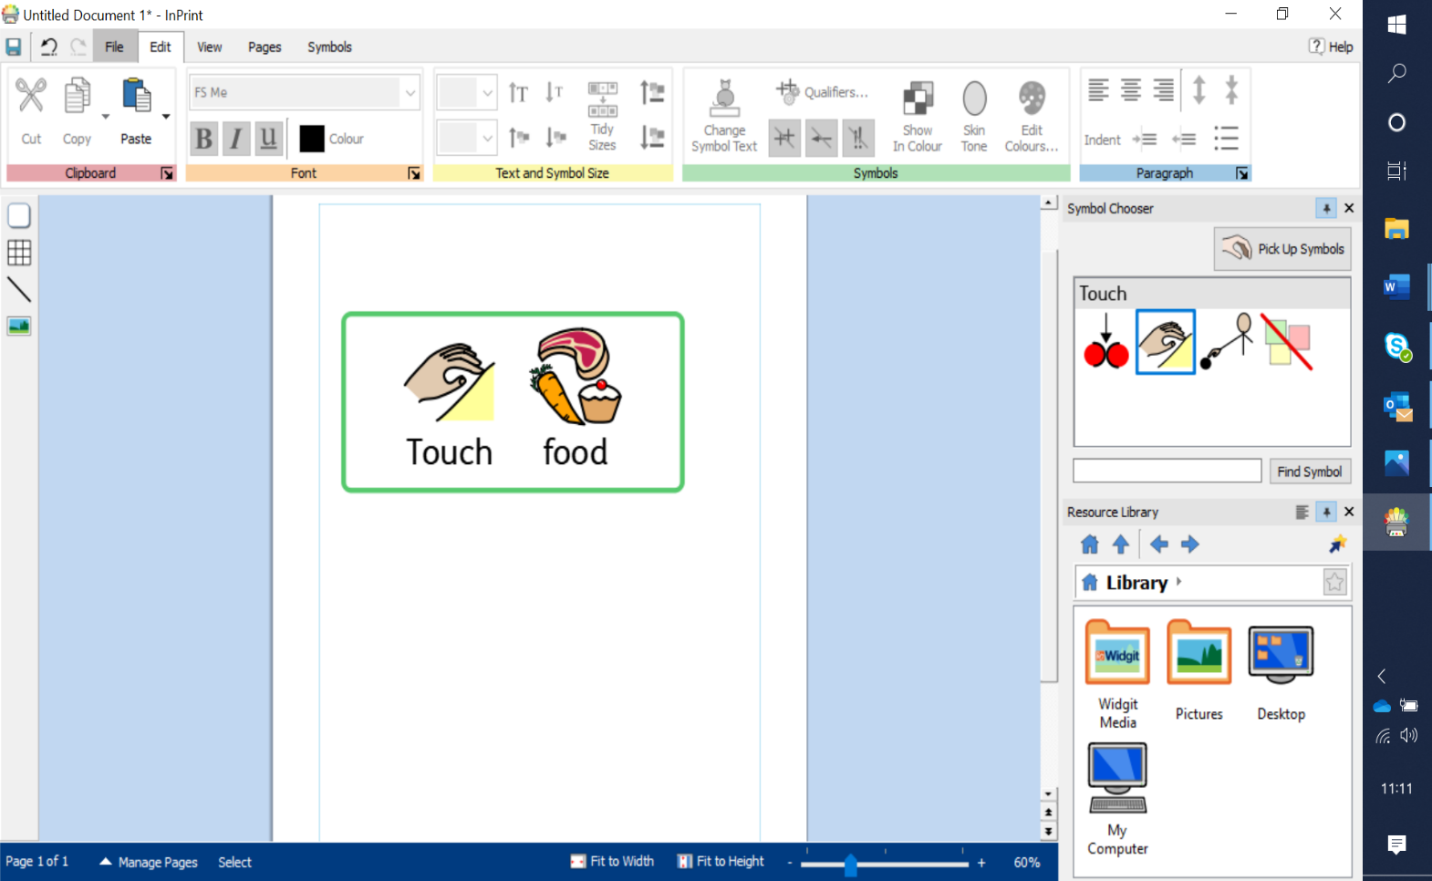

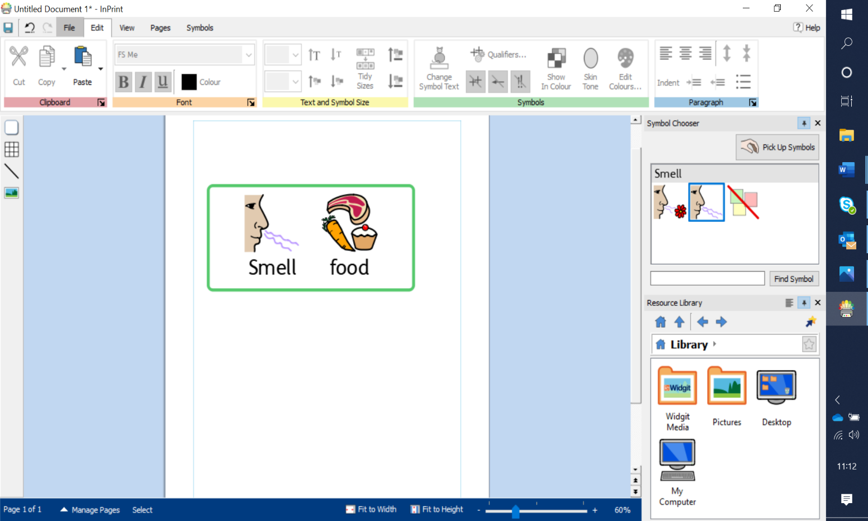

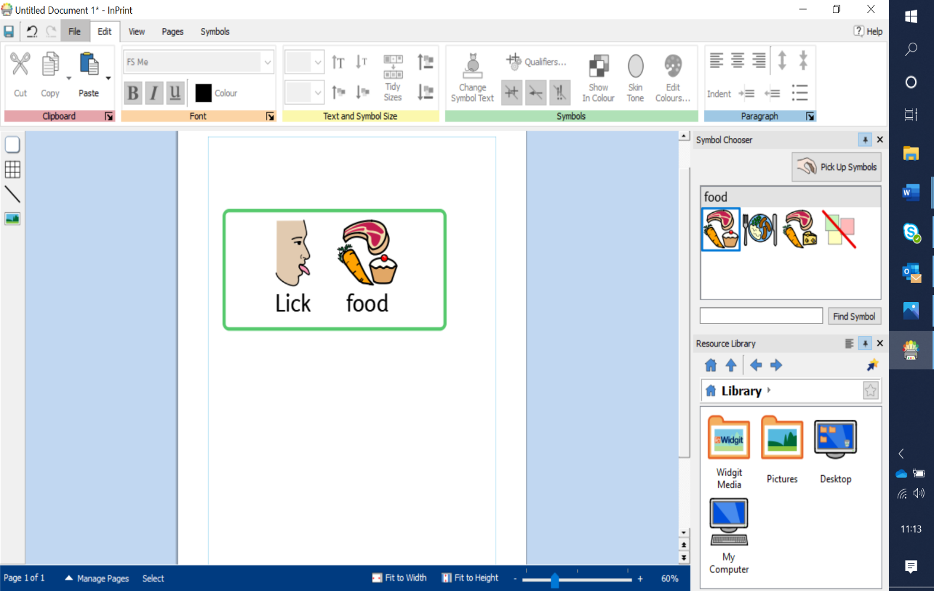

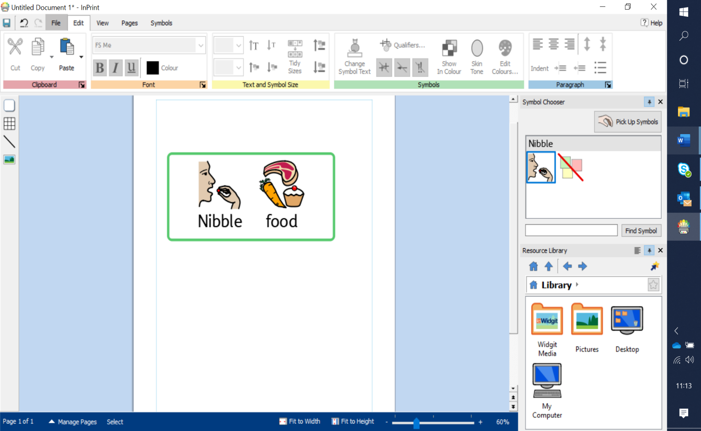

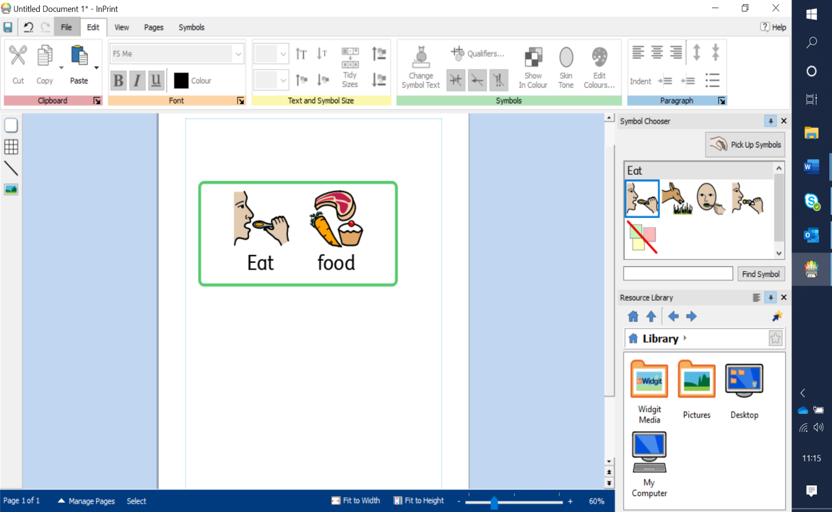

You may find some foods move through steps 1-6 quick others may remain at step 3 for a few days or even weeks. Ensure you use reinforcement. E.g first/then. First lick, then a balloon etc.  Try to target this at least once per day, more if you can.

