Please tick  under the correct face
= not good = good = very good
Question: |  |  |  | N/A
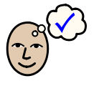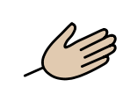
My nurse /support worker knew what I needed help with
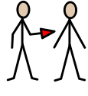
The help and support I got was

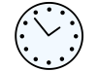
My sessions were

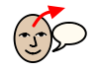
My nurse /support worker was kind and explained things

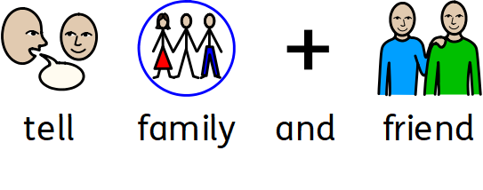
Would you tell your family and friends to use us?
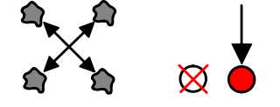
Anything else you would like to add?

