SCC ICT

General overview of the Pastoral Structure

Step by step user guide for schools

Author : Chris Skeet
Authorised by : Lizzie Winter

Version : 1.b
Date : 12/04/2022

Table of Contents
Page

1 Introduction 3
1.1 Purpose: 3
1.2 Assumptions and Constraints: 3
2 PROCESS 3
2.1 Pastoral Structure 3
2.2 Changing a class name 5
2.3 Adding a new year group 6
2.4 Adding a vertical structure 9
2.5 Creating a horizontal structure 11

Introduction

Purpose:

Procedure document for checking and updating the pastoral structure in SIMS.net

Assumptions and Constraints:

This guide needs to be used in conjunction with your ESS Detailed End of Year Procedure Guide which can be found on the Suffolk County Council Schools IT Website via https://www.suffolk.gov.uk/business/it-services-for-schools-and-academies/schools-information-management-system/#faqs

PROCESS

Pastoral Structure

First make sure you have created your academic year, the pastoral structure is copied from the current academic year.

Go to Focus | School | Pastoral Structure | Next Academic Year Structure.

The effective date will automatically default to the first day of the new academic year, click on Go.

You will need to click on the + next to Pastoral Structure to view more details.

In the screenshot below we have a mixed structure.

Year 2, Year 3, Year 4, Year 5 and Year 6 are what is known as a Horizontal Structure, eg. Pupils in these year groups are taught with only pupils who are in the same year taught in.

YearN1/Year N2 and Year R/Year 1 is what is known as a Vertical Structure, eg. Pupils in these year groups are mixed in classes together.

If you click on the + next to a year group in a horizontal structure you will see Head of Year, Supervisors and Registration Groups.

If you click on the + next to a vertical group you will see the years that are in the group, you need to click on the + next to the individual years to see the Head of Year and Supervisors.

You can add new Heads of Year and Supervisors by right clicking on them and then clicking New and then selecting the required person, or you can change these by Right clicking on the Head of Year or Supervisor and choose properties, then use the magnifying glass to select new person.

You can see what Registration Groups are assigned to each year by clicking the + next to the registration group folder.

Changing a class name

It is important to note that if you need to change an existing class name NEVER just edit the name and change it from there within the Pastoral Structure. This is because the history of the class will change, so if a class is changing name and you edit the existing class to the new name, all pupils who have been in the existing class will have their history altered to whatever the new name is.
Always add a new class and then remove the old one.
Right Click on the Registration Group folder and choose add new Registration Group.

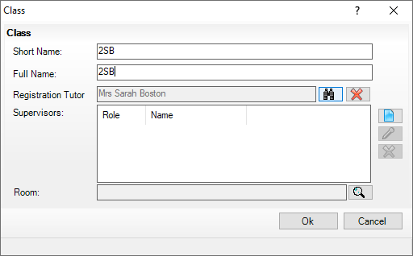

Enter the Short Name, Full Name and Registration Tutor details, click on OK.

The new class will now be visible in the pastoral structure and you can delete the old class if necessary by right-clicking on the name of the class and selecting Remove.

You will receive the following pop-up, click on OK to continue.

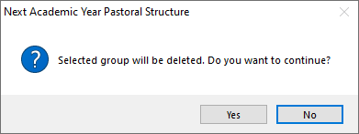

If a class has been used historically this registration group can be re used. Right Click on Registration Group folder and choose Reuse old Registration Group. It’ll give you an option to select any historic classes from this group.

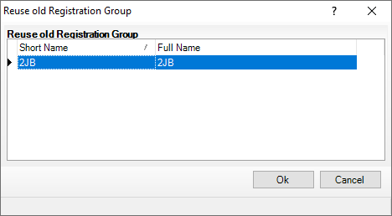

Select the class you wish to reuse and click on OK.

Adding a new year group

If you need to add a New Year group to your Pastoral Structure, please remember you must also add at least 1 Registration Group (class). If you do not do this, you will get an Invalid structure message when you try to save it.

Right Click on National Curriculum Year Taught in and select Set up National Curriculum Years to check the Curriculum year is available.

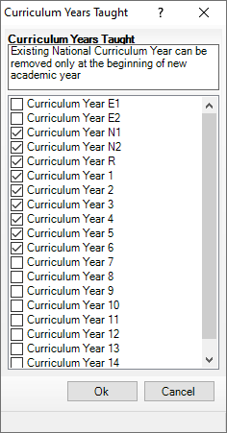

Tick the Curriculum Year you wish to add and click on OK.

You’ll see the following message at the bottom of the screen.

Now right-click on Pastoral Structure and select New Year Group.

Select the National Curriculum Year that you have just added, give it a Short Name, Full Name and Head of year (if applicable) and click on OK to save.
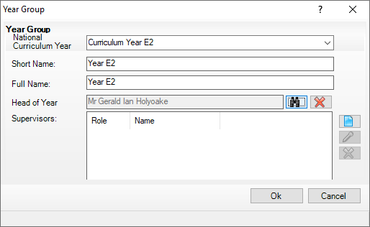

You will see the error at the bottom of the page has changed to.

Now find the new year group in your pastoral structure and click on the + to view more details.

Right-click on Registration Group and choose New Registration Group.

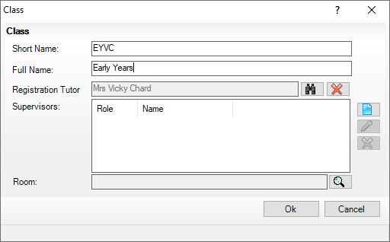

Complete the Short Name, Full Name and Registration Tutor, click on OK to save.

The details will show at the top of the new structure, you can easily move positions of the group by using the Up and Down buttons (next to Save).

Adding a vertical structure

This may be required if two or more year groups will be taught in mixed classes.

Right-click on Pastoral Structure and choose Organise Year Group Vertically.

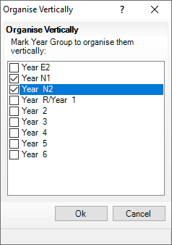

Tick the year groups you wish to mix and click on OK.

You will notice now that your chosen years are going across your screen with a folder beside them as shown below.

If you expand that folder by clicking on the + and then go to the Registration Group and click the + beside that you will notice all the classes that cover those different year groups. You can view the members of those year groups by right clicking on the Registration Group folder and choosing members. You will be able to move the children around easily from here by ticking the class they should be in.

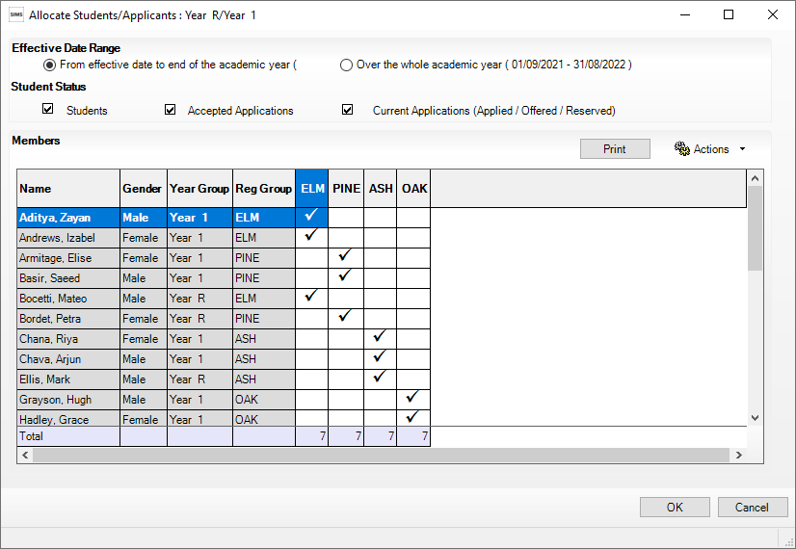

Creating a horizontal structure

You may decide that you need to make some of the vertical year groups horizontal. To do this all the structure will need to be made horizontal to start with.

Right click on your Vertical Structure and choose Organise Horizontally. You will see the below screen.

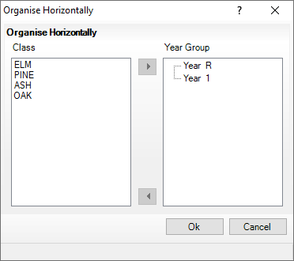

Each Class will need to be moved over to the Year group pane. Highlight the Class and Year Group then use the top arrow to move the selected Class to the selected Year group. You need to do this until the Class pane is empty.

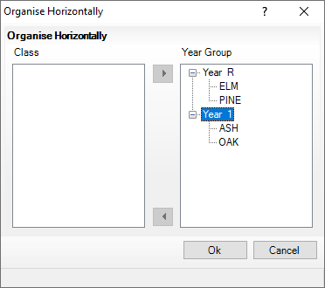

Click OK to continue. Your structure will now show the year groups on their own in a Horizontal Structure.

Don’t forget to save your changes.

