This application form is for: Road Closures, Width/Height/Weight/Length Restrictions, One Way, Banned Turn, Restricted Access, Speed Limit and Parking or Loading Restrictions.

Please Send Your Applications to:

Email  na.applications@suffolk.gov.uk  POSTAL  Please be aware that Suffolk County Council is no longer accepting postal applications. | Planned Works Fee  - Fee (payable in advance): £1,560.00  - Amendment fee: £450.00  - Change of dates (start and/or end)  - Each additional extension (within 18-month window)  - Each additional works phase (within 18-month window)  Immediate Works Fee  - Notice fee: £850.00  - Duration for up to 21 days  - Additional duration fee: £450.00  - If the immediate duration is anticipated to be for longer than 42 days, then an order will be required in addition to these fees at cost of £1,560.00 – please contact Network Assurance.

Do the works:
- Affect the A11, A47, A14, A12?
  - Please visit Trunk roads maintained by Highways England webpage for more information.
  - You must contact Highways England (details below) before applying

- Affect roads in Essex, Cambridge, and/or Norfolk?
  - You must contact the relevant Local Highway Authority before applying.

Suffolk County Council will not process your application without written confirmation that you have permission to use roads managed by other bodies.

Highways England Contact Details
East Region Road Space Booking | EastRegionRoadspace@highwaysengland.co.uk

For non-immediate works, please check https://one.network for the dates you require to avoid disappointment, as these works possibly could be classed as Major Works and may require minimum of 3 months in advance as outlined in legislation.

Application
- Applications for Planned works via the website, must be received at least 12 WEEKS ahead of your planned start date (unless prior agreement has been made).

- Applications for Emergency works have no lead in time and are enacted through a Temporary Traffic Regulation Notice (14.2 of the Road Traffic Regulation Act 1984).

Part One: Applicant business details
Applicant Business Name:
Applicant Business address (Incl. postcode):
Telephone:
E-mail:
Working on behalf of, if different from applicant business?
(i.e. Utility Company)
In conjunction with?
Other:

Part Two: Contact details during TTRO/N operation
“In Hours” Contact Number:
“Out of Hours” Contact Number:
E-mail:

Part Three: Order/Notice details
Type of TTRO/N to be made or suspended:
 | Other
Existing restrictions to be suspended?
Road Name:
Town/ Parish: |  |  | District/Borough:
Reason for TTRO:
Proposed start date:  Please refer to permit dates |  |  | Proposed finish date:  Please refer to permit dates

Please complete for Temporary Speed Limits Only
What is the existing speed limit of the Road?
What temporary speed limit is required?
Start Point | From its junction with... | End Point | To its junction with...
Distance (Approx.) | i.e. 100m

Please complete for Road Closures, Weight/Width/Length/One Way/Banned Turn/Restricted Access Only
Description of affected roads: | (Include start and end points, direction and distance in meters e.g. “Fox Street, from a point 20m north of its junction with West Street, north for a distance of 25m)
Proposed Diversion Route (including road names and/or numbers).
Please state if diversion is vice versa
Will the proposed Works or Diversion Route affect?  Please select either Yes or No | Yes | No
Bus route
Highways England road
Road managed by another Local Authority
Please ensure all permissions and bus service arrangements are attached to application.
Is access to properties to be maintained?
Is access to be maintained for emergency service vehicles?
 | If No, please ensure you have liaised with the emergency services prior to sending the application.
Will the road be closed 24 hours?
If No - please state time’s road will be closed and please supply a condition on NCT09b for traffic management outside these times. | Start time: | Finish time:
 | 00:00 | 00:00

Part Four: Declaration
For the purpose of this declaration, the person Signed and Printed below will be known as the applicant and referred to as “I” in the following statements. Furthermore, Suffolk County Council the Highway Authority will be referred to as “SCC”.

I understand that SCC will request payment for processing the above application and I agree to pay the sum outlined below, even if the works are cancelled and/or the closure does not take place:
- £1,560 for a Temporary Traffic Regulation Order,
- £850 for a Temporary Traffic Regulation Notice,
- £450 for an Amendment.

I agree to make such arrangements that this completed application, to the best of my knowledge and any supporting documentation (i.e. Diversion Route drawing) are attached to the corresponding email prior to submittal to SCC. I further understand that failure to attach this application form and any required supporting documentation as part of my submission, may result in the application process being delayed at my own risk and all the associated costs by losing the planned start date.

I have read “Annex A - Operational Requirements” and understand that I must comply with these and they are in addition to conditions which may be applied to a permit.

Please tick this box |  | ☐
If you freely give your consent to allow Suffolk County Council to share the details provided within this application with other public bodies, organisations, and individuals in relation to these works.
Name:  (Please print) |  |  | Date:
Signature: |  |  | Contact details:
Position in company: |  |  | Name of company:

Please submit the completed application to
na.applications@suffolk.gov.uk
And Cc
BSS@suffolk.gov.uk

Annex A - Operational Requirements

- Access may be allowed to Emergency Services IF safe passage permits.

- Pedestrian/Cyclist and Access to properties must be maintained at ALL times, unless otherwise agreed.

- Advance Warning Signs (1050mm by 750mm) MUST be placed at all approaches to the site at least 14 days prior to the commencement of the closure and MUST state the following (please also see example below):
  - Company logo and name
  - Exact location of the closure
  - Dates and duration of works
  - Type of work
  - Contact telephone number

- Advance Warning Signs MUST stay on site throughout the duration of the works and MUST be included on your traffic management plan for approval by Suffolk County Council.

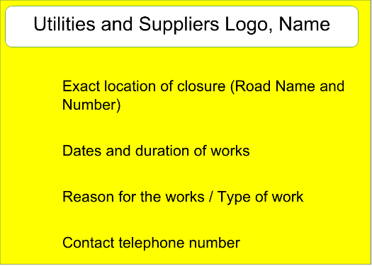

- End -

