Suffolk Sufficiency Strategy
for Children in Care and Care Leavers
2022-2026

Foreword

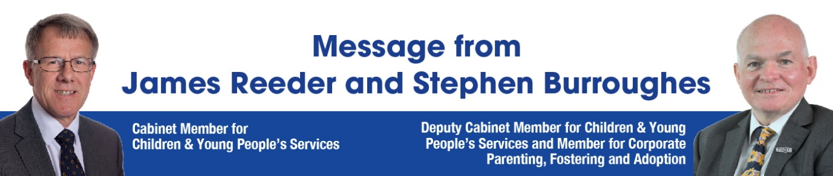

Dear Colleague,
This Sufficiency Strategy has been compiled in a time like no other. The remarkable resilience and collaboration that Suffolk's families, children and young people have demonstrated throughout this time is truly commendable. ‘Collaborative Suffolk’ showed its strength.
We must take this opportunity to also thank professional staff across partner agencies as well as internally for their continued contribution to Children’s Services throughout the pandemic. For a child who may have experienced trauma, everyday matters, and continuity of care is crucial.
We are really pleased that we have been able to maintain Suffolk's excellent record of keeping children with their families, remaining local, and sustaining their placements.
Our ambition to improve life outcomes for Children in Care (CiC) and Care Leavers was recognised in our previous Ofsted ‘Good’ judgment (2015). This has improved to an ‘Outstanding’ judgement (2019) during the last Strategy. This is a rare accolade which is only given to Local Authorities who can evidence the highest standards of practice and leadership.
We are committed to delivering our part of the mental health transformation programme and SEND commissioning, so that all services can strive to match those of the best. We are committed to listen to the voice of families, children and young people through genuine co-production.
This Strategy will span the life of the Independent Social Care Review and reforms to the unregulated sector. We are ready to embrace their findings and be flexible in our response. We will drive improvement, performance and share our best practice with other Local Authorities.

This Strategy will be shared through regular meetings with providers and partners, through market engagement events, and by ensuring our needs are clearly articulated to take every opportunity that presents itself to meet our sufficiency needs.
Kind regards.

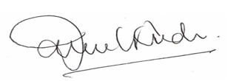
Councillor James Reeder Councillor Stephen Burroughes
Cabinet Member for Children & Young Deputy Cabinet Member for Children &
People’s Services Young People’s Services and Member for Corporate Parenting, Fostering and Adoption

Hi, I'm Holly, and I'm Joint Chair of C2C, Chat to Change. I’m going to be telling you what C2C is and what we do.
C2C, also known as the Children in Care Council, is a Council run by young people who are either in care or who are care leavers. It is supported by members of the Engagement Hub such as Julia and Susie.
We regularly talk with the Corporate Parenting Board. For example, in March 2021, I spoke with them about how children in care experienced lockdown and how they felt it was dealt with. C2C have also previously spoken with Ofsted and the Heads of the Virtual School, Matthew Cooke and Ro Harte.
We recently created a Coming into Care pack that had a range of activities and necessities a young person may need when they first come into care. This has been successful and is being given out to all new children and young people who come into care in Suffolk. To go with that we also made a short film to describe the type of professionals you may meet, which you can view here Coming into Care - C2C film (thesource.me.uk).
Once a year there is a Regional event where all the different Children in Care Council groups in the Eastern Region meet up. For example, in 2019, we went to the Cambridge Junction followed by lunch at Nines. This allows you to meet other young people from all over and share their thoughts about care from different perspectives, especially as different Councils do things in different ways. We usually work on a Regional project together too.
Being a part of C2C also allows you to broaden your horizons and learn new skills by connecting you to different groups. For example, by being a part of C2C I was given the opportunity to get a level 1 qualification in interviewing and have gone on to join the young person’s panel which allows me to interview prospective social workers and other service workers.
Currently C2C are working on two topics. We are working alongside SCC to change the language surrounding children in care as many of the words have negative connotations or only refer to certain cases and are being used incorrectly. We are also working on raising awareness about what it's like being a child in care in schools and getting rid of the idea that being a child in care is like how the media portray it in tv shows such as Tracey Beaker or The Dumping Ground.
Holly
Chair of C2C
Ps, please look at our I statement’s and supporting evidence – get to know Suffolk's children and young people! Our hopes for the next generation of care leavers are in speech marks.
PPS, look out for feedback from Suffolk’s providers throughout the document too!

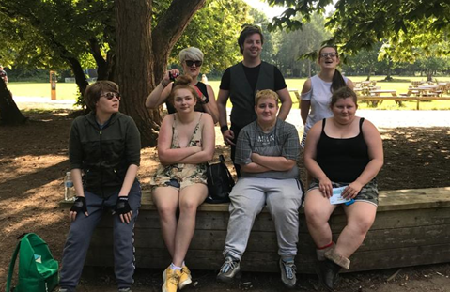

Suffolk's Demographic and Performance
Below is a snapshot of Suffolk's performance.
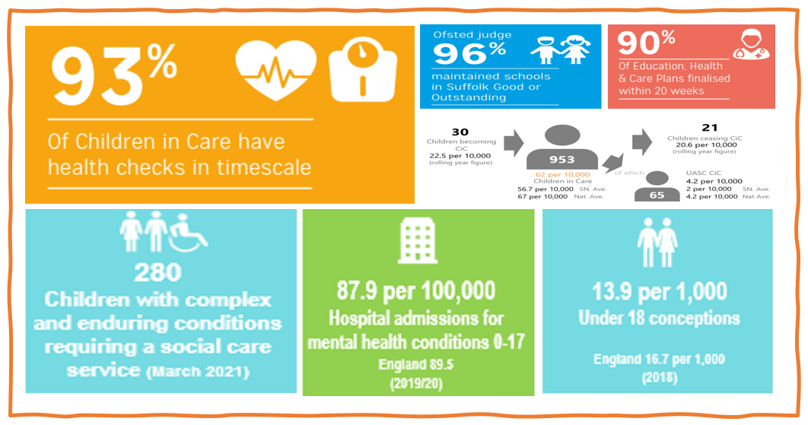
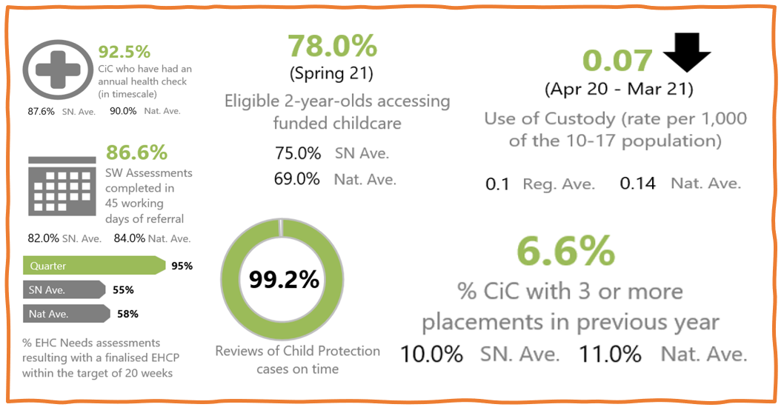
*June 2021

The Sufficiency Duty
This document sets out how Suffolk intends to meet its Sufficiency Duty as laid out in section 22G of the Children Act 1989. This requires Local Authorities to take steps that secure, as far as reasonably practical, sufficient accommodation for children in care within their Local Authority area. The 2004 Act states that: "Each Local Authority has a duty, under Section 10 of the Children Act (2004), to decide to promote co-operation with its relevant partners with a view to improving the wellbeing of children in the Authority's area. The Children Act 2008 further defines sufficiency as “a whole system approach which delivers early intervention and preventative work to help support children and their families where possible, as well as providing better services for children if they do come into care.”
For children in care, Local Authorities and their strategic partners should seek to secure several providers and a range of services, with the aim of meeting the wide-ranging needs of children in care and young people within their local area. In 2010, the Statutory Guidance for the Sufficiency Duty was issued. This guidance is explicit in placing a duty on all Local Authorities and children’s trusts to act strategically to address gaps in provision by ensuring that they include, in relevant commissioning strategies, their plans for meeting the Sufficiency Duty.
Corporate Parenting “Those with Corporate Responsibility”
The Children and Social Work Act 2017, extends the duties on all Local Authorities (including District and Borough Councils) to have regard to a set of corporate parenting principles when exercising their functions in relation to looked after children and care leavers up to the age of 25.

That children in care are treated the same as other children.

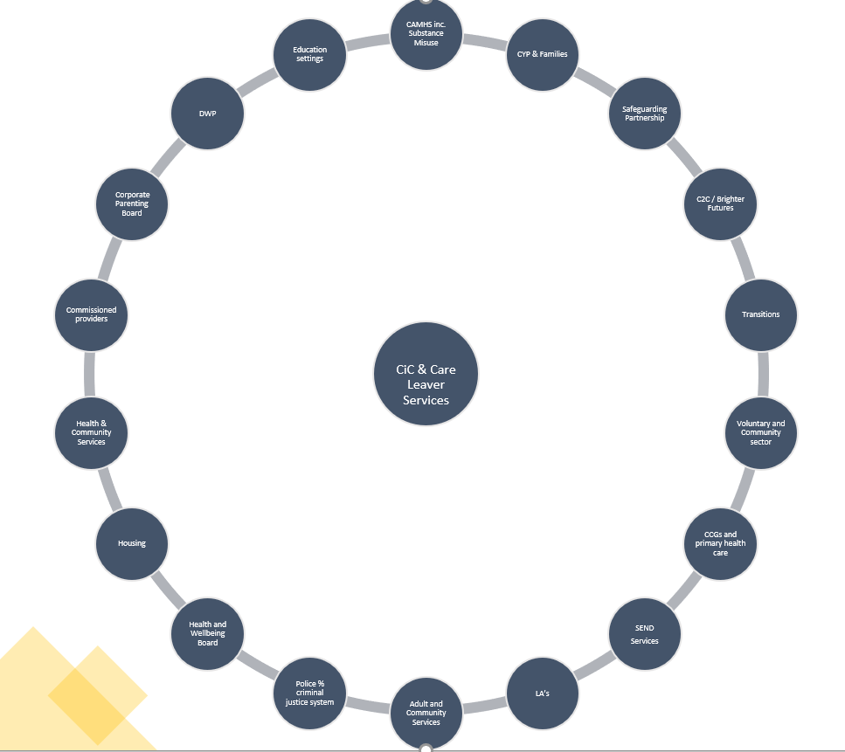

Purpose
The purpose of this Strategy is to set out Suffolk’s vision for, and approach to, providing sufficient, safe, secure and appropriate placements for children in care and care leavers over the next 4 years. It supports the delivery of Suffolk’s Children in Care Priorities and is aligned to the Council’s Business Plan. A crucial element of planning sufficient accommodation is to take early, preventative action to support children and families so that fewer children come into care. This document describes:
- Our Sufficiency progress since 2021

- Needs analysis and findings

- National areas for consideration

- Response to COVID and reforms

- Our priorities and recommendations for action

- Challenges meeting needs / demand

- Commissioning intentions to meet sufficiency

Governance
The Sufficiency Strategy is a live document. It will be underpinned by a set of action plans covering the Suffolk system that will support the priority actions and link to existing work. The Intelligence Hub will create a Sufficiency Strategy Dashboard that will monitor our performance, which will report to the Corporate Parenting Board and the Council’s Directorate Management Team for Children and Young People.
Our Vision
All children and families in Suffolk have the right to:
- Be safe

- The best education

- Physical and emotional health

- Successful preparation for adulthood and employment

Too many children do not have these opportunities and we are committed to changing that. We must be brave and change the way we work to deliver this.

Progress Between 2018-2021
Good progress has been made in Suffolk to improve sufficiency for children in care since the implementation of the Corporate Parenting Placement Sufficiency Strategy 2018-2021. We are grateful to services and partners who have enabled the following achievements:
- Children are thriving in their placements and stability has improved to 75.3% for long term placements.

- At the end of quarter 4 2021, there were only 6.4% of CiC with 3 or more placement moves in the previous year, compared to 10% of our Statistical Neighbours and a 11% National average.

- Fostering capacity is good with occupancy at 78-80% and a 2.89% increase in bed nights used to 46,910 in year 2020.

- A fee formula for interagency adoptions has been agreed between 8 Local Authority partners, with no fees chargeable between the partners.

- Care Leavers aged up to 25 are exempted from Council Tax liability.

- Attendance rates in education of Children in Care (95.7%) have been consistently above national levels for both CIC and all children.

- The percentage of children gaining qualifications has increased from 69% to 80%.

- The Staying Close pilot has been extended for a further year. There is currently a 100% successful move on rate when participating in this programme. The scope of delivery has widened throughout 2020-2021, meaning more young people can benefit from the service.

- Commissioning of a dual placement registered children’s home has substantially increased the sufficiency of suitable placements.

- Staying Put arrangements for care leavers continue to rise at a steady rate.

- Barnardo’s were commissioned to deliver virtual counselling to support CiC and care leavers throughout C19, around the restrictions and isolation. All available places were utilised and the service has been recommissioned and will offer 5 referrals a week.

- There is a new connected persons team – providing a single assessment process for all outcomes, Special Guardianship Order / Kinship / Child Arrangement Order.

- We have created a single specialist all age Unaccompanied Asylum-Seeking Team.

- The in-house residential review outcomes are being realised, including changes to our Statement of Purpose, refurbishment to our Homes, a new Recruitment and Retention Staff Strategy, embedding a trauma informed approach and creation of an outcome's framework.

- The SAGE team was part of a wider systems approach to tackle Child Criminal Exploitation (CCE) in Suffolk. Some of the achievements of the wider program:

- Bringing £1.36 million funding into the system.

- Co-ordination of work across Suffolk.

- Holiday Activities Fund.

- Schools' engagement co-ordination.

- Knowledge and Intelligence Hub.

- Police enforcement term consistently.

- Public Sector Leaders have funded two CCE Hubs (South and West).

- A new three-year work programme for the County has been agreed.

- COVID isolation unit available for emergencies during periods of lockdown.

- The Leaving Care Team is in touch with 96.3% of care leavers and 91.4% of them are suitably accommodated.

Sufficiency Progress According to Ofsted

The Ofsted Inspection of Children’s Social Care Services in April 2019, judged services ‘Outstanding’ overall and ‘Good’ for the experience and progress of Children in Care and Care Leavers. The Inspection report praised progress since the last Inspection detailing:
“Services for children are of an exceptionally high standard. They are child-focused and make a positive difference to children’s lives. Workers build positive and purposeful working relationships with children and their families. They ensure that children are safeguarded, and that their wider needs are addressed. They consistently act to ensure the best outcomes for children. Suffolk’s Early Help Services have continued to benefit from continuous investments and innovation. Children and their families are served well by an impressive range of early help provision. Skilled, child-centred practitioners work to high standards, providing effective evidence-based support. The Local Authority works well with its partners to confront the issues when children are at risk of going missing or are vulnerable to criminal or sexual exploitation or from involvement in gangs. Children become looked after when it is appropriate for them to do so”.
Since the last Inspection, leaders have expanded the scope of the Local Authority’s Stronger Families and Family Solutions services to better support children who are at the edge of care to remain in their families. This means that every effort is made to ensure that children only come into care when other options have been fully considered.
Children are thriving in their placements; many having had very complex and challenging histories. They are supported to pursue interests and are encouraged to follow their dreams. This includes unaccompanied asylum-seeking children (UASC) being supported to achieve and find purpose in a range of hobbies and interests. Leaders have high aspirations for children, and they ensure that their achievements are applauded and routinely celebrated.
The Local Authority has effectively established a strong ethos of permanence across the service. Staff recognise that permanence brings with it a greater sense of security for children in care. Commissioning functions have been strengthened, and overall placement choice has improved since the last Inspection, with a wide range of good-quality provision to suit the needs of children and young people.
The virtual school provides good support for and guidance to teachers, and they report positively about the intervention their schools receive. There is an improving pattern in attainment and progress of children in care in Key Stages 1 and 2. This is in part due to the oversight and intense scrutiny by the virtual school. The help and support that care leavers receive is much better than at the time of the last Inspection.
The Local Authority is now in touch with the vast majority of care leavers. It has increased the accommodation options available, and almost all care leavers are now living in suitable accommodation, many of them with their former foster carers as part of a staying put arrangement. The ongoing professional support offered as part of the ‘staying close’ initiative eases some of the stress for young people moving from residential care into semi-independent accommodation. Managers and staff work persistently to build and maintain meaningful relationships with care leavers. There is no doubting their passion. The local offer is comprehensive, detailed and ambitious. Care leavers have access to high-quality information about their rights and entitlements. Single and joint commissioning arrangements are strong, effective and responsive to changing needs.
The Local Authority has made considerable progress in implementing its Sufficiency Strategy. As a result, many of Suffolk’s children in care are living and growing up in Suffolk. Support for foster carers has been strengthened. The use of bed and breakfast accommodation for homeless 16 and 17 year olds has been eradicated.

Needs Analysis
This Strategy is underpinned by a comprehensive data set, children’s young people's voices, COVID assumptions and forecast of placement needs.
Appendix 1
Appendix 2
Young person's feedback:
National and Local Context
Sufficiency Guidance
Of note and consideration in terms of continuing our performance around suitably accommodated children.
Section 2.13 - in order to accommodate any emergency placements there is likely to be a limited need for planned standby accommodation or surplus provision (where spare capacity is not available).
England Social Care Independent Review - Case for Change
The key emerging themes are:
- We need to do more to help families

- We need a child protection system that keeps children safe through more effective support and decisive action

- The care system must build not break relationships

- Change will not happen without addressing the system causes

3 spending priorities:
- Family support

- Children’s homes

- Supporting CiC’s mental health

Part of the reason for a lack of support might be because the help which families need to turn things around is not available. Local services have experienced increasing demand in recent years, particularly at the acute end of services. Spending has shifted towards acute services and meeting statutory duties. Between 2012/13-2019/20, spending on non-statutory children’s services decreased by 35% in real terms (Department for Education, 2021b). 13 Local Authorities have finite budgets and have responded to financial pressures by reducing spending on non-statutory children’s services and increasing spending on statutory social work (National Audit Office, 2019). In 2017/18, the average Local Authority spends on a Child in Need intervention ranged between £566 and £5,166, showing a significant variation in the support received by families (National Audit Office, 2019).
Unregulated Consultation and Reforms
The Government has announced the following intentions:
- Legislate to enact a ban on the placement of children under the age of 16, with this coming into effect in September 2021.

- Issue a consultation on National Standards and Ofsted Regulation for the unregulated sector in 2021. We will work closely with Ofsted and the sector to carefully consider how best to introduce the new regime.

- Proceed with legislating at the earliest opportunity, to give Ofsted additional powers to take enforcement action against illegal unregistered providers.

COVID Interim Sufficiency 2020
2020 was an unprecedented year, and one which was not planned for in terms of our previous Sufficiency Strategy and plans.
Whilst this Strategy was evolving there was a need to urgently address some gaps in services and placements due to the impact of C-19 and in anticipation of the reforms to the unregulated sector. A summary of our interim sufficiency plans that will be taken forward under part of this Sufficiency Strategy is as follows:
  - To open an inhouse registered solo children’s home.

  - To commission a registered solo children’s home.

  - To create a Restore and Prevent offer to support placement stability for placements at risk of breakdown.

  - To develop an inhouse fostering for adolescent’s service.

  - Tendering our Disabled Children and Young People residential services to get all spend on contract and formalise arrangements for emergency placements.

  - Focus on Connected Persons fostering and reunification opportunities.

  - Staying Close service to be mainstreamed and progress as an opt out service.

  - Increase inhouse residential occupancy to 90%.

  - Work with Norfolk and Suffolk Foundation Trust and Local Authority commissioned services such as Turning Point and the Family Nurse Partnership for our young people with trauma.

  - Review language used in referral documentation.

  - DCYP emergency assessment bed and additional shared care residential placement.

Findings from Analysis of Data and Intelligence
The rate of children in care has increased from 55 to 61 per 10,000 since 2017.
The largest number of CiC in Suffolk in any point in time has increased by 15% since 2016. There are currently 954 children in the care of the Local Authority as of April 2021, with the main increase coming from very young children under 5 and adolescents aged 11 to 17, who are late entrants into the care system remaining in care.
The most significant reason for becoming looked after is parental needs, followed by mental health and family and environmental needs. This remains the most common factor until adolescence when the most common factor becomes the young person's needs particularly their mental health and emotional wellbeing.
The percentage of CiC aged 0-10 has grown from 38%-43% since 2018. The split of male and female CiC numbers are comparable until aged 14 plus where males are then more prevalent.
Children from an ethnic minority background are overrepresented in Suffolk’s CiC cohort. Whilst Suffolk is less diverse than England as a while, it is becoming more ethnically diverse, which may mean that numbers of children in minority groups may increase further in the future.
Our CiC population by placement type has remained fairly static in the last year, with a slight increase in semi-independent living from 12.2% to 13%, and with residential placements reducing from 5.6% to 4.4%.
The most common age in fostering is 15 years old, adoption 1 years old, independent living 17 years old and residential placement 14 years old.
The average cost of the highest cost 50 placements has risen by nearly 50% over the past 4 years, from £151,082 - £223,430 per week in total. This reflects the increasing complexities of needs, sector capacity and pricing. The average weekly cost of purchased Residential Home placements has increased by nearly a third over 4 years. This will in part reflect many LAs chasing a limited supply of places. There is growing proportion of females in the highest cost placements.
The percentage of CiC who have SEND identified at SEN support has reduced from 28%-26.2%. The percentage of CiC with an Education Health Care Plan has increased from 26.6% - 28% in the last 3 years, with a notable increase of 1.3% in the last year. Both indictors are in line with statistical and Eastern Region Neighbours, and national performance.
In total 5.7% of pupils with SEND (EHCPs and SEN Support) receive direct support from social care broken down as follows; 3.2% are a Child in Need, 0.5% are on Child Protection Plans and 3% are Children in Care.
Among CiC in Suffolk as of March 2021, 51 were recorded as having moderate learning difficulties, 15 with severe learning difficulties and 2 with profound and multiple learning difficulties. Among children in care with recorded learning difficulties, 21 were aged between 3 and 10, 33 were aged 11-15 and 14 were aged 16-18.
Rates of overall relative deprivation are rising in Suffolk. Much of this decline is linked to low education and skill levels. Rising crime, access to health and care, barriers to housing and services are also important. Rising deprivation is likely to lead to an increase in need for CYP. Inequalities in Suffolk are not confined to the urban areas. We are now seeing areas in smaller towns featuring in the most deprived parts of England, with pockets of rural deprivation persisting.
Inequalities of all types including health and educational inequalities have widened throughout the COVID pandemic.
The proportion of CiC increases with the severity of the disposal in the Youth Justice System. After several years of reducing overall proportion of CiC within the SYJS caseload, the latest financial year has seen an increase from 11.3% in 2019/20 to 17.6% in 2020/21.
CiC long term stability has been steadily increasing year upon year and CiC stability of placement for CiC with 3 or more placements in the previous 12 months has continued reducing and has reached its best level in 2020. COVID has played a role in this. Continued investment in Mockingbird and Restore and prevent models will hopefully continue this trend.
We have applied our current % placement dispersal by sector to the worst case COVID assumption for CiC populations to enable a plan for additional placements at a sector specific level. This has shown we are going to plan for an additional 7 residential placements, 57 fostering placements and 12 in supported living placements in the next 3 years based on the assumptions of worst-case planning. The increasing in complexity of needs is in addition to this, suggesting a requirement for more placements to meet this need, likely to impact reliance on the residential sector.
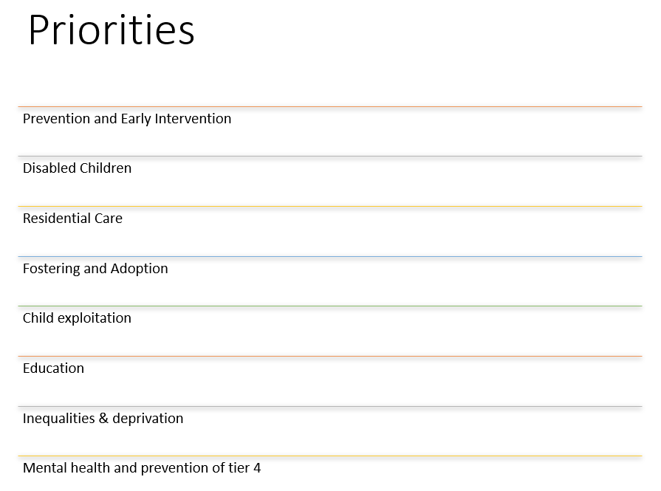

Priority Action – Prevention and Early Intervention | KPI’s and Targets | Related Strategies | Owner
Improving the way families can navigate the Early Help system | Implementation of Family Hubs evaluation 2023 | - MHCLG: EH System Guide response and priorities  - Early Intervention Foundation Family Hubs  - Children Centre core offer  - Healthy Child 0-19 Programme  - Best Start in life  - Case for Change  - Mental Health transformation and THRIVE | Head of Service – Early Help
Building communities capacity – full integration at prevention end | Numbers at CIN stage  Public Health - warm handovers  benchmarking to occur 2022  annual supporting families survey |  | Head of Service – Early Help
Strengthening restorative family approach using Signs of Safety Framework | Improve reunification levels by 5% |  | SOS Practice Development Lead
The new Restore and Prevent offer launched | Maintaining current stability – post COVID 80% utilised service |  | Strategic Commissioning Lead
Renew the Stronger Families Contract (Functional Family Therapy) | 2022 |  | Head of Programmes

Priority Action – Disabled Children | KPI’s and Targets | Related Strategies | Owner
Develop new shared care placements | Rise to 5 placements by year 3 (mix fostering and residential) | - SEND Sufficiency Plan and Strategy  - DCYP Review  - SEND Independent Review  - Short Breaks Review and Consultation  - All age Autism Strategy | Strategic Commissioning Lead
Move to new ‘sitting service’ for DCYP families | 2022 |  | SEND Operations Manager
Development of an all-ages autism service | 2024 |  | Practice Transformation Lead
All DCYP placements are transitional from age 12-25 | No forced system moves by 2024  That children and young people have settled homes. |  | Practice Transformation Lead
Increased short breaks for the most complex children | 2022 |  | SEND Operations Manager

Priority Action – Residential Care | KPI’s and Targets | Related Strategies | Owner
Increase occupancy of our inhouse children’s homes | 90% occupancy | - Residential Review  - ICHA  - Workforce Development Strategy  - Test the Temperate  - Recruitment and Retention Workstream  - Approach to Practice workstream  - Trauma informed  - BERRI | Responsible Individual
Growing and maintaining a Staff work force in inhouse residential | - Staff turnover improvement 5% year on year  - Monthly HR Clinics  - Development of recruitment website by 2022 |  | Head of Residential Care Services
Mainstreaming of Staying Close | 2022/2023 |  | Housing Development and Staying Close Manager
Implementation of the internal and external new Solo children’s homes | March 2022 |  | Service Development and Contract manager / Head of Residential Care Services
Replacement children’s Home and refurbishment of whole estate | 2022/2023  That young people can stay in their current foster homes post 18 and are not pressured to move on. |  | Head of Residential Care Services
Registration of the Emergency Bed | January 2022 |  | Head of Residential Care Services
Commission a new 7-11 registered children’s home | January 2022 |  | Strategic Commissioning Lead

Priority Action – Fostering and Adoption | KPI’s and Targets | Related Strategies | Owner
Increase mainstream fostering | Net gain of 60 foster placements sustained | - Recruitment Strategy  - Communications Strategy  - Data collection | Head of Fostering and Adoption
Increase parent and child placements alternative to Reverse Residential | Commission and maintain 4 placements per year |  | Head of Fostering and Adoption and Strategic Commissioning Lead
Grow and maintain PACE carers | Maintain 3 PACE carers |  | Head of Fostering and Adoption
Develop the new adolescent fostering service | 8 placements – 1 link carer by 2022 |  | Head of Fostering and Adoption
Development of an inhouse sibling offer | 50% inhouse placements by 2024 |  | Head of Fostering and Adoption
Increase the number of BME foster carers and adopters | 30% increase by 2024 |  | Head of Fostering and Adoption
Increase the number of Suffolk adopters | Approval of 50 adopters per year  5% reduction on Purchasing numbers |  | Head of Fostering and Adoption

Priority Action – Child Exploitation | KPI’s and Targets | Related Strategies | Owner
Annual Policy reviews of contracted provider | Monitoring the levels of missing episodes  adopting recommendations | - Stella Marris Report  - Op Culworth  - Megan Enquiry  - Philomenia Protocol  - Criminal Exploitation Plan  - Safeguarding Adolescent Strategy  - Young person's Homeless protocol  - Young person's Housing Protocol  - Suffolk Housing Board work plan  - ‘Everyone In’ Strategy  - The Leaving Care Strategy  - The Leaving Care Offer  - National Transfer Scheme  - Serious Youth Violence Strategy | SCC contract Managers  Responsible Individual
Improve the quality and effectiveness of inhouse Reg 44’s | - Embedding the Outcomes Framework by 2021.  - All inhouse residential to be ratings good or above by 2024. |  | Approach to Practice Steering Group
Implementation of the new Vulnerability Assessment Tracker (MACE meetings  ‘Disruption of perpetrators’) | - 100% of children and young people appropriately captured and monitored via the tracker and MACE meeting  - 100% Records of Engagement for all out of county placements in Suffolk where available |  | Child Exploitation Coordinator
Embed contextual safeguarding approach across services | - 70% EET by 2023  - Contextual Safeguarding approach across services by 2023 |  | Suffolk Safeguarding Partnership
Appropriate use and exploration of Section 45 defence and national referral | - 100% of National Referral Mechanism referrals are investigated to prove or disprove  - If proven, appropriate care and support is provided (individual to needs) |  | Suffolk Police  Head of Children Safeguarding

Prevention of homelessness  Increase of suitable provision for care leavers 18+ | 5% reduction in homelessness |  | The Leaving Care Service Manager
Improved transition process between CYP and ACS by commissioning suitable post 18 accommodation for vulnerable care leavers | - Transition Panel  - No 18 year old carer leavers in B&B by 2024 |  | ACS Practice Transformation Lead
Available Registered placements for UASC claiming to be under 16 out of hours | Identification of an IFA offer by 2022 |  | Strategic Commissioning Lead
Delivery of the County Lines  FLATS Programme  Restorative Parent Group - inclusive of corporate parents | - Sector awareness – briefing session  - Complete pathfinder  - 1 Training session per annum  - 2 parent groups per year |  | Suffolk Constabulary – Safeguarding Lead
Using Intelligence to support commissioning  - PPU checks  - Hot spotting  - Dispersal of services  - Mapping | - 100% of checks completed  - Avoiding all hotspot areas as applicable |  | Problem orientated Policing  Design Out Crime  Child Exploitation Co-ordinator
That children and young people are encouraged to choose education and to focus on it by tapping into their interests and skills.
That all schools are encouraged to support children and young people’s mental health. It shouldn’t be a postcode lottery!

Priority Action Education | KPI’s and Targets | Related Strategies | Owner
Reduce the levels of Exclusion both  - Temporary  - Reduced Offer | 88% of CiC who have never had exclusion by year 2 of the strategy | - Mental Health and wellbeing Strategy | Virtual School Head
Encouraging care leaver onto further and higher education including university | 8% of CiC / care leavers are in higher education (up to 21) by year 2 of the strategy |  | Virtual School Head
Jointly commissioned collocated residential and education placements | 10% reduction of out of County DCYP placements by 2024  That lack of money does not affect the lives of children and young people in care and their opportunities. |  | Assistant Director Inclusion

Priority Action – Inequalities and Deprivation | KPI’s and Targets | Related Strategies | Owner
Ensure Care Leavers are aware of their Welfare Rights | - 100% of care leavers offered FIAS support through their YPA  - 100% affordability checks completed where requested | - The Leaving Care Strategy  - Lowestoft EET Panel  - Lowestoft Rising  - Care Leaver Covenant  - Poverty Strategy | Specialist Support and Training Officer
Make available a mitigation fund for any care leaver disadvantage through seeking employment or apprenticeships facilitating attainable move on | 90% suitably accommodated by year 1 and sustained thereafter (local) |  | The Leaving Care Manager
Lobby DWP and DfE regarding financial poverty of care leavers in supported accommodation when working | - Assess the impact on Suffolk Care Leavers  - Review the EIA of the DWP around the decision of removal of UC uplift  - Case to Children’s Commissioner  - ADCS |  | Skills  DWP CPB representative  Staying Close Manager  FIAS  Young person's Housing Actions Group
Finalise Suffolk's Poverty Strategy | Completion by 2022 |  | Specialist Lead – Locality and Partnerships
Districts and Boroughs to priorities care leavers for Discretionary Housing applications | Process agreed by 2022 |  | Young person's Housing Actions Group
Protection of SCC Early help services. | Yearly reviewing and influence SCC Budget setting |  | Head of Service – Early Help
That children and young people get the support they need with their mental health at an early stage to stop it getting worse. Also, that their families are given support too so that they might be able to return home successfully.

Priority Action – Mental Health and Prevention of Tier 4 | KPI’s and Targets | Related Strategies | Owner
Implement and make available the new CHRIS team for CiC and Care Leavers | 2022 | - Trauma Informed Care Strategy  - A very different conversation  - All age Autism Strategy  - Mental Health Transformation Programme  - Evolution of the Emotional Wellbeing Hub early intervention and locality model – eating disorders, neuro developmental, speech and language, mental health training for practitioners and the Thrive approach  - ACS role – addressing parental trauma and mental health | Assistant Director of Nursing CYP and Maternity
Jointly commission services to Create a new “Place of safety” | - Feasibility study by 2022  - Service available by 2023 |  | Assistant Director of Nursing CYP and maternity
Parent mental health  Perinatal Team | Annual review if these services are meeting the needs of Suffolk families |  | Assistant Director of Nursing CYP and Maternity

Build up their self-esteem, help them feel that they can achieve the same as everyone else.
Placement Demand and Supply Gap Analysis
Demand | Supply | Gaps | Action | Enablers
Need for property to support all non-family-based placements | - District and Borough property  - Housing Association  - Private market | - Security of tenure  - Properties with C2 planning permission | - CYP Capital Strategy Programme | - Suffolk County Council Capital Strategy Group
Staff in residential, fostering / adopters and SIL sector | - Inhouse and purchased services  - Agency staff | - Enough workforce | - Workforce Development Plan  - Staff retention and career framework  - ‘Approach to practice’  - Workforce Planning Board influence  - NWOW expectations set corporately and accounted for in workloads  - Extension of our Duty of Care to external staff for Safety, Health and wellbeing | - Workforce Development Planning Group  - Human Resources
Need for registered services for 16 and 17 year olds | - Inhouse residential service with Statement of Purpose for 11-17 | - Insufficient registered services | - Registered the emergency bed  - Open an inhouse solo Children’s home  - Block purchase a solo children's home  - Inhouse adolescent fostering service  - Adolescent Strategy | - Priority action Child exploitation
Need for transitional services | - Staying Close Pilot | - DCYP Transitional Services 15-25 | - Mainstream Staying Close  - Joint commissioning of accommodation with ACS to enable care leavers to remain post 18 | - Priority action DCYP
Need for support for CiC with complex emotional and behavioural difficulties, as a result of trauma | - CAMHS  - Evolving Inhouse residential services | - Informed workforce  - Well performing Mental Health Service  - Mockingbird | - Mental Health project in support services Trauma informed sector  - BERRI  - Gangs and County Lines restorative approach  - Restore and prevent offer | - Priority action mental health and prevention of tier 4
Need for family-based settings | - Inhouse fostering  - IFA  - Supported Lodgings | - Link carers  - Additional inhouse fostering for older children, sibling groups and complex needs | - Ensuring practice supports exploration of networks throughout time in care  - Reunification golden thread | - Priority action fostering
Need for parent and child placements | - IFA  - ‘Reverse residential' | - Placements where parent can remain irrespective of decision to remove | - Supported lodgings offer with external assessment | - Priority action fostering
Need to maintain a high quality SIL sector post reforms | - 7-year contract | - Quality assured services by young people | - Young person's Quality Assurance role | - Priority action exploitation
Need to sustain DCYP at CP and CIN stage | - 1 shared care bed  - Short breaks | - Full offer | - Increased shared care and short break capacity | - Priority action DCYP
Place of Safety | - Emergency bed | - Health input | - 1 place of safety | - Priority action mental health and prevention of tier 4
Need for equitable dispersal of placements and services across Suffolk | - County wide contracted services | - UASC placements in the North  - Residential placements in the North  - Foster placements that can maintain school continuity | - Evolve the UASC contracts | - Priority action Inequalities and deprivation
COVID recovery – placement forecast | - Existing service Development plans | - Potential gaps in year 1, 2 and 3 to be monitored | - 5+ additional residential placements  - 59 additional fostering placements  - 14 additional SIL placements | - All priorities

Difficulties meeting demand
A Steering Group met and decided upon the below RAG ratings for the Council, based upon the following: Regulatory grading, market intelligence, performance, operational knowledge and availability.
The national ones were taken where available from the National Sufficiency Statement.
These are key area’s that may influence the effectiveness of this strategy due to it interdependencies.
For Services
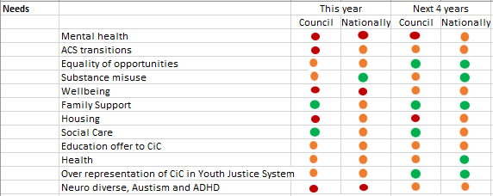
For Placements
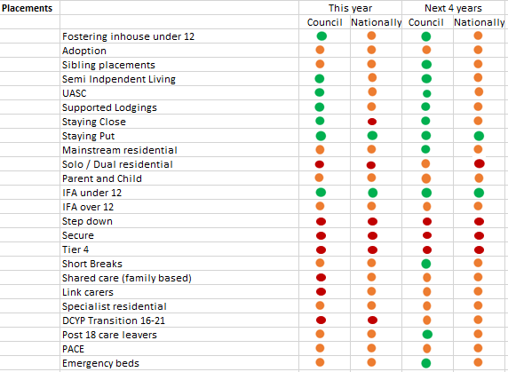
*Red indicates the Council expects they will face difficulties meeting demand through existing suppliers and or needs to produce services at a high cost. Amber indicates the Council expects that they will mostly meet demand through existing providers at a reasonable cost, but they will be some cases where that isn’t true. Green indicates that they Council expects they can meet the demand at a reasonable cost.
Suffolk work collaboratively with providers.

Commissioning Approach
Suffolk's approach to commissioning will be as follows:
- We will ensure commissioning is needs led, outcomes based and involves voices of children and young people, parents, and carers.

- We will continue to operate within a mixed economy of internal and external provision, always prioritising the best placement to meet the unique needs of each child.

- We are committed to an evidence-based approach to commissioning. This includes using our own data to inform decision making wherever appropriate, for example through building data-led scenarios.

- Commissioning will be focused on ensuring quality and early intervention to reduce demand and produce greater placement stability leading to better outcomes for children.

- We will ensure that we have robust contract management arrangements in place to ensure that outcomes are delivered within quality provision, which is cost effective.

- We will work closely with social workers and Independent Reviewing Officers to ensure they understand the cost of placements and support contract management.

- We will build our strategic relationships through greater regional and sub-regional collaboration.

- We will work strategically with our high-spend providers and collaborate with partners to ensure use of local placements is maximised and avoidable costs minimised.

- We will work closely with the provider market to develop provision and articulate a clear vision for our sufficiency needs.

- We will work with all our partners and the Suffolk Children’s Alliance to redesign services which support this Strategy.

- We will do everything we can to secure local placements for children to enable continuity of education and family networks and enable safe reunification at the earliest opportunity.

- We will use the family network as a strength-based resource for the child.

- Our Sufficiency Strategy will be used to influence registered housing providers and the Suffolk Housing Board to maximise the use of local social housing for children in care and care leavers.

- We will gain social value from our contracts.

- We will work with our supply chain and partners to achieve Suffolk Net Zero by 2030.

- We will approach the voice of service users as experts by experience.

- We will use a whole system approach reducing duplication.

- We will be timely and tenacious regarding our decision making.

- We will respond and utilise market intelligence.

- We will advocate for the role of a Corporate Parent / responsibility for partners.

They work innovatively, engage, and respond to changes well.

Commissioning Intentions
Activity | Timescales | Lead Commissioner
DCYP residential placements 15-25 | 2021 | Strategic Commissioning Lead
Jointly commissioned tier 4 service | 2022-2023 | Deputy Director of Transformation and Head of Strategic Commissioning
Short Breaks Provision | 2022 | SEND Operations Manager
UASC Supported contract |  | Service Development and Contract Manager
Jointly commissioned education and residential | 2023 | Assistant Director Inclusion
Shared care | 2023 | Head of Social Care Fieldwork
Independent fostering | 2022 | Strategic Commissioning Lead
Recommissioning of tier 3 ½ services | 2024 | Strategic Commissioning Lead
Recommission Stronger Families | 2022 | Head of Programmes

Key Contacts
We want to hear how you can help meet Suffolk's Sufficiency needs.
Strategic Commissioning lead - Tracey.curtis@suffolk.gov.uk
Senior Business Procurement Lead – Katrina.browning@suffolk.gov.uk
Service Development and Contract Manager – Chris.howard2@suffolk.gov.uk
Contracts and Placements Team Manager – Debbie.green2@suffolk.gov.uk

