Suffolk Fire and Rescue Service
Strategic Assessment of Risk 2022

Produced by:
Suffolk Public Health and Communities: Knowledge, Intelligence and Evidence Team
Contents
Suffolk Fire and Rescue Service (SFRS) 3
Executive summary 4
Risk summary 6
Suffolk 7
Suffolk Fire Stations 7
Suffolk Fire and Rescue key statistics 9
National and local risks 12
Suffolk Resilience Forum (SRF) 13
Suffolk community risk register 13
Demographics 14
Ethnicity and diversity 16
Ethnicity 16
Migration 16
Gypsy and Traveller populations 17
Health 19
Life expectancy 19
Falls 20
Smoking 20
Mental health 21
Suicide 21
Drug and alcohol misuse 21
Alcohol and related disease 22
Housing 22
Overview of housing in Suffolk 22
Listed buildings 22
Thatched properties 22
Blocks of flats 23
Deprivation 23
The impact of rurality and deprivation 24
Child poverty 24
Crime and community safety 25
Economy and employment 27
Daytime population (commuter flows) and visitors 28
Changing Suffolk 28
Predicted population growth 28
Risk areas 30
Main roads 30
Road users 30
Winter planning 31
Electric vehicle charging 31
Killed or seriously injured on the roads 33
Rail networks 33
Airports, air bases and military presence 34
The Port of Felixstowe 34
Harwich International 35
Other ports and maritime 35
Offshore wind farms 35
Piers 35
Other key tourism areas 36
Control of Major Accident Hazards (COMAH) Sites 36
Radiation (Emergency Preparedness and Public Information) (REPPIR) sites 36
Fire safety for farmers and rural businesses 37
Climate change and associated risk 37
Solar farms 38
Suffolk County Council climate emergency 38
Wildfire incidents 39
Flooding and severe weather 40
Suffolk Lowland Search and Rescue 40
Preparing for, and responding to emergencies 40
State of fire and rescue: The annual assessment of fire and rescue services in England 2021 41
Suffolk Fire and Rescue Service 2019 inspection report 41
Suffolk Fire and Rescue Service as part of Suffolk County Council 42
Public perception 42
Technology, new acquisitions and service development 43
Small Unmanned Surveillance Aircraft 43
Uniforms and appliances 43
Waterside prevention 44
Fleet management 44
SRFS prevention team 45
COVID-19 (Coronavirus) response, adaptation and recovery 45
More information 46
References: 47
Appendix: Suffolk Community Risk Register – Risk Matrix (last amended 21-11-2019) 51

Suffolk Fire and Rescue Service (SFRS)
The primary role of Suffolk Fire and Rescue Service (SFRS) is to deliver effective prevention, protection and emergency response services. SFRS provides emergency services to the communities of Suffolk and its visitors 24 hours a day, 7 days a week. The work SFRS undertakes to reduce fires and fire-related deaths and injuries is a major contribution to reducing risk in the community and making Suffolk safer.

One of SFRS’s main ambitions is that Suffolk continues to be 'a place where people live safe and fulfilling lives'. Multiple factors, both national and local, influence what the SRFS does.

The 2018 National Framework Document for fire and rescue services sets out the Government's expectations. This framework, together with the fire service's statutory responsibilities, plays an important role in what the service does. The document notes the crucial role fire and rescue services play in making communities safer, whether it be preventing and protecting people from fire and other risks, or responding swiftly and effectively to the incidents and emergencies that occur¹.

The national framework document notes the significant decreases in the number of fires over the last decade, indicative that as a society we are becoming safer than ever from the risk and consequences of fire. However, at the same time fire and rescue services nationally have been responding to a growing number of non-fire incidents. Therefore, collaboration should be at the heart of how services operate, so that services can work with, or on behalf of, local providers to deliver a range of public safety activity. This should protect local communities where it is in the interests of efficiency and effectiveness for them to do so. The report notes that such activity must not be at the expense of core functions around prevention, protection and response.

In 2016, the Home Office outlined an ambitious programme of reform which is being delivered by the fire and rescue sector to support continuous improvement, enable more accountability, and continue to build on the successes achieved in prevention and collaboration. The 2018 revision of the Fire and Rescue National Framework for England sought to embed these reforms, as well as continuing to provide an overall strategic direction to fire and rescue authorities across England. However, it is to local communities, not government, that fire and rescue authorities are accountable.

At a local level the Suffolk Community Strategy 'Transforming Suffolk' 2008 to 2028 sets out how local authorities in the county, including Suffolk County Council (SCC) and SFRS, along with the police, health partners and other agencies will tackle the challenges and opportunities facing Suffolk between now and 2028.

As part of SCC, SFRS supports the larger organisation with working towards achieving the overarching objectives, shown in Suffolk County Council corporate strategy for 2022 to 2026. These objectives are:
- Promoting and supporting the health and wellbeing of all people in Suffolk.
- Strengthening Suffolk’s economy.
- Protecting and enhancing Suffolk’s environment.
- Providing value for money for the Suffolk taxpayer.
The views of the community have a clear impact on the direction of SFRS. These views are captured through the consultation that supports the Community Risk Management Planning (CRMP) process.

National Fire Chiefs’ Council (NFCC)
The National Fire Chiefs’ Council (NFCC) is the professional voice of the UK fire and rescue service, and the NFCC have developed and published an updated strategy. The strategy includes four strategic commitments, which are also relevant at a local level²:
- The first strategic commitment is to reduce community risk and vulnerability through a number of programmes that will support fire and rescue services in the improvement of their deployment and service delivery through their risk management plans.
- The second commitment is focused on people. The greatest asset in fire and rescue services is people. The NFCC are working with members on a wide range of projects related to improving the way services recruit, train, lead, manage and support their employees.
- The third commitment is to lead digital and data solutions to drive transformation. This will enable services to improve the way they collect, store, use and present data, manage information, and make best use of digital technology.
- The fourth strategic commitment is for the NFCC to be an efficient and financially sustainable organisation that is collaborative and works in partnership with others for the benefit of all members.

Executive summary
“Every fire and rescue authority must assess all foreseeable fire and rescue related risks that could affect their communities, whether they are local, cross-border, multi-authority and/or national in nature from fires to terrorist attacks. Regard must be had to Community Risk Registers produced by Local Resilience Forums and any other local risk analyses as appropriate”³.
“Fire and rescue authorities must put in place arrangements to prevent and mitigate these risks, either through adjusting existing provision, effective collaboration and partnership working, or building new capability. Fire and rescue authorities should work through the Strategic Resilience Board where appropriate when determining what arrangements to put in place”³.
- Suffolk is a large county covering approximately 1,466 square miles, mainly comprised of low-lying arable land with the wetlands of the Broads in the north east, the Suffolk Coast and Heaths Area of Outstanding Natural Beauty in the east, and the sandy heathlands of Breckland in the north west.
- Suffolk has a mix of vibrant market towns and includes Britain’s biggest and busiest seaport in Felixstowe. It is served by two international airports located outside the county and has many road and rail network links. There is also a significant military air force presence in terms of two large US Air Force bases in Forest Heath in Suffolk (Lakenheath and Mildenhall).
- SFRS runs 35 Fire Stations comprised of 4 wholetime shift stations, 29 on-call stations and 2 wholetime day-crewed stations. There is also the County Day Crewing Team - a watch of Wholetime Firefighters providing Fire Cover across the On-Call and Wholetime stations of Suffolk. Together these serve the population of Suffolk, which is estimated to number 761,246 people. There were 5,449 emergency service incidents in 2020/21.
- The Suffolk Resilience Forum (SRF) is a multi-agency group that provides strategic, tactical and operational guidance and support in relation on planning for a multi-agency response to a major incident. The forum consists of a number of different agencies and organisations, who all have the common aim of ensuring that Suffolk is prepared for emergencies. This includes SFRS, as a category 1 responder.

Place and people:
- Suffolk is made up of five districts and boroughs; East Suffolk being the local authority with the largest population at an estimated 250,373 residents, Babergh has the lowest population (an estimated 92,735 residents).
- Suffolk has a higher percentage of adults aged 65 and over compared to national figures, and population forecasts indicate the proportion of people aged 65 and over is estimated to increase (see future demand section below).
- Life expectancy at birth in Suffolk for both males and females is statistically significantly higher compared to nationally.
- 2020 Annual Population Survey (APS) data indicates that 13.7% of the adult population in Suffolk smoke, a statistically similar proportion to both the East of England (12.7%) and England (12.1%). However, for those in routine and manual occupations the smoking prevalence is higher, and there is variation within districts and boroughs in Suffolk.
- 2020/21 data indicates there were a lower number of Road Traffic Collisions
(RTCs) compared to the previous year. This could be an impact of reduced travel due to the pandemic. There were 189 RTC incidents attended by SFRS in 2020/21 compared to 286 in 2019/20. Future trend data will need to be monitored to see if this reduction is sustained.

Specific risks:
- Suffolk is rural in nature, and access to certain areas can be challenging.
- Some properties such as thatched and heritage properties in Suffolk have a higher risk of fire and vulnerability compared to others.
- Blocks of flats in the county present extra challenges with prevention, protection and response. An example is St Francis Court in Ipswich, which is currently (2022) undergoing repairs and work to remove cladding.
- The Suffolk road network totals over 4,300 miles, the majority of which is Suffolk County Council’s responsibility. Around 55,000 vehicles cross the Orwell bridge daily.
- The Port of Felixstowe is the biggest and busiest container port in Great Britain, as well as one of the largest in Europe.
- There are four Control of Major Accident Hazards (COMAH) sites in Suffolk (in Haverhill, Stowmarket, Risby and Bury St Edmunds), and one Radiation Emergency Preparedness and Public Information (REPPIR) site, (the Sizewell B Nuclear Power Station near Leiston).
- Suffolk is subject to flooding from the sea, rivers, rain and ground water.
- The longer-term impacts of COVID-19 are beginning to emerge, but it will take some time for these to be fully understood.

Future demand:
- Population forecasts indicate that between 2021-2041 the population is expected to increase by 6.8% (approximately 52,000 people) to nearly 822,000 residents.
- Over the next twenty years there is likely to be a change in the population of Suffolk, specifically the age of the resident population. Suffolk is expected to see a shift from approximately 1 in 5 residents age 65+ to 1 in 3.
- Many more people are likely to have multiple long-term conditions in Suffolk in 20 years’ time.
- The demand for homes is likely to increase.

Risk summary
The following information provides a summary of some of the key potential risks in Suffolk in relation to SFRS. This table should not be used in isolation, and should be used in conjunction with local knowledge, and the data and information contained within the rest of this document.

 | Current potential risk | Emerging potential risk
Suffolk as a place | - The rural nature of Suffolk can make some areas difficult to access. In addition, farms and rural businesses have specific fire risks  - Port of Felixstowe  - Flooding risk  - Sizewell B (REPPIR site)  - 4 COMAH sites (upper tier)  - Orwell Bridge closures in high winds may impact accessibility  - Annual Latitude festival attracts thousands to a singular venue | - Plans to build Sizewell C nuclear power station  - As a result of climate change, both the chances and consequences of flooding and wildfires are likely to increase  - The longer-term impacts of COVID-19 are beginning to emerge, but it will take some time for these to be fully understood  - Solar farms are providing innovative and greener sources of energy in Suffolk (and nationally), but there are concerns around the risk of fire from battery storage
Suffolk people | - Whilst fire fatalities and casualties are generally low in Suffolk (2 fire fatalities and 100 casualties in 2020/21), there may be opportunities for further prevention work  - Fire fatalities are highest in older age groups. Suffolk has a higher proportion of older people compared to England There are also an increasing proportion of older people living with dementia  - 13.7% of Suffolk adults smoke, and smoking is a major cause of dwelling fires  - Fire fatalities and casualties are highest in single occupancy residences (national data)  - Survey findings indicate that the public have low awareness of staffing arrangements in their local fire and rescue service stations (note: national survey with Suffolk included) | - An increasing population, and increasing demand for homes is likely to also increase demand for services  - An increasing older population means that in 20 years’ time, nearly 1 in 3 Suffolk residents is likely to be aged 65 or over  - An increasing older demographic may be at increased risk of fire, and if driving, may also face challenges with complex traffic environments and the cognitive demands of driving  - Diversity in Suffolk is increasing, with increasing proportions of residents, having English as a second language. Communication/ prevention messages will be needed in multiple language formats  - Those affected by mental ill-health are likely to increase  - Suffolk is likely to see higher number of people with multiple long-term conditions – this may result in higher numbers of housebound residents or residents with mobility limitations
SFRS | - The nature of emergency responses are changing, with increased numbers of ‘non-fire’ incidents  - In relation to fleet management, staff retention and development for trained HGV mechanics is difficult, however it is recognised there are also general recruitment risks in all roles in the Service, both operational and non-operational | - SFRS Fleet strategy supports the SCC climate Emergency declaration and whilst electrification of small fleet is underway, the larger fleet does not yet have the infrastructure in place  - Training and retaining skilled employees, SFRS want to ensure they are seen as an employer of choice both locally and nationally

Suffolk
Suffolk is a large county covering approximately 1,466 square miles, mainly comprised of low-lying arable land with the wetlands of the Broads in the north east, the Suffolk Coast and Heaths Area of Outstanding Natural Beauty in the east, and the sandy heathlands of Breckland in the north west. Suffolk has a mix of vibrant market towns and includes Britain’s biggest and busiest seaport in Felixstowe. It is served by two international airports located outside the county, and has many road and rail network links⁴. There is also a significant military air force presence in terms of two large US Air Force bases in Forest Heath in Suffolk (Lakenheath and Mildenhall).

Suffolk has over 900 County Wildlife Sites (CWS), these play a key role in the conservation of Suffolk’s biodiversity and are important links in Suffolk's Living Landscape⁵. The Dedham Vale and Suffolk Coast and Heaths Areas of Outstanding Natural Beauty (AONBs) and the Norfolk and Suffolk Broads, are places in which the quality of landscape is formally recognised and given special statutory status to conserve and enhance natural beauty, and in the case of The Broads, an additional duty to promote open-air recreation⁴.

Suffolk is made up of 5 district and borough councils:
Babergh District Council
East Suffolk Council
Ipswich Borough Council
Mid Suffolk District Council
West Suffolk Council

On 1 April 2019 East Suffolk Council was formed, covering the former districts of Suffolk Coastal District Council and Waveney District Council. On the same day, Forest Heath District Council and St Edmundsbury Borough Council were replaced by a single district council called West Suffolk Council. When this merger occurred, East Suffolk council became the largest non-metropolitan district council in the country in terms of population served⁶.

Suffolk fire stations
Suffolk Fire and Rescue Service runs 35 fire stations made up of 4 wholetime shift stations, 29 on-call stations and 2 wholetime day-crewed stations.
There is also the County Day Crewing Team - a watch of Wholetime Firefighters providing Fire Cover across the On-Call and Wholetime stations of Suffolk.
Suffolk’s fire stations are divided up into 3 areas.

Table 1 List of fire stations by ‘fire district’⁷
North District | South District | West District
Aldeburgh | Debenham | Brandon
Beccles | Felixstowe | Bury St Edmunds
Bungay | Framlingham | Clare
Eye | Hadleigh | Elmswell
Halesworth | Holbrook | Haverhill
Leiston | Ipswich East | Ixworth
Lowestoft North | Ipswich Princes Street | Long Melford
Lowestoft South | Nayland | Mildenhall
Reydon and Southwold | Needham Market | Newmarket
Saxmundham | Orford | Stowmarket
Stradbroke | Woodbridge | Sudbury
Wrentham |  | Wickhambrook

Figure 1: Map of Suffolk fire stations⁷
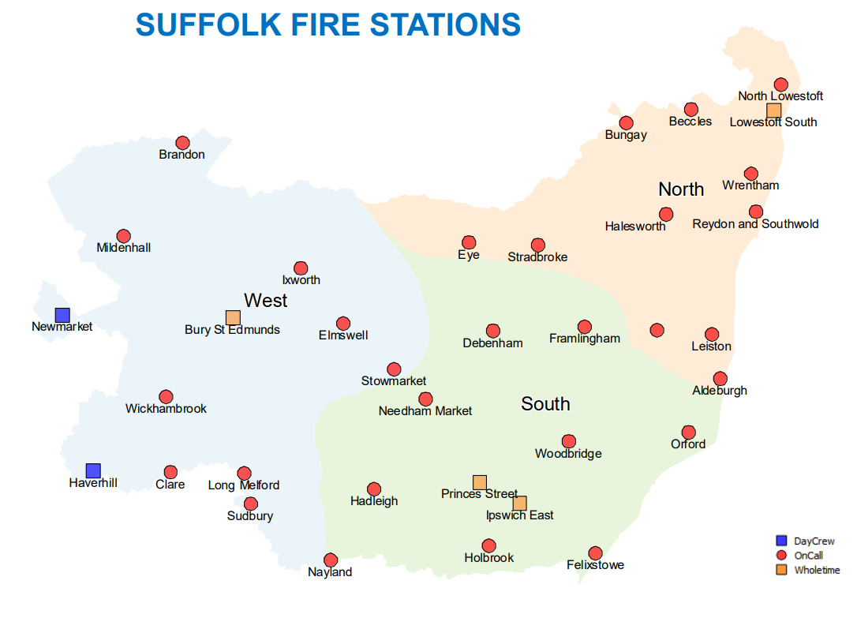

You can also view this map online.

Suffolk Fire and Rescue key statistics

  - As of October 2021:
596 Operational fire staff 76 Non-operational fire staff

43 Fire engines £22.5m 2020/21 budget
1,701 Safer Home Visits (2020/21) 5,449 Service incidents (2020/21)

Source: ⁸

Did you know? You can view live incidents fire and rescue incidents for Suffolk online.

Figure 2: Types of emergency service incidents attended 2016-2021⁸

There are no nationally specified standards for fire services to respond to emergencies. Suffolk endeavours to meet the locally agreed standards on 80% of occasions.

Table 2: Response standards to callouts, 2020/21⁸
Response standard | Description | 2020/21
1 | First fire engine to a property fire in 11 mins | 69.1%
2 | Second fire engine to a property fire in 16 mins | 72.7%
3 | First fire engine to a road traffic collision in 13 mins | 70.4%

Table 3: Protection and prevention (Home Office returns)⁸
 | Planned audit (protection) | Home fire safety checks (prevention)
2020/21 | 462 | 1,701
2019/20 | 782 | 2,970
2018/19 | 491 | 1,548

Table 4: Fire fatalities and casualties, 2020/21⁸
Area | Fatalities | Casualties
England | 240 | 6,347
Suffolk | 2 | 100
Average family group | 3.9 | 66.3

Table 5: Average time for first fire engine to arrive – all Suffolk incidents⁸
Type of crew | 2018/19 | 2019/20 | 2020/21
All Suffolk crew average | 10 mins 02 secs | 9 mins 52 secs | 9 mins 49 secs
On-call crew average | 12 mins 21 secs | 12 mins 11 secs | 12 mins 06 secs
Full time crew average | 08 mins 01 secs | 8 mins 00 secs | 7 mins 58 secs

In 2020/21⁸:
- There were 5,449 recorded fire service incidents, an increase of 188 from the previous year
- For 69% of incidents, the first fire engine arrived at a property fire within 11 minutes
- There were over 1,700 home fire safety checks
- There were 2 fire fatalities and 100 casualties in Suffolk
- The average response time to an incident for all Suffolk crew has decreased by 13 seconds compared to 2018/19
The following data is taken from Home Office returns and may not precisely correlate with the data provided in Figure 2.

Table 6: Fire statistics table 0102: Incidents attended by Suffolk fire and rescue services, by incident type⁹
 |  |  |  | Primary fires
Year | Total incidents |  | Total fires | Total | Dwellings | Other Buildings | Road Vehicles |  | Other Outdoors | Secondary Fires  1,151 | Chimney Fires  159
2011/12 | 5,742 |  | 2,322 | 1,012 | 355 | 261 | 317 |  | 79
2012/13 | 4,802 |  | 1,499 | 766 | 297 | 194 | 220 |  | 55 | 544 | 189
2013/14 | 5,208 |  | 1,953 | 831 | 302 | 209 | 233 |  | 87 | 921 | 201
2014/15 | 4,919 |  | 1,652 | 805 | 324 | 188 | 230 |  | 63 | 710 | 137
2015/16 | 4,956 |  | 1,740 | 879 | 330 | 190 | 256 |  | 103 | 761 | 100
2016/17 | 5,128 |  | 1,759 | 879 | 315 | 215 | 248 |  | 101 | 767 | 113
2017/18 | 4,779 |  | 1,656 | 804 | 296 | 180 | 220 |  | 108 | 754 | 98
2018/19 | 5,331 |  | 1,943 | 852 | 281 | 217 | 249 |  | 105 | 1,008 | 83
2019/20 | 5,107 |  | 1,641 | 790 | 303 | 213 | 209 |  | 65 | 773 | 78
2020/21 | 5,309 |  | 1,733 | 754 | 284 | 196 | 212 |  | 62 | 886 | 93
Year ending Dec 2021 | 5,301 |  | 1,422 | 714 | 305 | 170 | 179 |  | 60 | 630 | 78

Table 7: False alarms and non-fire incidents by year and type for Suffolk⁹
 |  | Fire false alarms |  |  |  |  | Non-fire incidents
Year | Total | Due to apparatus | Good intent | Malicious |  | Total | Non-fire false alarms | Special services
2011/12 | 2,593 | 1,734 | 811 | 48 |  | 827 | 42 | 785
2012/13 | 2,419 | 1,707 | 634 | 78 |  | 884 | 35 | 849
2013/14 | 2,435 | 1,656 | 707 | 72 |  | 820 | 40 | 780
2014/15 | 2,425 | 1,681 | 674 | 70 |  | 842 | 37 | 805
2015/16 | 2,374 | 1,684 | 631 | 59 |  | 842 | 38 | 804
2016/17 | 2,350 | 1,641 | 643 | 66 |  | 1,019 | 36 | 983
2017/18 | 2,137 | 1,448 | 638 | 51 |  | 986 | 25 | 961
2018/19 | 2,396 | 1,552 | 765 | 79 |  | 992 | 31 | 961
2019/20 | 2,318 | 1,621 | 638 | 59 |  | 1,148 | 47 | 1,101
2020/21 | 2,450 | 1,582 | 817 | 51 |  | 1,126 | 19 | 1,107
Year ending December 2021 | 2,531 | 1,719 | 765 | 47 |  | 1,348 | 19 | 1,329

Primary fires are defined as fires that meet at least one of the following conditions:
(a) any fire that occurred in a (non-derelict) building, vehicle or outdoor structure,
(b) any fire involving fatalities,
(c) any fire attended by five or more pumping appliances.

Table 8: Fire statistics table 0903: Rate of non-fire incidents attended per 100,000 people, by type of incident, Suffolk fire and rescue authority⁹
Rate of non fire-incidents per 100,000 people | Suffolk | England
Road Traffic Collision (RTC) | 25 | 40
Medical incidents | 3 | 24
Assist other agencies | 37 | 35
Flooding and rescue or evacuation from water | 18 | 29
Effecting entry / exit | 12 | 43
Lift release | 2 | 14
Suicide / attempts | 2 | 4
False alarm | 2 | 12
Other | 47 | 66
Total | 148 | 267

- Home Office returns indicate 1,733 primary fires in 2020/21, over the last 10 years the average number of primary fires in Suffolk was 1,790 per year.
- When broken down by fire type, in 2020/21 dwelling fires were the most common type of fire attended. This is akin to England data.
- 2020/21 data indicates there were a lower number of RTCs– this could be an impact of reduced travel due to the pandemic. There were 189 RTC incidents attended by SFRS in 2020/21 compared to 286 in 2019/20. Future trend data will need to be monitored to see if this reduction is sustained.
- There were 2,450 false alarms registered in 2020/21, 65% were due to apparatus, 33% were good intent false alarms, with 2% being malicious, these percentages align to England percentages.
- When examining non fire incidents SFRS is most commonly called to assist other agencies, predominately the ambulance service. This was followed by attendance to RTC and flooding.
- Data for England indicates a callout rate of 24 per 100,000 population for medical incidents, this was much larger than the Suffolk rate of 3 per 100,000 population in 2020/21.
- National data indicates that a higher number of fire fatalities were in older age groups (age 65 and over) in 2020/21. Those aged 80+ have the highest fatality rate at 17.2 per million population⁹.
- Nationally, both fatalities and non-fatal casualties were higher in single occupancy dwellings⁹.

National and local risks
The National Risk Register (NRR) provides a government assessment of the likelihood and potential impact of a range of national security risks. The risks are thematically grouped to bring together risks that share similar risk exposure and require similar capabilities to prepare mitigate and
respond. The thematic groups and most pertinent risks identified by the NRR for SFRS are provided below.

Table 9: Pertinent risk identified by the NRR for SFRS
Environmental Hazards | Human and animal health | Major Incidents | Societal Risks | Malicious Attacks | Risks occurring overseas.
Flooding | Human diseases | Widespread electricity failure | Industrial action | Attacks on publicly accessible locations | Risks occurring overseas.
Severe weather | Animal diseases | System failure | Widespread public disorder | Attacks on transport systems
Severe space weather | Antimicrobial resistance | Major transport accidents |  | Attacks on infrastructure
Poor Air Quality |  | Industrial accidents |  | Chemical, biological, radiological and nuclear attacks
Earthquakes |  | Major Fires |  | Cyber attacks
 |  |  |  | Disinformation
Note: Table reused from Lancashire Fire and Rescue Strategic Assessment of Risk

Suffolk Resilience Forum (SRF)
A lot of the information in this document links to the Suffolk Resilience Forum (SRF). Local resilience forums (LRFs) are multi-agency partnerships made up of representatives from local public services, including the emergency services, local authorities, the NHS, the Environment Agency and others. These agencies are known as Category 1 Responders, as defined by the Civil Contingencies Act. SFRS is classed as a Category 1 responder.

LRFs are supported by organisations, known as Category 2 responders, such as the Highways Agency and public utility companies. They have a responsibility to co-operate with Category 1 organisations and to share relevant information with the LRF. The geographical area the forums cover is based on police areas. The SRF agrees annually a Community Risk Register that allows a structure of standing contingency plans/protocols to be developed by a lead responding agency.

Suffolk community risk register
The Suffolk community risk register depicts risks that have been identified to affect Suffolk including the assessment of each risks impact and likelihood. The risks are presented in a matrix that allocates a risk rating (see appendix) according to government guidelines, it is a living document as the Suffolk Resilience Forum members review and update the risks in accordance with the National Risk Assessments produced biennially by the government¹⁰.

The Suffolk risk map below, summarises some of the core risks that impact Suffolk. This includes areas susceptible to flooding, major roads, mass attendance events (for example Latitude festival), sea ports, rail networks and airfields¹⁰. These risks are discussed in more detail later in this document.

Figure 4: Suffolk risk map¹⁰
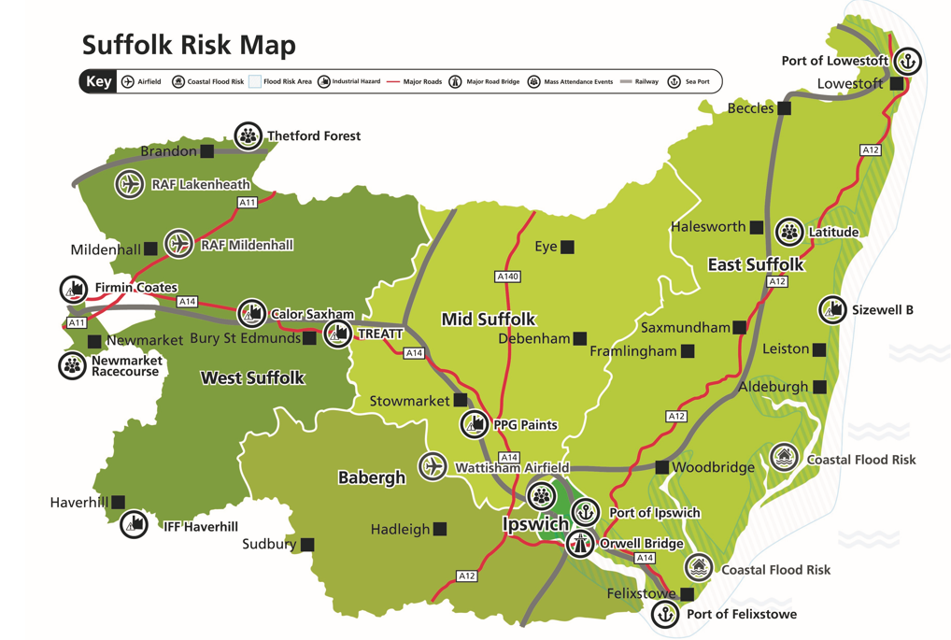

Demographics
The places people live, their age, and other characteristics, can all play a role in risk, and risk mitigation in relation to the Strategic Assessment of Risk. This section presents information about Suffolk residents.

761,246
Suffolk population
(2020)
23.8%
Suffolk residents aged 65 and over
(2020)
6.8%
Estimated population increase between 2021-2041
aged 65 and over
(2020)

2020 estimates indicate Suffolk has a population of 761,246, comprising 375,932 males (49.4%) and 385,314 females (50.6%)¹¹. The population has increased by 3.9% since 2012. Population forecasts indicate that between 2021-2041 the population is expected to increase by 6.8% (approximately 52,000 people) to nearly 822,000 residents¹². In 2020 there were 6,811 live births in Suffolk.

Suffolk is made up of 5 districts and boroughs; East Suffolk is the largest lower tier local authority (LTLA) in Suffolk, with 33% of Suffolk residents living in East Suffolk.

Table 10: Local authority population estimates, 2020¹¹:
Area | Males | Females | Total | % of Males | % of Females
Babergh | 45,088 | 47,647 | 92,735 | 48.6% | 51.4%
East Suffolk | 121,712 | 128,661 | 250,373 | 48.6% | 51.4%
Ipswich | 67,993 | 67,986 | 135,979 | 50.0% | 50.0%
Mid Suffolk | 51,782 | 53,075 | 104,857 | 49.4% | 50.6%
West Suffolk | 89,357 | 87,945 | 177,302 | 50.4% | 49.6%
Suffolk | 375,932 | 385,314 | 761,246 | 49.4% | 50.6%

The population pyramid below shows an older age demographic in Suffolk compared to England, with corresponding lower proportions in children and younger working age adults compared to England.
Figure 5 :Suffolk population by age group, 2020¹¹:

Suffolk has an older resident population compared to England. In Suffolk approximately 24% of people are 65 or over compared to 19% nationally. There is variation within Suffolk, with East Suffolk having the largest population aged 65 and over (28%). Conversely, Ipswich has the youngest population.

Table 11: Residents by age band for local authorities in Suffolk, 2020¹¹
 |  | Resident population
Area | All ages | 0-17 | 18-29 | 30-49 | 50-64 | 65-79 | 80+
Babergh | 92,735 | 17,598 | 9,888 | 20,127 | 20,573 | 17,792 | 6,757
East Suffolk | 250,373 | 47,169 | 27,135 | 52,412 | 54,290 | 49,756 | 19,611
Ipswich | 135,979 | 30,918 | 19,833 | 37,296 | 24,753 | 16,547 | 6,632
Mid Suffolk | 104,857 | 19,654 | 11,778 | 24,002 | 23,384 | 19,393 | 6,646
West Suffolk | 177,302 | 37,524 | 23,450 | 43,751 | 34,213 | 27,390 | 10,974
Suffolk | 761,246 | 152,863 | 92,084 | 177,588 | 157,213 | 130,878 | 50,620
A breakdown of the population of Suffolk by district and borough shows that there is variation around the county, with some local authorities having higher or lower proportions of each age group, compared to figures for the county overall. Those aged over 65 years comprise over 20% of the total population in four of the local authorities, but just 17.1% of the total population of Ipswich. Over 1 in 5 (22.7%) of Ipswich residents are children and young people aged 0-17.

Table 12: Percentage of total local authority population by age band in Suffolk, 2020¹¹
 | % of total area population
Area | 0-17 | 18-29 | 30-49 | 50-64 | 65-79 | 80+
Babergh | 19.0% | 10.7% | 21.7% | 22.2% | 19.2% | 7.3%
East Suffolk | 18.8% | 10.8% | 20.9% | 21.7% | 19.9% | 7.8%
Ipswich | 22.7% | 14.6% | 27.4% | 18.2% | 12.2% | 4.9%
Mid Suffolk | 18.7% | 11.2% | 22.9% | 22.3% | 18.5% | 6.3%
West Suffolk | 21.2% | 13.2% | 24.7% | 19.3% | 15.4% | 6.2%
Suffolk | 20.1% | 12.1% | 23.3% | 20.7% | 17.2% | 6.6%

Ethnicity and diversity

Ethnicity
Please note, the data displayed below is presented for the old district and borough areas, as the data has not been updated since 2011. New census data is due in winter 2022.

At the time of the last Census in 2011, 95.2% of the resident population in Suffolk identified as White, around 5% above the rate for England and 10% higher than the East of England. Suffolk has lower percentages of the other ethnic groups compared to national figures. All local authorities within Suffolk have higher percentages of White residents compared to the county overall, except Forest Heath and Ipswich. Forest Heath is more ethnically diverse, largely due to the presence of American airbases at Mildenhall and Lakenheath.

Table 13: Ethnicity by local authority in Suffolk, 2011¹³
 | % Usual residents
 | White | Mixed | Asian | Black | Other ethnicities
Babergh | 97.8% | 0.9% | 0.8% | 0.3% | 0.2%
Forest Heath | 91.9% | 2.9% | 2.1% | 2.2% | 0.9%
Ipswich | 88.9% | 3.6% | 4.3% | 2.3% | 0.9%
Mid Suffolk | 97.9% | 1.0% | 0.7% | 0.4% | 0.1%
St Edmundsbury | 96.0% | 1.3% | 1.6% | 0.8% | 0.2%
Suffolk Coastal | 96.5% | 1.2% | 1.6% | 0.5% | 0.2%
Waveney | 97.7% | 1.1% | 0.8% | 0.3% | 0.1%
Suffolk | 95.2% | 1.7% | 1.8% | 0.9% | 0.3%
East of England | 90.8% | 1.9% | 4.8% | 2.0% | 0.5%
England | 85.4% | 2.3% | 7.8% | 3.5% | 1.0%

Migration
A note from the Office for National Statistics (ONS): Caution should be taken with all figures when making comparisons between 2020 and previous years' data. The latest data is from pre-COVID (up to March 2020) and from during the pandemic (April to December 2020). The ONS note that restrictions in place during the 2020 lockdown directly impacted population change at the national and subnational level, affected the volume of international migration to and from the UK, as well as disturbing the collection and processing of demographic data from surveys, registration and administrative sources.
As mentioned above, 2020 migration figures have been heavily impacted by COVID-19 and should be interpreted with caution. Therefore, table 14 includes data for 2010/11, 2018/19 (pre-pandemic) and 2019/20 (during pandemic) for a broader comparison. International outflow in Suffolk is slightly below inflow, and internal migration inflow is greater than outflow.
2019 births data shows there were 1,510 live births to mothers born outside of the UK in Suffolk – equating to 20.9% of all live births. This is lower than regionally (26.2%) and England (29.5%).
Suffolk has persistently had a lower percentage of non-British residents as a proportion of the population as a whole, compared to regionally and England. In 2019, there were an estimated 51,000 non-British residents in Suffolk, and in 2020 the estimate was 56,000¹⁴.
Table 14: Long-term international and internal migration mid 2010/11, mid 2018/19 and mid 2019/20 comparison¹⁴
Mid-2010 to Mid-2011
Mid-2011 Population Estimate | Long-Term International Migration |  | Internal Migration (within UK)
 | Inflow | Outflow | Inflow | Outflow
730,133 | 3,083 | 3,022 | 32,791 | 29,942
Mid-2018 to Mid-2019
Mid-2019 Population Estimate | Long-Term International Migration |  | Internal Migration (within UK)
 | Inflow | Outflow | Inflow | Outflow
761,350 | 3,320 | 3,251 | 26,969 | 23,500
Mid-2019 to Mid-2020
Mid-2020 Population Estimate | Long-Term International Migration |  | Internal Migration (within UK)
 | Inflow | Outflow | Inflow | Outflow
761,246 | 3,038 | 2,926 | 24,484 | 21,135

Gypsy and Traveller populations
The term Gypsy, Roma and Traveller (GRT) describes a diverse minority group who come from a range of ethnic backgrounds. GRT are known to experience poorer health and educational outcomes, to face racial discrimination and to be victims of hate crime¹⁵. Gypsies, Travellers and Roma have their own cultural health beliefs, and generally have a lower rate of GP registrations compared to the general population, as well as a life expectancy that is 10 years lower¹⁶.
Information about GRT in Suffolk, especially children and young people, is limited. Data from January 2020 shows there were 370 Traveller caravans in Suffolk¹⁷. Just over one third of these (126 caravans) were based in Mid Suffolk. Whilst some of these 370 caravans will be occupied by families with children, we don’t know how many children there are. There were also 20 caravans belonging to Travelling Showpeople, 17 of which were in Mid Suffolk. The largest site was West Meadows in Ipswich.

Department for Education (DfE) data for January 2021 indicates 0.6% of all school pupils in Suffolk are of Gypsy/ Roma or Traveller of Irish Heritage, this is small number (602 pupils). The proportions are slightly higher compared to England levels (0.4%).

Refugees and asylum seekers
At the end of 2019, nearly 80 million people worldwide had been forcibly displaced from their homes as a result of conflicts, persecution, human rights abuses, and of these, 26 million were refugees¹⁸. Among those displaced, an estimated 40% were children below the age of 18, many of whom would have been living in poor conditions, lost family members, and traumatised by their experiences. Refugees and asylum seekers have distinct needs and require appropriate services, and whilst many are likely to arrive in Suffolk in good health, this is not the case for everyone.

Prior to the invasion of Ukraine there were estimated to be around 2,500 refugees in Suffolk, the majority of whom lived in Ipswich¹⁹. During 2020, the Suffolk Refugee Support charity worked with 227 children in the county aged 0-18 (this number refers only to those children ‘worked with’). There are also currently 80-90 asylum seekers, many of them families, housed in Ipswich under the government’s ‘dispersal’ system.

Data is available on the numbers of confirmed visa applications, visas issued, and the number of persons that have arrived in the UK under the Homes for Ukraine Sponsorship Scheme. The Sponsorship Scheme is for visa applications from Ukrainians who wish to travel to the UK and who have named people in the UK willing to sponsor them. As of 30 May 2022 in Suffolk, there had been²⁰:
  - 1,072 visa applications
  - 946 visas issued
  - 563 arrivals

Housebound populations
There is no single indicator representing the number of housebound residents in Suffolk. However, the following data provides an overview of potential proxy for this indicator. For example, disabled populations may be less likely to leave their homes due to the severity of their disablement; carer populations may be indicative of a housebound resident being cared for, and the carer may also be housebound due to their caring commitments.

At the 2011 census 0.8% of the Suffolk population were residing in medical/care communal establishment (just over 5,600 people)¹³. Caution is advised when using census data as it is now over 10 years old. In 2019/20 there were 1,550 permanent admissions to residential and nursing care homes in Suffolk, a rate of 864 per 100,000 population aged 65 and over. This is statistically significantly higher than the England rate (584 per 100,000 population aged 65 and over).

Attendance allowance is given to those aged 65+ for personal care because an individual is physically or mentally disabled. Entitlement data (so including people that may have their payments suspended as they are in hospital), indicates 20,182 people entitled to attendance allowance in Suffolk, with the highest numbers in East Suffolk (7,833)²¹.
- There are 375 people in Suffolk in receipt of incapacity benefit and severe disablement allowance as of May 2021, and over 12,000 people in receipt of Disability Living Allowance (DLA).
- There are around 13,600 people entitled to carers allowance in Suffolk, with the highest proportion (39%) in East Suffolk.

Table 15:Disability Living Allowance (DLA), cases in payment, May 2021²¹
 | Age
 | 0-17 | 18-64 | 65-84 | 85+ | Total*
Babergh | 662 | 188 | 496 | 60 | 1,409
East Suffolk | 2,270 | 306 | 1,840 | 212 | 4,622
Ipswich | 1,467 | 165 | 795 | 106 | 2,519
Mid Suffolk | 757 | 82 | 502 | 53 | 1,401
West Suffolk | 1,294 | 101 | 916 | 98 | 2,410
Total* | 6,451 | 828 | 4,541 | 527 | 12,352
*Totals may not sum due to rounding

Health
Understanding the health of Suffolk’s residents is also an important component of understanding risk. This is for multiple reasons, but a core factor is that the people most likely to die in a fire are the same people at increased risk of poor health²².

Life expectancy
Life expectancy at birth gives the total number of years a person can expect to live from birth based on contemporary mortality rates. After decades of steady improvements in life expectancy in the UK, the Office for National Statistics (ONS) reported in 2018 on the slowdown in increases in life expectancy since 2011. This trend is continued in the most recent data.

Typically, Suffolk residents live longer than the England average and females live longer than males. Life expectancy at birth in 2018-20 was 84.1 for females and 80.7 years for males in Suffolk. Both figures are statistically significantly higher than the figures for England (83.1 for females and 79.4 for males). However, there is variation across Suffolk. Most districts and boroughs in Suffolk (including Suffolk as a whole) have a significantly higher life expectancy at birth for both males and females than England. However, life expectancies at birth Ipswich males and females are statistically similar to life expectancy for England.

Table 16: Life expectancy at birth 2018-20²³
 | Life Expectancy at Birth
 | Female | Male
Babergh | 85.2 | 81.6
East Suffolk | 83.8 | 80.4
Ipswich | 83.0 | 79.4
Mid Suffolk | 84.8 | 81.4
West Suffolk | 84.3 | 81.0
Suffolk | 84.1 | 80.7
England | 83.1 | 79.4
Colour notes statistical significance compared to England:
Green=better, yellow=similar, red=worse

Quick statistics:
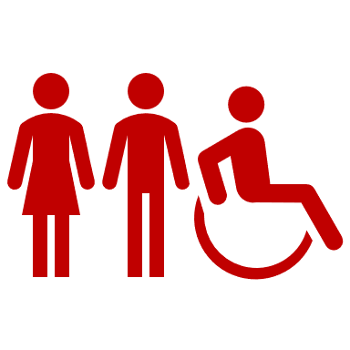

17.9% Suffolk residents with a long term health problem or disability (2011)

21.6% Suffolk children in reception year that are overweight or obese (2019/20)*caution is advised with using this data due to the impact of the pandemic reducing the number of children measured in this age group

31.8% Suffolk children in year 6 that are overweight or obese (2019/20)

62.9% Suffolk adults that are overweight or obese (2020/21)

23.8% Suffolk adults that are physically inactive (2020/21)

Source: ²³

Falls
As people become older, they become increasingly likely to fall. About 1 in 3 people aged over 65 and 1 in 2 people aged over 80 will fall at least once a year²⁴. Women are more likely to fall than men. Falls can cause serious physical injury, for example, a fractured hip, and they can also make people fearful and anxious, which means that they restrict their activities and lose their independence²⁴.

In 2020/21 in Suffolk there were 3,245 emergency hospital admissions for injuries due to falls in persons aged 65 years and over, this equates to approximately 9 admissions per day²³. 70% of these admissions were for people aged 80 years and over. Suffolk has a statistically lower rate of falls compared to the East of England and England overall. In Suffolk, no local authorities had a statistically significantly higher rate of emergency admissions due to falls (aged 65 and over) compared to England.

Smoking
2020 Annual Population Survey (APS) data indicates that 13.7% of the adult population in Suffolk smoke, a statistically similar proportion to both the East of England (12.7%) and England (12.1%)²³. However, for those in routine and manual occupations the smoking prevalence is higher, rising to 24.7% in Suffolk, compared to 23.3% for the East of England and 21.4% for England.

Within Suffolk, whilst the latest data is not available for all areas, data that is available shows variation in overall smoking prevalence, and smoking in routine and manual occupations. Overall smoking prevalence is highest in Ipswich, where approximately 20.2% of the adult population smoke. Smoking in routine and manual occupations is also highest in Ipswich where 43.2% of people working in these occupations smoke.

Figure 6: Smoking prevalence in local authorities in Suffolk (APS), 2018²³

Between 2017-2019, 2,912 deaths were attributable to smoking, equating to nearly 3 deaths every day. In 2019/20 there were 6,696 smoking attributable hospital admissions²³.

Mental health
One in four Suffolk residents experience some form of mental ill health across a spectrum of severity levels in any given year²⁵. Depression is a common and debilitating condition. Figures for 2020/21 indicate that 12.6% people aged 18 and over in Suffolk have been recognised by their GP as having depression (approximately 82,600 people)²³. This is statistically significantly higher compared to England (12.3%) and the East of England (11.3%). Recorded prevalence of depression has consistently increased both nationally and locally over the past 8 years. 2020/21 data indicates that 7,235 people registered at a Suffolk GP were diagnosed with schizophrenia, bipolar affective disorder or other psychoses (approximately 0.9% prevalence rate)²³. 2020/21 data indicates Suffolk has a statistically significantly higher rate of emergency hospital admissions for intentional self-harm, and this has been the case since 2016/17. At LTLA level, self-harm emergency admissions are statistically significantly higher in Ipswich and East Suffolk²³.

Suicide
There were 208 deaths from suicide between 2018-20 in Suffolk, the majority being men (151). The age standardised suicide rate per 100,000 people is not significantly different from regional and national averages²³.

Drug and alcohol misuse
Prevalence estimates for 2016/17 remain the latest available for Suffolk. These suggest there are 3,116 opiate and/or crack cocaine users resident in Suffolk, giving an estimated prevalence rate of 6.9 per 1,000 population²³. Not all of these individuals will be in substance misuse treatment services, and many will be unknown to treatment services. 2020/21 data indicates that there were 1,751 people at specialist drug misuse services, and 793 people at specialist alcohol misuse services in Suffolk. 2020 Suffolk data on successful treatment (i.e. leaving treatment and not re-presenting to treatment again within 6 months) indicates²³:
- Opiate user successful completion of drug treatment percentage: 6.1% (statistically significantly higher than England: 4.7%)
- Non-opiate user successful completion of drug treatment percentage: 32.0% (statistically significantly similar to England: 33.0%)
- Alcohol successful completion of treatment percentage: 29.0% (statistically significantly lower than England: 35.3%)

Alcohol and related disease
Although many people consume alcohol without damaging their health, excessive consumption can cause severe physical and mental ill-health. 2018/19 estimates (latest available) indicate that an estimated 6,811 people in Suffolk are alcohol dependent²⁶. This equates to a rate of 1.1 per 100,000 of the adult population, statistically similar to the England rate (1.37 per 100,000). There were 3,371 hospital admissions for alcohol related conditions (narrow definition) in 2020/21.

Housing
Some properties in Suffolk have a higher risk of fire and vulnerability compared to others (for example thatched properties). The following section provides an overview of buildings that may exhibit higher risk.

Overview of housing in Suffolk
349,940 Properties in Suffolk in 2021

The current housing stock in Suffolk is predominantly old and inefficient to heat

14.5% Suffolk homes are in fuel poverty- 49,018 properties in 2020

Source: ²⁷,²⁸

In 2021, there were nearly 350,000 properties in Suffolk, and there are plans to build more over coming years. Suffolk already has a diverse pipeline of housing sites – ranging from 3-4 houses in rural villages through to major sites with potential to host up to 1,300 homes in major settlements²⁹.

2019 data indicates there were almost 50,000 households in Suffolk in fuel poverty. This equates to 14.5% of all households in the county (compared to 13.4% across England)²⁸. 2020 data indicates that in England 14.3% of properties were off the gas grid³⁰. Within Suffolk the percentage is much higher at 28.7% and varies greatly by district and borough.

Listed buildings
Services relating to conservation areas and the conservation of historic buildings is provided by district and borough councils in Suffolk. Please log on to the Planning Portal for more information.

The Suffolk Register of Buildings at Risk provides details of listed buildings known to be at risk through neglect and decay, or vulnerable to becoming so. View the buildings at risk webpages for more information.

Thatched properties
Due to the history and heritage of Suffolk, there are many thatched properties in the county. Thatched properties have their own special fire safety issues. A thatched roof is always at risk from fire. Once a fire has taken hold in a thatched property it will spread rapidly. Although the most common cause of thatched fires is heat transfer from a chimney, electrical faults, sparks from chimneys/bonfires and lightning strikes can also cause thatched fires. SFRS have produced an online guide to thatched properties.

Blocks of flats
2021 dwelling count data indicates there were 44,510 flats/maisonettes, representing approximately 13% of all properties. This is lower than both the East of England (18%) and England (24%)²⁷.

Suffolk data from the Home Office Incident Recording System indicates that in 2020/21 there were:
- 17 fires attended for converted flats/ maisonettes (single occupancy)
- 48 fires attended for purpose-built low-rise flats/maisonettes (1-3 flats)
- 9 fires attended for purpose built medium rise flats and maisonettes (4-9 flats)
- 1 fire attended for purpose-built high-rise flats (10+ flats)
- 4 fires attended for dwellings of multiple occupancy

Since the Grenfell Tower fire, SFRS has visited and inspected all high-rise residential buildings in Suffolk to ensure that the owners have appropriate fire safety arrangements in place. One example that is currently undergoing repairs and updates to remove cladding is St Francis Court in Ipswich.

The Government have also made recent changes to the Fire Safety legislation that Responsible Persons (RPs) need to be aware of. The Act clarifies that Responsible Persons (RPs) for multi-occupied residential buildings must manage and reduce the risk of fire for the structure and external walls of the building, including cladding, balconies and windows, and entrance doors to individual flats that open into common parts.

Deprivation
Deprivation is another important factor to understand, as there is a link between fire risk and economic and social disadvantage. The English Indices of Deprivation measure relative levels of deprivation in 32,844 small geographical neighbourhoods, called Lower-layer Super Output Areas (LSOAs), in England. It is important to note that these statistics are a measure of relative deprivation, not affluence, and to recognise that not every person in a highly deprived area will themselves be deprived. Likewise, there will be some deprived people living in the least deprived areas³¹.

Suffolk continues to experience below average levels of deprivation. The dramatic change in relative deprivation seen in Suffolk between 2010 and 2015 has not been repeated, but neither has there been much of a recovery in Suffolk’s relative position. At the county level, Suffolk was in the least deprived third of LAs nationally in 2015; now Suffolk ranks just outside the least deprived third (53rd out of 151 Authorities).

11.3% of Suffolk’s LSOAs are in the 20% most deprived in England. 96% of the 20% most deprived LSOAs in Suffolk are in either East Suffolk (20 LSOAs) or Ipswich (28 LSOAs). Ipswich has the highest number and proportion of LSOAs in the 20% most deprived areas nationally, when compared to other local authorities in Suffolk.
Figure 7: Deprivation by LSOAs in Suffolk comparative IMD distribution in 2010, 2015 and 2019
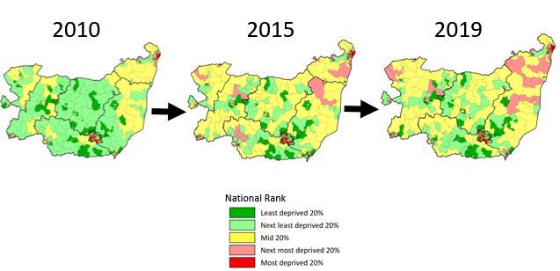

The impact of rurality and deprivation³²
Despite these relatively low levels of overall rural deprivation in Suffolk, small distinct pockets of rural deprivation do clearly exist; these can be hidden by the Indices of Multiple Deprivation being calculated at LSOA level. Suffolk’s rural population is older than its urban population, and the proportion of older people in Suffolk’s rural population is increasing faster than the proportion of older people in urban areas. This trend, combined with the higher cost of providing services in rural areas, housing stock which is often difficult to heat and maintain, poor transport, and more limited social networks, is likely to lead to high and increasing needs and costs for Suffolk’s rural population now and in the future.

Child poverty
Provisional 2021 data for Suffolk indicates 19,929 children aged under 16 living in relative low income families³³. Relative low income is defined as a family in low income Before Housing Costs (BHC) in the reference year. A family must have claimed Child Benefit and at least one other household benefit (Universal Credit, tax credits, or Housing Benefit) at any point in the year to be classed as low income in these statistics.

The chart below shows variation in where children in low income families live in Suffolk. Over 1 in 5 (22.0%) live in Ipswich – equating to 6,130 children. The lowest number of children living in low income families in Suffolk is in Mid Suffolk (1,976), however the lowest percentage is in West Suffolk (10.9%).

Absolute low income is defined as a family in low income Before Housing Costs (BHC) in the reference year in comparison with incomes in financial year ending 2011. A family must have claimed Child Benefit and at least one other household benefit (Universal Credit, tax credits, or Housing Benefit) at any point in the year to be classed as low income in these statistics. 15,925 children under the age of 16 are estimated to be living in absolute low income families in Suffolk in 2021, again the highest number (4,956) and percentage (17.8%) residing in Ipswich³³.

Figure 8: Children (aged under 16) living in Relative low income families³³

Crime and community safety
Crime rates in Suffolk are consistently lower compared to regional and national averages. However, 51,268 offences were recorded from May 2021-April 2022³⁴. The most commonly reported crimes were violence and sexual offences, followed by public order offences. This was the same as in England. Over the same period the three wards with the highest number of recorded crimes were: Harbour and Normanston ward in Lowestoft (3,504) Alexandra ward in central Ipswich (3,333), and Gipping ward in Ipswich (1,661)³⁴.

Safer Neighbourhood Teams work closely with partner agencies to address the issues identified as priorities by the local community. Safer Neighbourhood Teams deliver a truly local policing style – local people working with local police and partners to identify and deal with issues of concern in their neighbourhood.

The Suffolk Police and Crime Commissioner's Police and Crime Plan 2022-2025 sets out strategic priorities for policing and how local resources will be managed to deliver the best possible policing service to communities in Suffolk.

As of March 2021, there were 1243.4 full-time equivalent police officer posts, 897.6 police staff, 118 special constables and 155 police support volunteers. In addition, the force funds 32.8 full-time equivalent police officers based in regional secondments³⁵.

The Police and Crime plan notes that Suffolk Constabulary polices the ninth largest county area in England, and while the population is small compared to some policing areas, the rurality of the area and sparsity of the population, present challenges for policing visibility and emergency response. Similar challenges with rurality exist for SFRS.

Housing and commercial developments (including Freeport East and the proposed development of Sizewell C) in Suffolk will bring more people into Suffolk to work and live, which means more people that need to rely on policing services³⁵. This need will also be felt for SFRS.

Figure 9: Crime rates per 1,000 population by type for Suffolk for May 2021-April 2022³⁴
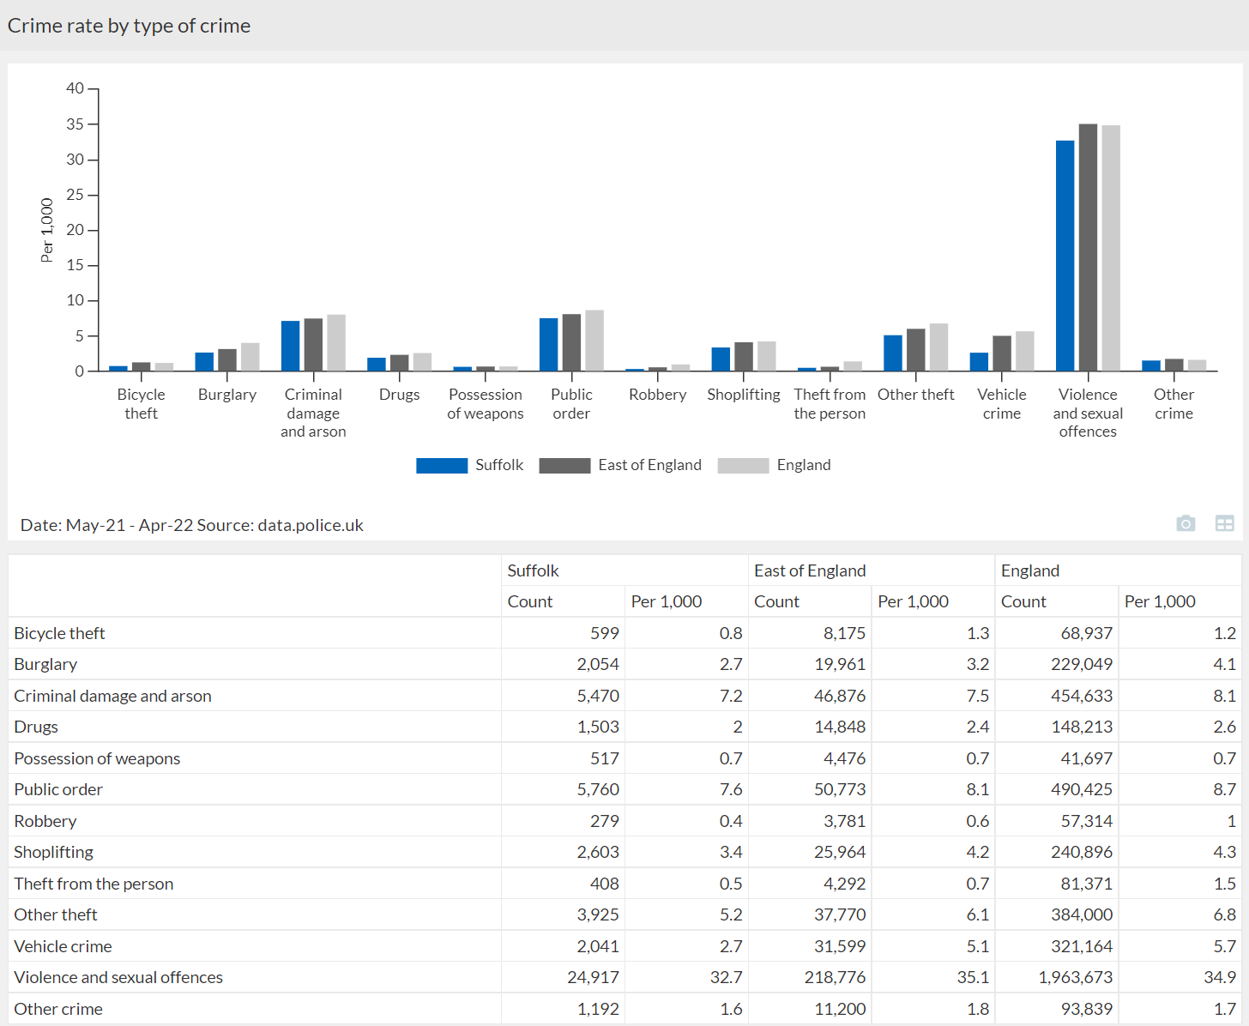

Need more information?
- Visit the Suffolk Observatory crime profile
- Read more about community safety in Suffolk
- Visit the Suffolk Police website

Economy and employment
A very high proportion of Suffolk’s working age residents work. Suffolk has a history of high levels of employment, and has maintained this even through the economic downturn since 2008/9³⁶. Data for 2021 indicates that 78.0% of Suffolk residents aged 16-64 were in employment, compared to 77.9% in the East of England, and 75.1% for England overall.

Figure 10: Employment summary Suffolk, 2021³⁷
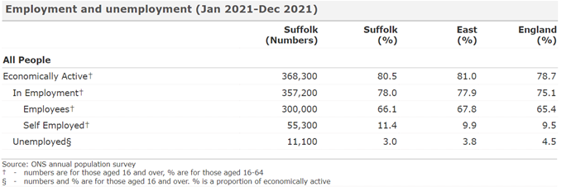

However, for a proportion of Suffolk residents the outlook is more challenging. 2020 data indicates that there were 33,500 workless households in Suffolk (13.6% of households, higher than the East of England- 12.0% and England 13.0%). Rising house prices, a paucity of high paid employment, rural isolation and deprivation, and unemployment all contribute to a challenging living environment. In-work poverty is also a key issue in Suffolk.

2021 data shows that Suffolk residents working full time earn roughly £55 less per week compared to their East of England counterparts, and £40 less per week compared to England as a whole³⁷.

2021 data indicates that the proportion of Suffolk residents with ‘no qualifications’ is 6.7%, higher than the East of England 5.7% and England 6.4%. Longer term trend data (from 2006) has shown the proportion of residents with no qualifications has fallen considerably, but there have been fluctuations in the most recent 3 years – further monitoring is required. Additionally, Suffolk has a lower proportion of the working age population qualified to NVQ4 and above (equivalent to a degree) compared to the East of England and England.

Need more information?
- Visit the Nomis labour market profiles
- Visit the Suffolk Observatory economy and employment profile

Daytime population (commuter flows) and visitors
Please note this data has not been updated since the 2011 census
Data for Suffolk local authorities indicates that Ipswich has the highest net commuter inflow, increasing the overall population size during the working hours. Mid Suffolk has the highest net commuter outflow, resulting in a decreased working hours population.
As well as workday movement, research by Visit England and Office of National Statistics estimated that in 2019 there were a total number of 36,510,922 day visitors to Suffolk. In 20919 there were 1,734,000 staying visitors in Suffolk, staying a total of 6,709,000 nights. The total number of day visitors was 34,776,922³⁸.
Figure 11: Local authority commuter flow data, Suffolk, 2011³⁹
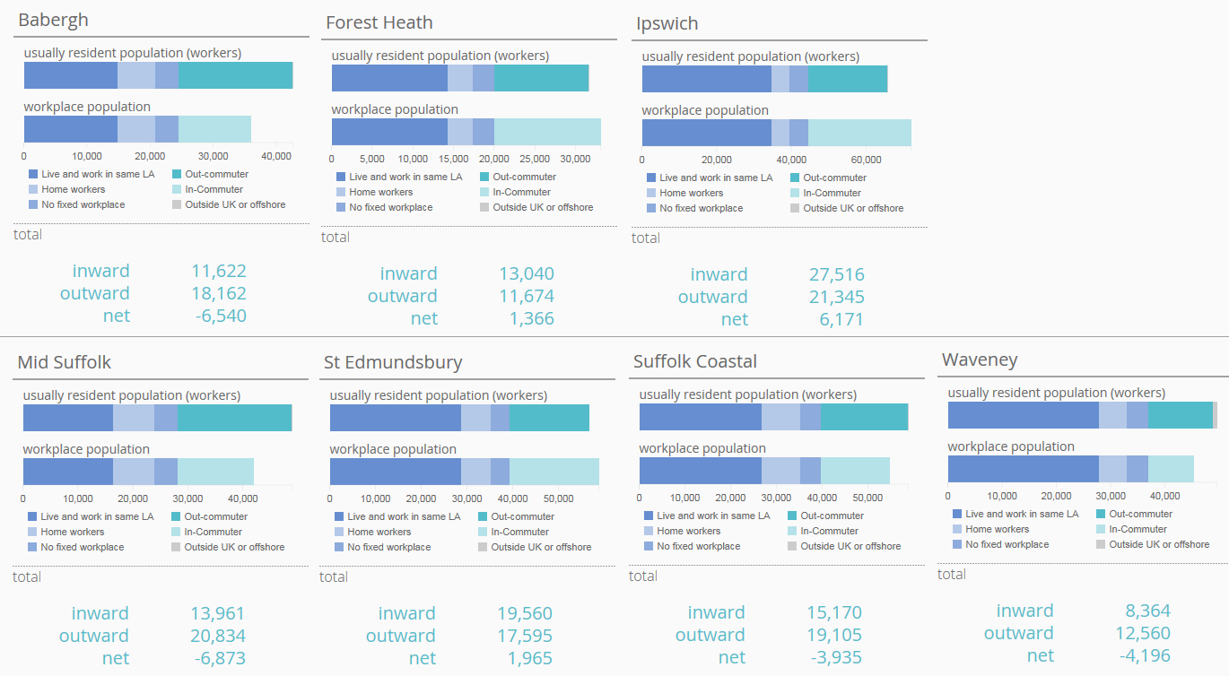

Changing Suffolk
Over the next twenty years there is likely to be a large change in the population of Suffolk, specifically the age of the resident population. Suffolk is expected to see a shift from approximately 1 in 5 residents aged 65 and over to approximately 1 in 3.

Predicted population growth
Population projections from the ONS suggest that the population of Suffolk is expected to increase to an estimated 785,000 by 2026 and 826,000 by 2043. The chart below shows how the different age groups are predicted to change over the coming years. Older age groups are set to increase, most notably those aged 65 and over, who will make up over 30% of the population from 2035.

Figure 12: Population projections by age group 2020 to 2043, Suffolk¹²

Other predicted changes in Suffolk include:

A higher number of people with multiple long-term conditions. As people age, conditions such as heart disease become more common; and some new age-related conditions appear. Many more people will have multiple conditions in Suffolk in 20 years’ time – and multi-morbidity is a key driver of cost.

Those affected by mental health conditions are likely to increase. Suffolk’s overall population is growing, and as many mental health conditions are ‘common’, the number of people experiencing these types of conditions is likely to increase proportionately. At the same time, prevalence of mental health conditions may also be increasing.
Increase in the number of people with dementia. The number of people living with dementia in Suffolk is likely to increase; many new cases will be in people aged over 85.

The demand for homes is likely to increase. The number of households and demand for dwellings are forecast to increase over the next 20 years, and there are likely to be more older households.

Risk areas

Main roads
3. 44 billion vehicle miles were travelled on roads in Suffolk in 2020, down from 4.36 billion miles 2019⁴⁰, this reduction is largely due to the restrictions in place because of the pandemic.

The Suffolk road network totals over 4,300 miles, National Highways maintain trunk roads (roads of strategic importance), but the rest is Suffolk County Council’s responsibility. Included as trunk roads is the A14 linking the port of Felixstowe, to the Midlands. The other strategically import links are the A12 linking Yarmouth to London, the A11 from Newmarket to Thetford and Norwich and the A47 (North) from Lowestoft (River Waveney/Bascule lifting bridge) to Great Yarmouth. Both the A12 and A14 links bypass Ipswich via the south over the Orwell bridge, with 55,000 vehicles crossing the bridge on a daily basis⁴¹. During 2021 National Highways undertook work to make changes to allow the Orwell Bridge to remain open more frequently during high winds, installing new electronic signs on the bridge which display changeable driver speed limits. This allows traffic to still use the bridge even during strong winds (of less than 60mph).

Construction has also started on the creation of a new highway crossing of Lake Lothing, Lowestoft known as the Gull Wing. This will connect Riverside Road to the south of Lake Lothing with Peto Way to the north of Lake Lothing. The Gull Wing will reduce traffic congestion in the town, regenerate the area and attract new investment for the local economy.

The strategic lorry network gives the preferred links for lorries for haulage and distribution. It identifies not only the preferred routes within the county, but those same routes also interconnect to adjacent counties. In 2021, a technical and community led review of lorry routes that considered changes to the highway network commenced. Look and explore the draft version of the Lorry Route Network map online. The final review will be published during 2022.

Road users
While accepting that all road users have a responsibility for road safety, several cohorts of specific concern have been identified in Suffolk⁴²:
- Motorcyclists - especially those riding bikes over 500cc
- Young drivers/ riders (16-24 years of age)
- Pedestrians (especially school age children in deprived areas)

Other areas of concern are:
- Safety of work-related driving - including those commuting to work as well as for work purposes
- Offending drivers – otherwise known as ‘the fatal four’, drink/drug driving, speeding, driver distraction and failure to wear a seatbelt
- Older drivers

Suffolk Roadsafe is a non-statutory Board which was created in May 2007. The partnership aims to make Suffolk’s roads safer for all. Suffolk Fire and Rescue Service forms part of this partnership.

SFRS offer a variety of road safety education initiatives:
- The FireBike team attends events and biker gatherings throughout Suffolk and the Eastern Region, to talk to riders about road safety.
- As bikers tend to ride in groups or pairs, it is usually the case that when one is involved in an incident, the first person on the scene will be a fellow biker. Biker Down is a free awareness-raising course for bikers.
- ItCanWait is a pre-driver road safety intervention which aims to reduce the use of mobile phones by drivers, it is delivered by SFRS personal to 15 to 18-year-olds.

Suffolk Roadsafe’s 3-year review 2016-2018 (latest available), highlighted several potential areas to monitor in relation to horizon scanning:
- Changes in Suffolk’s home to school transport policy could result in an increase in walking and cycling on unlit rural roads, more young drivers from identified groups already overrepresented, increased ‘school gate congestion’ and associated issues around inconsiderate parking.
- Housing developments: there is a need to ensure that only the sites that contribute positively to road safety are allocated in the local plans.
- Connected and Autonomous Vehicles (CAVs) offer the potential to significantly improve access for those who are unable to drive. This could be very positive in reducing collisions, but technology is still developing in this area and needs to be monitored.
- The changing and ageing population demographic is likely to result in an increase in older drivers on Suffolk’s roads. For many, due to the rural nature of the county, driving may be their only transport option. There is a need to ensure older drivers dealing with complex traffic environments and the cognitive demands of driving are both safe to drive and supported where necessary.

Winter planning
Suffolk County Council has a legal duty to ensure that, as far as is reasonably practicable, safe passage along a highway is not endangered by snow or ice and ‘Suffolk Highways’ delivers the winter service function on behalf of Suffolk County Council⁴³. The objective of the Winter Service Plan is to put in place the policy and processes to maintain the highway in a safe condition for the travelling public, free from snow and ice as far as is reasonably practicable. The plan is reviewed on an annual basis at the end of each winter period.

The plan notes:
- The winter period is from 1st October to 30th April.
- The core winter period and the main period of risk for the winter service is from 1st November until the 1st March.
- Forecasts are monitored daily during the winter period to ensure that a response can be provided should it be necessary.
- Suffolk Highways introduced a COVID-19 Winter 2021/2022 Support Document which forms part of the appendices to the main winter plan.
- Under the winter plan access to 24 hour fire stations is included under the ‘Priority 1 (P1) Network’.

Electric vehicle charging
Suffolk County Council, in partnership with Suffolk's district and borough councils, is working towards supporting and facilitating the uptake of electric vehicle (EV) charging opportunities across the county.

There are a range of benefits of electric vehicles, including air quality and economic benefits. As the up-take of electric vehicles increases, SCC need to ensure that a strategy is in place that reflects the role of the local authorities and explores the options for public charging across Suffolk.

There are already a number of electric vehicle charging points available to the public in Suffolk. These are provided by several different charge point networks. You can see an overview of most of the UK charging networks on Zap-Map.

Babergh and Mid Suffolk District Councils led a bid on behalf of councils in the East of England for 100% grant funding to install rapid EV charge points in East Anglia. The rapid charge point will have the ability to provide an 80% charge in 30 minutes which will help remove range anxiety for EV drivers.

The locations are:
- St Edmundsbury Borough Council and Forest Heath District Council (Central Bury St Edmunds)
- Great Yarmouth Borough Council (Great Yarmouth)
- Norwich City Council (UEA Norwich)
- Breckland District Council (Attleborough, Swaffham, Thetford, Dereham)
- Suffolk Coastal District Council (Felixstowe)
- Ipswich Borough Council (Central Ipswich)
- Tendring District Council (Harwich)
- Babergh and Mid Suffolk District Council (Needham Market)

All 11 will have contactless payment facilities so there is no need to subscribe to a specific charging network.

SFRS will have electric vehicle charging in place at 3 strategic sites by end of 2022 to support the purchase of 20 EV's (mixture of officer response cars and non-operational support vehicles) this will include both fast and rapid charge points at Bury St Edmunds, Ipswich East, and Lowestoft South Fire Stations.

SFRS have gained additional knowledge in dealing with EV fires from site visits to garages in Suffolk, for example a visit to Ipswich Volkswagen in September 2021. SFRS’s equipment officer has been researching electric vehicle (EV) products to support fire service intervention at such events involving EV vehicles in fires, RTC’s etc. SFRS has established and maintained several links within the NFCC attending meetings together, discussing this evolving subject, sharing best practice and updates.

Need more information?
- More information about Suffolk’s policy, strategy and plans for maintaining highways assets in Suffolk can be found on the Suffolk County Council roads and transport webpages.
- Take part on the Biker Down course, or book an #ItCanWait session, which both aim to reduce the number of collisions on Suffolk's roads through education.
- More information about Suffolk Road Traffic Collision Data is available online.

Killed or seriously injured on the roads
Data for Suffolk indicates that in 2020, 265 people were killed or seriously injured (KSI) on the county’s roads and the rate of KSI in Suffolk is statistically significantly similar compared to England. Pooled data for Suffolk for 2018-20 indicates that 53 children under 16 years of age were KSI, again the rate was statistically similar to England. Emergency admissions to hospital for motorcyclists aged under 25 were statistically significantly worse compared to England, as were slight and serious casualties aged under 25 years.

Figure 13: Summary traffic accident data for Suffolk, mixed years²³
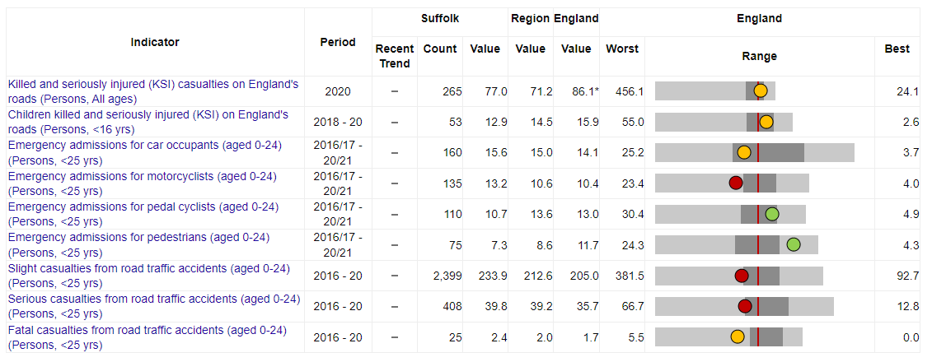
Benchmark = England
Note KSI for adults is per billion vehicle miles travelled, all others are per 100,000 population.

Rail networks
Although major railway incidents in the UK are rare, they place significant demands on local fire and rescue services and often require resources and support from neighbouring fire and rescue services and emergency responders. Additionally, smaller scale incidents involving railways are more prevalent⁴⁴. The Fire and Rescue Service Operational Guidance – Railway Incidents provides guidance that can be adapted to the nature, scale and requirements of the incident.

Passenger Train Services in Suffolk are provided by Greater Anglia. Passenger services run along the Great Eastern Main Line (GEML) between London Liverpool Street and Norwich in addition to the East Suffolk Line (Ipswich to Lowestoft and Felixstowe) and the West Suffolk Line (Ipswich to Cambridge/ Ely via Bury St Edmunds). The GEML is electrified (25Kva Overhead Line) with services being provided by a mixture of electric and diesel traction. The East and West Suffolk lines are not electrified and are operated by diesel traction only.

There are 25 rail stations in Suffolk. The busiest stations in Suffolk are Ipswich (726,756 entries and exits in 2020/21) followed by Stowmarket (185,762) and Bury St Edmunds (151,515)⁴⁵. Statistics on station usage can be found via the Office of Rail and Road website. The Anglia route strategic plan is also published online.

In addition to passenger services, Suffolk’s railway carries a significant amount of rail freight which is primarily container traffic to and from the Port of Felixstowe. However, there are a smaller number of trains carrying aggregates from a number of sites and natural gas condensate from North Walsham. These freight services use the GEML to and from London and the West Suffolk Line towards Ely/Peterborough and are operated by several rail freight companies⁴⁶.

Airports, air bases and military presence
There are no public airports in Suffolk, however there are several in neighbouring counties:
- London Stansted (Essex)
- Norwich Airport (Norfolk)
- Cambridge International Airport (Cambridgeshire)
- The Imperial War Museum Duxford is also near to the Suffolk border.

There is a significant military air force presence in terms of two large US Air Force bases in Forest Heath in Suffolk (Lakenheath and Mildenhall). 2015 plans for the United States Airforce to withdraw from Mildenhall were scrapped in 2020. There are UK armed forces bases at Honington, Wattisham and Woodbridge.

Drones/ small unmanned surveillance aircraft may pose a collision risk to an aircraft. More information is available on the Civil Aviation Authority website.

The current Suffolk Community Risk Register identifies the relative likelihood of an aviation incident as LOW risk. The Suffolk Resilience Forum’s Aviation Incident Plan from 2016 identifies that particular attention must be paid in relation to crashed military aircraft as there are specific hazards associated with munitions. The 2016 aviation incident plan notes that in the event of an incident SRFS responsibilities will include:
- Early consideration of the effects the incident may have on the environment and potential action to be taken to minimise this.
- In conjunction with the police, participate in the aircraft crash investigations led by the AAIB and preparation of reports with supporting evidence for subsequent enquiries.
- Facilitate a coordinated Fire and Rescue / USAF response where appropriate, utilising specialist knowledge and equipment from both services.
United States Air Force Base Plans are restricted due to data sensitivity.

Need more information?
- A list of all UK units in Suffolk and their location can be found on the Suffolk military covenant website.

The Port of Felixstowe
The Port of Felixstowe is the biggest and busiest container port in Great Britain, as well as one of the largest in Europe. An estimated 3,000 ships use the Port every year, including the largest container vessels afloat, and the Port handles over 4 million containers (TEUs – twenty-foot equivalent units)⁴⁷.

The Port of Felixstowe provides some of the deepest water close to the open sea of any European port, with an estimated 30 shipping lines operating from it, that offer 90 services to and from 400 global ports⁴⁷.

Additionally, 70% of the containers that come through the port are delivered to the ‘Golden Triangle’. This is a region in the middle of Britain where a vast number of main high street and online retailers have their national distribution centres⁴⁷.

Harwich International
Although located in north-east Essex, Harwich International port is very close to the Suffolk border and is one of the UK’s leading multi-purpose freight and passenger ports. It is included here as there may be a need for SRFS to respond to a marine and/or shore-based incident.
Need more information?
- Port of Felixstowe website
- Harwich International website

Other ports and maritime
The Port of Ipswich is the UK’s biggest grain export port and handles approximately 2 million tonnes worth of goods each year. The Port of Lowestoft is the home of the Operation and Maintenance Base for Greater Gabbard Offshore wind farm and handles around 100,000 tonnes each year. Due to Suffolk’s coastal nature there are many sea fishing locations such as Aldeburgh and Southwold.
Need more information?
- Ipswich port
- Lowestoft port

Offshore wind farms
There are several large wind farms proposed or being constructed off the coast of Suffolk:
- The Galloper Wind Farm and the Greater Gabbard Wind Farm, 14 miles off the Suffolk coast from Orford are complete and in operation. Further development is planned in the form of Five Estuaries Offshore Wind Farm.
- The East Anglia Offshore Wind Farm, approximately 27 miles off the Suffolk coast is also now fully operational with 102 offshore wind turbines. Further development includes East Anglia Two and East Anglia Three.
- The Suffolk County Council website has more information about offshore wind energy in Suffolk.

Piers
Piers in Suffolk are key to tourism and part of Suffolk’s heritage. However, due to the exposed nature of the piers, they can be at risk of fire, storm damage and maritime incidents⁴⁸. There are four piers in Suffolk, one in Felixstowe, one in Southwold and two in Lowestoft (Claremont and South Pier).
Need more information?
- Felixstowe pier
- Southwold pier
- Southwold South pier
- Southwold Claremont pier

Other key tourism areas
Locations where large groups of people congregate for business, leisure or other reasons, have the potential to pose a variety of risks and hazards that SFRS may have to attend to. Key sites in Suffolk include:
- Ipswich Town Football Club – Portman Road in central Ipswich is home to the Ipswich Town football team. On matchdays, the stadium can accommodate just over 30,000 supporters seated in four separate stands⁴⁹.
- Center Parcs Elveden – The popular holiday village resort is located in 400 acres of Suffolk woodland, approximately 450,000 guests visit Elveden Forest every year.
- Foxhall Stadium – Situated in Kesgrave the Foxhall International Raceway hosts events such as the National Banger World Final and the National Hot Rod World Championship⁵⁰
- Go Ape – This popular tree top zip wire and high rope activity course is situated in Thetford Forest.
- Latitude festival – This annual event attracts thousands of festival goers over a weekend in Henham Park in Suffolk.

Control of Major Accident Hazards (COMAH) Sites
COMAH (Control of Major Accident Hazards) sites are industrial sites which hold a quantity of dangerous substances over a certain level, the consequences of an incident involving these substances could potentially harm the public or the environment⁵¹.

The Control of Major Accident Hazards (COMAH) Regulations ensuring that businesses: "Take all necessary measures to prevent major accidents involving dangerous substances. Limit the consequences to people and the environment of any major accidents which do occur"⁵².

Public COMAH 2015 information (searchable by postcode) can be found on the Health and Safety Executive (HSE) webpages.

Suffolk has 4 upper tier COMAH sites that require the production of offsite emergency plans, known as External Emergency Plans:
- International Flavours & Fragrances (GB) Limited - Duddery Hill, Haverhill CB9 8LG
- PPG Industries (UK) Limited - Needham Road, Stowmarket, IP14 2AD
- Calor Gas - Saxham Operations Centre, Newmarket Road, Risby, IP28 6QY
- Treatt PLC - Skyliner Way, Bury St Edmunds, Bury Saint Edmunds IP32 7FR
Suffolk COMAH External Emergency Plans are held by the Suffolk Resilience Forum.

Radiation (Emergency Preparedness and Public Information) (REPPIR) sites
“REPPIR establishes a framework of emergency preparedness measures to ensure that members of the public are properly informed and prepared, in advance, about what to do in the unlikely event of a radiation emergency occurring, and provided with information if a radiation emergency actually occurs”⁵³.

There is one REPPIR site in Suffolk, the Sizewell B Nuclear Power Station near Leiston in Suffolk. Sizewell B is the UK’s only Pressurised Water Reactor. The Sizewell Offsite Plan sets out the Multi-Agency strategic and tactical management arrangements for dealing with a nuclear emergency (i.e. an incident with off-site radiological implications) at either Sizewell A (shut down in 2006) or Sizewell B nuclear power stations⁵⁴.

There are plans to open a new nuclear power station in Suffolk – Sizewell C. The scale and nature of this construction project (including a large workforce influx) may pose additional risks to SRFS that may need to be considered.

Fire safety for farmers and rural businesses
Suffolk is a rural county, with many farms and rural businesses. SFRS produces advice for farmers and businesses working in Suffolk's countryside on prevention, reducing arson and Avian flu. This includes advice on arson reduction, fertilizer storage and management.

Climate change and associated risk
Human activities emit carbon dioxide (CO₂) into the atmosphere. Along with other ‘greenhouse gases’, too much CO₂ in the atmosphere raises the global temperature. This rise in temperature is driving changes to our climate that will, if left unchecked, make the population’s current way of life impossible on the planet⁵⁵.

The 2022 UK Climate Change Risk Assessment report highlights that climate change has already caused irreversible damage to the planet⁵⁶. Many risks are highlighted in the report. However, eight priority risk areas have been identified as requiring the most urgent UK-wide action over the next two years. These are highlighted in the table below.

Table 17: Priority risk areas for the next two years⁵⁶
Priority risk area | Magnitude of risk | Priority risk area
Risks to the viability and diversity of terrestrial and freshwater habitats and species from multiple hazards | High | Biodiversity  Soil and water protection and restoration  Environmental land management Sustainable farming and forestry Net Zero  Green finance
Risks to soil health from  increased flooding and  drought. | Medium but will increase to high by 2050. | Biodiversity  Soil and water protection and  restoration  Environmental land management  Sustainable farming and forestry  Net Zero  Green finance
Risks to natural carbon stores and sequestration from multiple hazards leading to increased emissions. | Medium but will increase to high by 2050. | Biodiversity  Soil and water protection and restoration  Environmental land management Sustainable farming and forestry  Net Zero  Green finance
Risks to crops, livestock and  commercial trees from multiple hazards. | Medium but will increase to high by 2050. | Biodiversity  Soil and water protection and restoration  Environmental land management Sustainable farming and forestry  Net Zero  Green finance
Risks to supply of food, goods and vital services due to climate-related collapse of supply chains and distribution networks | High | Public procurement  Business resilience  Environmental land management Trade
Risks to people and the  economy from climate-related  failure of the power system | High | Infrastructure  Energy  Net Zero
Risks to human health, wellbeing and productivity from increased exposure to heat in homes and other buildings | High | Building regulations and strategies  Planning reform
Multiple risks to the UK from  climate change impacts  overseas | High | National resilience  Overseas aid  Research and capacity building

These risks may have both direct and indirect impacts on SFRS for example:
- Increased flooding may result in increased emergency callouts.
- Water shortages or droughts could cause not only issues for the public water supply, but also in relation to extinguishing fires in emergencies.
- Droughts and high temperatures also increase the risk of wildfires.
- Supply chain shortages may cause issues with technology or fleet delivery.

Solar farms
Whilst solar farms are providing innovative and greener sources of energy, there are concerns around the risk of fire from battery storage. This is because whenever a large amounts of energy is stored (whether in traditional liquid/gas forms or in batteries), there is a possibility that an uncontrolled release of the energy could result in a fire or explosion⁵⁷. Thermal runaway is a risk here – this is where a damaged battery begins to release energy in the form of heat, leading to further damage and a feedback loop that results in rapid heating⁵⁷. Examples of solar farms in Suffolk include Toggam Solar in West Suffolk, various sites in Babergh and Mid Suffolk and East Suffolk, with proposals are in place for a new energy farm (Sunnica) on the Cambridgeshire/ Suffolk border.

SFRS have been working closely with Cambridgeshire FRS regarding a large-scale project (Sunnica), which has seen large media interest and specialists on both sides offering opinions and objections. SFRS have also been working with additional companies looking at installing Battery Energy Storage Systems (BESS) within Suffolk and offering advice as to what the Service would require to support such developments. This has seen SFRS engaging with both engineers, developers and local crews feeding into the ‘Emergency Action Plan’ (EAP) for such sites. Several SFRS staff and crews have visited sites both in Suffolk and cross boarder in Cambridgeshire. SFRS has communicated with Merseyside FRS regarding a significant fire, supporting learning nationally on BESS sites, which is again supporting ongoing workstreams.

Suffolk County Council climate emergency
In 2019, Suffolk County Council declared a climate emergency. The council has pledged to become a carbon neutral authority by 2030. In order to start to drive this change, the council has set up a Policy Development Panel (PDP) to explore how Suffolk County Council's carbon and harmful emissions on a spend to save basis. Work will occur with partners both at a county and regional level, as well as working with Government to become cleaner and greener.

Whilst all efforts to reduce Suffolk’s carbon footprint are welcomed, there is an acknowledgement that the SFRS vehicle fleet still relies upon fossil fuels. However, new technology is constantly being explored. For example, SFRS has started Phase 1 of its fleet electrification which will see the next procurement of 20 vehicles being EV's and this is supported by capital investment in strategic charging sites across the county with both fast and rapid chargers for dedicated SFRS use being install during 22.

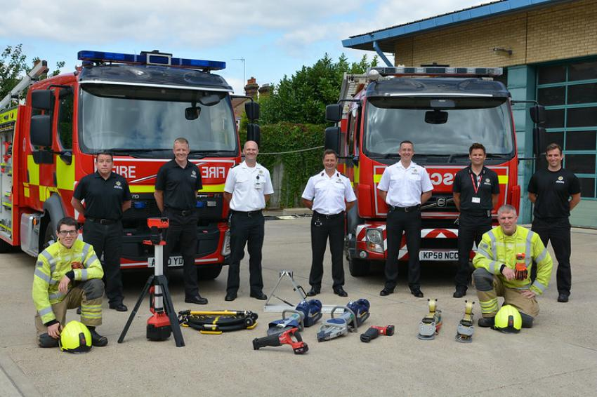
In August 2021, four new “enhanced rescue tenders” were added to SFRS’s fleet, based at Bury St Edmunds, Lowestoft, Newmarket and Princes Street (Ipswich)⁵⁸. These vehicles provide cover across the county and strengthen the emergency response across Suffolk’s communities. The new equipment and vehicles are also the latest innovations in green technology, supporting Suffolk County Council’s climate emergency declaration and ambitions to be net zero by 2030. The fire appliances are the first in Suffolk to be fitted with solar panels, have more fuel-efficient engines and also carry battery powered hydraulic rescue equipment.

In addition, in November 2021, significant investment was made by SCC to decarbonise buildings and this includes fire stations.

Wildfire incidents
Wildfires not only endanger human life, but they also kill wildlife and destroy habitats and the natural environment. Climate change is a factor in the frequency and severity of such fires. SFRS publishes data on wildfire incidents attended. These are shown in the accompanying chart. Suffolk data indicates that over the last 7 years, there has been a mix of both deliberate and accidentally started wildfires in Suffolk.
Figure 14: Wildfire incidents by year⁵⁹
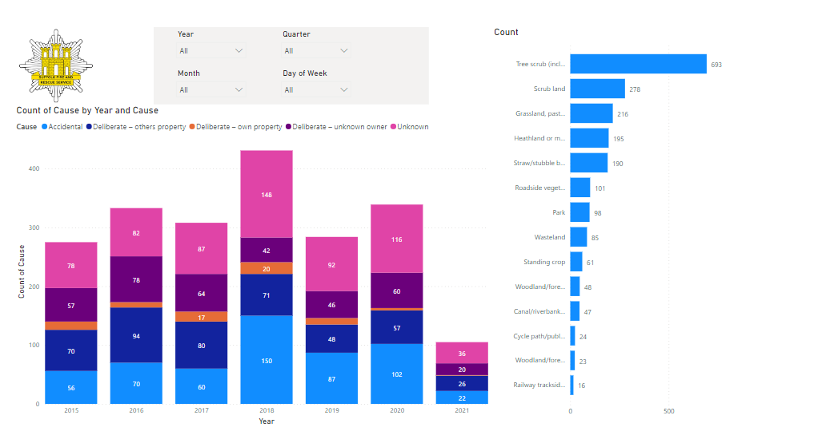

Flooding and severe weather
Suffolk is subject to flooding from the sea, rivers, rain and ground water⁶⁰. As a result of climate change, both the chances and consequences of flooding are likely to increase⁶¹. In February 2022, Suffolk declared a major incident in relation to storm Eunice, which caused major disruption in Suffolk⁶². During the storm:
- Suffolk Constabulary received 339 calls to 999 and 431 calls to 101 – 150 of these were weather related.
- Suffolk Fire and Rescue Service attended 51 incidents.
- Suffolk Highways received 146 reports of fallen trees and road obstructions. Teams worked throughout the night to clear these.
- UK Power Networks reported 13,900 properties in Suffolk without power.

Suffolk County Council is a Lead Local Flood Authority as defined in the Flood and Water Management Act 2010. The council is responsible for coordinating a partnership approach to flood and coastal risk management with all risk management authorities in Suffolk. This is done through the Suffolk Flood Risk Management Partnership.

The partnership has produced a Flood Risk Management Strategy to help everyone understand and manage flood risk within Suffolk. The Green Suffolk website provides more information about flooding.

Local authorities in Suffolk won’t provide sandbags to try to protect individual properties, but instead use these limited resources in bulk to raise and repair defences or divert water away from groups of properties.

The Suffolk Resilience Forum produced a Suffolk Flood Plan in 2018. The Suffolk Community Risk Register matrix identifies the likelihood of coastal flooding as medium/high and fluvial flooding as medium (see appendix).

Need more information?
- Suffolk Local Energy Asset Representation (LEAR) report
- GOV.UK Flood Risk Mapping information service
- Suffolk County Council flood reporting tool

Suffolk Lowland Search and Rescue
Suffolk Lowland Search and Rescue (SULSAR) is a member unit of the UK’s Lowland Rescue service. It is a voluntary specialist search team which helps the emergency services find missing vulnerable adults and children. SULSAR are normally called out by Suffolk Constabulary, but also respond to calls from SFRS and other search teams in neighbouring counties⁶³.

Preparing for, and responding to emergencies
Whilst 2019 research indicates that responding to fires is the duty that the public are most are most aware of⁶⁴, the challenges faced by SFRS are evolving. This is reflected in the data, and throughout SFRS colleagues. Events such as road traffic collisions and rescues of both animals and people, from water or height are examples of such incidents.

It is vital that SFRS continues to effectively prepare for, respond to, and prevent emergencies. The following section gives an overview of wider factors that may all want to be considered within the Strategic Assessment of Risk. This information should be considered with wider contextual information, as well with strategic planning documents.

State of fire and rescue: The annual assessment of fire and rescue services in England 2021
The latest annual assessment of fire and rescue services in England report was published in 2021, where 13 inspections informed the assessment (Suffolk was not included in this round of inspections). Inspections of all 44 services are expected to be completed during 2022.

Whilst the local findings are most pertinent within this Strategic Assessment of Risk, it is also important to consider the national context. A selection of findings include⁶⁵:
- The pandemic and public health restrictions in place due to COVID-19 placed a strain on public services and on the inspection programme.
- Many services had done more to prioritise fire protection (which had previously been heavily criticised).
- In many respects, the sector is well prepared when it comes to responding to routine and major emergency incidents, and this has been the case throughout the pandemic.
- Most services we inspected are better at promoting a positive professional culture.
- However, more change is urgently required, too many services aren’t taking enough action on prevention. A clear disconnect was observed between what is in public-facing service plans and what is actually being done by public-facing staff.
- Good intentions to promote equality, diversity and inclusion generally haven’t resulted in tangible improvements, many services don’t clearly define what they are working towards and there is a lack of representation (particularly women and those from Black and minority Ethnic backgrounds).
- Almost universally, the focus of fire staff is to protect the communities they serve. Their dedication to protect life and property is highly commendable, and their efforts throughout the pandemic have saved many lives.

Suffolk Fire and Rescue Service 2019 inspection report
Suffolk Fire and Rescue Service was last inspected during 2019. The Service has been rated as good for its effectiveness, efficiency and how well it leads and manages its staff⁶⁶.

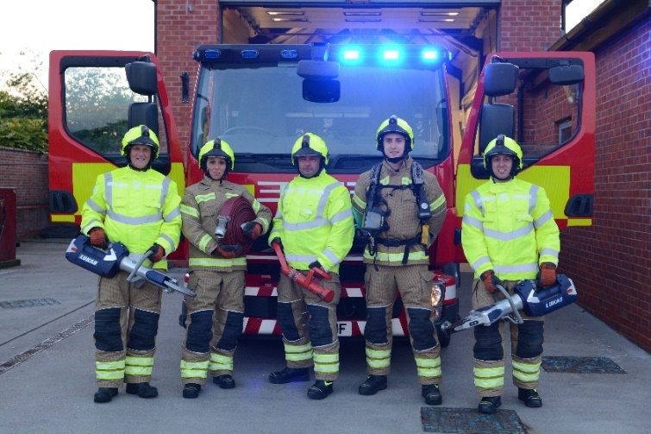
The inspection found that SFRS performed well in relation to:
- Understanding the risk of fire and other emergencies, responding to fires and other emergencies, and responding to national risks.
- The efficiency of its services, making the best use of resources, and making services affordable now and in future.
- Promoting the right values and culture, getting the right people with the right skills, and ensuring fairness and promoting diversity.

However, there were some areas for improvement:
- The service requires improvement to the way it prevents fires and other risks. It makes good use of volunteers and other organisations to promote community safety. But operational staff do limited work in this area.
- It also requires improvement to how it protects the public through fire regulation. The service approaches enforcement in a supportive way. It works well with enforcement partners. But it doesn’t make full use of its enforcement powers.
- The service doesn’t carry out fitness testing in line with national recommendations, but it has started to introduce annual fitness testing for operational staff.
- Suffolk FRS requires improvement at managing performance and developing leaders. It needs to improve its promotion processes, to ensure they are consistent and fair.
- The service should ensure that it has effective arrangements in place to support staff following a traumatic incident.
- The service should ensure its values and behaviours are understood and demonstrated at all levels of the organisation.
- The service should assure itself that it has effective grievance procedures for all staff.
- The service should improve the understanding of positive action and the benefits of having a diverse workforce, amongst staff.
Need more information?
- Read the HMICFRS inspection report on Suffolk Fire and Rescue Service

Suffolk Fire and Rescue Service as part of Suffolk County Council
SFRS forms part of Suffolk County Council, and this is a key strength in terms of collaboration, coordination, and having a shared strategy and direction of travel. It also helps in mitigating some of the barriers seen nationally. Some examples include (but are not limited to)^{67,68}:
- As part of Suffolk County Council (SCC), the Service follows the council’s financial procedures for budget setting, monitoring and the production of final accounts.
- Suffolk County Council, as Suffolk’s Fire and Rescue Authority, is responsible for ensuring Suffolk Fire and Rescue Service operates in accordance with the law.
- The council publishes its Annual Governance Statement through the Audit Committee. The Statement sets out the Council’s governance arrangements, which apply to, and include, Suffolk Fire and Rescue Service.
- Suffolk County Council recognises the importance of its fire and rescue service and continues to invest in fire stations, vehicles, equipment, firefighter clothing and people to provide effective prevention, protection and emergency response services.
- There are opportunities for closer collaborative working with other council directorates, such as Adult Care Services and Public Health.
- The council’s constitution sets out the framework for political and managerial leadership. This framework, and the wider leadership of the council and fire and rescue service, is underpinned by the organisational behavioural values.

Public perception
National research by HMICFRS investigated the public’s perceptions of local fire and rescue services across England⁶⁴. The 2019 survey conducted across 44 local fire and rescue service areas found that both satisfaction with local fire and rescue services, and perceived value for money of these services is high.

The findings of this survey were national but included 150 surveys in Suffolk. Therefore, it is worth taking these findings into account when thinking about prevention and awareness opportunities within Suffolk. Clear and targeted awareness raising initiatives may help in increasing the public’s understanding of their local fire service and help to engage them in prevention messages.

Respondents indicated that the top three most important statutory duties for local fire and rescue services to prioritise were responding to fires (85%), rescuing people from road traffic collisions (62%) and responding to emergencies such as floods and terrorist incidents (48%).

When respondents were shown a list of non-statutory response incidents, responding to medical incidents (either assisting the ambulance service or as a first responder or to serious medical calls) was the most commonly selected activity. This formed one of the top three most important areas for local fire and rescue services to prioritise (77%). This was followed by responding to storms and other natural disasters (74%) and responding to water rescue incidents (73%).

The report indicates that the public have low awareness of staffing arrangements in their local fire and rescue service stations.

Respondents were asked about their knowledge of the staffing arrangements for stations in their local fire and rescue service. Respondents have low awareness of this (42% gave an incorrect answer and a further 28% say they don’t know). Whilst around one in five (21%) respondents have had contact with their local FRS in the past 12 months, over half of respondents (57%) do not feel informed about what their local fire and rescue service is doing. This percentage had increased from 52% in 2018. Respondents reported the main reason for feeling ill-informed was due to not any information about it (79%). Over three quarters of respondents (78%) were interested in knowing what the fire and rescue service is doing in their local area.

Additionally, nine in ten respondents (88%) say that they had not been asked about their views on the local fire and rescue service in the area where they live in the past 12 months.

A low proportion of respondents (19%) saw, heard or read something about fire safety in the last three months, this percentage increased to 24% when someone in the respondent’s household smoked.

Technology, new acquisitions and service development

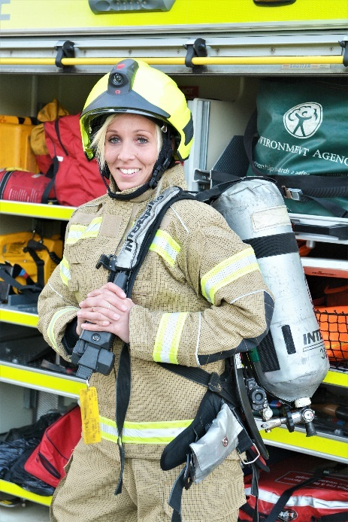
Small Unmanned Surveillance Aircraft
In 2017 Suffolk Fire and Rescue Service and multi-agency partners (through the Suffolk Resilience Forum) developed a Small Unmanned Surveillance Aircraft (SUSA) capability as part of a multi-agency Air Support Unit (ASU). The drone provides a range of aerial surveillance options to support emergency services and voluntary organisations across a wide range of incidents.

Uniforms and appliances
In May 2019, Suffolk Firefighters were given state-of-the-art uniforms, coupled with three brand new appliances, in a drive to make Suffolk safer⁶⁹. Three new fire appliances were also put into action, based at Framlingham, Holbrook and Long Melford fire stations.

In May 2021, three Command Support Vehicles joined the fleet, replacing older vehicles. These will typically be used as a hub at large, complex incidents, from which officers can manage operations and work with other emergency services. These new vehicles have dedicated WiFi, LCD display built into the side of the vehicle, as well as the latest communications and computer technology with access to live information⁷⁰.

As mentioned in the climate change section of this document, in August 2021, four new “enhanced rescue tenders” were added to SFRS’s fleet.

In December 2021, a significant investment in new equipment saw the introduction of digital radios, smoke hoods and smoke curtains – benefitting both residents and firefighters across Suffolk⁷¹.
- The state-of-the-art digital handheld radios offer a clearer and greater range than previous models – vastly improving communication between firefighters when attending incidents.
- These are accompanied by two pieces of new equipment designed specifically to reduce the harmful impact of smoke. All fire engines will now carry escape smoke hoods – enabling firefighters to protect people when rescuing or evacuating them from fires.
- Smoke curtains have also been introduced to help ensure that escape routes are kept clear of smoke, while also aiding in protecting property by reducing smoke damage.
A tender has recently been awarded for aerial appliance replacement at Bury St Edmunds and the next nine appliances, one of which will be a dedicated driver training vehicle to support legislative change in driver training.

Waterside prevention
In August 2019, bars, restaurants and businesses along Ipswich’s Waterfront attended awareness training in the event of anyone falling into water. As part of Suffolk Fire and Rescue Service’s prevention work, these waterside businesses have been supplied with a safety throw line to keep at their premises. This is a small bag containing a floating line which can be deployed very quickly and easily in the event of someone falling into the water around the marina. Staff were given training on how to effectively operate the new equipment, supported by the local Coastguard from Felixstowe and Holbrook, which could be the first action in saving someone’s life⁷².

In May 2022, SFRS worked in partnership with the RNLI, Coastguard, Broads Beat and Harbour master to deliver water awareness training. Over 30 personnel worked to deliver this in the Oulton Broad area, and SFRS are looking at pushing this out to Beccles and revisiting Ipswich Marina shortly. In addition, prevention work in the Lowestoft and Oulton Broad area has occurred, with SFRS offering advice to the live-aboard boat community in the Marinas. This was accomplished in partnership with the Broad's beat who have identified risks in the area.

Fleet management
SFRS operate over 150 vehicles of varying type, and hundreds of items of operational kit. These enable SFRS to discharge its statutory and mission critical duties under the Fire & Rescue Services Act 2004 and Civil Contingencies Act 2004. The workshops in which these are maintained are based on one site. As the Business Continuity Plan highlights, loss of workshops or mechanics increase organisational risk which would escalate proportionally as the time scale of risk critical unavailability increases. The short-term impact however is negligible, and only losses of site access/usage of one-month duration or above would create major reorganization in that alternative maintenance providers / facilities will be required. Additionally, senior colleagues have noted that staff retention and development for trained HGV mechanics is difficult, as the private market is able to afford more competitive salaries.

SRFS prevention team
Prevention activity is a core element of SFRS. The SFRS prevention team deliver a range of interventions to identified risk groups, prioritising Suffolk’s vulnerable residents. The aim of the team is for all Suffolk residents to live long, healthy and fulfilling lives. Some of their targeted work to prevent and mitigate risk includes:
- Continued collaborative work such as Emergency Service Cadets and Suffolk Roadsafe Partnership projects. Current partnerships add financial support such as the long-standing Rotary relationship and sensory team who offer additional financial resource to the department.
- Utilising data and analysis methodology to best allocate resource to the primary risk and risk groups. This will assist in delivering the best, most efficient service to the people of Suffolk.
- Utilising partners across Suffolk to help identify vulnerabilities and include SFRS in their invaluable work. An example of this is the work completed around care providers having the skills and knowledge to recognise fire risk and seek help and support from SFRS.
- The Community Engagement Unit has been used across Suffolk, and work will continue to develop competent users and drivers as well as technology to support its use. Other key resources include fire bikes, Ford Ranger, modern publicity materials and limited use of merchandise for large events. Combined, this makes for a sustainable collection of resources to allow SFRS to deliver a consistent and professional message across Suffolk.
- Volunteers have been supporting SFRS in engaging with the community from carrying out Home Fire Safety Checks with vulnerable communities, as well as supporting Crucial Crew and working alongside trading standards during the recent Avian flu outbreak.
- Working with Fire IT to ensure that data collection methods best serve the needs of SFRS and obligations to the Home Office for data collection. New technology, funding opportunities and partnerships will be key to a sustainable future in prevention.
- Training is continuous across prevention subjects from safeguarding to dementia awareness, driver training to equipment fault finding. SFRS will continue to invest energy and time into training staff and operational crews to deliver a competent and professional service.

COVID-19 (Coronavirus) response, adaptation and recovery
SFRS provided an integral part of the local COVID-19 response, including providing support as part of the Suffolk Resilience Forum. SFRS worked closely with partners across the Suffolk system to respond to COVID-19 effectively, efficiently and safely.

In August of 2020, Her Majesty’s Inspector of Fire & Rescue Services were commissioned by the Home Secretary to inspect how fire and rescue services in England are responding to the COVID-19 pandemic⁷³. The report noted that⁷³:
- They were impressed with how SFRS adapted and responded to the pandemic effectively.
- The efficient use of staff was notable, utilising extra capacity and providing support and resource for remote and home working. SFRS provided support to Suffolk County Council (SCC) and the LRF, including advice, resources and effective command and control frameworks to co-ordinate its response.
- SFRS maintained its statutory functions of prevention, protection and response while providing additional support to the community during the first phase of the pandemic, especially to its health partners. Staff delivered essential items to vulnerable people; wholetime and on-call staff drove ambulances; and other staff supported SCC and LRF activities. Resources were well managed, and SFRS’s financial position was largely unaffected. Reserves didn’t have to be used to cover extra costs.
- SFRS communicated well with its staff throughout the pandemic, including issues relating to staff wellbeing. Extra wellbeing support was provided for its workforce who are at higher risk from COVID-19. SFRS also made sure all staff had the resources they needed to do their jobs effectively, including extra information and technology, and put in place additional flexible working arrangements.
SFRS also conducted a review of its response to the pandemic, including a staff survey, and is reviewing the lessons learned to inform ways of working for the future⁷³. SFRS has improved its relationships with the police, ambulance and health partners and is looking to build on its collaborations Suffolk. Virtual communication platforms are resulting in improved communication and staff welfare, as well as making SFRS more effective and efficient.

More information
There are lots of places you can look to find more information, data and statistics about Suffolk.

The Suffolk Observatory
The Suffolk Observatory contains all Suffolk’s vital statistics; it is the one-stop-shop for data, statistics and reports all about Suffolk provided by a variety of organisations.
Through data, reports and analysis, the Suffolk Observatory provides a comprehensive picture of the County and is a great source for useful facts and figures.
Visit the Suffolk Observatory online.

Open Data Suffolk
Find free data about Suffolk and the Council available to the general public and organisations.
Visit the Open Data Suffolk portal.

The Healthy Suffolk website
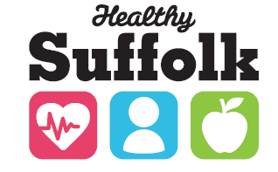
Find detailed reports and information. The Healthy Suffolk website is home to the Health and Wellbeing Board, as well as the Joint Strategic Needs Assessment (JSNA).
Visit Healthy Suffolk online.

GOV.UK

The Home Office collects detailed information on incidents attended by Fire and Rescue Services.

References:
1. Home Office. Fire and rescue national framework for England. Published 2018. Accessed June 8, 2022. https://www.gov.uk/government/publications/fire-and-rescue-national-framework-for-england--2
2. National Fire Chiefs’ Council (NFCC). NFCC strategy & plan. Published 2018. Accessed June 8, 2022. https://www.nationalfirechiefs.org.uk/Our-Strategy
3. Home Office. Fire and Rescue National Framework for England Government consultation. Published 2017. Accessed January 31, 2018. https://www.gov.uk/government/uploads/system/uploads/attachment_data/file/672148/171222_National_Framework_consultation_document_-v2.pdf
4. Public Health Suffolk. The State of Suffolk.; 2015.
5. Suffolk Wildlife Trust. County Wildlife Sites. Published 2022. Accessed June 7, 2022. https://www.suffolkwildlifetrust.org/countywildlifesites
6. BBC News. Suffolk now has “largest district council in country.” Published 2019. Accessed January 17, 2020. https://www.bbc.co.uk/news/uk-england-suffolk-47753858
7. Suffolk County Council. Fire Stations in Suffolk. Published 2022. Accessed June 7, 2022. https://www.suffolk.gov.uk/suffolk-fire-and-rescue-service/map-of-fire-stations-in-suffolk/#tab1
8. Suffolk County Council. Suffolk Fire and Rescue Service Summary of Performance- October 2021. Published 2021. Accessed June 7, 2022. https://www.suffolk.gov.uk/assets/fire-rescue-and-emergencies/about-suffolk-fire-and-rescue-service/Deluxe-i-sheet-October-2021.pdf
9. Home Office. Fire statistics data tables. Published 2022. Accessed June 7, 2022. https://www.gov.uk/government/statistical-data-sets/fire-statistics-data-tables
10. Suffolk County Council. Community Risk Register. Published 2022. Accessed June 8, 2022. https://www.suffolk.gov.uk/community-and-safety/suffolk-resilience/community-risk-register/
11. Office for National Statistics. Estimates of the population for the UK, England and Wales, Scotland and Northern Ireland. Published 2021. Accessed December 8, 2021. https://www.ons.gov.uk/peoplepopulationandcommunity/populationandmigration/populationestimates/datasets/populationestimatesforukenglandandwalesscotlandandnorthernireland
12. Office for National Statistics. Subnational population projections for England Statistical bulletins - 2018 Projections. Published 2020. Accessed December 10, 2021. https://www.ons.gov.uk/peoplepopulationandcommunity/populationandmigration/populationprojections/bulletins/subnationalpopulationprojectionsforengland/previousReleases
13. Nomis. 2011 Census Data. Published online 2011. www.nomisweb.co.uk
14. Office for National Statistics. Local area migration indicators, UK. Published 2021. Accessed December 15, 2021. https://www.ons.gov.uk/peoplepopulationandcommunity/populationandmigration/migrationwithintheuk/datasets/localareamigrationindicatorsunitedkingdom
15. House of Commons. Tackling inequalities faced by Gypsy, Roma and Traveller communities. 2019. Published 2019. Accessed December 17, 2021. https://publications.parliament.uk/pa/cm201719/cmselect/cmwomeq/360/full-report.html#content
16. Suffolk County Council. Groups At Risk of Disadvantage Needs Assessment. Published online 2015. http://www.healthysuffolk.org.uk/assets/JSNA/Final-GAROD-Needs-Assessment-20151202.pdf
17. Department for Levelling Up Housing and Communities. Traveller caravan count. Published 2021. Accessed December 17, 2021. https://www.gov.uk/government/collections/traveller-caravan-count
18. The United Nations High Commissioner for Refugees (UNHCR). Forced Displacement in 2020. Published 2021. Accessed December 17, 2021. https://www.unhcr.org/flagship-reports/globaltrends/globaltrends2019/
19. Suffolk Refugee Support. Suffolk Refugee Support – Supporting Refugees and Asylum Seekers in Suffolk. Published 2021. Accessed December 17, 2021. https://suffolkrefugee.org.uk/
20. Department for Levelling Up Housing and Communities. Ukraine Sponsorship Scheme: Visa data by country, upper and lower tier local authority. Published 2022. Accessed June 7, 2022. https://www.gov.uk/guidance/ukraine-sponsorship-scheme-visa-data-by-country-upper-and-lower-tier-local-authority
21. Department for Work and Pensions. Stat Xplore. Published 2021. Accessed December 17, 2021. https://stat-xplore.dwp.gov.uk/
22. UK Health Security Agency (UKHSA) / PHE. Preventing fires and protecting health. Published 2016. Accessed June 13, 2022. https://ukhsa.blog.gov.uk/2016/12/15/preventing-fires-and-protecting-health/
23. Office for Health Improvement and Disparities (OHID). Public Health Profiles. Published 2022. Accessed June 7, 2022. https://fingertips.phe.org.uk/
24. Suffolk County Council. Suffolk Annual Public Health Report 2015. Published online 2015. http://www.healthysuffolk.org.uk/assets/JSNA/Annual-Report/19673-APHR-2015-LR-20151209.pdf
25. Suffolk County Council. Suffolk Minds Matter - Annual Public Health Report.; 2016. http://www.healthysuffolk.org.uk/assets/JSNA/Annual-Report/APHR-2016/21991-APHR-2016-ONLINE.pdf
26. Public Health England. Alcohol dependence prevalence in England. Published 2021. Accessed June 13, 2022. https://www.gov.uk/government/publications/alcohol-dependence-prevalence-in-england
27. Suffolk Observatory. Housing. Published 2021. Accessed June 10, 2022. https://www.suffolkobservatory.info/housing/reports/#/view-report/a6981d21aa7549eaaefaa3a82d60fbc2/E10000029/G3
28. Department for Business Energy & Industrial Strategy. Fuel poverty sub-regional statistics. Published 2021. Accessed March 21, 2022. https://www.gov.uk/government/collections/fuel-poverty-sub-regional-statistics
29. Suffolk County Council. Updates on the five key priorities raised in the Council Leaders’ Executive Statement 23 May 2019. Presentation - unpublished.
30. Department for Business Energy & Industrial Strategy. Sub-national estimates of properties not connected to the gas network. Published 2021. Accessed March 21, 2022. https://www.gov.uk/government/statistics/sub-national-estimates-of-households-not-connected-to-the-gas-network#full-publication-update-history
31. Suffolk County Council. Suffolk Changes in the Index of Multiple Deprivation from 2010 to 2015.; 2016. http://www.healthysuffolk.org.uk/assets/JSNA/PH-reports/SCC-Index-of-Multiple-Deprivation-2010-2015-FINAL.pdf
32. Suffolk County Council. Rural Deprivation in Suffolk.; 2016. http://www.healthysuffolk.org.uk/jsna
33. Department for Work and Pensions. Children in low income families: local area statistics 2014 to 2021. Published 2022. Accessed June 10, 2022. https://www.gov.uk/government/statistics/children-in-low-income-families-local-area-statistics-2014-to-2021
34. Suffolk Observatory / Police.UK. Crime and Community Safety. Published 2022. Accessed June 9, 2022. https://www.suffolkobservatory.info/crime-and-community-safety/reports/#/view-report/d74b7b4e839b46e08861c0c777aa54f7/E05012763/G7
35. Suffolk Police and Crime Commissioner. Police and Crime Plan 2022-2025. Published 2022. Accessed June 9, 2022. https://suffolk-pcc.gov.uk/wp-content/uploads/2022/02/Police-Crime-Plan-2022-2025.pdf
36. Suffolk County Council. Working for Wellbeing Suffolk Annual Public Health Report 2017. Published 2017. Accessed December 1, 2017. https://www.healthysuffolk.org.uk/uploads/Working_for_wellbeing_2017_report_v9_Online.pdf
37. NOMIS. Labour market profile - Suffolk. Published 2022. Accessed June 9, 2022. https://www.nomisweb.co.uk/reports/lmp/la/1941962836/report.aspx?c1=2013265926&c2=2092957699
38. Destination Research. Economic impact of Tourism Suffolk. Published 2019. Accessed December 17, 2021. https://mediafiles.thedms.co.uk/Publication/ee-stp/cms/pdf/Economic Impact of Tourism - Suffolk Report 2019.pdf
39. Office for National Statistics. Where do we commute to? Published 2011. Accessed April 1, 2017. http://webarchive.nationalarchives.gov.uk/20160105224014/http://www.ons.gov.uk/ons/rel/census/2011-census/origin-destination-statistics-on-migration--workplace-and-students-for-local-authorities-in-the-united-kingdom/sum---commuting-patterns-in-the-uk--20
40. Department for Transport. Local Authority Suffolk. Published 2022. Accessed June 9, 2022. https://roadtraffic.dft.gov.uk/local-authorities/126
41. National Highways. The Orwell Bridge. Published 2022. Accessed June 9, 2022. https://nationalhighways.co.uk/travel-updates/the-orwell-bridge/
42. Roadsafe S. Strategy. Published 2020. Accessed January 24, 2020. https://www.suffolkroadsafe.com/about-suffolk-roadsafe/strategy
43. Suffolk County Council. Winter Service Plan 2021-22. Published 2021. Accessed June 9, 2022. https://www.suffolk.gov.uk/assets/Roads-and-transport/Check-which-roads-are-gritted-in-Suffolk/2021-09-30-FINAL-WS-Plan-21-22-v1.pdf
44. Department for Communities and Local Government, Chief Fire and Rescue Officer. The Fire and Rescue Service Operational Guidance – Railway Incidents. Published 2012. Accessed January 1, 2018. https://www.gov.uk/government/uploads/system/uploads/attachment_data/file/5916/2112404.pdf
45. Office of Rail and Road. Estimates of station usage. Published 2021. Accessed June 13, 2022. https://dataportal.orr.gov.uk/statistics/usage/estimates-of-station-usage/
46. Safety Security and Sustainability Department. Greater Anglia Information Request (Email Correspondence). Published online 2018.
47. Port of Felixstowe. Port of Felixstowe.
48. Lancashire Fire and Rescue Service. Strategic Assessment of Risk 2016. Published 2016. Accessed December 1, 2017. https://www.lancsfirerescue.org.uk/publication/strategic-assessment-of-risk-2016/
49. Ipswich Town Football Club. Visiting Portman Road. Published 2017. Accessed January 1, 2018. https://www.itfc.co.uk/club/visit-us/
50. Spedeworth Motorsports. Ipswich. Published 2017. Accessed January 1, 2018. http://www.spedeworth.co.uk/venue.php?name=Ipswich
51. Suffolk Resilience Forum. Advice for people living close to an industrial site. Published 2020. Accessed January 24, 2020. https://www.suffolkresilience.com/risk-advice/advice-for-people-living-close-to-an-industrial-site
52. Health and Safety Executive (HSE). Control of Major Accident Hazards (COMAH). Published 2018. Accessed January 1, 2018. http://www.hse.gov.uk/comah/
53. Health and Safety Executive (HSE). Radiation (Emergency Preparedness and Public Information) Regulations 2001 (REPPIR). Published 2018. Accessed January 1, 2018. http://www.hse.gov.uk/radiation/ionising/reppir.htm
54. Suffolk Resilience Forum. Suffolk Resilience Forum. Published 2018. Accessed January 1, 2018. http://www.suffolkresilience.com/
55. Suffolk County Council. Pledge to climate emergency declaration. Published 2019. Accessed January 31, 2020. https://www.suffolk.gov.uk/planning-waste-and-environment/pledge-to-climate-emergency-declaration/
56. HM Government. UK Climate Change Risk Assessment 2022. Published 2022. Accessed June 15, 2022. https://assets.publishing.service.gov.uk/government/uploads/system/uploads/attachment_data/file/1047003/climate-change-risk-assessment-2022.pdf
57. Taylor C. Battery Energy Storage Systems and the rising risk of thermal runaway. Published 2021. Accessed July 13, 2022. https://www.marsh.com/uk/industries/energy-and-power/insights/battery-energy-storage-systems-and-rising-risk-of-thermal-runaway.html
58. Suffolk County Council. Suffolk Fire and Rescue Service adds four new enhanced appliances to its fleet, fitted with solar panels. Accessed June 8, 2022. https://www.suffolk.gov.uk/council-and-democracy/council-news/show/suffolk-fire-and-rescue-service-adds-four-new-enhanced-appliances-to-its-fleet-fitted-with-solar-pan
59. Suffolk County Council. Wildfire Incidents. Published 2022. Accessed June 13, 2022. https://www.suffolk.gov.uk/suffolk-fire-and-rescue-service/about-suffolk-fire-and-rescue-service/common-questions-about-incidents-we-attend/wildfire-incidents/
60. Get Prepared Now. Flooding. Published 2018. http://www.getpreparednow.co.uk/home/flooding/
61. Suffolk Resilience Forum. Suffolk Flood Plan. Published 2018. Accessed January 24, 2020. https://www.suffolkresilience.com/uploads/20190219_SRF_Flood_Plan_Issue7.1.pdf
62. Babergh District Council. Suffolk agencies respond to Storm Eunice challenges. Published 2021. Accessed June 8, 2022. https://www.babergh.gov.uk/news/suffolk-agencies-respond-to-storm-eunice-challenges/
63. Suffolk Lowland Search and Rescue. Suffolk Lowland Search and Rescue. Published 2017. http://www.sulsar.org.uk/about-us/
64. HMICFRS. Public perceptions of fire and rescue services in England 2019. Published 2020. Accessed January 31, 2020. https://www.justiceinspectorates.gov.uk/hmicfrs/wp-content/uploads/public-perceptions-of-fire-and-rescue-services-in-england-2019-report.pdf
65. Her Majesty’s Inspector of Fire & Rescue Services. State of Fire and Rescue – The Annual Assessment of Fire and Rescue Services in England 2021. Published 2021. Accessed June 13, 2022. State of Fire and Rescue – The Annual Assessment of Fire and Rescue Services in England 2021
66. Suffolk County Council. Suffolk Fire and Rescue Service 2019 inspection report. Published 2020. Accessed January 27, 2020. https://www.suffolk.gov.uk/suffolk-fire-and-rescue-service/about-suffolk-fire-and-rescue-service/2019-hmicfrs-inspection-report/
67. Suffolk County Council. Statement of Assurance 2018 – 2019. Published 2018. Accessed January 31, 2020. https://www.suffolk.gov.uk/assets/fire-rescue-and-emergencies/about-suffolk-fire-and-rescue-service/Suffolk-Fire-Rescue-Service-Statement-of-Assurance-2018-2019.pdf
68. Suffolk County Council. Integrated Risk Management Plan 2019-22. Published 2019. Accessed January 31, 2020. https://www.suffolk.gov.uk/suffolk-fire-and-rescue-service/about-suffolk-fire-and-rescue-service/integrated-risk-management-plan-2019-22/
69. Gibbons A, East Anglian Daily Times. New “multi-purpose” uniforms help put out fires across Suffolk. Published 2019. Accessed January 27, 2020. https://www.eadt.co.uk/news/new-uniforms-help-put-out-fires-across-suffolk-1-6066169
70. Suffolk County Council. State-of-the-art vehicles join Suffolk Fire and Rescue Service’s fleet. Published 2021. Accessed June 8, 2022. https://www.suffolk.gov.uk/council-and-democracy/council-news/show/state-of-the-art-vehicles-join-suffolk-fire-and-rescue-services-fleet
71. Suffolk County Council. Significant investment in firefighting equipment secures safer future for Suffolk. Published 2021. Accessed June 8, 2022. https://www.suffolk.gov.uk/council-and-democracy/council-news/show/significant-investment-in-firefighting-equipment-secures-safer-future-for-suffolk
72. Suffolk County Council. Fire Service works with local businesses to prevent accidental drownings. Published 2019. Accessed January 28, 2020. https://www.suffolk.gov.uk/council-and-democracy/council-news/show/fire-service-works-with-local-businesses-to-prevent-accidental-drownings
73. Her Majesty’s Inspector of Fire & Rescue Services. COVID-19 inspection: Suffolk Fire and Rescue Service. Published 2021. Accessed June 8, 2022. https://www.justiceinspectorates.gov.uk/hmicfrs/publication-html/covid-19-inspection-suffolk-fire-and-rescue-service/

Appendix: Suffolk Community Risk Register – Risk Matrix (last amended 21-11-2019)

Risk Rating | Definition
Very High Risk | Primary risks requiring immediate attention due to potential consequences. Risk reduction or mitigation strategies should be developed.  Hazard specific multi-agency contingency plans required, exercise and training for hazards in place.  Risk monitored regularly.
High Risk | Sufficiently serious to warrant appropriate consideration after Very High Risks. Consider developing risk reduction or mitigation strategies.  Generic multi-agency contingency plans required, exercise and training for hazards in place. Risk monitored regularly.
Medium Risk | Less significant but may cause upset or inconvenience in the short term. Consider being managed under generic emergency planning arrangements. Risk monitored
Low Risk | Managed using normal or generic emergency planning arrangements.  Minimal monitoring and control unless risk assessment changes to move to a higher rating.  her rating.

The risk rating is devised from the impact of an incident resulting from one of the hazards and the likelihood of an incident occurring. Further information on the impact and likelihood scores is given after the table of risks below.
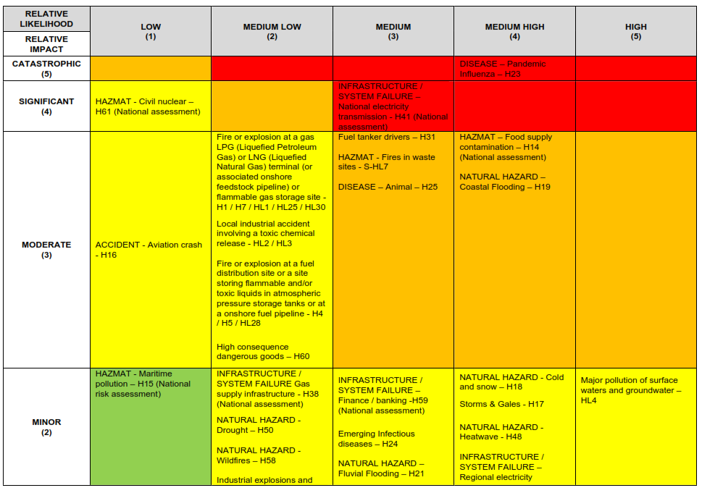
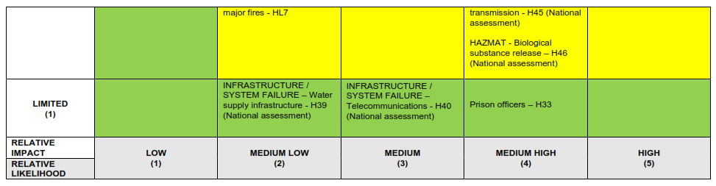
* Multiagency plans have been developed for these risks as they are classed as some of the highest risks facing the East Coast on the National Risk Register. The Risk Assessment process conducted in Suffolk did not place these risks at the same level that they are accorded nationally but they remain credible risks.

Please note that the Office of National Statistics (ONS) population forecasts use different population bases to those that estimate the current population size.

