NVR Referral form (From Day, E. and Heissman, E. (2010).*

Confidential NVR programme referral form
*Please note: this symbol indicates required fields: if they are not completed the referral will not be accepted.*
*Referred child/ren:
*Date of birth:
*Address:

*Name(s) of parents/carers:
*Phone number:
*Email address:
Ethnicity:

*Name, Role and contact details of referrer:

*Date of referral:

School/education setting of child:
*Is the child in care?
Are you able to attach a recent assessment?
*Please draw a genogram/family tree (see below for guidance):

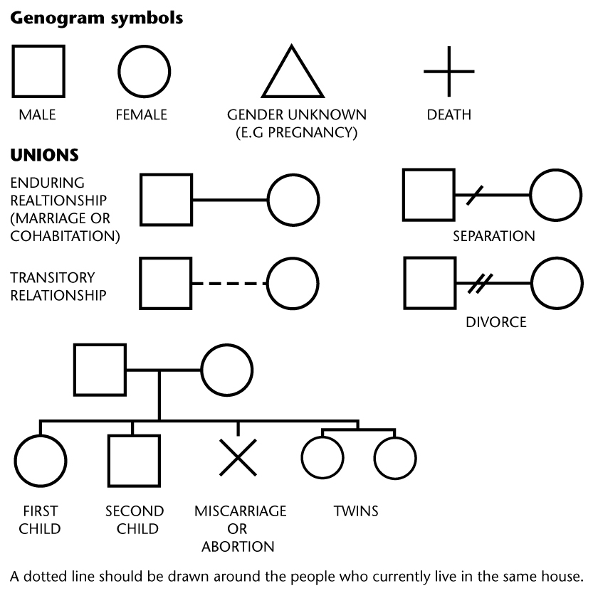

- * Why do you think that this family would benefit from NVR at this point in time?

- * From the conversations you have had with the family about this referral, what would you say is their understanding of the approach and their commitment to NVR?

- What do you think the family’s hopes for change would be from attending these sessions?

- What would be your expectations of the outcome of these sessions?

- What strengths do the family show that would enable them to make use of this approach?

- * Unless this is a single parent family, are BOTH parents willing and able to attend all sessions (min 10 sessions)?

- * What is your current role with the family and how will this referral change your role?

- *

For the NVR intervention to take place, the referrer needs to remain involved/commit not to close the case until the first six sessions have taken place. Please tick the box below:

I confirm that I will remain involved/commit not to close the case until the 10 sessions of NVR intervention have taken place. If a decision is made to continue the intervention beyond ten sessions, I will keep the case open until the work agreed has ended. If I need to end my professional involvement with the family before the NVR work ends, I will inform the NVR practitioner who my replacement is and inform the new professional about the ongoing NVR work.

Referrer’s Name:

Signature:

Date:

- Any other information (continue on a different sheet if necessary):

*We agree to this referral for NVR

*Signed:
*Parents’/Carers’ names (printed):
*Date:

*Name of referrer:
*Signature:
*Date:

For information on how we store/use your data, please visit http://www.suffolk.gov.uk/CYPprivacynotice

*If your referral is not accepted on this occasion, would your client(s) like our Service to keep the referral form for 10 weeks in case of changes of circumstances that might make it acceptable slightly later? We will not use the referral information for any other purposes. Please indicate: YES/NO

*Day, E. and Heissman, E. (2010) Non-Violent Resistance Programme. For all those working with parents and carers of children and adolescents with violent behaviour. Hove: Pavilion Publishing and Media Ltd.
Top of Form
Bottom of Form

