APPLICATION TO CREATE OR ALTER A VEHICULAR ACCESS
(DROPPED KERB)

PLEASE NOTE: This application is for accesses serving one or two neighbouring residential properties only. If your application is for a commercial or agricultural access, or serving three or more dwellings, you will instead need to apply for a Minor Works Licence. For more information visit this link:
https://www.suffolk.gov.uk/planning-waste-and-environment/planning-and-development-advice/application-for-works-licence/

What type of application is this for? (Refer to Dropped Kerb Criteria for guidance)

Pre-Application Advice (£200) Full Application (£400)

- Applicant details

Name

Address
Town |  | Postcode
Telephone no. |  | Mobile no.
Email address

- Location of intended vehicular access if different to above

Address

Town |  | Postcode

- Owner of property, if different from above

We will need the owner’s signed permission. There is a space for this at the end of the form.

Name

Address
Town |  | Postcode
Telephone no. |  | Mobile no.
Email address

- Does the proposed work require planning permission? | Yes | No
Note: If yes, please provide Planning Reference:

- Are any watercourses or ditches affected by your proposals?  Note: If Yes, you must supply evidence of agreement from Suffolk County Council’s Floods and Water Management Team. | Yes | No

- Are any trees affected by your proposals?  Note: If Yes, you must supply evidence of agreement from your District or Borough Council’s Arboricultural Officer. | Yes | No

- To complete your application please complete Appendix A (Key Dimensions)

Signatures

Applicant | Property Owner, if other (or written confirmation) | Neighbouring Owner  (If applying for new shared access)
Print Name: | Print Name: | Print Name:
Signed: | Signed: | Signed:
Date: | Date: | Date:

This completed application should be emailed to dropped.kerbs@suffolkhighways.org or posted to:

Dropped Kerbs
Phoenix House

3 Goddard Road
Ipswich
IP1 5NP

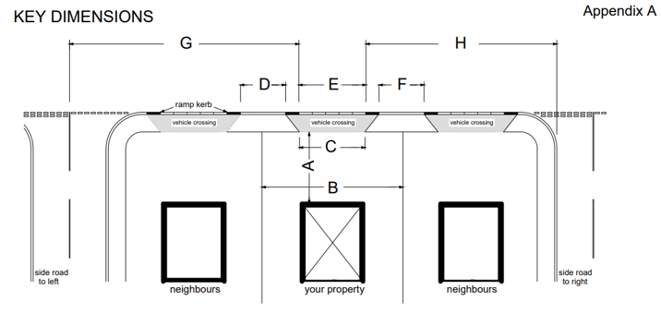

A | Depth of parking space available |  | metres
B | Width of parking space available |  | metres
C | Proposed width of access at back of footway/verge |  | metres
D | Distance to neighbour’s access on the left |  | metres
E | Proposed width of access at carriageway |  | metres
F | Distance to neighbour’s access on the right |  | metres
G | Distance to junction on the left |  | metres
H | Distance to junction on the right |  | metres
Additional comments:

