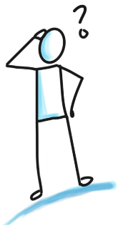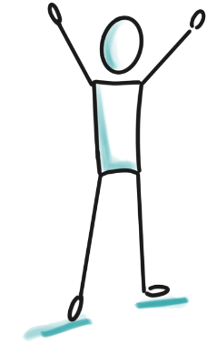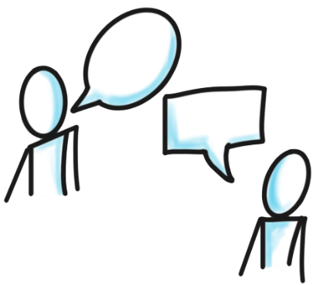

My name: ……………………….…..

I am ………years old

**Let’s think together…**

**What is happening now?**

**Who?**

Who can I talk to? Who is around me?

What do I need from them? What do I need them to know?

**Goals + Hopes** Where would I like to be? How do I want to feel?

**What are the little steps to get closer?** What has already changed?