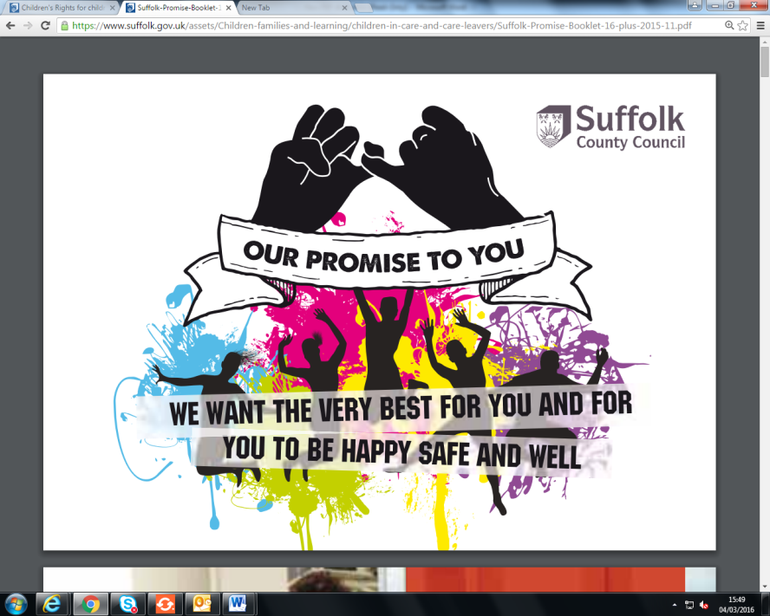
My Post-16 Pathway to
Education/Employment/Training

My name: | My date of birth:
Date of meeting: | Date I became NEET:
Lead organisation helping me access education, employment, or training: | Lead worker helping me access education, employment, or training:
My current study level: If you are unsure please seek advice from the Virtual School.

Entry Level or below –
Level 1 – GCSEs D-G, BTEC Level 1 or other equivalent award
Level 2 – GCSEs A-C, BTEC Level 2 or other equivalent award
Level 3 – A Levels, BTEC Level 3 or other equivalent award

Present at meeting | Title/Role

Initial Post-16 Pathway PEP Review Post-16 Pathway PEP
My view and the views of others on My Current Position
What is going well?
What are the worries?
What needs to happen?
Section 1 – My Current Position
Goals from previous plan – if applicable | What has gone well? | What have been the worries? | What needs to happen?

Section 2 – My Future
What are my aspirations?
How committed am I to achieving my aspirations? (A scaling question may be helpful here)

What options are available to me to achieve these?
Who can help me explore these options?
What are the barriers stopping me from achieving my aspirations?

Section 3 – What needs to happen?
Goals/Outcomes | Actions – need to be SMART* | By Whom? | By When?
*Specific, Measurable, Achievable, Realistic, Time Limited

What will happen if this plan doesn’t work? (Plan B)
Section 4 – My Progress Towards
Education, Employment, and Training (EET)

(This section to be completed with the views sought of all involved)

Red | Amber | Green
Multiple significant barriers to engagement in EET | Significant barriers to engagement in EET but engaging with support to overcome those barriers | Ready to re-engage in EET – awaiting suitable opportunity

New Rating
Previous Rating
Tick box for Red Amber Green rating of readiness to engage with EET - New Rating

My view (if different from above)

My views on my Post-16 Pathway to EET Plan:
Comment on identified goals/outcomes, barriers, and actions.

Once completed, please send a copy by secure email to the Suffolk Virtual School at suffolkvirtualschool@suffolk.gov.uk

Suffolk County Council uses Microsoft Office 365 Message Encryption for sending secure emails. If you would like to request a secure email, please email us and we can send you a secure email for the PEP.
Information on O365 Mail Encryption can be found here: https://www.suffolk.gov.uk/about/secure-emails/

