How to whitelist websites via Fortiportal

Login to the https://fpl.mlltelecom.com/fpc/app/login
Click on “Security” followed by “Firewall Objects” as below.

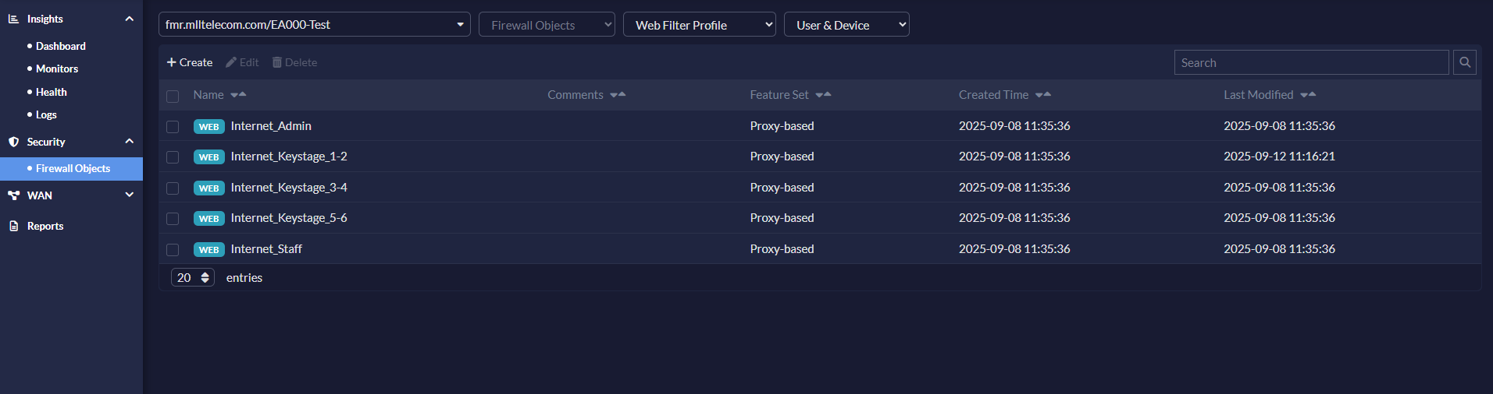

Click on the filter requiring the change followed by “Edit”.

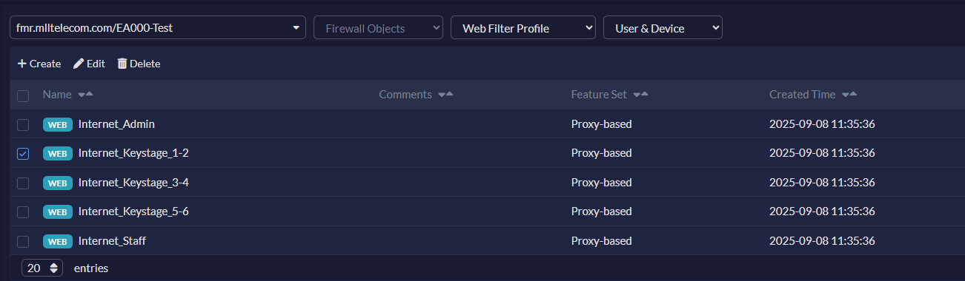

Click on “Create” as below.

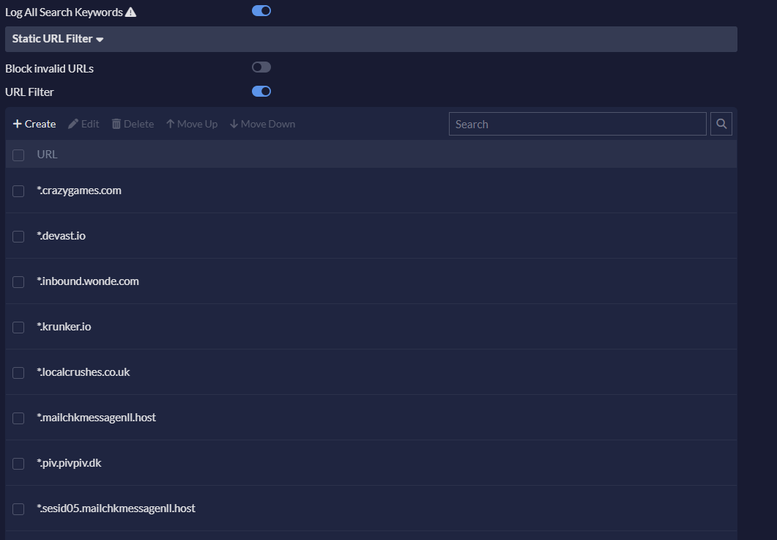
Type in the URL as below followed by clicking on “Allow”. Then click “Save”.

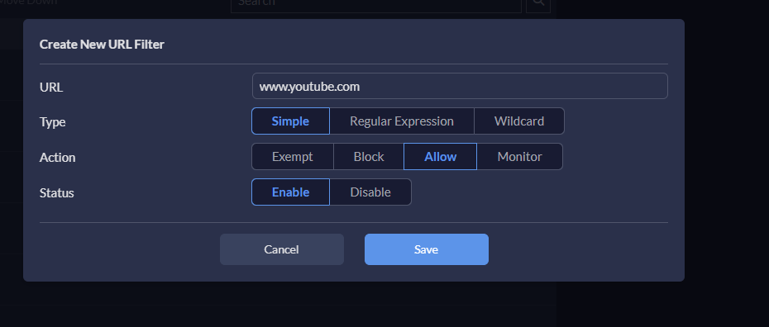

Click on “Install” on the top tool back next to login name.



Tick the box next to “Installation Target”.

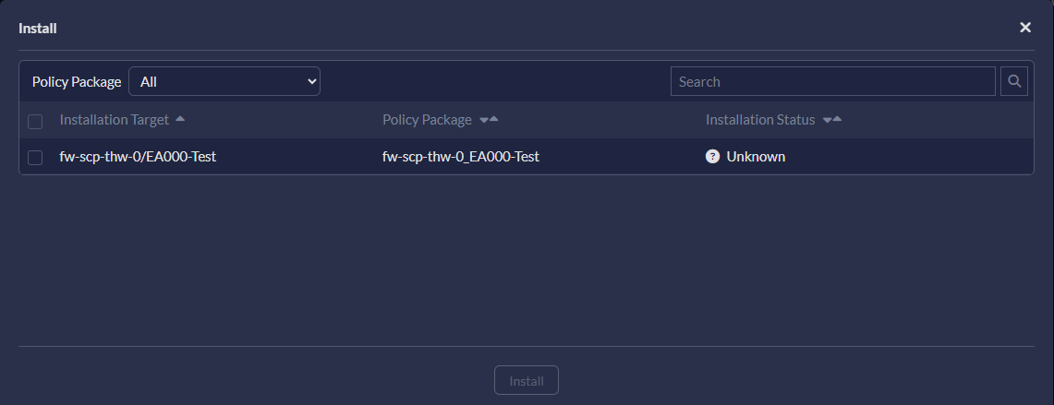

Click on “Install”.
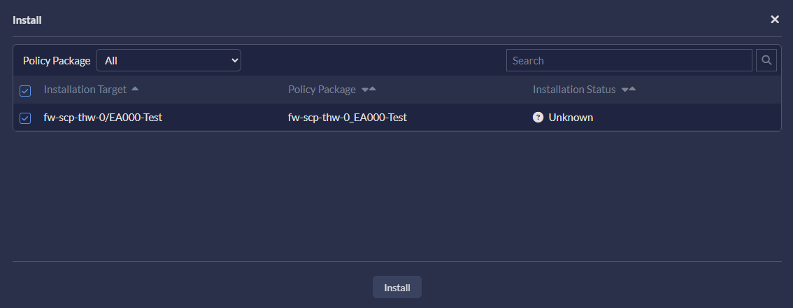

Click on “Yes” to confirm.



Once complete as below. You may close the window and log out as normal.

