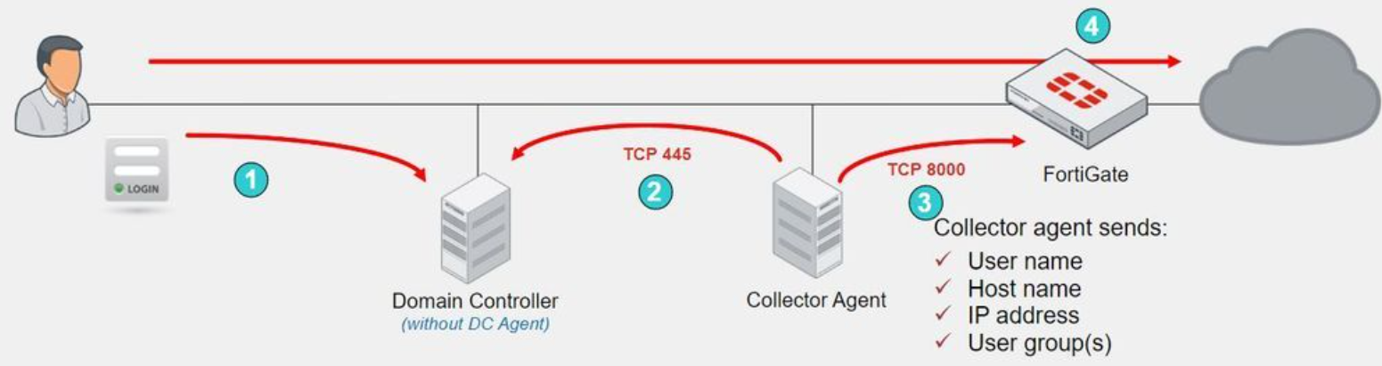

- You will be sent the FSSO_Setup file to install FSSO-CA (collector agent)

- Configure user account that will access event logs
https://community.fortinet.com/t5/FortiGate/Technical-Tip-Restricting-a-Fortinet-Single-Sign-On-Agent/ta-p/198065

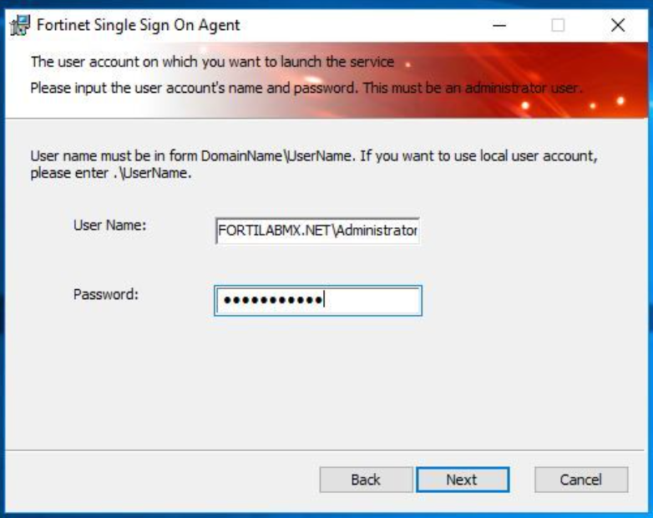

- Install in Standard Mode
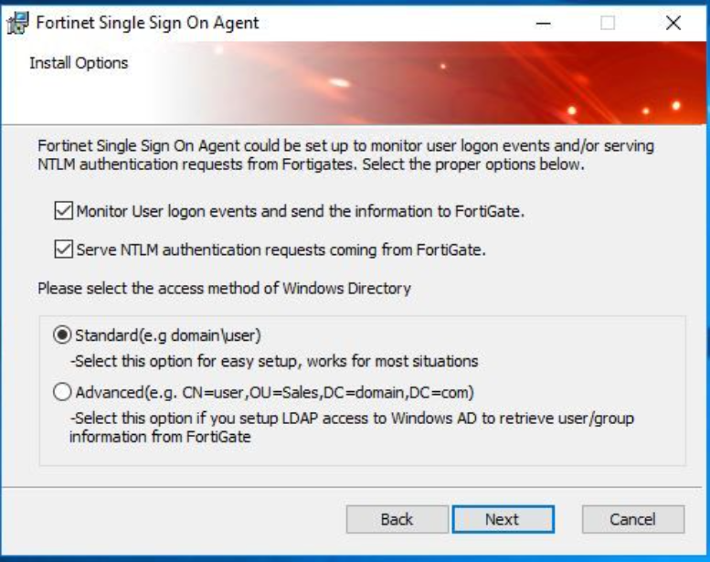

- The FSSO-CA should be configured in Polling Mode.

- To select this work mode, open FSSO-CA as an administrator, select Show Monitored DCs -> Select DC to Monitor... and select Polling Mode.

- In this mode, the collector agent 'polls' for logon events to each Windows DC. No DC_agent is required on the Domain Controller server.
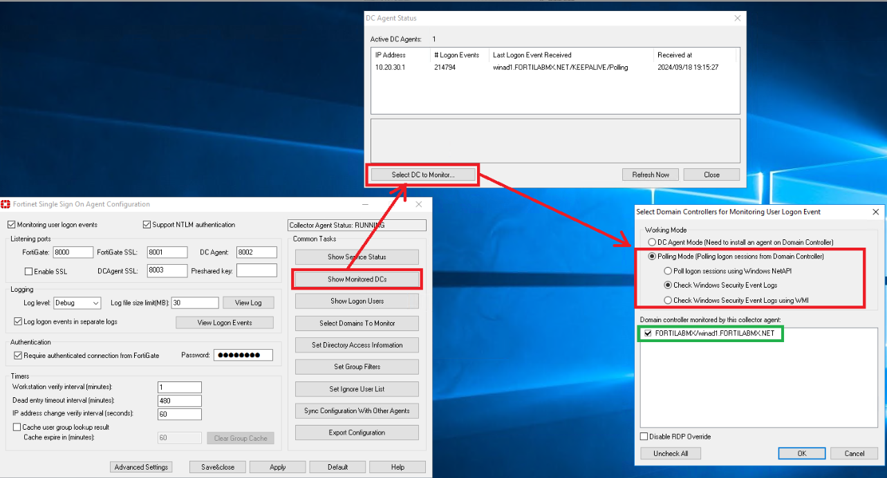

- Turn on "Cache user group lookup result Cache expire in (minutes)"
- Go to Advanced settings --> Windows Security Event Logs --> Event IDs to poll --> Set to 2
- Authentication Password will be provided on day of migration

- When FSSO-CA is installed, make sure the service is set to restart each day in the early hours of the morning to help reliability.

