How to manually install Fortigate on to a Windows 11 device.

Double click Fortinet_CA_SSL.cer file
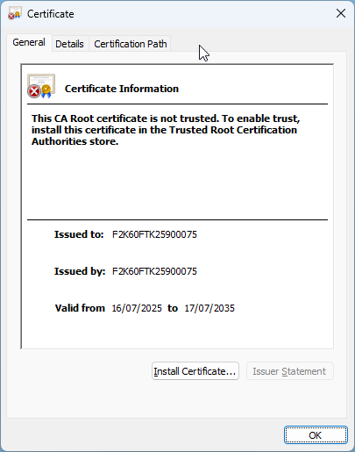
Click on Install Certificate
Change to Local Machine and click Next
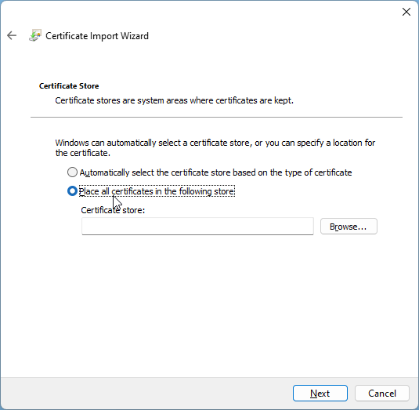

Click on place all certificates in following store and click Browse.
Click on Trusted Root Certification Authorities and Click OK.
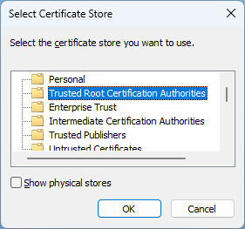

Click on Next
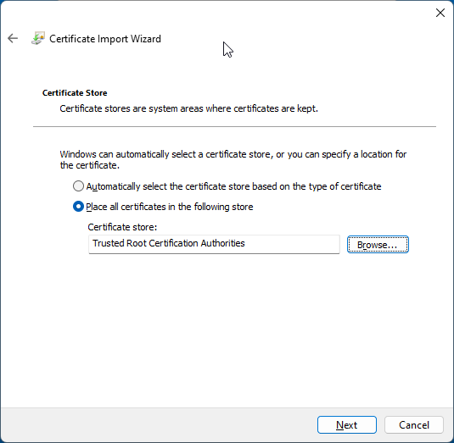

Click on Finish

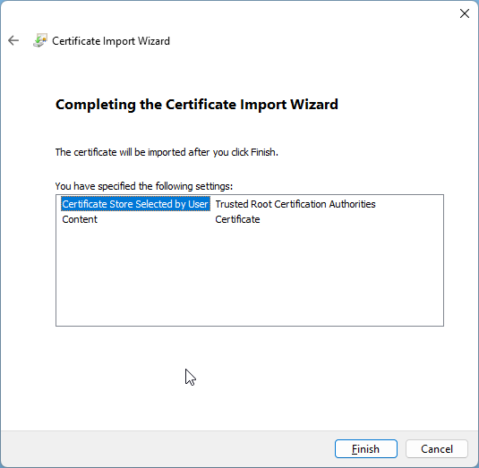

Click on OK to confirm import was successful

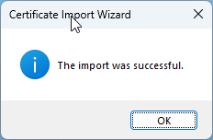
Click on Ok once Complete

