|  |
| --- |
| 20465 - Suffolk Highways Documents - Letterhead BGYour Ref:  Our Ref: 255524 /JC / 001  Date: 24th February 2023  Enquiries to: Jason Crane  Email: LHB@suffolkhighways.org |

Dear Sir or Madam,

**FORMAL CONSULTATION**

**PROPOSED WAITING RESTRICTIONS – VARIOUS ROADS - SNAPE**

Following the initial consultation, which concluded on the 21st November, Suffolk Highways forward comments received during this consultation to County Councillor Andrew Reid and Snape Parish Council, for their consideration. Suffolk County Council have amended the proposals to reflect some of the comments received and are now proposing to implement the revised proposals, as part of the ongoing improvements to road safety within the surrounding area of Snape Primary School.

Please find attached for your perusal, a plan showing the revised proposal.

Objections or any other representations related to the proposed waiting restrictions, specifying the grounds on which they are made, must reach Farhana Begum (Suffolk Legal) at the following address ,Suffolk County Council Legal Services, Endeavour House, 8 Russell Road, Ipswich, IP1 2BX or at [farhana.begum@suffolk.gov.uk](mailto:farhana.begum@suffolk.gov.uk), not later than 13th March 2023. Please bear in mind that any such correspondence cannot be regarded as confidential and may be inspected by any interested party.

Yours Faithfully

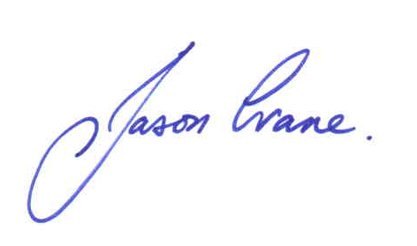

Design Engineer (LHB team)

Phoenix House | 3 Goddard Road | Ipswich | Suffolk | IP1 5NP