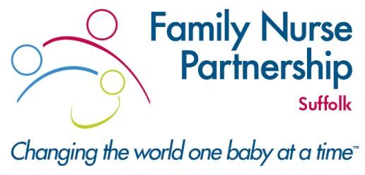
FAMILY NURSE PARTNERSHIP (FNP) AND YOUNG PARENTS PATHWAY (YPP)
NOTIFICATION FORM

Please use this form to notify the Family Nurse Partnership (FNP) team of all first-time pregnant clients, who were less than 21 years of age at conception and are under 28 weeks gestation. You do not need to do more than complete the form and send to the FNP practitioners at CYP.FNP@suffolk.gov.uk

Please note: FNP would ideally like to recruit new clients before 16 weeks gestation.

Please ensure that date of birth, NHS No. and practice details are provided

Name:
Address:
Date of Birth:
NHS number:

If the service user requires an interpreter, please specify language
Accessible Information Standards
Does the service user have additional needs related to: | Please specify below as applicable:
Vision
Hearing
Speech
Other communication difficulties

Practice Name:
Practice Address:
Practice Tel No:
Parity:
EDD:
Telephone contact numbers:
Partner name and dob :
Named midwife (if known):
Named midwife’s contact no:
Referrer name & contact no:
Date:
Essential: Additional supporting information i.e. vulnerabilities/safeguarding:

