

APPLICATION TO CREATE A RESIDENTIAL EV CHARGING CHANNEL

((APPLICATION FOR PERMISSION TO FIX OR PLACE A RAIL, PIPE, CABLE, WIRE OR SIMILAR APPARATUS ACROSS THE HIGHWAY_ HIGHWAYS ACT 1980 Section 178)

PLEASE NOTE: This application is for accesses serving one residential property only.

Application Notes

1. General
A licence is required to excavate in the public highway. The term highway includes footpaths, cycleways, verges, and roads. It is an offence under the Highways Act 1980 to excavate without first obtaining a licence from Suffolk County Council (SCC) as the Highway Authority. Failure to obtain the required licence could result in legal action being taken by SCC.

2. Application procedure
Once the application form has been received by the Highways Licensing Team an acknowledgement will be sent to you, and we will endeavour to respond within 20 working days with our decision.
A payment of £210.00 will be required before the licence is issued. Payment options will be provided on receipt of your application.
Please remember that no work can commence on the highway until you have received written permission from us.

Please note: Any Planning permisson that may be required for the installation of the ‘home EV Charger’ within your property frontage is separate to this application for the installation of the ‘EV Charge channel’ within the pavement. Resident to ensure that Planning are consulted and any required permissions are obtained.

Useful contacts:
  - Visit West Suffolk Council’s Planning Webpage
  - Visit Ipswich Borough Council’s Planning Webpage
  - Visit East Suffolk Council’s Planning Webpage
  - Visit Babergh District Council’s Planning Webpage
  - Visit Mid Suffolk District Council’s Planning Webpage

3. Licence conditions for Installer at address.
You will need to satisfy the standard conditions before a licence is issued such as:
- Highways Licensing and Enforcement issue licences in line with the National Street Gazetteer (NSG) and where your proposal is on separate street names this may require more than one licence.
- The ability to indemnify SCC against third party liability.
- Compliance with legislation in operating equipment on or over the highway.
- Ability for SCC to inspect works.
- Keeping the area safe whilst undertaking works to protect the public.
- Making good of the highway on completion.
- If we have started work on processing the application, the fees will not be returned even if we do not approve the application.
- Any form of Traffic Management required must conform with the Safety at Street Works and Road Works Code of Practice (Red Book) and Chapter 8 of the Traffic Signs Manual, and must be installed by an Accredited Operative. form of Traffic Management required, must conform with the New Roads and Streetworks Act 1991 (Red Book), Chapter 8 and installed by an Accredited Operative.

Application
(£210)

- Applicant details

Name

Address

Town |  | Postcode
Telephone no. |  | Mobile no.
Email address

- Location of intended EV Electric Vehicle Charging Channel, if different to above

Address

Town |  | Postcode

- Owner of property, if different from above (eg Housing Association)

We need the owner’s signed permission. There is a space for this at the end of the form.

Name

Address

Town |  | Postcode
Telephone no. |  | Mobile no.
Email address

- Please indicate which EV Channel you may wish to install

Charge Gully KerboCharge Gul-E

- To complete your application please complete Appendix A (Key Dimensions)

DECLARATION: By signing below, the applicant confirms they have read and understood the terms of Suffolk County Council’s current guidance, and accepts that in the event of an approved application they agree to construct the EV Channel exactly as described in the approval letter. In the event the works are not carried out in accordance to the Criteria to the County Council’s satisfaction, the Council may undertake or alter the works and recover the costs in doing so from the applicant.
T

Signatures

Applicant | Property Owner, if other  (or written confirmation)
Print Name: | Print Name:
Signed: | Signed:
Date: | Date:

Your completed application should be emailed to highways.streetfurniture@suffolk.gov.uk

or posted to:

Highways Licensing (EV Chargepoints)
Phoenix House
3 Goddard Road
Ipswich
IP1 5NP

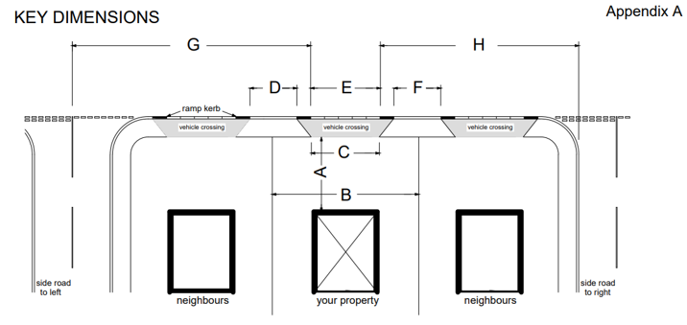
Above diagram to be amended to illustrate an EV charge channel at Property

A | Width of the pavement/footway (property wall to kerb at roadside) |  | metres
B | Distance to neighbour’s EV Charging channel on the right (if applicable) |  | metres
C | Distance to neighbour’s EV Charging channel on the right (if applicable) |  | metres
D | Distance to junction on the left |  | metres
E | Distance to junction on the right |  | metres
Additional comments:

PAYMENT INSTRUCTIONS

A Licence reference number will be provided to you by the Highways Licensing Team on receipt of your application, which you will need to quote when making payment.

ONLINE – Website: www.suffolk.gov.uk
Follow links to Roads and Transport & Suffolk Highways Licences

Select the “Pay for a Licence” link
Select the “Pay for a Licence” (Green Button)

Enter the provided Licence / Licence Reference Number, i.e. NRSWA-LICENCE-00011111 (Please ensure that “000” is entered before the given Licence / Licence Reference number. To make the number 8 digits long.)
Enter your Organisation Name
Enter your contact Telephone Number
Select Application Cost from the drop-down box, “Licence/Penalty Charge”
Enter the amount that is being paid
Click “Proceed to Pay” (for single payments)
For multiple licences, click “Add Another”, followed by the “Proceed to Pay” button

ELECTRONICALLY – by the Bankers Automated Clearing Services (BACS).

Payment should be made to: Suffolk County Council
Sort Code: 30-00-00
Account No: 00293148

If you are a Lloyds Customer, you may have difficulty using the above Sort Code and Account number. Therefore, please use the following:

To: Suffolk County Council
Sort Code: 30-00-02
Account No: 01305978

Payment must be accompanied by the Licence/Licence Reference Number covered by the payment and the amount being paid in relation to each number and be sent via email to highways.streetfurniture@suffolk.gov.uk.

BY POST

Please make your cheque payable to Suffolk County Council and send it to:

Highways Licensing and Enforcement Team, Phoenix House, 3 Goddard Road, Ipswich, Suffolk, IP1 5NP

Please note that paying by cheque will delay the process by 7 days, until authorisation of cheque clearance has been received.

If you have any queries regarding the any of the above information, please get in contact by emailing highways.streetfurniture@suffolk.gov.uk.

