APPLICATION TO CREATE OR ALTER A VEHICULAR ACCESS
(DROPPED KERB)

PLEASE NOTE: This application is for accesses serving one or two neighbouring residential properties only. If your application is for a commercial or agricultural access, or serving three or more dwellings, you will instead need to apply for a Minor Works Licence. For more information visit this link: https://www.suffolk.gov.uk/planning-waste-and-environment/planning-and-development-advice/application-for-works-licence/

What type of application is this for? (Refer to Dropped Kerb Criteria for guidance)
https://www.suffolk.gov.uk/roads-and-transport/parking/apply-and-pay-for-a-dropped-kerb

Pre-application Full application
advice (£215) (£430)

- Applicant details

Name

Address

Town |  | Postcode
Telephone no. |  | Mobile no.
Email address

- Location of intended vehicular access, if different to above

Address

Town |  | Postcode

- Owner of property, if different from above

We need the owner’s signed permission. There is a space for this at the end of the form.

Name

Address

Town |  | Postcode
Telephone no. |  | Mobile no.
Email address

- Does the proposed work require planning permission? | Yes | No
Note: If yes, please provide Planning Reference:

- Are any watercourses or ditches affected by your proposals?  Note: If Yes, you must supply evidence of agreement from Suffolk County Council’s Floods and Water Management Team. | Yes | No

- Are any trees affected by your proposals?  Note: If Yes, you must supply evidence of agreement from your District or Borough Council’s Arboricultural Officer. | Yes | No

- To complete your application please complete Appendix A (Key Dimensions)

DECLARATION: By signing below, the applicant confirms they have read and understood the terms of Suffolk County Council’s current Criteria document, and accepts that in the event of an approved application they agree to construct the access exactly as described in the approval letter. In the event the works are not carried out in accordance to the Criteria to the County Council’s satisfaction, the Council may undertake or alter the works and recover the costs in doing so from the applicant.

Signatures

Applicant | Property Owner, if other  (or written confirmation) | Neighbouring Owner  (If applying for new  shared access)
Print Name: | Print Name: | Print Name:
Signed: | Signed: | Signed:
Date: | Date: | Date:

Your completed application should be emailed to dropped.kerbs@suffolkhighways.org
or posted to:

Dropped Kerbs
Phoenix House
3 Goddard Road
Ipswich
IP1 5NP

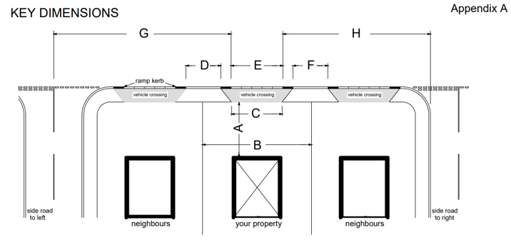

A | Depth of parking space available |  | metres
B | Width of parking space available |  | metres
C | Proposed width of access at back of footway/verge |  | metres
D | Distance to neighbour’s access on the left |  | metres
E | Proposed width of access at carriageway |  | metres
F | Distance to neighbour’s access on the right |  | metres
G | Distance to junction on the left |  | metres
H | Distance to junction on the right |  | metres
Additional comments:

