SCC ICT
Guidance for Creating the New Academic Year
Step by step user guide for schools
Author : David Sheppard
Authorised by : Lizzie Winter
Version : 2.0
Date : 31/05/2023

Table of contents
Contents
1. Introduction 3
1.1. Purpose 3
1.2. Assumptions and Constraints 3
2. Creating a New Academic Year 3
2.1. Gathering the Required Data 3
2.2. Using the Next Academic Year Wizard 4
2.3. School Working Week Sessions AM/PM 5
2.4. Entering Term Dates 5
2.5. Half Term Dates 6
2.6. Professional Development Days (PD Days) 6
2.7. Public Holidays 7
2.8. Completing the process 7
3. Validating Memberships 9
4. Useful Links: 9

Introduction

Purpose
Procedure documentation for creating a new academic year in Sims .Net version 7.210.

Assumptions and Constraints
This guide needs to be used in conjunction with your ESS Detailed End of Year Procedure. This can be located from the Sims 7 Documentation Centre.
These instructions are primary school focused but can be used as guidance for secondary schools.
Assumption is that the staff changes have been made in sims.
Term dates are supplied for all maintained school from Suffolk County Council:
https://www.suffolk.gov.uk/children-families-and-learning/schools/school-term-and-holiday-dates
It is assumed that the school is aware of their term dates, half term breaks, professional development days and public holidays.

Creating a New Academic Year
Note: Please ensure that you have implemented all the teaching staff changes via the ESS processes before creating the new academic year.

Note: Creating the academic year needs to be undertaken before creating a new pastoral structure or promoting students.

Gathering the Required Data
You will require the term dates, periods of half term breaks, public holidays and professional development days that the school has agreed upon.
All maintained schools can obtain term dates and half term breaks from the Suffolk County Council website, (SCC):
https://www.suffolk.gov.uk/children-families-and-learning/schools/school-term-and-holiday-dates
You will have to locate and expand the academic year sort there, in our case that would be 2023 to 2024. Professional development days are set at the school level, so this information is not available from SCC websites.
Academies can set the own term and professional development days, there is no central collection site for these dates.

Using the Next Academic Year Wizard
Go to ‘Routines | School | Academic Year’ to display the Create Academic Year wizard.
You should then be greeted with a dialogue box:
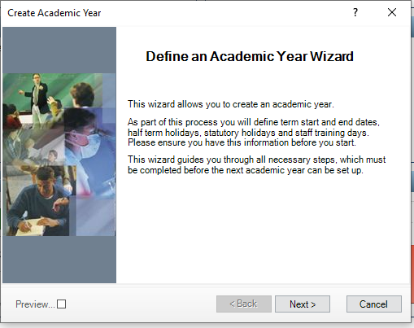
Click ‘Next’ to proceed.

School Working Week Sessions AM/PM
From this dialogue box you will have to define the school working week. Normally this is Monday through Friday. The first day of the week is read only and cannot be altered. You will have to indicate both am and pm sessions.
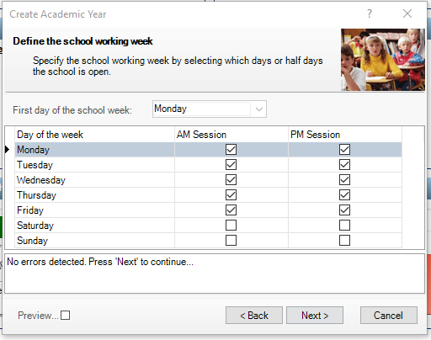
When you select ‘Next’ a warning message indicating ‘Are you sure’ will be displayed as this cannot be changed later and will affect attendance and cover arrangements in Sims. By default am and pm for Monday through to Friday are selected. Once you are happy this is correct then click ‘Yes’ to proceed.

Entering Term Dates
Enter the term dates that you have gathered from an authoritative source and enter them into the ‘Define the terms and term holidays for academic year’ grid.
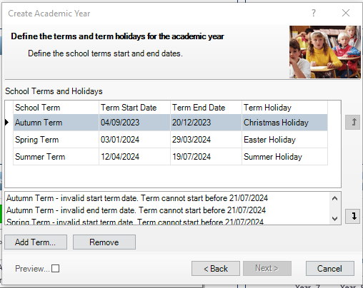
Ignore the errors above as I am using a training data base that has the academic year already inserted. You will need the message that indicates ‘No errors detected. Press ‘Next’ to continue’.
Once you are happy with the dates, select ‘Next’ to proceed.

Half Term Dates
From this location you will need to add the half term breaks, again you are looking for the message as before ‘No errors detected. Press ‘Next’ to continue’. To add a holiday, select ‘Add Holiday’ button the populate the dialogue box.
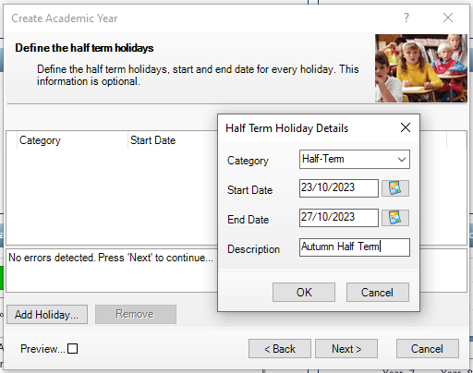
Click ‘OK’ when complete, then repeat for each half term break until the entire academic year half term breaks have been added. Once this has been completed, click ‘Next’ from the main dialogue box to continue.

Professional Development Days (PD Days)
The next step would be to add the professional development days that the school has agreed upon. Click on add and enter each day in turn, you are looking for no errors again at the bottom of the dialogue box.
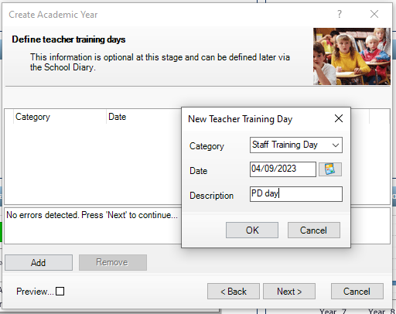
Once you have entered all the agreed days and are happy to proceed, select the ‘Next’ button.

Public Holidays
The next dialogue box is to enter the public holidays, this information can be obtained from the .GOV site.
https://www.gov.uk/bank-holidays
As with the previous dialogue box, you click on ‘Add holiday’ to add a date for each event. Once you have added the public holidays for the academic year, click on ‘Next’ to proceed providing that there are no errors or clashes.
I have used as an example the Christmas bank holiday but you will only need to add days that are in term time.
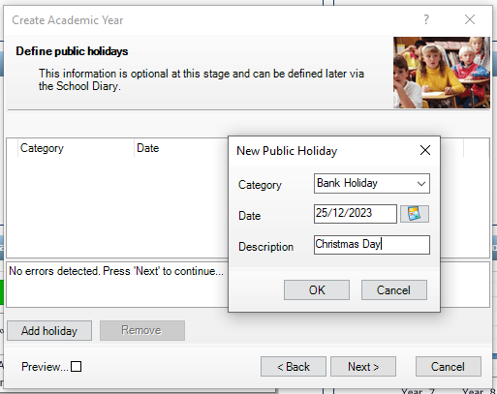

Completing the process
Once you have completed the public holiday stage you are presented with a summary of term dates and breaks. You can expand each branch by selecting the ‘+’ to examine the dates in each term. Once you are happy with the summary, select ‘Create’ to process these dates.
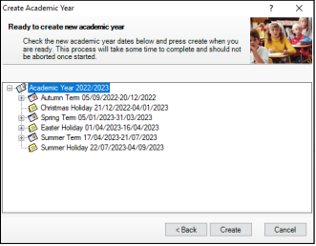
Ignore the dates above as they are from my training database set by ESS.

Once you select the ‘Create’ button a warning message will appear denoting that the process will take time to complete and should never be interrupted as this could cause issues for the sims database.
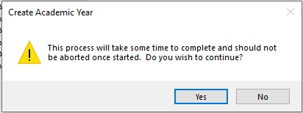
Once you select ‘Yes’ a “progress bar” will appear.
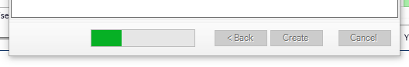
Note: This process may take some time, but as stated earlier, it is important that you do not interrupt it for any reason as closing sims at this point may corrupt your database badly.
Once the process has concluded, a final dialogue box appears indicating that the academic year has been created.
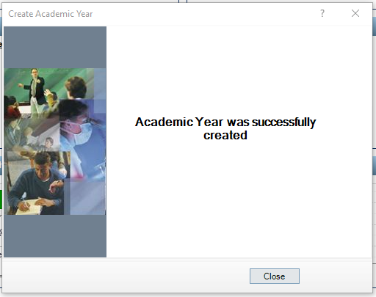
Close the dialogue box.

Validating Memberships
At this stage it is recommended that you validate memberships for sims to resolve any table membership issues. This can be undertaken by selecting ‘Tools | Validate Memberships’.
This will indicate when it was last run, ignore this and click ‘OK’. Again, you will be presented with a “progress bar”. Allow this process to complete and you are finished.

Useful Links:
Sims 7 Documentation Centre
https://www.suffolk.gov.uk/children-families-and-learning/schools/school-term-and-holiday-dates
https://www.gov.uk/bank-holidays
https://www.suffolk.gov.uk/business/it-services-for-schools-and-academies

