Name of applicant:

Suffolk County Council:
EXPRESSION OF INTEREST submission

To enter into a lease agreement for
New Henley Gate Pre-school
Henley Gate Neighbourhood
Ipswich Garden Suburb

This building is to be used solely for childcare purposes.

Suffolk County Council is seeking expressions of interest in taking on a lease in the New Henley Gate Pre-school, Henley Gate Neighbourhood, Ipswich Garden Suburb
The building is to be offered on a 25-year lease.

Location of the building and building information:

New Henley Gate Pre-school, Henley Gate Neighbourhood, Ipswich Garden Suburb.
Please refer to the Henley Gate New School Specification for further details about the pre-school
For further information and data please see the childcare sufficiency assessment- https://www.suffolk.gov.uk/children-families-and-learning/childcare-information-and-support-for-parents-and-providers/childcare-sufficiency-report/
Legal costs

£1,000 is payable to Suffolk County Council for legal costs upon lease completion.

The lease holder will ensure the building is used to provide high quality Early Years Foundation Stage (EYFS) provision for children. This will contribute to enabling Suffolk County Council to fulfil its duty to provide sufficient childcare places for all parents wishing to take up their free entitlement.
Please number the documents that you attach and include as an appendix to this submission.
Consideration will be given to your application and your response to each question detailed below.
We will offer the lease to the organisation who is best able to evidence their ability to provide a flexible, high quality, sustainable, childcare service, which best meets the needs of the local community.
We reserve the right to not consider any applicant who does not fully complete this EOI.
Please see plan below for the proposed building for a 60 place pre-school. The rooms sizes are as follows:
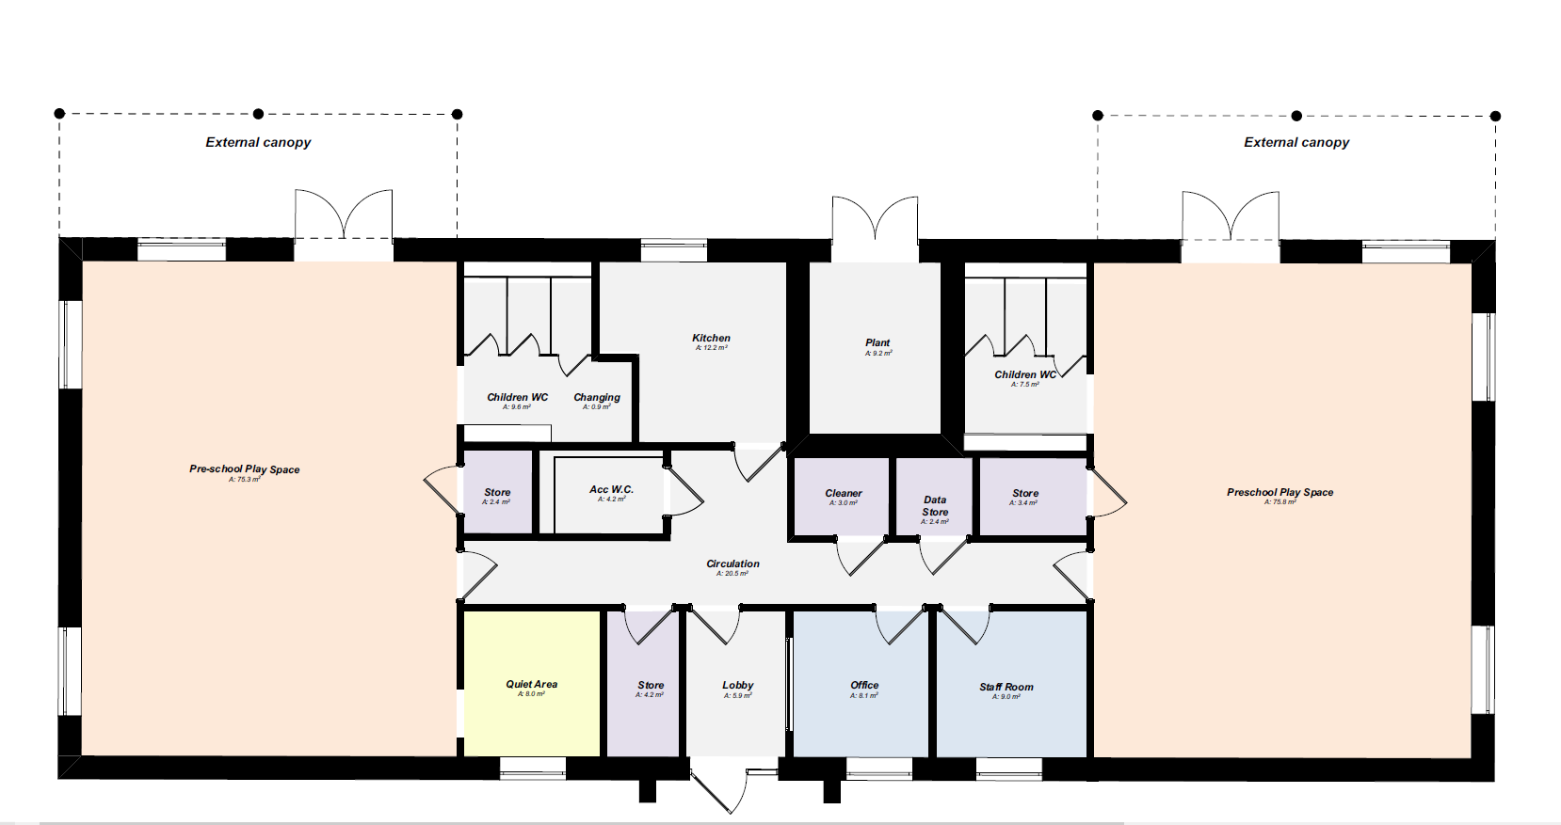
- Preschool play spaces = 75.8m²
- Quiet areas = 8m²

 | Organisation | To submit an Expression of Interest (EOI) you should be a ‘Relevant Body’. E.g one of the identified organisation types below. Please indicate.
 | Organisation | Private organisation
 | Organisation | Voluntary organisation
 | Organisation | Community organisation
 | Organisation | Social enterprise
 | Organisation | Community benefit society
 | Organisation | Community interest company
 | Organisation | Charitable incorporated organisation
 | Organisation | Other (detail below
 | Organisation | Co-operative (whose activities are primarily for the benefit of the community)
 | Name of organisation
Contact person name:
(Or name of lead contact for consortium)

 | Contact person Telephone No.:
 | Contact person address:
 | Relevant Body (organisation) Registered Office:
 | Principal place of business:
 | Date of formation of Organisation (relevant body):
Companies Act Registration No.
or Charity number:

 | Relationship with SCC | Please state if any Trustee, Director, Partner, Senior Manager, or Associate of your organisation is a relative or has any private or business relationship with a Suffolk County Council elected member or officer employed by the Council:
 | Relationship with SCC | Yes |  |  |  |  |  |  |  | No
 | Relationship with SCC | Provide detail
 |  | Please provide a copy of the organisation’s governance document, for example constitution or memorandum of articles.
 |  | Name and number of document attached
 |  | Name and number of document attached
 | Financial Resources | Please attach acceptable documents (see below) which provide information in respect of your financial resources.
 | Financial Resources | Name and number of document attached
 | Financial Resources | Name and number of document attached
 | Financial Resources | Name and number of document attached
 | Financial Resources | Name and number of document attached
 | Financial Resources | Guidance on acceptable financial information: The organisation will have appropriately audited annual accounts.  Acceptable guidance:  - Most recent annual financial report showing income, expenditure, assets, and liabilities  - Projected budget for organisation’s income and expenditure in current/ next financial year  - 6 most recent bank statements showing the organisation’s current financial position
 | Other provision | Do you currently operate an Ofsted registered childcare service at another location/s?
 | Other provision | Yes |  |  | If yes provide details of your current provision by attaching relevant documents.
 | Other provision | Is this proposal is in addition to your current provision?. |  |  |  |  |  |  |  |  |  |  |  | Yes / No
 | Other provision | No |  | If no please evidence how you will have the experience and knowledge to complete Ofsted registration at a level of Good or above by attaching relevant documents.
 | Evidence of capability to enter into a lease | Please provide evidence that demonstrates that the relevant body submitting this EOI will be capable of entering into a 25-year lease, evidence could include  - Leases with SCC and other organisations.  - Business Plan  - Cash flow forecast  Complete text box below (maximum of 500 words) You may also attach supporting documents, e.g. business plan
 | Evidence of capability to enter into a lease | Text box
 | Evidence of capability to enter into a lease | Name and number of document attached
 | Evidence of capability to enter into a lease | Name and number of document attached
 | Evidence of capability to enter into a lease | Name and number of document attached
 | Reference | Please provide a reference that can demonstrate your ability to carry out leasing responsibilities i.e. payment of rent, adherence to lease agreement.
 | Reference | Name and Address of referee
 | Reference | Name and number of document attached (reference)
 | Relevant Business | Please provide details of your proposal in sufficient detail to enable us to understand what service you wish to provide, include hours of operation.  Complete text box below (maximum of 500 words). You may also attach supporting documents.
 | Relevant Business | Text box
 | Relevant Business | Name and number of document attached
 | Relevant Business | Name and number of document attached
 | Relevant Business | Name and number of document attached
 | Free entitlement offer | Provide a copy of your statement of how you will deliver the free entitlement and any additional charges for optional activities outside the free entitlement.  Complete text box below (maximum of 500 words). You may also attach supporting documents.
 | Free entitlement offer | Text box
 | Free entitlement offer | Name and number of document attached
 | Free entitlement offer | Name and number of document attached
 | Free entitlement offer | Name and number of document attached
 | Ofsted registration | Would you be willing to enter into at tenancy at will whilst you are completing Ofsted registration? Y/N
 | Ofsted registration | Text box
 | Age range | Please indicate the age range of the children which your business will service:
 | Age range | 0-2 |  |  |  |  | 2-5 years |  |  |  |  | 5 years +
 | Meeting the needs of families | How will the proposed nursery meet the needs of families in the local community?  Include an admission policy.  Complete text box below (maximum of 500 words). You may also attach supporting documents.
 | Meeting the needs of families | Text box
 | Meeting the needs of families | Name and number of document attached
 | Meeting the needs of families | Name and number of document attached
 | Meeting the needs of families | Name and number of document attached
 | Working in partnership | How will you engage with key stakeholders, for example, local school, childminders, health visitors and local employers?  Complete text box below (maximum of 500 words). You may also attach supporting documents.
 | Working in partnership | Text box
 | Working in partnership | Name and number of document attached
 | Working in partnership | Name and number of document attached
 | Working in partnership | Name and number of document attached
22 | Quality of service | What ability do you have to offer Good or above Ofsted registered childcare?  Complete text box below (maximum of 500 words). You may also attach supporting documents.
22 | Quality of service | Text box
22 | Quality of service | Name and number of document attached
22 | Quality of service | Name and number of document attached
22 | Quality of service | Name and number of document attached

