|  |
| --- |
| **Document Control Sheet** |

|  |  |
| --- | --- |
| **Document Reference** | SCHRBP 060 |
| **Document Title** | Applying to the Suffolk ECT Pool: Information Sheet for SCITT Students |
| **Description** | Information Sheet |
| **Version Number** | 1.0 |
| **Version Date** | December-21 |
| **Last Review Date** | December-21 |
| **Next Review** | September-22 |
| **Reviewed By** | Christine Challenger |
| **Document History** | V1-Dec-21 |

**Suffolk ECT Pool for Posts in Reception and Years 1-6: Information for Applicants**

## Welcome



Thank you for considering Suffolk as a place to start your teaching career.

Applying online, through the Suffolk ECT pool saves you time and effort. You complete one online application form which is made available to schools across Suffolk who are looking for an ECT.

We’re looking for people who want to make a difference in Suffolk and are up for the challenge of raising attainment in our schools. Suffolk’s children and young people need the brightest and best teachers – could that be you?

**Who is the ECT Pool for?**

Trainee teachers can use the Pool to apply for ECT posts teaching ages 4-11 in any setting – mainstream, special or Pupil Referral Unit. Candidates for secondary school positions should apply direct to schools, not through the pool.

## How to apply for ECT roles

You can apply online through the ECT Pool from 1st February each year. Just go to [https://ect.schoolschoice.org/](https://nqt.schoolschoice.org/) and create a log in to get started. More details on how to make the most of your online application are outlined in this guide. If you can’t complete the online form, please contact us. The pool will remain open for applications until the end of the summer term.

You can also choose to apply directly to schools who are advertising roles suitable for ECTs. Some schools will accept your completed pool application form, so you don’t have to complete another form, but do check first.

Please be aware that ECT jobs can come up at any time so it pays to check regularly. Once you’ve registered with the Suffolk ECT Pool you can opt to receive regular email bulletins promoting opportunities in Suffolk schools.



1

# Completing the online application form

1. Register by going to [https://ect.schoolschoice.org/](https://nqt.schoolschoice.org/) and clicking on **New User**. You’ll need an email address and you’ll need to create a password which includes at least one upper case letter, one number and one symbol. If you need to change your password go to **My Profile**.
2. Select **My Profile** and add your personal details – please be aware that this information then pre-populates the application form, your personal information can be updated in **My Profile** at any time and will automatically update these details in your application.
3. Next, select **My Application** from the four tabs available.
4. You can print off a blank application form before you start filling it in. Select the

**download form** button to do this.

1. The form is broken down into eight sections – see the **Applying online guide** on pages 5 and 6.

You can complete the sections in any order and in more than one sitting if you want to. Save your progress regularly on each section and before moving on. There’s a status bar on each mandatory section so that you can check your progress.

1. There are a number of mandatory fields shown by * - you can’t submit your

application until all of these have been completed. If you try to submit before

you’ve completed the mandatory fields a prompt message will appear and the fields

you’ve missed will be highlighted (fill them in and click ‘Save Progress’ to move on!).

1. Make sure you’re happy with your whole application before you submit it – once you have clicked ‘submit’ you can’t go in to make further changes apart from your contact details. If you need to add more supporting information to your application at a later date, e.g. following a teaching placement, you can upload an additional personal statement using the link provided (see question 8 in our FAQs).
2. Once submitted you can download a pdf of the whole application form for your own use.



# Completing the Supporting Statement Questions

The Supporting Statement is a chance for you to tell us what you can do. It provides really

useful information about your knowledge, skills and experience for Headteachers considering your application. You have 300 words for each of the five questions set out below.

Take some time to think about good examples and key points for each question. 

1. Think of a session that you particularly enjoyed teaching. Briefly describe what you did and then reflect on the impact you think it had on pupils’ learning and progress. How did you build on this in future lessons?
2. How have you created a purposeful learning environment? (You may wish to consider classroom management as well as the physical environment)
3. Drawing on your experience and knowledge, what strategies have you used, or would you use, to manage learners’ behaviour constructively?
4. Drawing on your experience and knowledge, how and why have you used assessment to improve pupil progress?
5. What are your key strengths and areas of expertise and how have you, or could you, use these for the benefit of the school and the curriculum?

**Important:** to save your answers to the questions in the Supporting Statement you must have some content for each question. We recommend that you answer these questions in a separate document and then copy and paste them when you are happy with the content.

# Completing the Application Form - Hints and tips

**Take your time** – you don’t have to do it all in one go and there’s no fixed deadline. You may find it helpful to work on some sections separately and then copy and paste them in.

**Make the most of it** – this won’t be the first or last time that you have to list all your

 dates and qualifications. Once you’ve done it keep a copy as it will make your life

easier in the future!

**Proof read** – are you happy that you’ve got everything across that you want to say? Have you checked your use of English, spelling and grammar? Remember, this is your chance to make an impression.

**Pick your examples carefully** – when answering the ‘Supporting Statement’ questions, choose examples that give you the best opportunities to evidence that you meet the criteria

# What happens after I’ve submitted my application?

We review every application to check that it’s been fully completed and that your answers

demonstrate evidence of:

* Professional knowledge and understanding e.g. assessment, subject knowledge, classroom practice, quality of teaching
* Ability to reflect on and evaluate own teaching and learning experiences
* Commitment to teaching and desire to progress in your teaching career
* Creativity and innovation in your practice
* Effective communication in written English; using appropriate grammar, spelling and punctuation.

Applications that meet these criteria will be published for Headteachers to view – we will notify you as soon as your application is published. If you’ve not provided sufficient evidence, we will contact you to explain why.

You should expect contact from Headteachers via the details you’ve provided, so make sure these are correct and that you check your phone/email regularly. Let us know as soon as you find a job, otherwise you will keep getting calls!

In deciding whether to invite you for interview, Headteachers will particularly look at:

* + Your location preference – so please be clear about where you want to work in Suffolk
  + Your key stage/ subject specialism
  + Your answers in the Supporting Statement
  + Your references (once they are available).

Interviews/assessments will usually take place in the recruiting school. **Do** expect questions

that relate to the information you’ve provided in your application form and make sure

you’re well prepared. Most schools will also want to see you teach as part of the selection

process.

# References

Once you’ve completed your application your ITT provider and placement schools will automatically be contacted and asked to provide a reference for you. Make sure you tell

them that you’ve applied to the Suffolk pool so that they expect an email request from us.

If you apply early, we don’t expect the references to be submitted to us immediately, but it’s to your advantage if we have them by early March when schools are actively looking for ECTs.

# Applying online guide

Go to [https://ect.schoolschoice.org/](https://nqt.schoolschoice.org/) and click on **New User.** To register you’ll need your email address and a password containing at least one upper case letter, number and symbol.

**Once you’ve registered you’ll see this home page:**

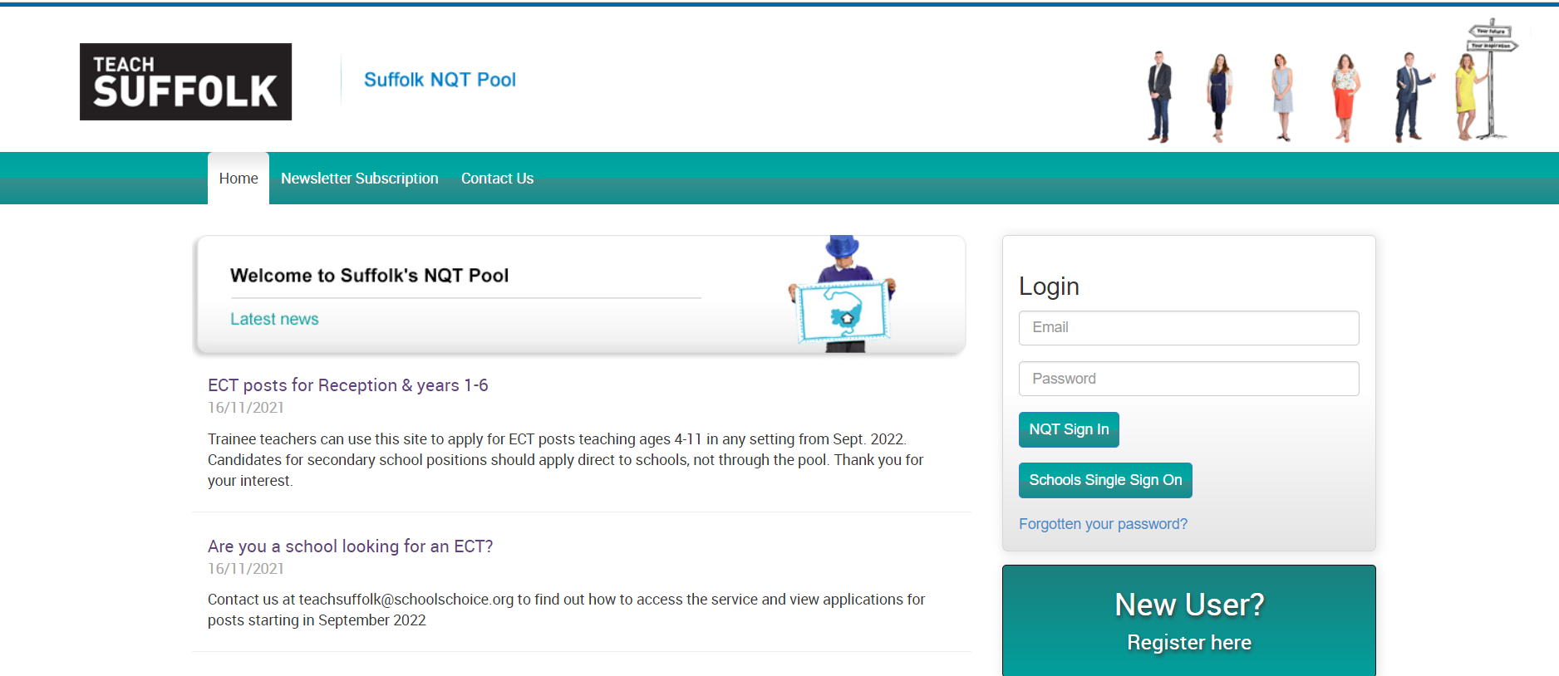

**My Profile tab**

Your key contact details are held here as well as the option to change your password and upload an image of yourself. Your home address details are stored here and populate the application form.

**My Application tab**

**The application form is straightforward to complete and contains clear guidance notes and headings for every section. Specific guidance on information required is set out below:**

**Section 1 – Personal**

* + When completing the information on your ITT provider please give the name and email address of the person who will provide your reference. Please check who this is as some ITT providers manage this centrally and not through your ITT ‘tutor’.
  + For QTS qualifications select your degree and your ITT programme.

**Section 2 – Preferred Post**

* + Select your preferred school type – you can choose as many as you want to.
  + Select one main subject area and one subsidiary subject area from the lists – for most candidates ‘Primary general’ will be most appropriate as the main subject.
  + Choose your preferred locations. These are based on regions in Suffolk and you can choose as many as you want to. If there is a particular town or location you’d like to work in, you can add this in the free text box.

**Section 3 - Education & Training**

* + Type in the name of the first secondary school you attended and the ‘from’ and ‘to’ dates

then click ADD. Then add any additional secondary schools attended.

* + Then add your qualifications one at a time including subject and grade for each school. Click ADD until you’ve entered them all.
  + Repeat this process for Higher Education e.g. your degree, any other post-graduate qualifications, etc.
  + You can also add ‘Other Relevant Qualifications’ such as First Aid or Coaching – please include grade and date obtained.

**Section 4 – Child Protection - Employment History and Teacher Placements**

* + **Employment History** - start with your first job since age 16 and then keep using the ADD button for subsequent employers. You’ll need employer name, your role and the dates you joined and left, plus your reason for leaving.
  + **Breaks in employment** – give dates and reasons.
  + **Schools at which professional placements have been or will be undertaken** – only include schools you attended whilst on an ITT placement **that included teaching practice.**

**Section 5 - Extra Curriculum Contributions**

* + Tell us about your wider interests and how you can support the life of the school through clubs, activities, etc.

**Section 6 - Personal and Employer References**

* + Your ITT provider and placement schools will automatically be contacted for a reference using the details in section 1. You can include additional referees here, e.g. from previous employment. Schools may take these up prior to interview.

**Section 7 - Supporting Statement**

* + This is where you answer the five questions. There is a 300-word limit for each answer, anything over this will not be visible on your application.

**Section 8 - Declarations**

* + Make sure you put ‘None’ in these boxes, if you have nothing to declare!

## If you get stuck at all remember that you can email us: [teachsuffolk@schoolschoice.org](mailto:teachsuffolk@schoolschoice.org)

# Frequently Asked Questions

**Q1 Which schools participate in the pool? Does this include academies?**

A significant proportion of Suffolk’s primary schools with ECT vacancies participate in the pool. This includes both maintained schools and academies.

**Q2 What if I want to leave the ECT pool?**

Just contact [teachsuffolk@schoolschoice.org](mailto:teachsuffolk@schoolschoice.org) and ask for your details to be removed from the database. You can do this at any time. Make sure you tell us immediately if you accept a job offer so that we can remove your details – otherwise schools will continue to contact you.

**Q3 Can I have feedback on my application form?**

We can provide feedback on your application form if your request it, and we’ll commit to do this within 15 working days of your request. If you require feedback following an interview or assessment at a school, you should request it from the school.

**Q4 What if I see a vacancy at an individual school in Suffolk?**

If you see a role that interests you, please feel free to apply directly to the school concerned. Contact the school to ask if they will accept a copy of your pool application form – often they will, and this can save you time. Write a personalised letter to accompany the pool form, describing how you meet the requirements of the advertised post.

**Q5 Can I apply to other counties as well as Suffolk?**

Yes, you can of course apply to other Local Authorities and schools – although we hope you’ll choose a Suffolk school for your first post! Our pool is only available to schools in Suffolk so you will have to make separate applications to be considered in other counties. When you secure a post (wherever it is!) we ask that you let us know, as soon as possible, so we can update your details.

**Q6 By applying to Suffolk through the ECT pool, will I be allocated to a specific post/school?** No, each school makes its own decision about who they want to interview and appoint. If a school is interested in your application, they will contact you to arrange an interview.

**Q7 Who offers me a job?**

All offers of appointment are made by governing bodies of individual schools or by the Trust for an academy school, and not by the Local Authority. You are not obliged to accept an offer of employment, but should be aware that verbal acceptance is usually regarded as ethically binding on all parties. You should only accept an offer if you are confident that the role and the school are right for you.

**Q8 My application was written in January, but since then I have had more experience in a school: can I update my application to reflect this?**

Yes, we actively encourage this. We recognise that applicants often gain more experience on their teaching placements. You can submit an **additional personal statement at any time in the process** which will then be available for Headteachers to view. This should be in the form of an open letter, with your name as a header on each page. You can upload it using the link on the application form. You can also add an updated version of that personal statement at any time.