APPLICATION FOR PERMISSION TO PLACE
SCAFFOLDING ON THE PUBLIC HIGHWAY
HIGHWAYS ACT 1980 Section 171

Note: this application is for Tube & Fitting scaffolds only.

Application to place a Mobile Tower Scaffold on the highway can be made via this link:
https://www.suffolk.gov.uk/roads-and-transport/highway-licences/crane-inc-oversail-mobile-elevating-work-platform-or-other-forms-of-lifting-equipment-licence

Application Notes
1. General
A licence is required to place scaffolding on the highway. The term highway includes footpaths, cycleways, verges, and roads. It is an offence under the Highways Act 1980 to place a scaffolding on or over the highway without first obtaining a licence from Suffolk County Council (SCC) as the Highway Authority. Failure to obtain the required licence could result in legal action being taken by SCC.
Should the scaffolding be positioned behind hoarding and within the highway, a separate application is required for a hoarding licence in addition to this application.
2. Application procedure
Once the application form has been received by the Highways Licensing and Enforcement Team an acknowledgement will be sent to you, and we will endeavour to respond within 10 working days with our decision.
A payment of £260.00 will be required before the licence is issued. Payment options will be provided on receipt of your application. The licence is valid for 4 weeks and should you need the licence for longer than this period, an extension fee is charged at £130.00 every 4 weeks.
Please remember that no work can commence on the highway until you have received written permission from us.
3. Licence conditions
You will need to satisfy standard conditions before a licence is issued, such as:
- Highways Licensing and Enforcement issue licences in line with the National Street Gazetteer (NSG) and where your proposal is on separate street names this may require more than one licence.
- The ability to indemnify SCC against third party liability.
- Compliance with legislation in placing a Scaffolding on the Highway.
- Ability for SCC to inspect works.
- Keeping the area safe whilst undertaking works to protect the public.
- Making good of the highway on completion.
- If we have started work on processing the application, the fees will not be returned even if we do not approve the application.
- Any form of Traffic Management required must conform with the Safety at Street Works and Road Works Code of Practice (Red Book) and Chapter 8 of the Traffic Signs Manual, and must be installed by an Accredited Operative.

Application Form

Please complete the following to enable us to process your application.

Applicant details

Name
Address
(including postcode)
Company

Telephone number |  | Email

Client details (if different to above)

Name
Address
(including postcode)
Company

Telephone number |  | Email

Proposed location of the Scaffolding

Address
(including postcode and property Number/name)

Outline of works (all relevant sections must be completed)

Please provide a plan view of the site to support application.

First street name: |  | 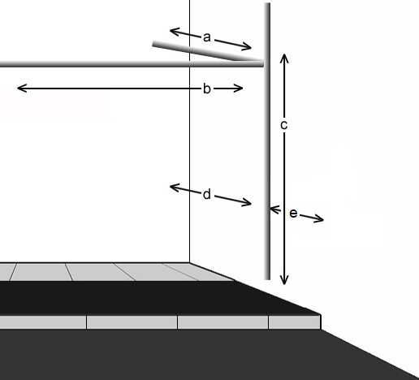
Extent of scaffold out over highway (a): | m
Length of scaffold along highway (b): | m
Height of scaffold (c): | m
Access width under scaffold (d): | m
Width of footway/verge outside scaffold (e): | m
Estimated width of carriageway at narrowest point: | m
If all footway/verge access is blocked, reason for blockage and alternative route for footway users;

Second street name (if applicable)

Extent of scaffold out over highway (a): | m
Length of scaffold along highway (b): | m
Height of scaffold (c): | m
Access width under scaffold (d): | m
Width of footway/verge outside scaffold (e): | m
Estimated width of carriageway at narrowest point: | m
If all footway/verge access is blocked, reason for blockage and alternative route for footway users;

Description of Works

Site CISRS card holder |  | Card number
Site CISRS card holder |  | Expiry Date
10 working days’ notice must be provided before the intended installation date.

INSTALLATION DATE |  | REMOVAL DATE

Should your proposal require a site meeting to discuss Traffic Management, please continue to apply and ask to enable this requirement to be carried out by the Highways Licensing Inspector.

Public Liability Insurance

The applicant must hold Public Liability Insurance to the value of at least £5 million and it must be valid for the duration of the licence. A copy of the insurance certificate must be held on record with Suffolk County Council. If you have not previously provided us with a copy, please attach a copy to this application form.

Declaration

Name (in block capitals)
Occupation

Signature |  | Date

Please return completed form and any additional information you may feel necessary to support your application to highways.licensing@suffolk.gov.uk. If you are unable to return the form via email, please send to any of the three addresses at the bottom of this form.

Data Protection Act 1998

The personal data you provide on this form will be used by Suffolk County Council to administer your Licence.

We may occasionally share your personal data with other council departments and with other bodies (including District / Borough Councils, the Police, Inland Revenue) for purposes of protecting public money, preventing and detecting crime and/or fraud and ensuring public safety. Such sharing will only occur on a case-by-case basis where a justifiable purpose in line with legislation has been demonstrated. The information may also be used for internal training.

PAYMENT INSTRUCTIONS

A Licence reference number will be provided to you by the Highways Licensing and Enforcement Team on receipt of your application, which you will need to quote when making payment.

ONLINE – Website: www.suffolk.gov.uk
Follow links to Roads and Transport & Suffolk Highways Licences

Select the “Pay for a Licence” link
Select the “Pay for a Licence” (Green Button)

Enter the provided Licence / Licence Reference Number, i.e. NRSWA-LICENCE-00011111 (Please ensure that “000” is entered before the given Licence / Licence Reference number. To make the number 8 digits long.)
Enter your Organisation Name
Enter your contact Telephone Number
Select Application Cost from the drop-down box, “Licence/Penalty Charge”
Enter the amount that is being paid
Click “Proceed to Pay” (for single payments)
For multiple licences, click “Add Another”, followed by the “Proceed to Pay” button

ELECTRONICALLY – by the Bankers Automated Clearing Services (BACS).

Payment should be made to: Suffolk County Council
Sort Code: 30-00-00
Account No: 00293148

If you are a Lloyds Customer, you may have difficulty using the above Sort Code and Account number. Therefore, please use the following:

To: Suffolk County Council
Sort Code: 30-00-02
Account No: 01305978

Payment must be accompanied by the Licence/Licence Reference Number covered by the payment and the amount being paid in relation to each number and be sent via email to highways.licensing@suffolk.gov.uk.

BY POST

Please make your cheque payable to Suffolk County Council and send it to:

Highways Licensing and Enforcement Team, Phoenix House, 3 Goddard Road, Ipswich, Suffolk, IP1 5NP

Please note that paying by cheque will delay the process by 7 days, until authorisation of cheque clearance has been received.

If you have any queries regarding the any of the above information, please get in contact by emailing highways.licensing@suffolk.gov.uk.

