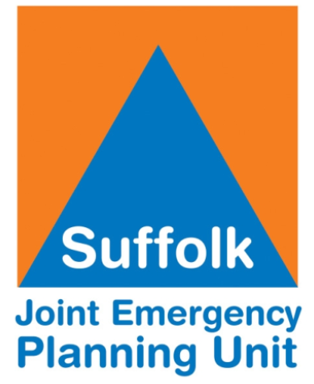
10-Minute Business Continuity Assessment
This quick assessment helps you review how well your business continuity arrangements are in place. It is divided into sections for ease of reference, and ideally all criteria should be met.

Business Continuity Planning
Question | Yes | No | Don't know
Do you have a Business Continuity Plan (BCP)?
If yes, have you tested your plan within the last 12 months?
Is the plan owner clearly identified?
Is the plan documented clearly and easily accessible?
Do you have a policy for when to activate your plan?
Is the plan regularly reviewed?
Has a Business Impact Analysis been completed?
Are staff aware of business continuity arrangements and communication processes?

Data Backup and IT
Question | Yes | No | Don't know
Do you have a data backup plan?
Are essential systems backed up?
Do you store backups securely?
Do you test your backups regularly?

Facilities and Building
Question | Yes | No | Don't know
Do you have building evacuation procedures?
Do you have building lockdown procedures?
Do you have an alternative location, if you lose access?
Does your building require 24-hour 7-day access?
Do you have a generator in place?
Do you have key contact numbers?

Security
Question | Yes | No | Don't know
Is there a security system installed?
Are access controls in place?
Are staff trained in security awareness?
Are contractors checked, including both the company and individual staff?

Suppliers and External Support
Question | Yes | No | Don't know
Do key suppliers have continuity plans?
Do you have alternative suppliers?
Do you have up-to-date contact details?

People and Training
Question | Yes | No | Don't know
Are staff aware of their roles in an incident?
Have you conducted training or exercises?
Do you have a clear communication cascade?
Do staff know where to go for advice and information internally?
Do staff know where to go for external advice and information (for example JEPU, SRF or Protect)?

Insurance
Question | Yes | No | Don't know
Do you have sufficient insurance to cover business disruption, repairs, temporary staff, temporary accommodation and equipment?
Do you have your insurance company details in order to contact them immediately at the time of the incident?

Grab Bag
Question | Yes | No | Don't know
Business recovery plan
List of employees with contact details
Details of IT providers
Building site plans
Spare keys
Data backup
Stationery
First aid kit
Torch
Spare Batteries

Summary
This assessment provides a simple snapshot of your current business continuity arrangements and helps identify areas that may need further attention.
If you answer no or don’t know any of the questions, these should be treated as priorities for review, action or further discussion to strengthen your resilience.

