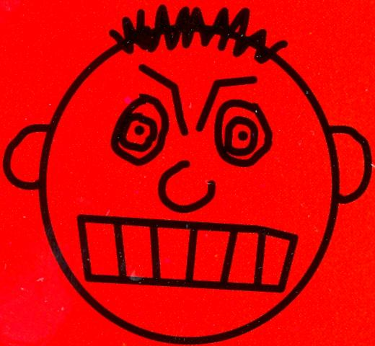

THIS CAN MAKE ME LOSE CONTROL
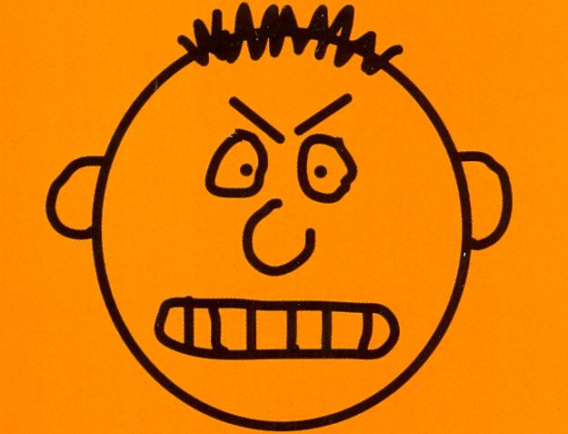

This can make me MAD!!
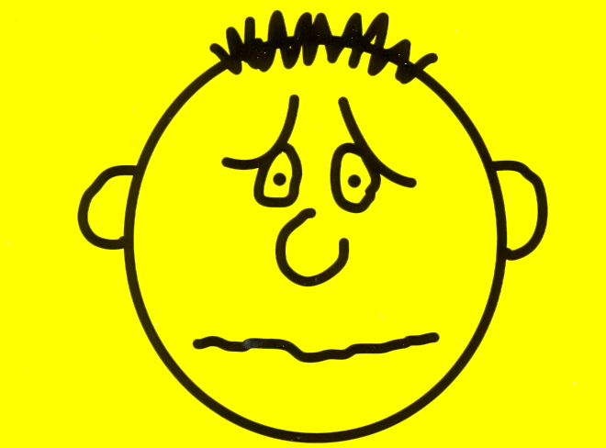

This could make me really nervous
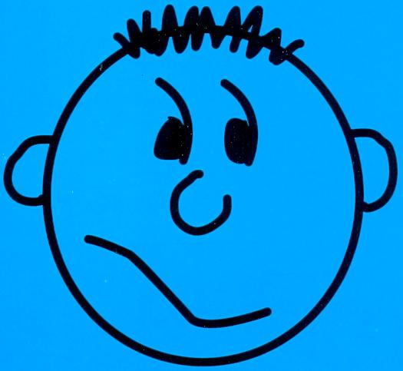

This might make me feel uncomfortable
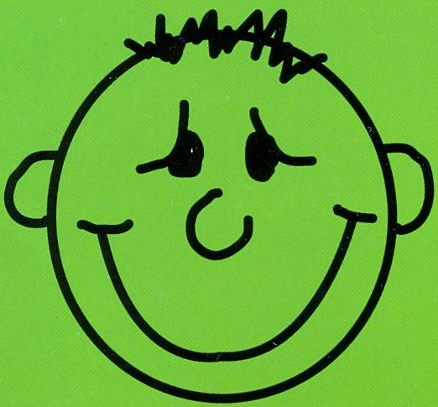

I can handle this

 | THIS CAN MAKE ME LOSE CONTROL
4 | This can make me MAD!!
3 | This could make me really nervous
2 | This might make me feel uncomfortable
1 | I can handle this

