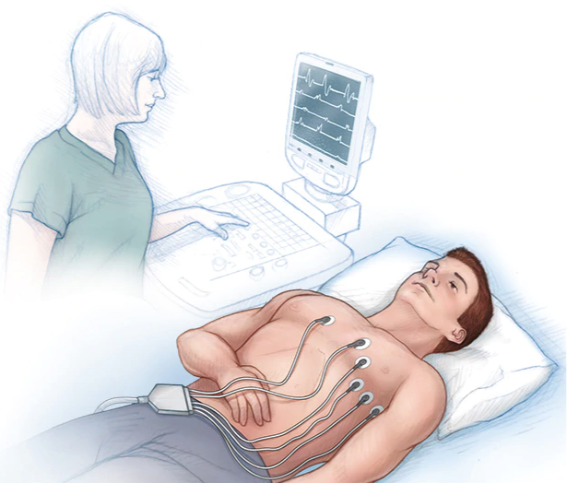

**NAME’s Hospital Story**

**NAME has an electrocardiogram (ECG)**

**NAME goes to the hospital and has an ECG.**

**Name in the car park.**

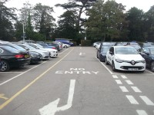

[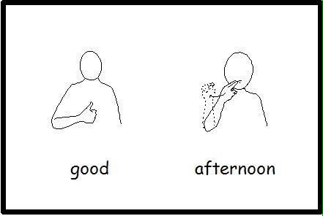](https://www.google.co.uk/url?sa=i&rct=j&q=&esrc=s&source=images&cd=&cad=rja&uact=8&ved=2ahUKEwjZyrn1mJjgAhWRMBQKHcjaBTUQjRx6BAgBEAU&url=https://www.pinterest.co.uk/pin/395261304776025951/&psig=AOvVaw2pvAyVMemldoF4QpyC-KA7&ust=1549030081765691)

**Name can see the hospital.**



**NAME goes through the doors.**

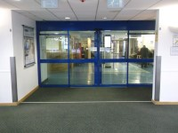

[](https://www.google.co.uk/url?sa=i&rct=j&q=&esrc=s&source=images&cd=&cad=rja&uact=8&ved=2ahUKEwjZyrn1mJjgAhWRMBQKHcjaBTUQjRx6BAgBEAU&url=https://www.pinterest.co.uk/pin/395261304776025951/&psig=AOvVaw2pvAyVMemldoF4QpyC-KA7&ust=1549030081765691)

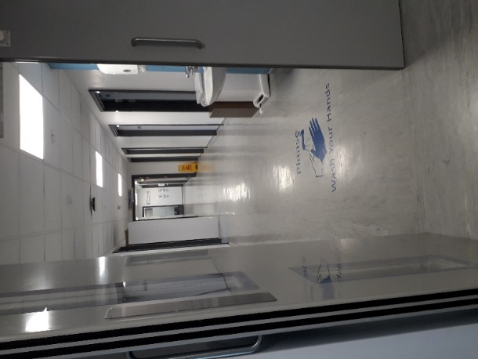

**Walk through the corridor.**

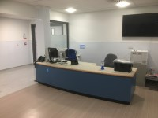

**NAME can see Reception and chairs.**

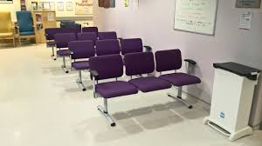

**NAME waiting.**

**Good waiting.**

[](https://www.google.co.uk/url?sa=i&rct=j&q=&esrc=s&source=images&cd=&cad=rja&uact=8&ved=2ahUKEwjZyrn1mJjgAhWRMBQKHcjaBTUQjRx6BAgBEAU&url=https://www.pinterest.co.uk/pin/395261304776025951/&psig=AOvVaw2pvAyVMemldoF4QpyC-KA7&ust=1549030081765691)

**NAME goes into x ray room.**

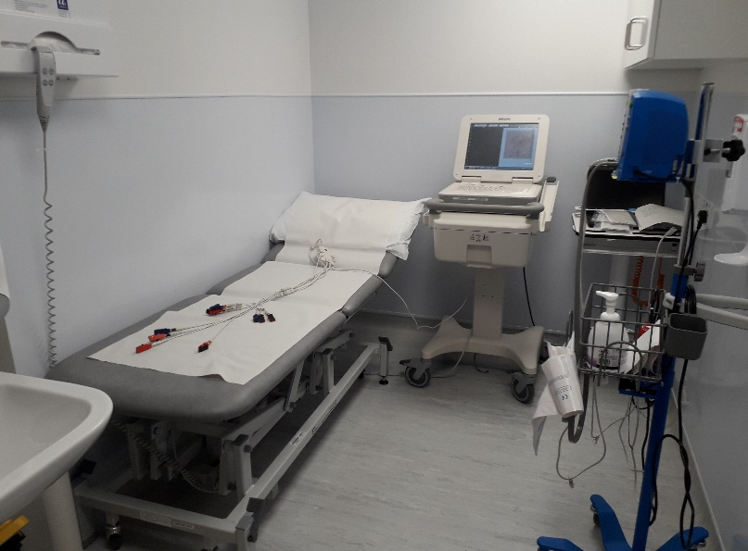

[](https://www.google.co.uk/url?sa=i&rct=j&q=&esrc=s&source=images&cd=&cad=rja&uact=8&ved=2ahUKEwjZyrn1mJjgAhWRMBQKHcjaBTUQjRx6BAgBEAU&url=https://www.pinterest.co.uk/pin/395261304776025951/&psig=AOvVaw2pvAyVMemldoF4QpyC-KA7&ust=1549030081765691)

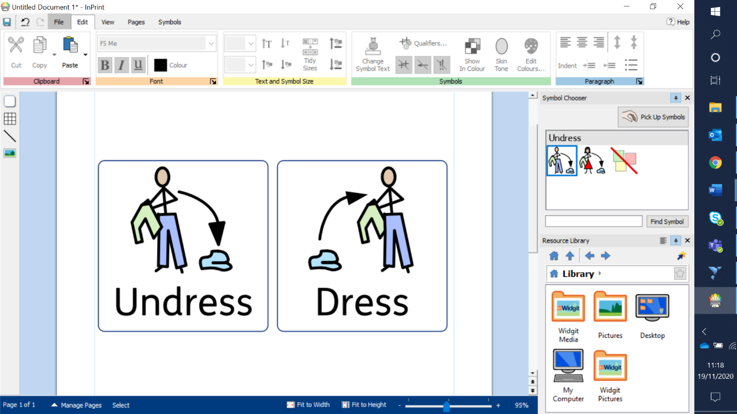

**Clothes off.**

**Mummy help.**

**Lay down on the bed.**

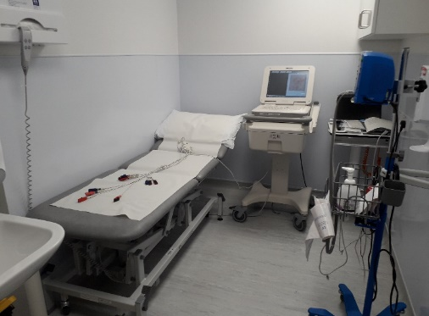

**Stickers on.**

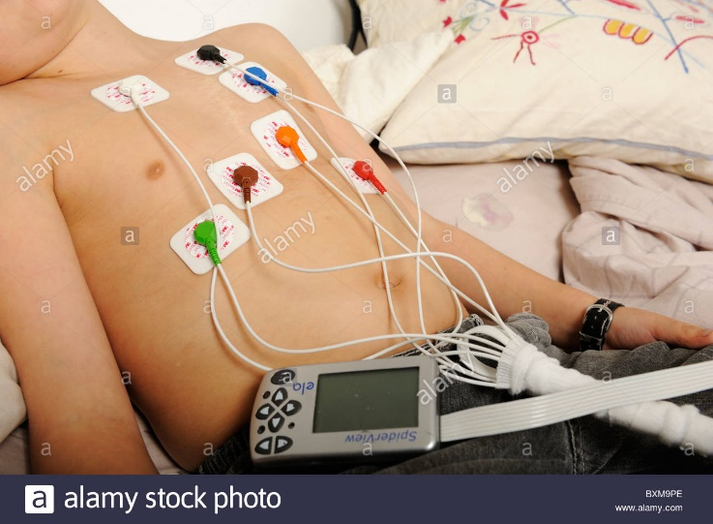

**NAME waiting.**

**Good waiting.**

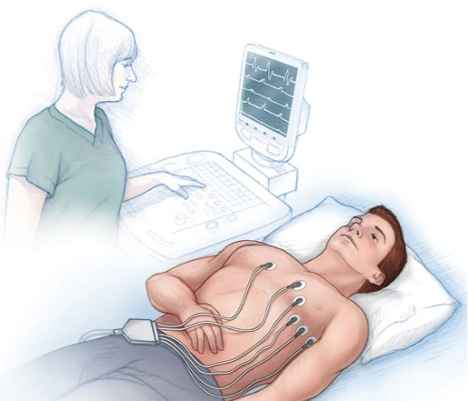



[](https://www.google.co.uk/url?sa=i&rct=j&q=&esrc=s&source=images&cd=&cad=rja&uact=8&ved=2ahUKEwjZyrn1mJjgAhWRMBQKHcjaBTUQjRx6BAgBEAU&url=https://www.pinterest.co.uk/pin/395261304776025951/&psig=AOvVaw2pvAyVMemldoF4QpyC-KA7&ust=1549030081765691)

**Finished!**



**Car then home.**

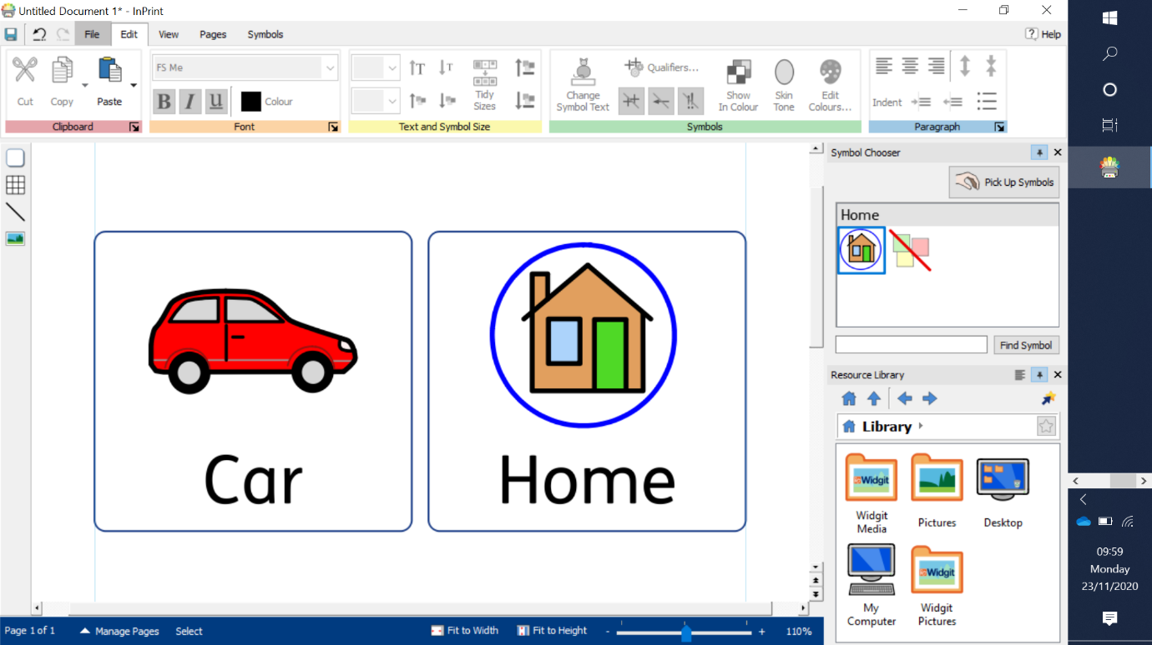

**Well done!**



[](https://www.google.co.uk/url?sa=i&rct=j&q=&esrc=s&source=images&cd=&cad=rja&uact=8&ved=2ahUKEwjZyrn1mJjgAhWRMBQKHcjaBTUQjRx6BAgBEAU&url=https://www.pinterest.co.uk/pin/395261304776025951/&psig=AOvVaw2pvAyVMemldoF4QpyC-KA7&ust=1549030081765691)